Issues:

Edit Enrollment Button not there in Employee User.
Name: Vignesh L
SSN: 342-43-4535

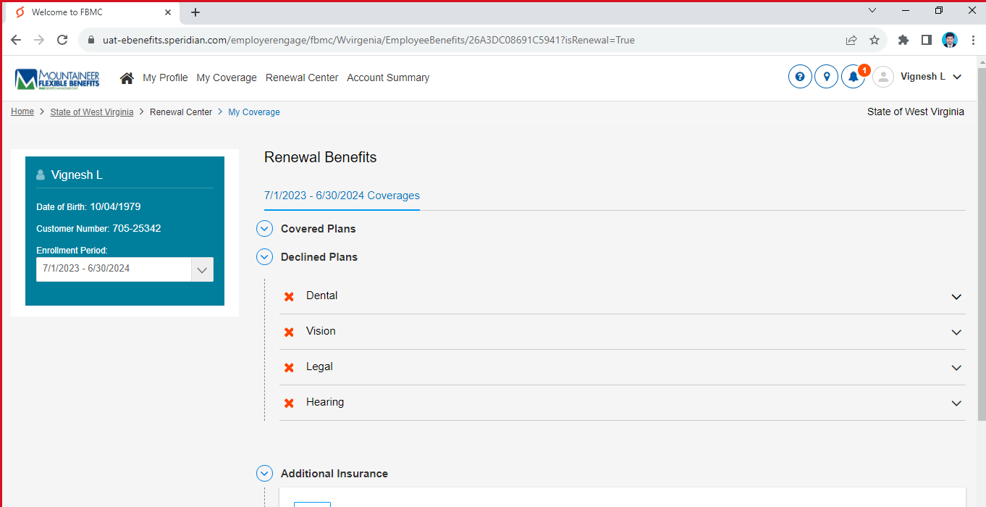
Admin User:
Edit Enrollment Button is there.
