Create Job in Jenkins:
Click on New Item:
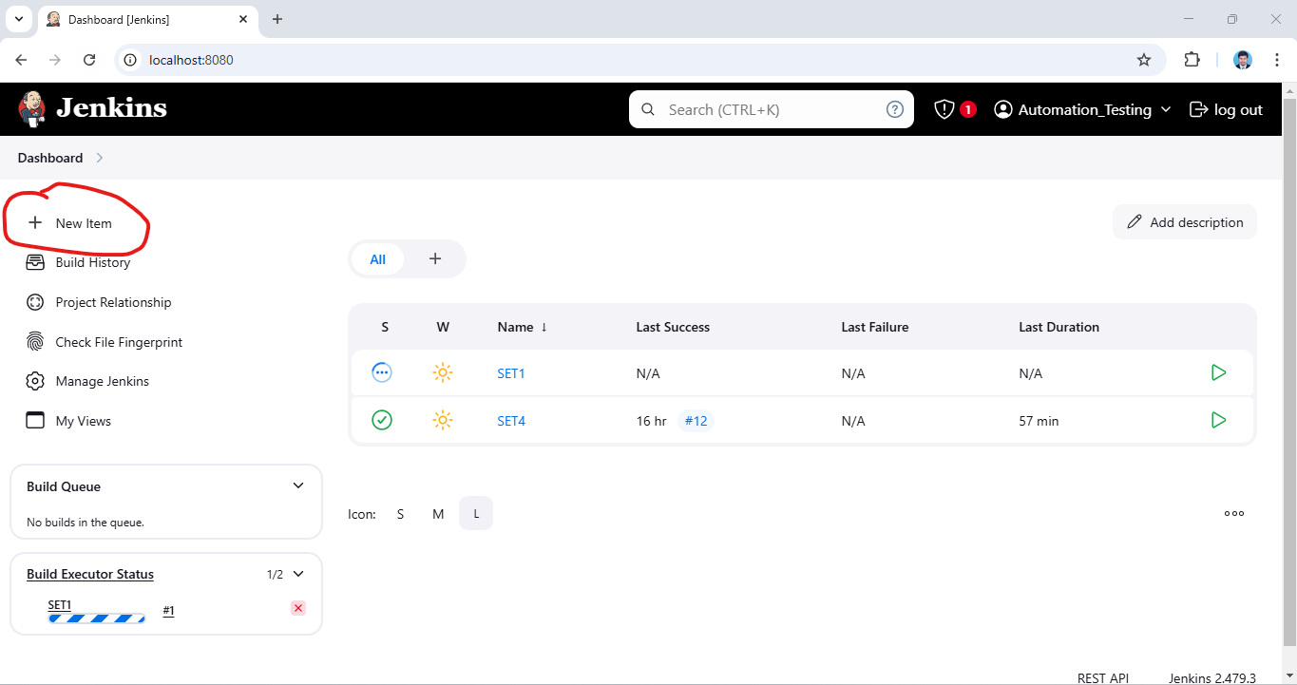
Enter Item Name & Click on Maven and Click on OK:
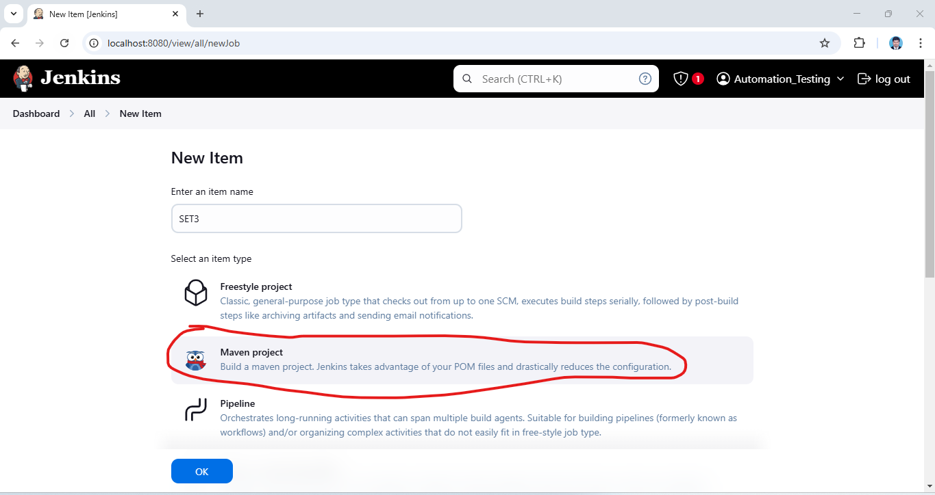
Click on Project Parameterized and click on Choice Parameter:
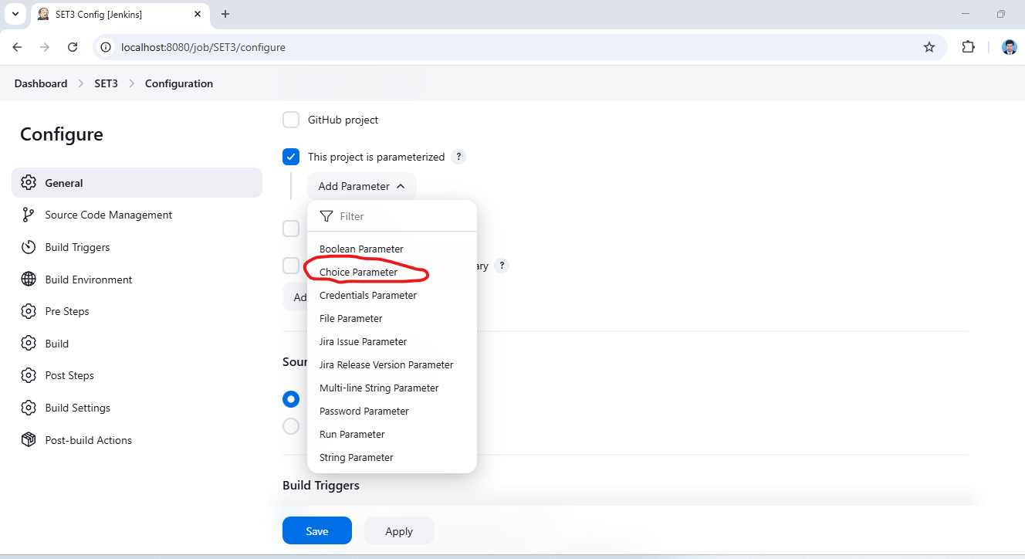

Project Parameterized Choice Parameter Add URL
URL
https://mme.benefitalign.com/mme/
https://ce-uat.benefitalign.com/mme/
https://mme.brokerengage.net/mme/
https://ce-qa.benefitalign.com/mme/

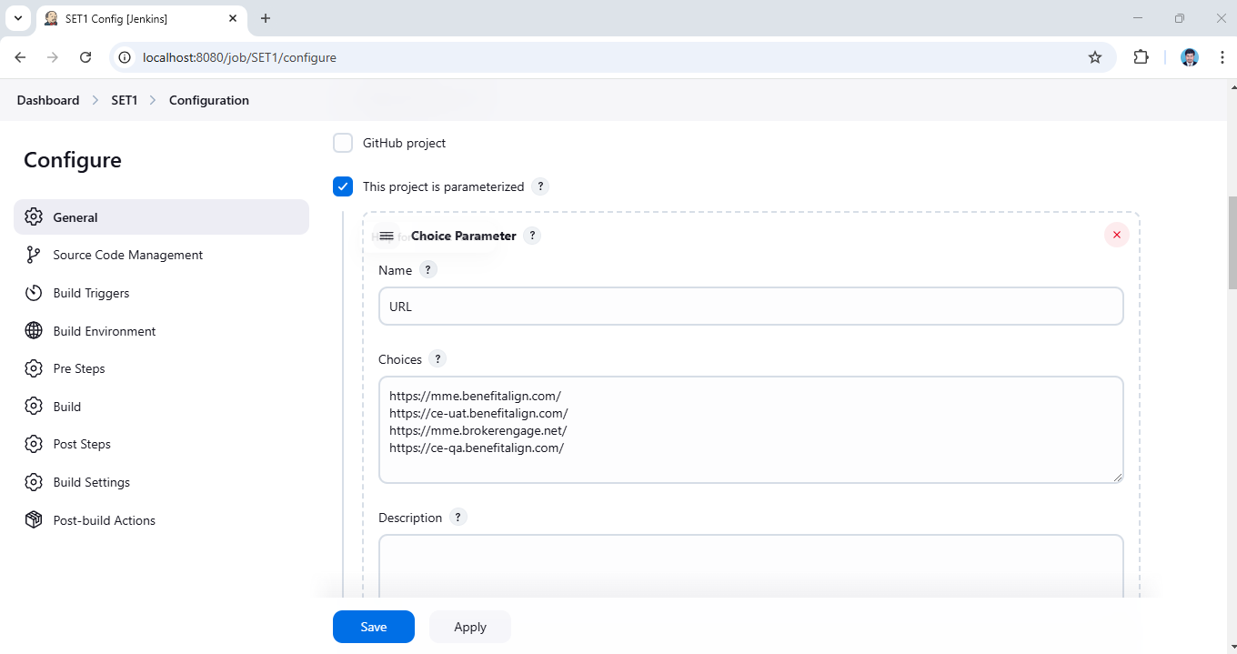

Add Parameterized Choice Parameter Add Browser

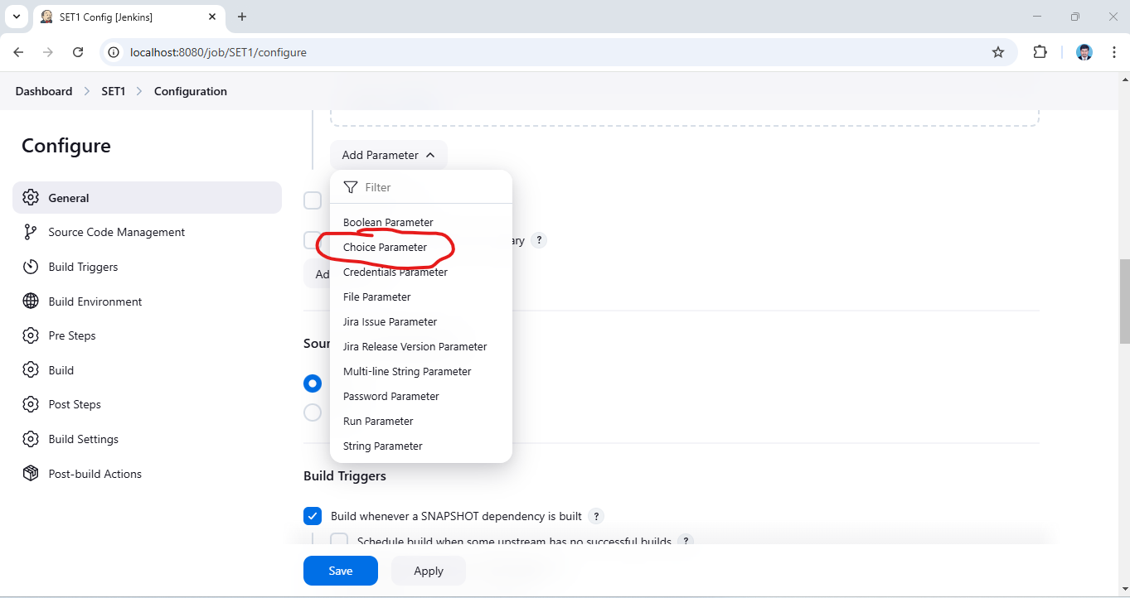
BROWSER
Chrome
Edge
Firefox
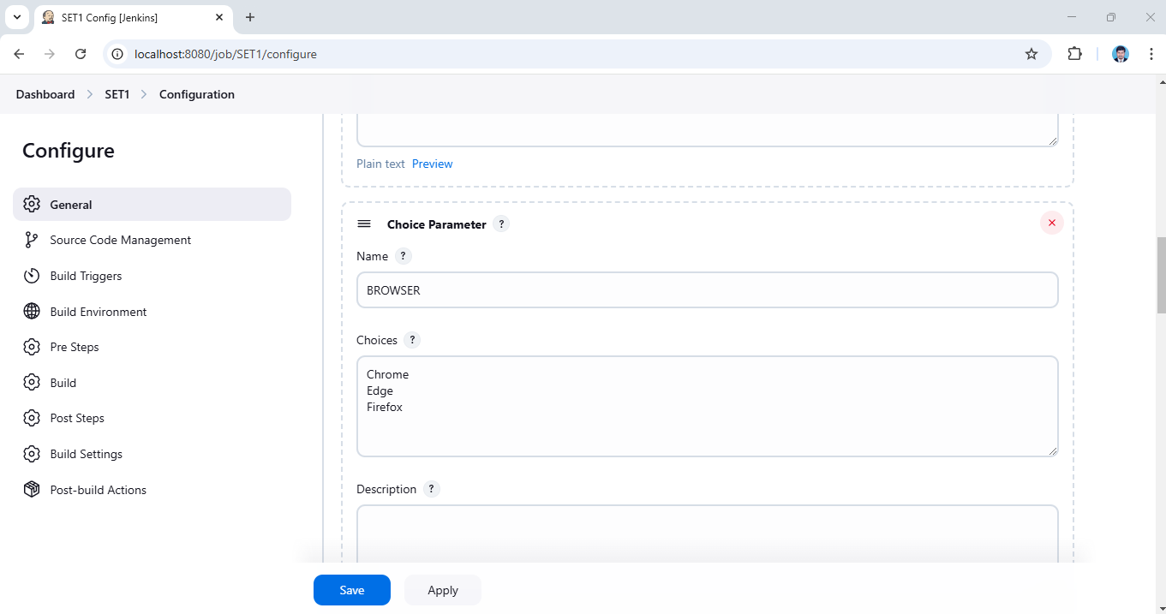

Build Periodically Automatically Build Trigger Based on Comments

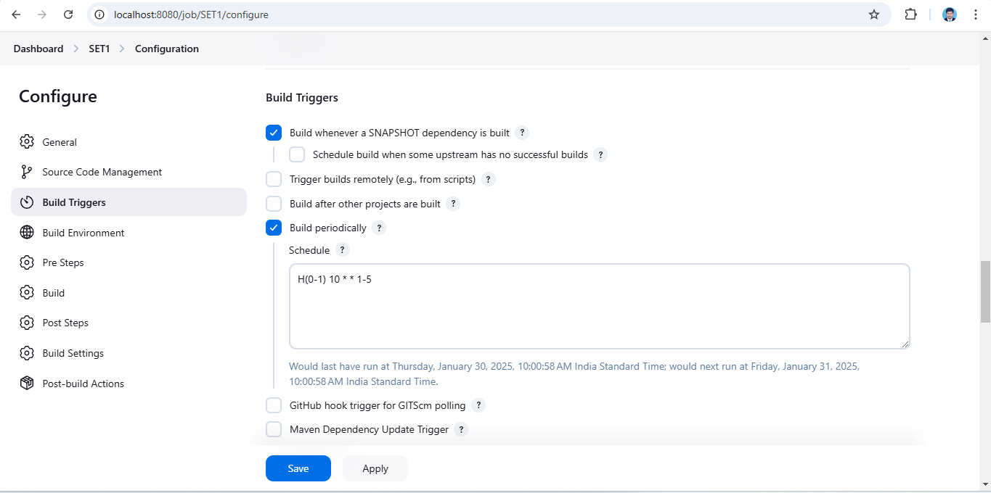

Pom SET UP Based on Project Pom file path & Goals and Options:
test -DsuiteXmlFile="testng.xml" -DBROWSER=${BROWSER} -DURL=${URL}
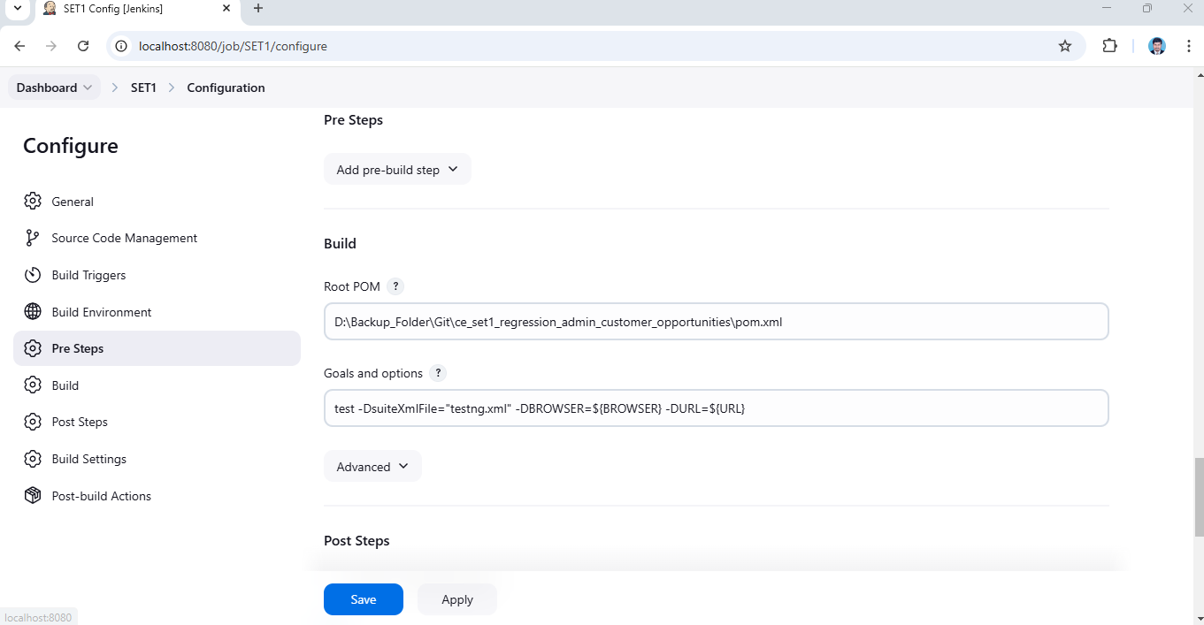

Pre steps:

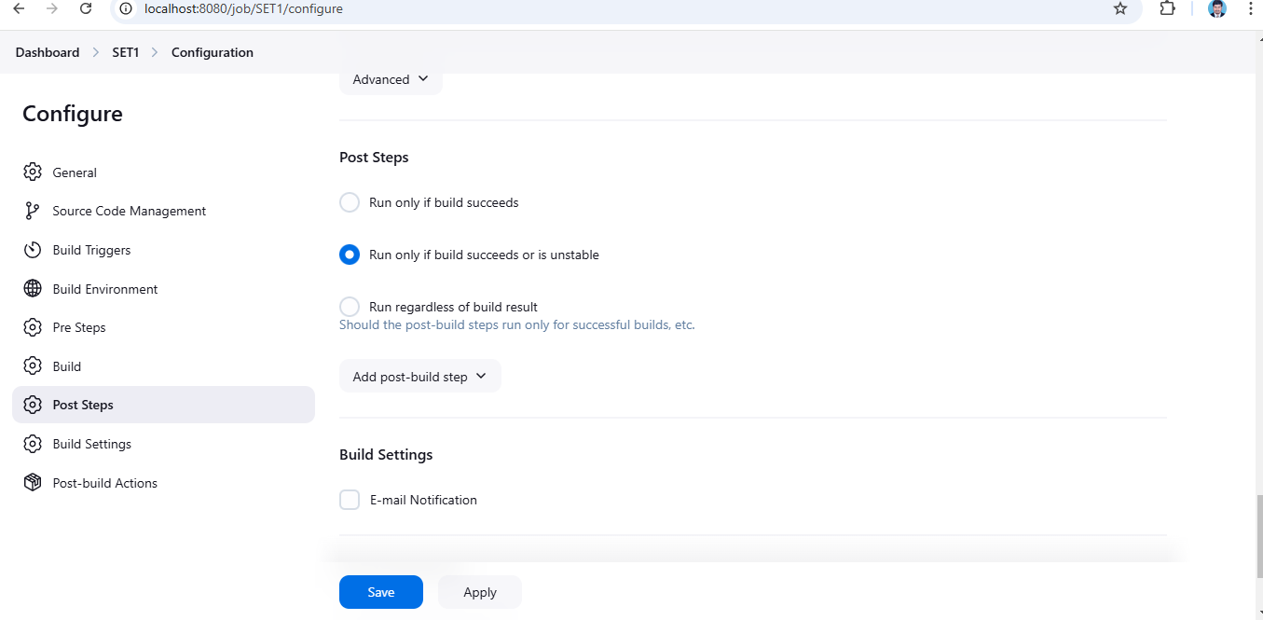

Post Build Action Click on Add:

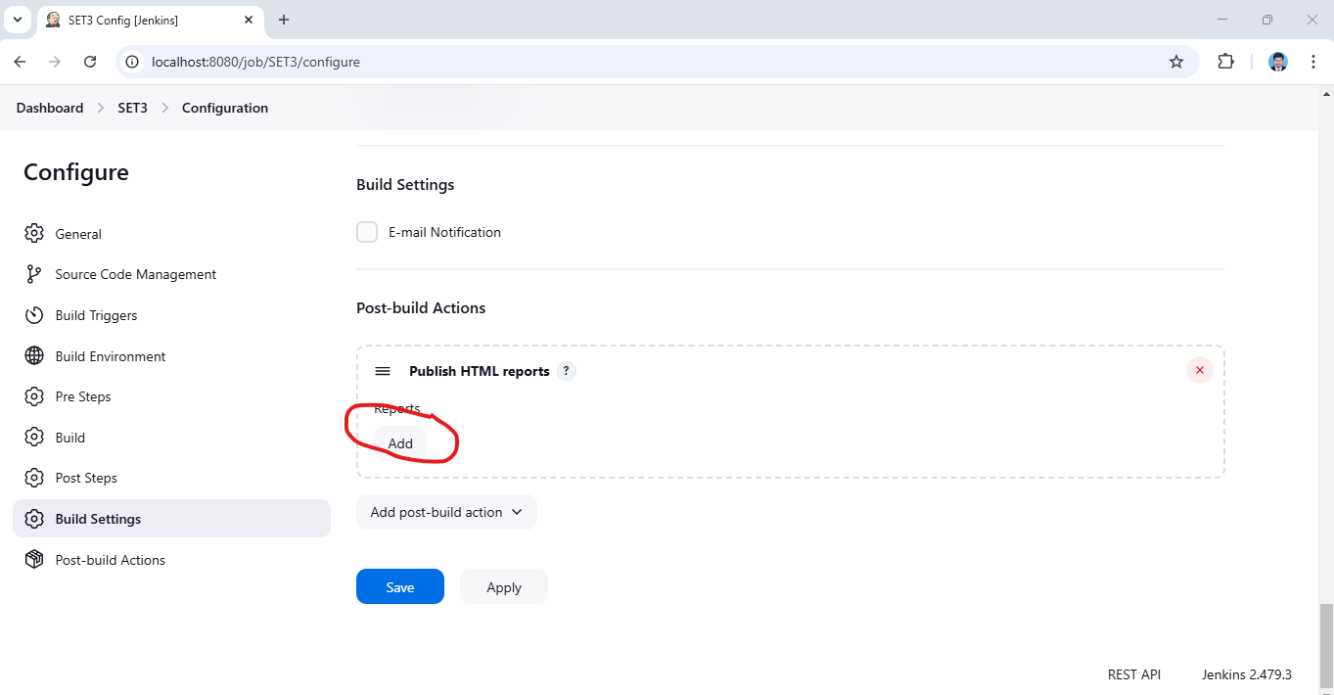

Post Build Actions Publish HTML Reports:

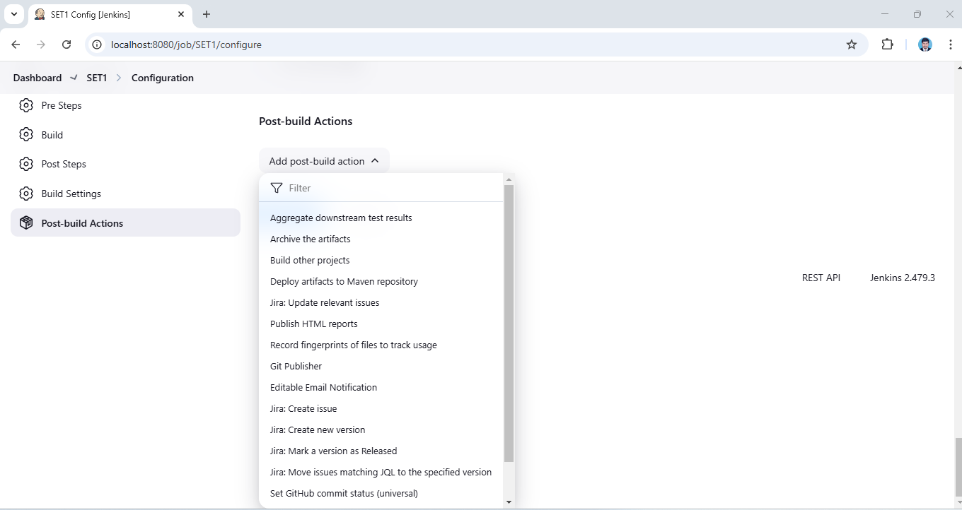

HTML Report File path & Apply and Save:

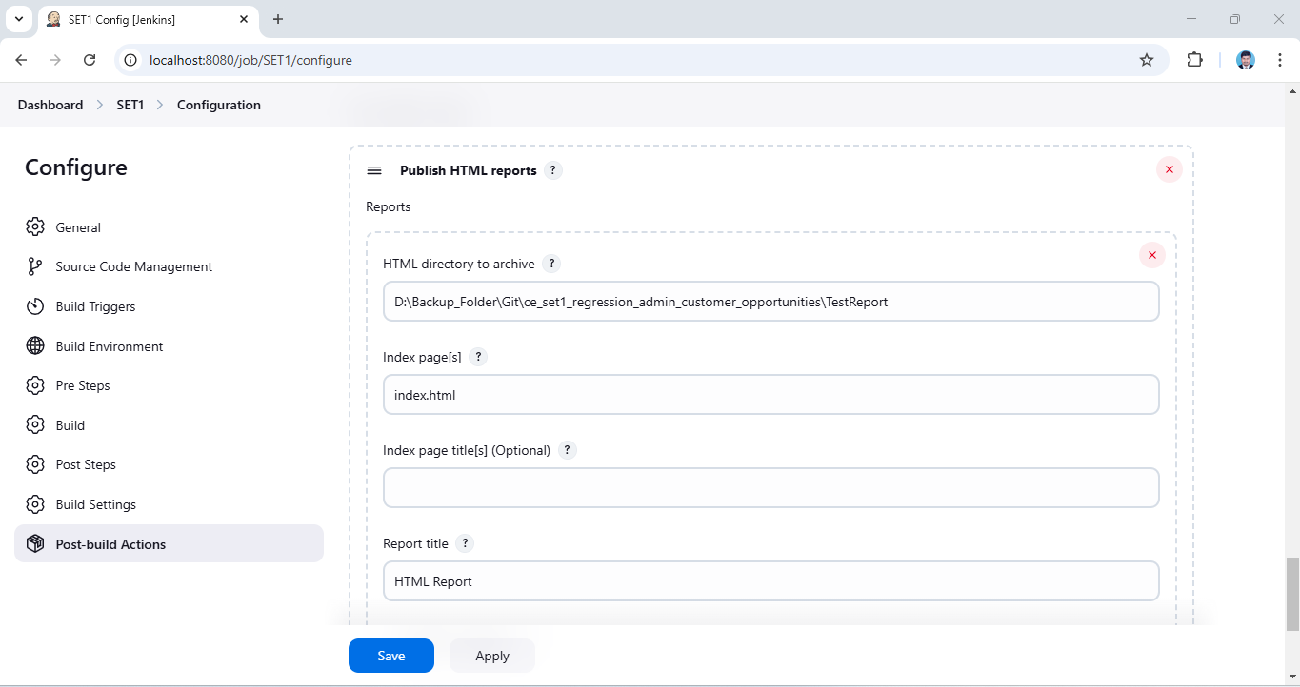

Jenkins Server:
