//Constructor implementation
class Sample
{
public static void main(String args[])
{
StringBuffer sb=new StringBuffer();
StringBuffer sb1=new StringBuffer();
StringBuffer sb2=new StringBuffer("hello");
String st="abcd";
StringBuffer sb3=new StringBuffer(st);

System.out.println("sb="+sb);
System.out.println("sb1="+sb1);
System.out.println("sb2="+sb2);
System.out.println("sb3="+sb3);
}
}

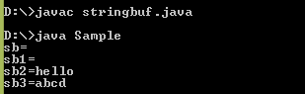
StringBuffer constructor insert method (implement boolean,char, array of char,int, long, float, double, string) implementation.
class Sample
{
public static void main(String args[])
{
StringBuffer sb=new StringBuffer("hello welcome again");
char c[]={'a','b','c','d'};
//boolean
sb=sb.insert(5,true);
System.out.println("insert of boolean="+sb+"\n");
//char
StringBuffer sb1=new StringBuffer("hello welcome again");
sb1=sb1.insert(5,'g');
System.out.println("insert of char="+sb1+"\n");
//array char
StringBuffer sb2=new StringBuffer("hello welcome again");
sb2=sb2.insert(5,c);
System.out.println("insert of array char="+sb2+"\n");
//integer
StringBuffer sb3=new StringBuffer("hello welcome again");
sb3=sb3.insert(5,10);
System.out.println("insert of integer="+sb3+"\n");
//long
StringBuffer sb4=new StringBuffer("hello welcome again");
sb4=sb4.insert(5,675000);
System.out.println("insert of long="+sb4+"\n");
//float
StringBuffer sb5=new StringBuffer("hello welcome again");
sb5=sb5.insert(5,7.12);
System.out.println("insert of float="+sb5+"\n");
//double
StringBuffer sb6=new StringBuffer("hello welcome again");
sb6=sb6.insert(5,72565.112);
System.out.println("insert of double="+sb6+"\n");
//String
StringBuffer sb7=new StringBuffer("hello welcome again");
sb7=sb7.insert(5,"sir");
System.out.println("insert of String="+sb7);
}
}

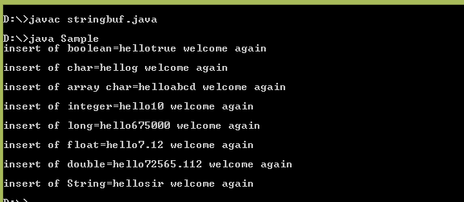
//Delete method implementation
class Sample
{
public static void main(String args[])
{
StringBuffer sb=new StringBuffer("hello welcome again");
sb=sb.delete(3,8);
System.out.println("insert of boolean="+sb+"\n");

}
}

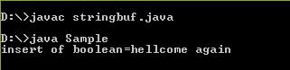
// StringBuffer constructor deleteCharAt method implementation.
class Sample
{
public static void main(String args[])
{
StringBuffer sb=new StringBuffer("hello welcome again");
sb=sb.deleteCharAt(3);
System.out.println("insert of boolean="+sb+"\n");

}
}

