ASSIGNMENT:
Create a class PersonalInfo(personal information), Student(Student details with personal information), Staff(Staff Details with personal information) and access
a. PersonalInfo and Student class members inside the class CollegeDetail by creating object for the class Student

class Personalinfo
{
int id;
String name;
String address;
int age;
String gender;
}
class Student extends Personalinfo
{
int mark;
String classname;
int year;
}
class Staff extends Personalinfo
{
int salary;
int experience;
}
class Collegedetail
{
public static void main(String args[])
{
Student ob2=new Student();
System.out.println("Enter the Student Details....");
ob2.id=Integer.parseInt(System.console().readLine());
ob2.name=System.console().readLine();
ob2.address=System.console().readLine();
ob2.age=Integer.parseInt(System.console().readLine());
ob2.gender=System.console().readLine();
ob2.mark=Integer.parseInt(System.console().readLine());
ob2.classname=System.console().readLine();
ob2.year=Integer.parseInt(System.console().readLine());
System.out.println(ob2.id+"****"+ob2.name+"****"+ob2.address+"****"+ob2.age+"****"+ob2.gender+"****"+ob2.mark+"****"+ob2.classname+"****"+ob2.year);
System.out.println("Enter staff Details");
Staff ob3=new Staff();
ob3.salary=Integer.parseInt(System.console().readLine());
ob3.experience=Integer.parseInt(System.console().readLine());
System.out.println(ob3.salary+"****"+ob3.experience);
}
}
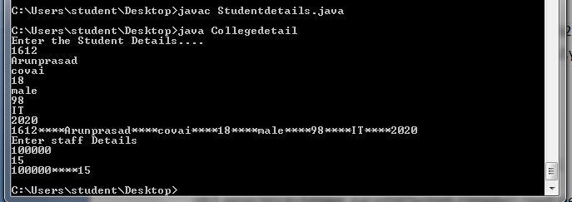
b. PersonalInfo and Staff class members inside the class CollegeDetail by creating object for the class Staff
using Hierarchical inheritance concept..

class Personalinfo
{
int id;
String name;
String address;
int age;
String gender;
}
class Student extends Personalinfo
{
int mark;
String classname;
int year;
}
class Staff extends Personalinfo
{
int salary;
int experience;
}
class Collegedetail
{
public static void main(String args[])
{
Student ob2=new Student();
Staff ob3=new Staff();
System.out.println("Enter the Student Details....");
ob2.id=Integer.parseInt(System.console().readLine());
ob2.name=System.console().readLine();
ob2.address=System.console().readLine();
ob2.age=Integer.parseInt(System.console().readLine());
ob2.gender=System.console().readLine();
ob2.mark=Integer.parseInt(System.console().readLine());
ob2.classname=System.console().readLine();
ob2.year=Integer.parseInt(System.console().readLine());
System.out.println("Enter staff Details and Personal Info");
ob3.salary=Integer.parseInt(System.console().readLine());
ob3.experience=Integer.parseInt(System.console().readLine());
ob3.id=Integer.parseInt(System.console().readLine());
ob3.name=System.console().readLine();
ob3.address=System.console().readLine();
ob3.age=Integer.parseInt(System.console().readLine());
ob3.gender=System.console().readLine();
System.out.println(ob2.id+"****"+ob2.name+"****"+ob2.address+"****"+ob2.age+"****"+ob2.gender+"****"+ob2.mark+"****"+ob2.classname+"****"+ob2.year);
System.out.println(ob3.salary+"****"+ob3.experience+"****"+ob3.id+"****"+ob3.name+"****"+ob3.address+"****"+ob3.age+"****"+ob3.gender);
}
}
