//Create a class PersonalInfo(personal information), Student(Student details with personal information), Staff(Staff Details with personal information) and access
a. PersonalInfo and Student class members inside the class CollegeDetail by creating object for the class Student
class Personalinfo
{
int id;
String name;
String address;
int age;
String gender;
}
class Student extends Personalinfo
{
int mark;
String dept;
int year;
}
class Staff extends Personalinfo
{
int salary;
int experience;
}
class Collegedetails
{
public static void main(String args[])
{
Student s=new Student();
System.out.println("Enter the Student details id,name,address,age,gender,mark,dept,year");
s.id=Integer.parseInt(System.console().readLine());
s.name=System.console().readLine();
s.address=System.console().readLine();
s.age=Integer.parseInt(System.console().readLine());
s.gender=System.console().readLine();
s.mark=Integer.parseInt(System.console().readLine());
s.dept=System.console().readLine();
s.year=Integer.parseInt(System.console().readLine());
System.out.println(s.id+"---"+s.name+"---"+s.address+"---"+s.age+"---"+s.gender+"---"+s.mark+"---"+s.dept+"---"+s.year);
System.out.println("Enter staff Details salery,experience");

Staff stf=new Staff();
stf.salary=Integer.parseInt(System.console().readLine());
stf.experience=Integer.parseInt(System.console().readLine());
System.out.println(stf.salary+"---"+stf.experience);
}
}

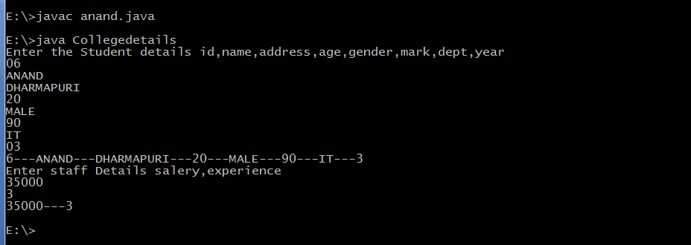

b. PersonalInfo and Staff class members inside the class CollegeDetail by creating object for the class Staff
using Hierarchical inheritance concept..

class Personalinfo
{
int id;
String name;
String address;
int age;
String gender;
}
class Student extends Personalinfo
{
int mark;
String dept;
int year;
}
class Staff extends Personalinfo
{
int salary;
int experience;
}
class Collegedetail
{
public static void main(String args[])
{
Student s=new Student();
Staff stf=new Staff();
System.out.println("Enter the Student Details ID NAME,ADDRESS,AGE,GENDER,MARK,DEPT,YEAR");
s.id=Integer.parseInt(System.console().readLine());
s.name=System.console().readLine();
s.address=System.console().readLine();
s.age=Integer.parseInt(System.console().readLine());
s.gender=System.console().readLine();
s.mark=Integer.parseInt(System.console().readLine());
s.dept=System.console().readLine();
s.year=Integer.parseInt(System.console().readLine());

System.out.println("Enter staff Details ID,NAME,ADDRESS,AGE,GENDER,SALARY,EXPERIENCE");
stf.id=Integer.parseInt(System.console().readLine());
stf.name=System.console().readLine();
stf.address=System.console().readLine();
stf.age=Integer.parseInt(System.console().readLine());
stf.gender=System.console().readLine();
stf.salary=Integer.parseInt(System.console().readLine());
stf.experience=Integer.parseInt(System.console().readLine());
System.out.println( s.id+"---"+ s.name+"---"+ s.address+"---"+ s.age+"---"+ s.gender+"---"+ s.mark+"---"+ s.dept+"---"+ s.year);
System.out.println(stf.id+"---"+stf.name+"---"+stf.address+"---"+stf.age+"---"+stf.gender+"---"+stf.salary+"---"+stf.experience);
}
}

