1. read the following data from console and display the value
String
byte
short
int
long
float
double
char
boolean
import java.util.Scanner;

class SampleScanner
{
public static void main(String []args)

{
Scanner s=new Scanner(System.in);
System.out.println("ENTER THE NAME");
String name=s.next();
System.out.println("WELCOME" + name);

System.out.println("ENTER THE VALUE INTEGER");
int i=s.nextInt();
System.out.println("INTEGER=" + i);

System.out.println("ENTER THE VALUE BYTE");
byte b=s.nextByte();
System.out.println("BYTE=" + b);

System.out.println("ENTER THE VALUE SHORT");
short sh=s.nextShort();
System.out.println("short=" + sh);

System.out.println("ENTER THE VALUE LONG");
long l=s.nextLong();
System.out.println("LONG=" + l);

System.out.println("ENTER THE VALUE DOUBLE");
double dob=s.nextDouble();
System.out.println("Double=" + dob);

System.out.println("ENTER THE VALUE CHAR");
char c=s.next().charAt(0);
System.out.println("Char=" + c);

System.out.println("ENTER THE VALUE OF BOOLEAN");
boolean bb=s.nextBoolean();
System.out.println("Boolean=" +bb);

}
}

Output
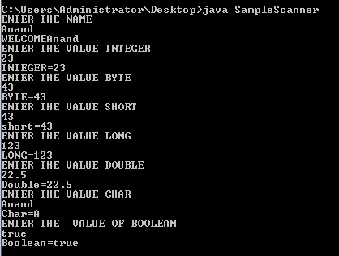

2) 2. read the following data from console and perform the operations
2.a -> read first name, last name and print the Name = (first name and last name)
2.b -> read two integer value and display the addition result
2.c -> read two double value and display the addition result
import java.util.Scanner;

class Scenner
{
public static void main(String ar[])
{
Scanner s=new Scanner(System.in);
System.out.println("ENTER THE FIRST NAME");
String name=s.next();
System.out.println("ENTER THE SECOND NAME");
String name1=s.next();
System.out.println("WELCOME" + name+name1);

System.out.println("ENTER THE VALUE FIRST INTEGER");
int i=s.nextInt();
System.out.println("ENTER THE VALUE SECOND INTEGER");
int i1=s.nextInt();
System.out.println("INTEGER=" + i+i1);

System.out.println("ENTER THE VALUE FIRST DOUBLE");
double dob=s.nextDouble();
System.out.println("ENTER THE VALUE SECOND DOUBLE");
double dob1=s.nextDouble();
System.out.println("Double=" + dob+dob1);

}
}

Output
