ASSIGNMENT:
- Pass boolean value inside the while block
class Sample
{
public static void main(String args[])
{
boolean b=true;
while(b)
{
System.out.println("hi");
}
}
}

- Pass nothing inside the while block
class Sample
{
public static void main(String args[])
{
boolean b=true;
while()
{
System.out.println("hi");
}
}
}
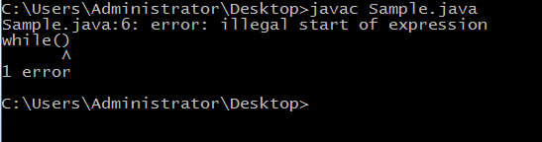

- Pass integer / double value inside the while block
class Sample
{
public static void main(String args[])
{
int b=4;
while(b)
{
System.out.println("hi");
}
}
}
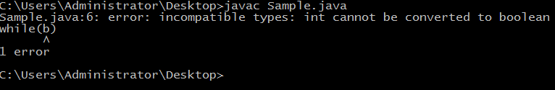

- Perform assignment operation inside the while statement for boolean data type
class Sample
{
public static void main(String args[])
{
boolean b;
while(b=true)
{
System.out.println("hi");
}
}
}


  - Perform assignment operation inside the while statement for integer data type

class Sample
{
public static void main(String args[])
{
int b;
while(b=2)
{
System.out.println("hi");
}
}
}
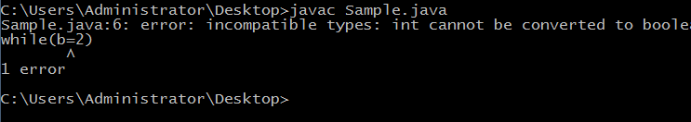

  - Perform assignment operation inside the while statement for double data type

class Sample
{
public static void main(String args[])
{
double b;
while(b=2.1)
{
System.out.println("hi");
}
}
}
