//1.string
import java.util.Arrays;
class string
{
public static void main(String ar[])
{
int a[]={1,10,2,9,3,8,4,7,5,6,12,11};
int arr[]=new int[5];
String arr1=Arrays.toString(a);
System.out.println(arr1);
}
}
OUTPUT:
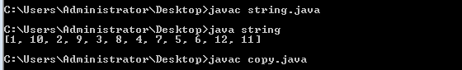
//2.copyof
import java.util.Arrays;
class copy
{
public static void main(String ar[])
{
int a[]={1,10,2,9,3,8,4,7,5,6,12,11};
int arr[]=new int[5];
arr=Arrays.copyOf(a,5);
System.out.println(Arrays.toString(arr));
}
}

OUTPUT:
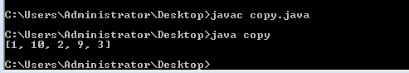
//3.range
import java.util.Arrays;
class range
{
public static void main(String ar[])
{
int a[]={1,10,2,9,3,8,4,7,5,6,12,11};
int arr[]=new int[5];
arr=Arrays.copyOfRange(a,3,5);
System.out.println(Arrays.toString(arr));
}
}
OUTPUT:
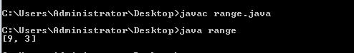
//4.equals
import java.util.Arrays;
class equals
{
public static void main(String ar[])
{
int a[]={1,10,2,9,3,8,4,7,5,6,12,11};
int arr[]=new int[5];
boolean b=Arrays.equals(a,arr);
System.out.println(b);
}
}
OUTPUT:
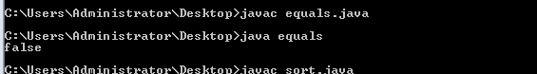
//5.length
import java.util.Arrays;
class length
{
public static void main(String ar[])
{
int a[]={1,10,2,9,3,8,4,7,5,6,12,11};
int arr=a.length;
System.out.println(arr);
}
}

OUTPUT:
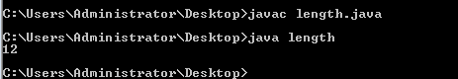
//6.
import java.util.Arrays;
class sort
{
public static void main(String ar[])
{
int a[]={1,2,3,4,5};
int arr[]=new int[]{1,10,2,9,8,3,7,5};
System.out.println(Arrays.toString(arr));
Arrays.sort(arr);
System.out.println(Arrays.toString(arr));
}
}
OUTPUT:
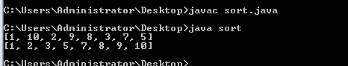
//7.descending
import java.util.Arrays;
class descending
{
public static void main(String ar[])
{
int a[]={1,2,3,4,5};
int arr[]=new int[]{1,10,2,9,8,3,7,5};
System.out.println(Arrays.toString(arr));
Arrays.sort(arr);
for(int i=7;i>0;i--)
{
System.out.println(arr[i]);
}
}
}
OUTPUT:
