- Write a program to create a simple package and import the package outside the package and use it with public methods.

//Sample.java
package Package1;
public class Sample
{
public void display()
{
System.out.println("Sample");
}
}
//MainClass.java
import Package1.Sample;
class MainClass
{
public static void main(String args[])
{
Sample s=new Sample();
s.display();
}
}

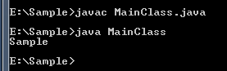

2.Write a program to create a simple package and import the package outside the package and use it with protected methods.
//Sample.java

package Package1;
class Sample
{
protected void display()
{
System.out.println("Sample");
}
}
//MainClass.java
import Package1.Sample;
class MainClass
{
public static void main(String args[])
{
Sample s=new Sample();
s.display();
}
}
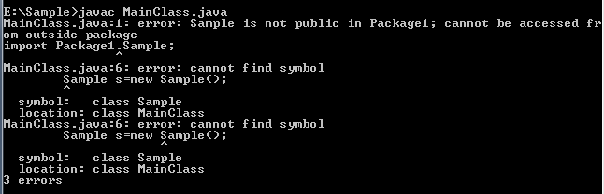

3.Write a program to create a simple package and import the package outside the package and use it with protected methods (import the package and use it as sub class).

//Sample.java

package Package1;
public class Sample
{
protected void display()
{
System.out.println("Sample");
}
}
//MainClass.java
import Package1.Sample;
class MainClass extends Sample
{
public static void main(String args[])
{
MainClass m=new MainClass();
m.display();
}
}
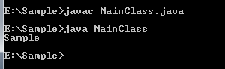

4.Write a program to create a simple package and import the package outside the package and use it with default methods (import the package and use it as sub class).

//Sample.java
package Package1;
class Sample
{
protected void display()
{
System.out.println("Sample");
}
}
//MainClass.java
import Package1.Sample;
class MainClass extends Sample
{
public static void main(String args[])
{
MainClass m=new MainClass();
m.display();
}
}
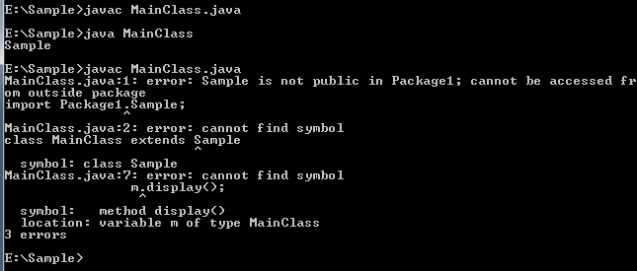

5.Write a program to create a simple package (with multiple classes) and import the package outside the package and use (import each and every class separately).
//Sample1.java

package Package1;
public class Sample1
{
public void display()
{
System.out.println("Sample1");
}
}
//Sample2.java
package Package1;
public class Sample2
{
public void display()
{
System.out.println("Sample2");
}
}
//Sample3.java
package Package1;
public class Sample3
{
public void display()
{
System.out.println("Sample3");
}
}
//MainClass.java
import Package1.Sample1;
import Package1.Sample2;
import Package1.Sample3;
class MainClass
{
public static void main(String args[])
{
Sample1 s1=new Sample1();
s1.display();
Sample2 s2=new Sample2();
s2.display();
Sample3 s3=new Sample3();
s3.display();

}
}
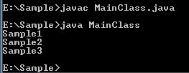
6.Write a program to create a simple package (with multiple classes) and import the package outside the package and use (import all the class in same line).

import Package1.*;
class MainClass
{
public static void main(String args[])
{
Sample1 s1=new Sample1();
s1.display();
Sample2 s2=new Sample2();
s2.display();
Sample3 s3=new Sample3();
s3.display();

}
}

7. Write a program to create a container -> package (with multiple classes) and import the package outside the package and use.
//outside the package and use.
//Sample1.java
package Samplepackage.Package1;
public class Sample1
{
public void display()
{
System.out.println("Sample");
}
}
//Sample2.java
package Samplepackage.Package1;
public class Sample2
{
public void display()
{
System.out.println("Sample");
}
}
//Sample3.java
package Samplepackage.Package1;
public class Sample3
{
public void display()
{
System.out.println("Sample");
}
}
//Mainclass.java
import Samplepackage.Package1.*;
class MainClass
{
public static void main(String args[])
{
Sample1 s1=new Sample1();
s1.display();
Sample2 s2=new Sample2();
s2.display();
Sample3 s3=new Sample3();
s3.display();
}
}
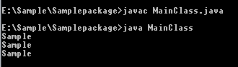

8. Write a program to implement static import process (import each and every method / variable separately).

//Sample1.java
package Samplepackage.Package1;
public class Sample1
{
public static void display1()
{
System.out.println("Sample");
}
}
//Sample2.java
package Samplepackage.Package1;
public class Sample2
{
public static void display2()
{
System.out.println("Sample");
}
}
//Sample3.java
package Samplepackage.Package1;
public class Sample3
{
public static void display3()
{
System.out.println("Sample");
}
}
//Mainclass.java
import static Samplepackage.Package1.Sample1.*;
import static Samplepackage.Package1.Sample2.*;
import static Samplepackage.Package1.Sample3.*;
class MainClass
{
public static void main(String args[])
{
display1();
display2();
display3();
}
}
9. Write a program to implement static import process (import each and every method / variable in a same line).

//Sample1.java
package package1;
class Sample1
{
public static void display1()
{
System.out.println("Sample1");
}
}
//Sample2.java
package package1;
class Sample2
{
public static void display2()
{
System.out.println("Sample2");
}
}
//Sample3.java
package package1;
class Sample3
{
public static void display3()
{
System.out.println("Sample3");
}
}
//MainClass.java
import static Samplepackage.package1.*;
class MainClass
{
public static void main(String args[])
{
display1();
display2();
display3();
}
}

