//PATTERN
1. If i=3 (Note for this program '-' should be replaced by empty space)
* - *
- * -
* - *
If i = 5
* - - - *
- * - * -
- - * - -
- * - * -
* - - - *
import java.util.Scanner;
class Anand
{
public static void main (String[] args)
{
Scanner in=new Scanner(System.in);
System.out.println("ENTER THE LOOP");
int t=in.nextInt();
for(int k=0;k<t;k++)
{
System.out.println("ENTER THE VALUE");
int n=in.nextInt();
for(int i=0;i<n;i++)
{
for(int j=0;j<n;j++)
{
if(i==(n/2))
{
if(j==(n/2))
System.out.print("*") ;
else
System.out.print(" ");
}
else
{
if(i==j)
System.out.print("*");
else if(i==(n-1-j))
System.out.print("*");
else
System.out.print(" ");
}
}
System.out.println();
}
System.out.println();
}
}
}
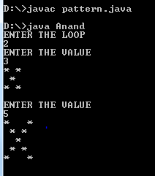

2. If i = 3 (Note for this program '-' should be replaced by empty space)
* * *
- * -
* * *
If i=5
* * * * *
- * * * -
- - * - -
- * * * -
* * * * *

import java.util.Scanner;
class Anand
{
public static void main (String[] args)
{
Scanner in=new Scanner(System.in);
System.out.println("ENTER THE VALUE");
int n=in.nextInt();
for(int i=0;i<=n/2;i++)
{
for(int j=0;j<n;j++)
{
if(i==0 || i==n-1)
System.out.print("*");
else
{
if(j<i || j>(n-i-1))
System.out.print(" ");
else
System.out.print("*");
}
}
System.out.println();
}
for(int i=n/2+1;i<n;i++)
{
for(int j=0;j<n;j++)
{
if(i==0 || i==n-1)
System.out.print("*");
else
{
if(j>i || j<(n-i-1))
System.out.print(" ");
else
System.out.print("*");
}
}
System.out.println();
}
}
}

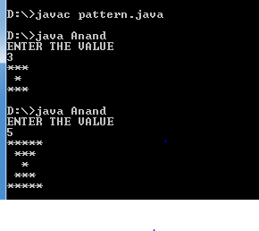
3. If i = 3 (Note for this program '-' should be replaced by empty space)
* - *
* * *
* - *
If i=5
* - - - *
* * - * *
* * * * *
* * - * *
* - - - *
import java.util.Scanner;
class Anand
{
public static void main (String[] args)
{
Scanner in=new Scanner(System.in);
int n=in.nextInt();
for(int i=0;i<=n/2;i++)
{
for(int j=0;j<n;j++)
{
if(i==n/2)
System.out.print("*");
else
{
if(j<=i || j>=(n-1-i))
System.out.print("*");
else
System.out.print(" ");
}
}
System.out.println();
}
for(int i=n/2+1;i<n;i++)
{
for(int j=0;j<n;j++)
{
if(j>=i || j<=(n-1-i))
System.out.print("*");
else
System.out.print(" ");
}
System.out.println();
}
}
}

