1. StringBuffer constructor implementation.
class Test
{
public static void main(String srgs[])
{
StringBuffer sb1=new StringBuffer();
StringBuffer sb2=new StringBuffer(4);
StringBuffer sb3=new StringBuffer("abcde");
char c[]={'a','b','c','d','e'};
String sb4=new String(c);
System.out.println("StringBuffer= "+sb1);
System.out.println("StringBuffer= "+sb2);
System.out.println("StringBuffer= "+sb3);
System.out.println("StringBuffer= "+sb4);
}
}

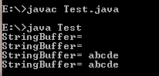

2. StringBuffer constructor insert method (implement boolean,char, array of char,int, long, float, double, string) implementation.

//Boolean
import java.util.Arrays;
class Sample
{
public static void main(String args[])
{
StringBuffer s1=new StringBuffer("ANAND");
s1.insert(5,true);
System.out.println("BOOLEAN = "+s1);

}
}
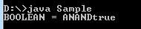

//char

import java.util.Arrays;
class Sample
{
public static void main(String args[])
{
StringBuffer s=newStringBuffer("ANANDHARUR");
s=s.insert(2,'z');
System.out.println("char = "+s);
}
}
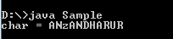
//array of char

import java.util.Arrays;
class Sample
{
public static void main(String args[])
{
StringBuffer s=new StringBuffer("JAVA");
char c[]={'a','b','c','d'};
s=s.insert(2,c);
System.out.println("char = "+s);
}
}
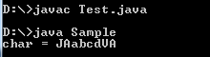

//int
import java.util.Arrays;
class Sample
{
public static void main(String args[])
{

StringBuffer s=new StringBuffer("ANAND");
int a=15;
s=s.insert(3,456);
System.out.println("char = "+s);
}
}

