LED Dimming 21 V with MOSFET

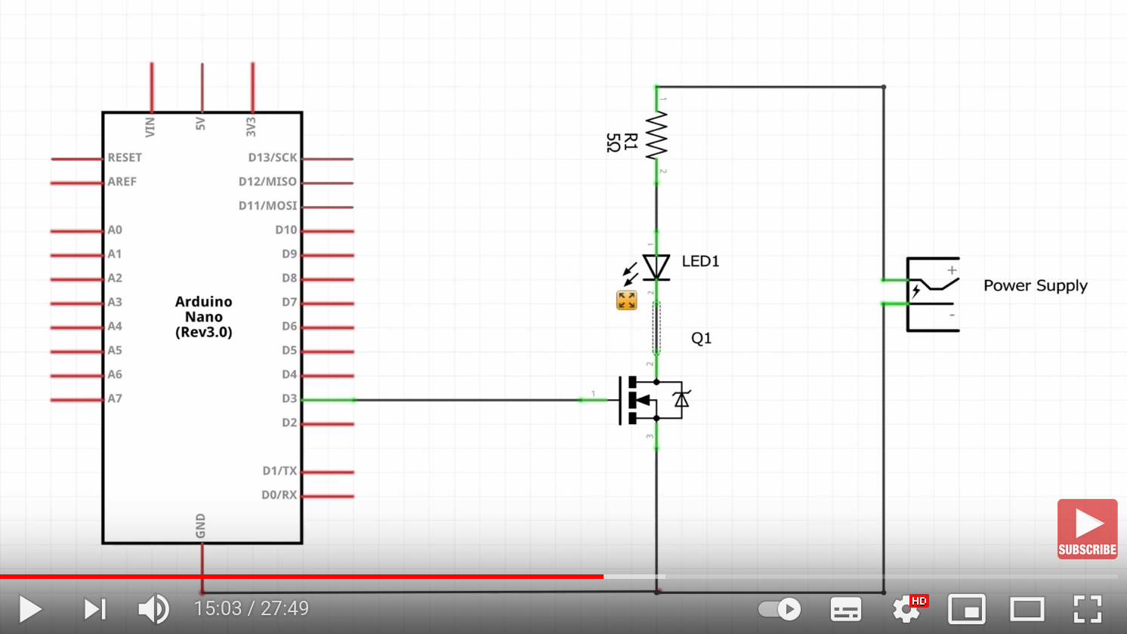
Type
IRF3708 (TO-220) http://s.click.aliexpress.com/e/_sUN3um
