Adafruit MAX98357 I2S Class-D Mono Amp

- Output Power: 3.2W at 4Ω, 10% THD, 1.8W at 8Ω, 10% THD, with 5V supply
- PSRR: 77 dB typ @ 1KHz
- I2S sample rates from 8kHz to 96kHz
- No MCLK required
- Click + Pop reduction
- Five pin-selectable gains: 3dB, 6dB, 9dB, 12dB, 15dB
- Excellent click-and-pop suppression
- Thermal shutdown protection

I2S Pins
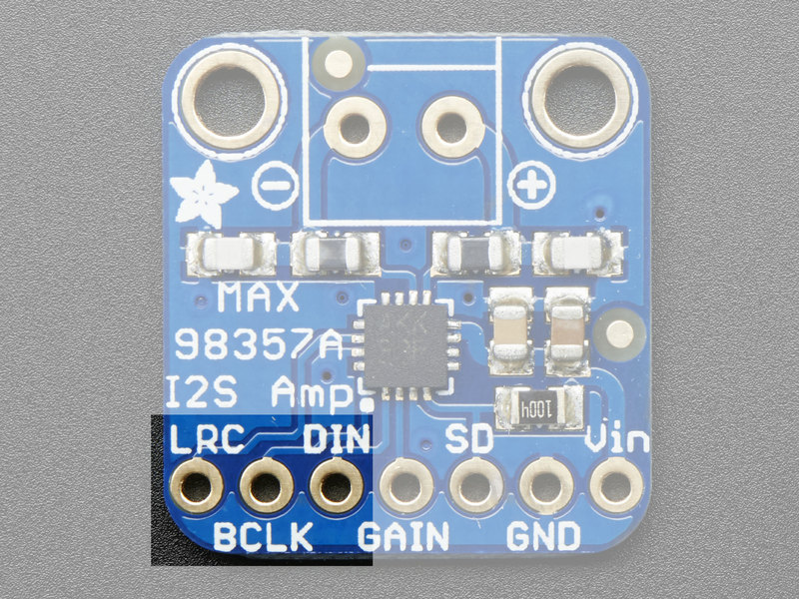
Three pins are used to receive audio data. These can be 3.3-5V logic
- LRC (Left/Right Clock) - this is the pin that tells the amplifier when the data is for the left channel and when its for the right channel
- BCLK (Bit Clock) - This is the pin that tells the amplifier when to read data on the data pin.
- DIN (Data In) - This is the pin that has the actual data coming in, both left and right data are sent on this pin, the LRC pin indicates when left or right is being transmitted

