Transfer Learning

Starting Situation

Inital Training with “my voice”, 1min voice 16k, 700ms samples per number (600ms window +100 ms) , 12 classes (0 to 9, yes and now – in German), 1D model (13/23), 130 epochs with 0.001 steps
Validation: 95% - I guess this model is a bit overfit.
Performance on device: poor!
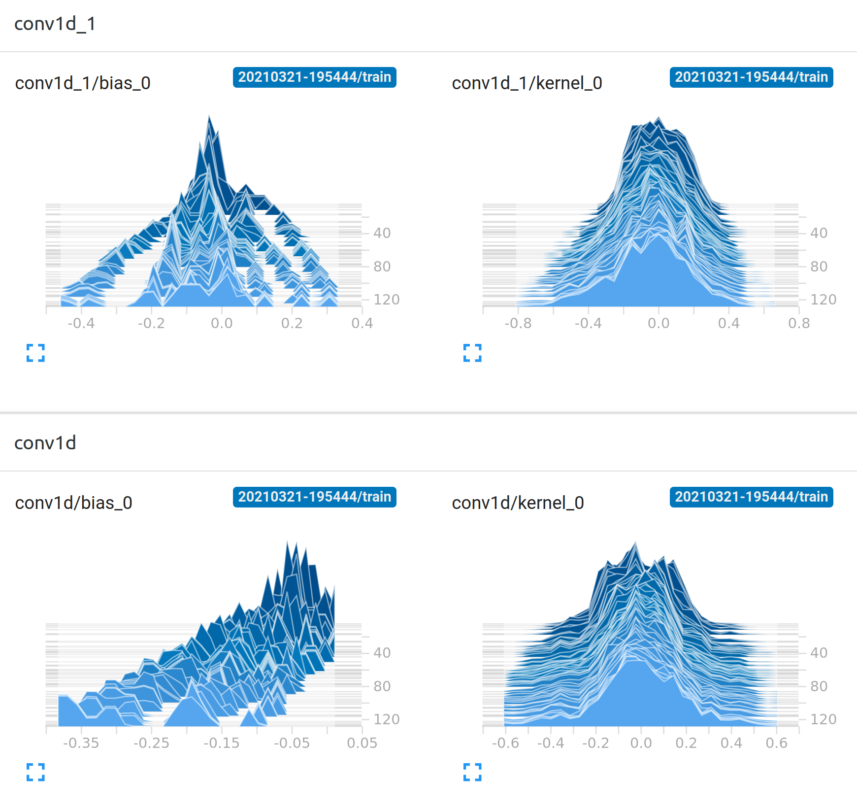
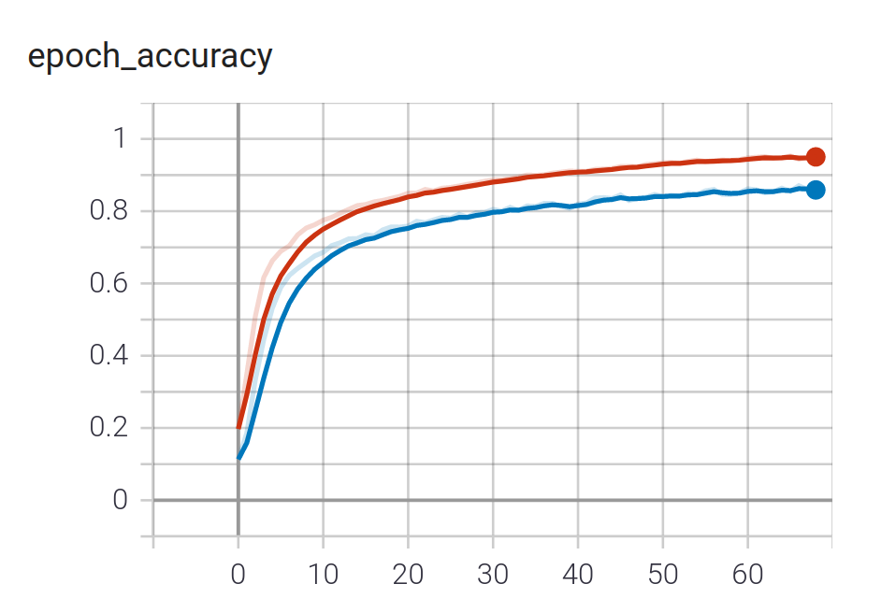

Transfer Leaning – Base Model
Round-1: Using Firefox Command Set – German to trains same way as in “Starting Situation”. Save Model-Weights into H5 file
Round-2: Load Model-Weights from Round-1 , run “my-voice” training 70 epochs with 0.0005 steps

Notice: That epoch-accuarcy alreaday starts with 75% and still increases. The histogram start with values from Round-1 and changes a bit, in total the value rages increases a bit and the bias ov the 2nd level seems to be more even distributed.

