UML Class Diagram :

|  |
| --- |
| MainWindow |
| -QPushButton *restart;  -QPushButton *Exit;  +ix: int  +iy : int  + finalx : int  + finaly : int  +presstime :int  -Bird *birdie;  -Bird2 *birdie2;  -Bird3 *birdie3;  -Bird4 *birdie4;  -Bird5 *birdie5;  -STONE *stone ;  -STONE *stoneb;  -STONE *stonec ;  -STONE *stoned;  -STONE *stonee ;  -STONE *stonef;  -PIG *pig;  -PIG *pig2;  -Ui::MainWindow * : ui  QGraphicsScene *scene;  b2World *world;  b2World *world2;  QList<GameItem *> itemList;  QTimer timer; |
| <<constructor>>+ MainWindow  + *showEvent*(QShowEvent *) : void  + *eventFilter*(QObject *,QEvent *event) : bool  + *closeEvent*(QCloseEvent *) : void  + quitGame() : void  - tick():void  - QUITSLOT():void  - Restart():void  - QUIT():void  - position():void  - *keyPressEvent*(press : QKeyEvent *): void  - *keyReleaseEvent*(release : QKeyEvent *): void |

Screen shot :

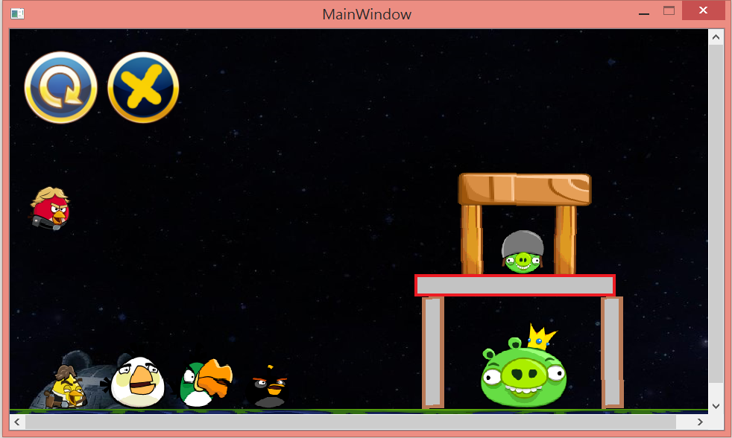

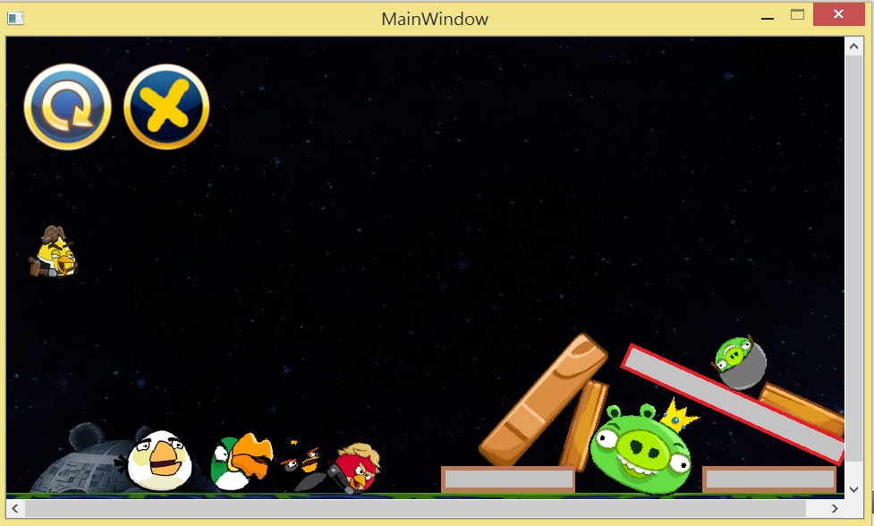

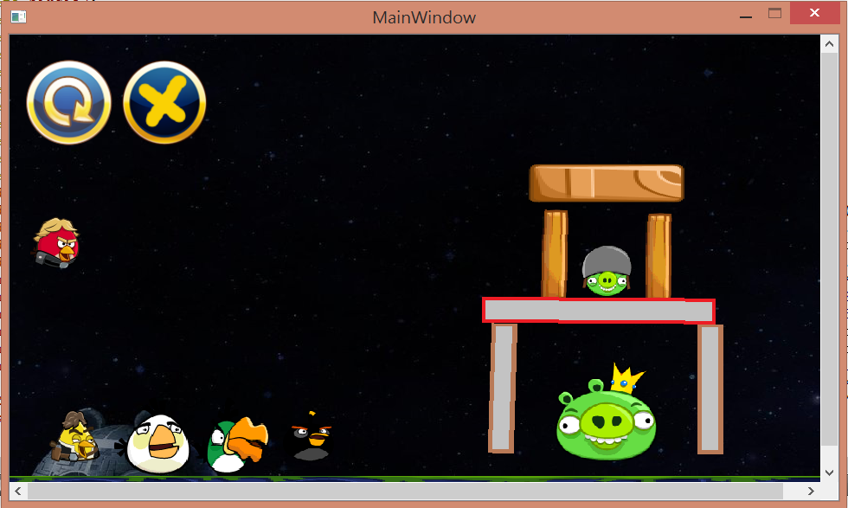

How to play ?

先拉紅鳥，次拉黃鳥，中途按滑鼠便產生技能，再拉白鳥，中途按滑鼠便產生技能，再拉綠鳥，中途按滑鼠便產生技能，最後拉黑鳥，中途按滑鼠便產生技能

Program architecture :

先建立上下左右的邊界，次生成不會動的鳥，然後再生成障礙物，方法和鳥一樣，接著利用計算滑鼠拉動的距離換算成速度射出，再來設定每隻鳥的技能，最後，製作RESTART 和 EXIT 的按鈕，完成Project3