 | INTERNATIONAL TELECOMMUNICATION UNION

ITU-T DRAFT G.723

TELECOMMUNICATION (Draft of 1995-October-17)
STANDARDIZATION SECTOR
OF ITU

_________________________________________________

DUAL RATE SPEECH CODER FOR MULTIMEDIA COMMUNICATIONS TRANSMITTING AT 5.3 & 6.3 KBIT/S

ITU-T Recommendation G.723
_________________________________________________

Summary
This Recommendation specifies a coded representation that can be used for compressing the speech or other audio signal component of multimedia services at a very low bit rate as part of the overall H.324 family of standards. This coder has two bit rates associated with it, 5.3 and 6.3 kbit/s. The higher bit rate has greater quality. The lower bit rate gives good quality and provides system designers with additional flexibility. Both rates are a mandatory part of the encoder and decoder. It is possible to switch between the two rates at any frame boundary. An option for variable rate operation using discontinuous transmission and noise fill during non-speech intervals is also possible.
This coder was optimized to represent speech with a high quality at the above rates using a limited amount of complexity. It encodes speech or other audio signals in frames using linear predictive analysis-by-synthesis coding. The excitation signal for the high rate coder is Multipulse Maximum Likelihood Quantization (MP-MLQ) and for the low rate coder is Algebraic Codebook Excited Linear Prediction (ACELP). The frame size is 30 ms and there is an additional look ahead of 7.5 msec, resulting in a total algorithmic delay of 37.5 msec. All additional delays in this coder are due to processing delays of the implementation, transmission delays in the communication link and buffering delays of the multiplexing protocol.
The description of this Recommendation is made in terms of bit-exact, fixed-point mathematical operations. The ANSI C code indicated in Section 5 of the Recommendation constitutes an integral part of this Recommendation and shall take precedence over the mathematical descriptions in this text if discrepancies are found. A non-exhaustive set of test sequences which can be used in conjunction with the C code are available from the ITU.

Foreword
The ITU Telecommunication Standardization Sector (ITU-T) is a permanent organ of the International Telecommunication Union. The ITU-T is responsible for studying technical, operating and tariff questions and issuing Recommendations on them with a view to standardizing telecommunications on a worldwide basis.
The World Telecommunications Standardization Conference (WTSC), which meets every four years, established the topics for study by the ITU-T Study Groups which, in their turn, produce Recommendations on these topics.
ITU-T Recommendation G.723 was prepared by the ITU-T Study Group 15 (1993-1995) and was approved by the WTSC (Place, Month xx-xx, 199x).
_________________

© ITU 199x
All rights reserved. No part of this publication may be reproduced or utilized in any form or by any means, electronic or mechanical, including photocopying and microfilm, without permission in writing from the ITU.
Contents
Page
1. Introduction
1.1 Scope
1.2 Bit rates
1.3 Possible input signals
1.4 Delay
1.5 Speech coder description
2. Encoder principles
2.1 General description
2.2 Framer
2.3 High pass filter
2.4 LPC analysis
2.5 LSP quantizer
2.6 LSP decoder
2.7 LSP interpolation
2.8 Formant perceptual weighting filter
2.9 Pitch estimation
2.10 Sub frame processing
2.11 Harmonic noise shaping
2.12 Impulse response calculator
2.13 Zero input response and ringing subtraction
2.14 Pitch predictor
2.15 High rate excitation (MP-MLQ)
2.16 Low rate excitation (ACELP)
2.17 Excitation decoder
2.18 Decoding of the pitch information
2.19 Memory update
2.20 Bit allocation
2.21 Coder initialization
3. Decoder principles
3.1 General description
3.2 LSP decoder
3.3 LSP interpolator
3.4 Decoding of the pitch information
3.5 Excitation decoder
3.6 Pitch postfilter
3.7 LPC synthesis filter
3.8 Formant postfilter
3.9 Gain scaling unit
3.10 Frame interpolation handling
3.10.1 LSP interpolation
3.10.2 Residual interpolation
3.11 Decoder initialization.
4. Bit stream packing
High rate
Low rate
5. ANSI C code
6. Glossary

Draft Recommendation G.723
Dual Rate Speech Coder for Multimedia Communications Transmitting at 5.3 & 6.3 kbit/s

1. Introduction

1.1 Scope
This recommendation specifies a coded representation that can be used for compressing the speech or other audio signal component of multimedia services at a very low bit rate. In the design of this coder, the principal application considered was very low bit rate visual telephony as part of the overall H.324 family of standards.

1.2 Bit rates
This coder has two bit rates associated with it. These are 5.3 and 6.3 kbit/s. The higher bit rate has greater quality. The lower bit rate gives good quality and provides system designers with additional flexibility. Both rates are a mandatory part of the encoder and decoder. It is possible to switch between the two rates at any 30 ms frame boundary. An option for variable rate operation using discontinuous transmission and noise fill during non-speech intervals is also possible.

1.3 Possible input signals
This coder was optimized to represent speech with a high quality at the above rates using a limited amount of complexity. Music and other audio signals are not represented as faithfully as speech, but can be compressed and decompressed using this coder.

1.4 Delay
This coder encodes speech or other audio signals in 30 msec frames. In addition, there is a look ahead of 7.5 msec, resulting in a total algorithmic delay of 37.5 msec. All additional delays in the implementation and operation of this coder are due to:
(i) actual time spent processing the data in the encoder and decoder;
(ii) transmission time on the communication link;
(iii) additional buffering delay for the multiplexing protocol.

1.5 Speech coder description
The description of the speech coding algorithm of this Recommendation is made in terms of bit-exact, fixed-point mathematical operations. The ANSI C code indicated in Section 5, which constitutes an integral part of this Recommendation, reflects this bit-exact, fixed-point description approach. The mathematical descriptions of the encoder and decoder, given respectively in Sections 2 and 3, can be implemented in several other fashions, possibly leading to a codec implementation not complying with this Recommendation. Therefore, the algorithm description of the C code of Section 5 shall take precedence over the mathematical descriptions of Sections 2 and 3 whenever discrepancies are found. A non-exhaustive set of test sequences which can be used in conjunction with the C code are available from the ITU.

2. Encoder principles

2.1 General description
This coder is designed to operate with a digital signal obtained by first performing telephone bandwidth filtering (ITU Rec. G.712) of the analog input, then sampling at 8000 Hz and then converting to 16 bit linear PCM for the input to the encoder. The output of the decoder should be converted back to analog by similar means. Other input/output characteristics, such as those specified by ITU Rec. G.711 for 64 kbit/s PCM data, should be converted to 16 bit linear PCM before encoding or from 16 bit linear PCM to the appropriate format after decoding. The bitstream from the encoder to the decoder is defined within this Recommendation.
The coder is based on the principles of linear prediction analysis-by-synthesis coding and attempts to minimize a perceptually weighted error signal. The encoder operates on blocks (frames) of 240 samples each. That is equal to 30 msec at an 8 kHz sampling rate. Each block is first high pass filtered to remove the DC component and then divided into four sub frames of 60 samples each. For every sub-frame, a 10th order linear prediction coder (LPC) filter is computed using the unprocessed input signal. The LPC filter for the last sub-frame is quantized using a Predictive Split Vector Quantizer (PSVQ). The unquantized LPC coefficients are used to construct the short term perceptual weighting filter, which is used to filter the entire frame and to obtain the perceptually weighted speech signal.
For every two sub-frames (120 samples), the open loop pitch period, 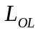, is computed using the weighted speech signal. This pitch estimation is performed on blocks of 120 samples. The pitch period is searched in the range from 18 to 142 samples.
From this point the speech is processed on a 60 samples per sub-frame basis.
Using the estimated pitch period computed previously, a harmonic noise shaping filter is constructed. The combination of the LPC synthesis filter, the formant perceptual weighting filter, and the harmonic noise shaping filter is used to create an impulse response. The impulse response is then used for further computations.
Using the pitch period estimation, , and the impulse response, a closed loop pitch predictor is computed. A fifth order pitch predictor is used. The pitch period is computed as a small differential value around the open loop pitch estimate. The contribution of the pitch predictor is then subtracted from the initial target vector. Both the pitch period and the differential value are transmitted to the decoder.
Finally the non periodic component of the excitation is approximated. For the high bit rate, multi-pulse maximum likelihood quantization (MP-MLQ) excitation is used, and for the low bit rate, an algebraic codebook excitation (ACELP) is used.
The block diagram of the encoder is shown in Figure 1.

2.2 Framer

File : LBCCODEC.C | Procedure : main() | Reads 240 samples input frames
File : CODER.C | Procedure : Coder() | Performs sub-frame division

The coder processes the speech by buffering consecutive speech samples, y[n], into frames of 240 samples, s[n]. Each frame is divided into two parts of 120 samples for pitch estimation computation. Each part is divided by two again, so that each frame is finally divided into four sub-frames of 60 samples each.

2.3 High pass filter

File : UTIL_LBC.C | Procedure : Rem_Dc() | Performs high pass filter

This block removes the DC element from the input speech, s[n]. The filter transfer function is :
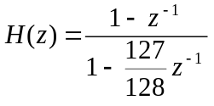 (1)
The output of this filter is x[n]_{n=0..239}.
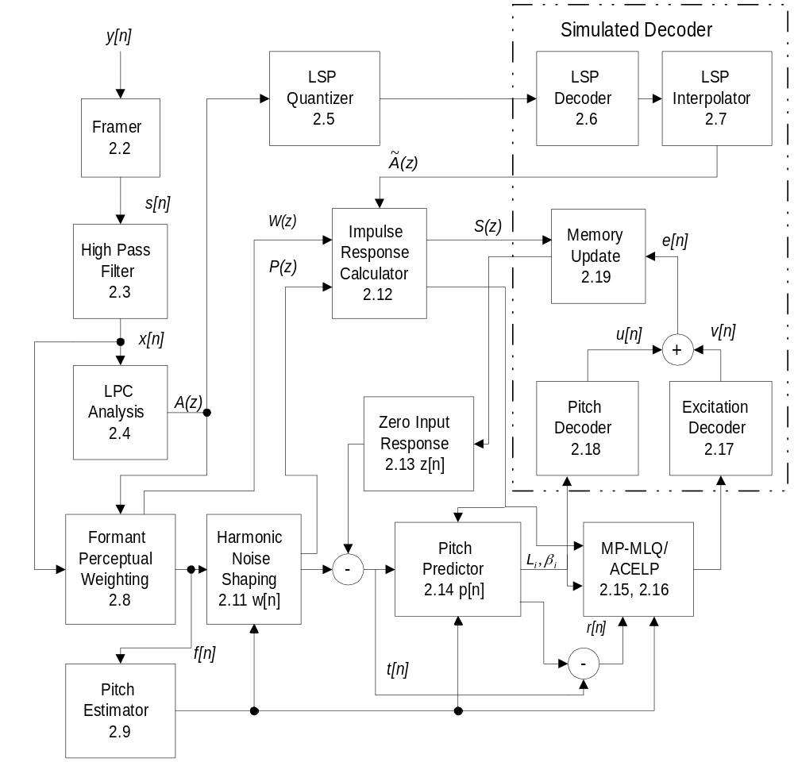
Figure 1. Block diagram of the speech coder. For each block the corresponding section number is indicated.

2.4 LPC analysis

File : LPC.C | Procedure : Comp_Lpc() | Performs LPC coefficients calculation
File : LPC.C | Procedure : Durbin() | Levinson-Durbin recursion

The LPC analysis is performed on signal x[n] in the following way. Tenth order linear predictive (LP) analysis is used. For each sub-frame, a window of 180 samples is centered on the sub-frame. A Hamming window is applied to these samples. Eleven autocorrelation coefficients are computed from the windowed signal. A white noise correction factor of (1025/1024) is applied by using the formula R[0] = R[0](1 + 1/1024). The other 10 autocorrelation coefficients are multiplied by the binomial window coefficients table. (The values for this table and all others are given in the C code.) The linear predictive coefficients (LPC) are computed using the conventional Levinson-Durbin recursion. For every input frame, four LPC sets are computed, one for every sub-frame. These LPC sets are used to construct the short term perceptual weighting filter. The LPC synthesis filter is defined as:
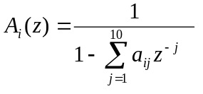 , 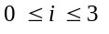 (2)
where i is the sub-frame index and is defined to be between 0 and 3.

2.5 LSP quantizer

File : LSP.C | Procedure : AtoLsp() | Converts LPC to LSP coefficients
File : LSP.C | Procedure : LspQnt() | LSP vector quantization
File : LSP.C | Procedure : Lsp_Svq() | LSP sub-vectors quantization

First, a small additional bandwidth expansion (7.5 Hz) is performed. Then the resulting 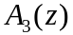 LP filter is quantized using a predictive split vector quantizer. The quantization is performed in the following way:
1. The LP coefficients, 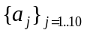, are converted to LSP coefficients, 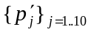, by searching along the unit circle and interpolating for zero crossings.
2. The long term DC component, 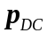, is removed from the LSP coefficients, 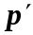, and a new DC removed LSP vector, , is obtained.
3. A first order fixed predictor, b = (12/32), is applied to the previously decoded LSP vector 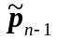, to obtain the DC removed predicted LSP vector, 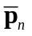, and the residual LSP error vector, at time (frame) n.
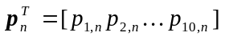 (3.1)
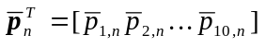 (3.2)
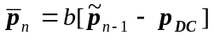 (3.3)
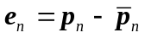 (3.4)
4. The unquantized LSP vector,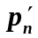, the quantized LSP vector,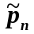, the residual LSP error vector, e_{n}, are divided into 3 sub-vectors with dimension 3, 3 and 4 respectively. Each mth sub-vector is vector quantized using an 8 bit codebook. The index, l, of the appropriate sub-vector codebook entry that minimizes the error criterion 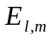 is selected
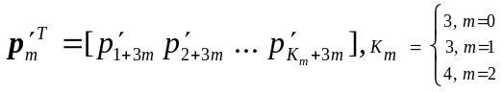 (4.1)
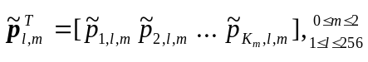 (4.2)
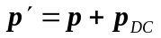 (4.3)
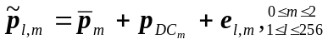 (4.4)
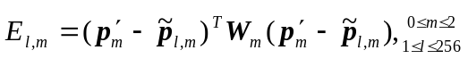 (4.5)
where 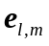 is the lth entry of the mth split residual LSP code-book and W_{n} is a diagonal weighting matrix, determined from the unquantized LSP coefficients vector 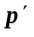, with weights defined by:
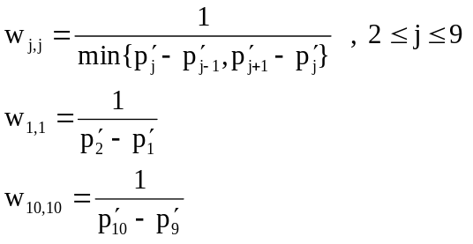 (5)
5. The selected indices are transmitted to the channel.

2.6 LSP decoder

File : LSP.C | Procedure: Lsp_Inq() | Inverse quantization of LSP

The decoding of the LSP coefficients is performed in the following way:
1. First, the three sub-vectors, 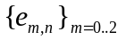, are decoded to form a tenth order vector, 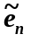.
2. The predicted vector, 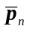, is added to the decoded vector, , and DC vector, , to form the decoded LSP vector,.
3. A stability check is performed on the decoded LSP vector,, to ensure that the decoded LSP vector is ordered according to the following condition
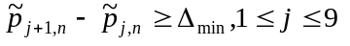 (6)
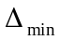 is equal to 31.25 Hz. If this stability check (6) fails for 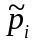 and 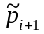, then 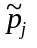 and 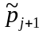are modified in the following way:
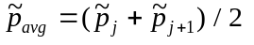 (7.1)
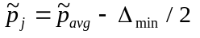 (7.2)
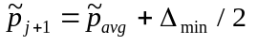 (7.3)
The modification is performed until condition (6) is met. If after 10 iterations the condition of stability is not met, the previous LSP vector is used.

2.7 LSP interpolation

File : LSP.C | Procedure : Lsp_Int() | LSP interpolator
File : LSP.C | Procedure : LsptoA() | Converts LSP to LPC coefficients

Linear interpolation is performed between the decoded LSP vector, , and the previous LSP vector, 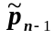, for each sub frame. Four interpolated LSP vectors, 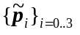, are converted to LPC vectors,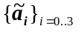.
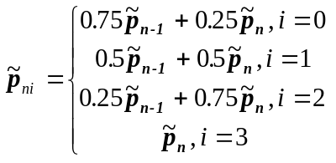 (8)
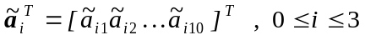 (9)
The quantized LPC synthesis filter, 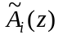, is used for generating the decoded speech signal and is defined as:
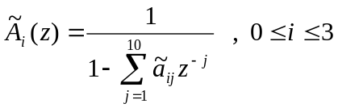 (10)

2.8 Formant perceptual weighting filter

File : LPC.C | Procedure : Wght_Lpc() | Computes perceptual filter coefficients
File : LPC.C | Procedure : Error_Wght() | Applies perceptual weighting filter

For each sub-frame a formant perceptual weighting filter is constructed, using the unquantized LPC coefficients {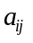 }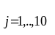. The filter has a transfer function:
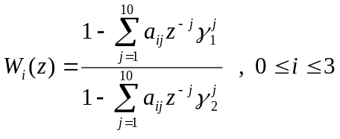 (11)
where 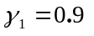and 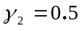. The input speech frame, {x[n]}n=0..239, is then divided to four sub frames and each sub frame is filtered using the W_{i}(z) filter, and the weighted output speech signal, {f[n]}n=0..239 is obtained.

2.9 Pitch estimation

File : EXC_LBC.C | Procedure : Estim_Pitch() | Open loop pitch estimation

Two pitch estimates are computed for every frame, one for the first two sub-frames and one for the last two. The open loop pitch period estimate,, is computed using the perceptually weighted speech f[n]. A crosscorrelation criterion, C_{OL}(j), maximization method is used to determine the pitch period, using the following expression:
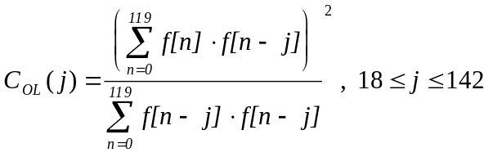 (12)
The index j which maximizes the crosscorrelation, C_{OL} (j), is selected as the open loop pitch estimation for the appropriate two sub-frames. While searching for the best index, some preference is given to smaller pitch periods to avoid choosing pitch multiples. Maximums of C_{OL} (j) are searched for beginning with j=18. For every maximum C_{OL} (j) found, its value is compared to the best previous maximum found, C_{OL} (j’). If the difference between indices j and j’ is less than 18 and C_{OL} (j) > C_{OL} (j’), the new maximum is selected. If the difference between the indices is greater than or equal to 18, the new maximum is selected only if C_{OL} (j’) is greater than C_{OL} (j) by 1.25 dB.

2.10 Sub frame processing
From this point on, all the computational blocks are performed on a once per sub-frame basis.

2.11 Harmonic noise shaping

File : EXC_LBC.C | Procedure : Comp_Pw() | Computes harmonic noise filter coefficients
File : EXC_LBC.C | Procedure : Filt_Pw() | Applies harmonic noise filter

In order to improve the quality of the encoded speech, a harmonic noise shaping filter is constructed. The filter is:
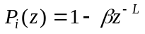 (13)
The optimal lag, L, for this filter is the lag which maximizes the criterion, C_{PW}(j), while considering only positive correlation values for the numerator, N(j), before squaring:
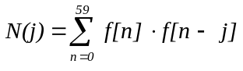 (14.1)
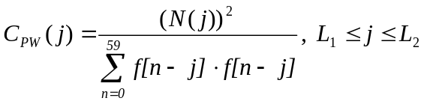 (14.2)
where L1=LOL-3 and L2=LOL+3. The maximum value will be defined as C_{L}. The optimal filter gain, Gopt, is
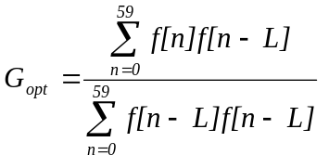 (15)
Gopt is limited to the range [0,1]. The energy, E, of the weighted speech signal, {f[n]}n=0..59 is given by
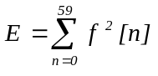 (16)
Then the coefficient β of the harmonic noise shaping filter, P(z), is given by
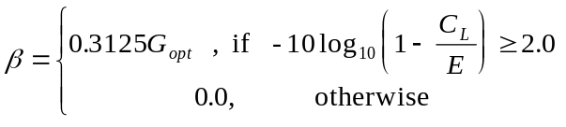 (17)
After computing the harmonic noise filter coefficients, the formant perceptually weighted speech, f[n], is filtered using P(z) to obtain the target vector, w[n] .
w[n] = f[n] - βf[n - L] , 0 ≤ n ≤ 59 (18)

2.12 Impulse response calculator

File : LPC.C | Procedure : Comp_Ir() | Impulse response computation

For closed loop analysis the following combined filter, S_{i}(z) , is used:
(19)
where the components of S_{i}(z) are defined in the formulas 10, 11 and 13. The impulse response of this filter is computed and will be referred as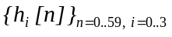.

2.13 Zero input response and ringing subtraction

File : LPC.C | Procedure : Sub_Ring () | Performs ringing subtraction

The zero input response of the combined filter, Si(z), is obtained by computing the output of that filter when the input signal is all zero-valued samples. The zero input response is denoted {z[n]}n=0..59. The ringing subtraction is performed by subtracting the zero input response from the harmonic weighted speech vector, {w[n]}n=0..59. The resulting vector is defined as t[n] = w[n] - z[n].

2.14 Pitch predictor

File : EXC_LBC.C | Procedure : Find_Acbk() | Adaptive codebook contribution. Calls Get_Rez() and Decod_Acbk()
File : EXC_LBC.C | Procedure : Get_Rez() | Gets residual from the excitation buffer
File : EXC_LBC.C | Procedure : Decod_Acbk() | Decodes the adaptive codebook contribution

The pitch prediction contribution is treated as a conventional adaptive codebook contribution. The pitch predictor is a fifth order pitch predictor, (see eq. 41.2). For sub-frames 0 and 2 the closed loop pitch lag is selected from around the appropriate open loop pitch lag in the range 1 and coded using 7 bits. (Note that the open loop pitch lag is never transmitted.) For sub-frames 1 and 3 the closed loop pitch lag is coded differentially using 2 bits and may differ from the previous sub-frame lag only by -1, 0, +1 or +2. The quantized and decoded pitch lag values will be referred to as L_{i} from this point on. The pitch predictor gains are vector quantized using two codebooks with 85 or 170 entries for the high bit rate and 170 entries for the low bit rate. The 170 entry codebook is the same for both rates. For the high rate if L₀ is less than 58 for sub-frames 0 and 1 or if L₂ is less than 58 for sub-frames 2 and 3, then the 85 entry codebook is used for the pitch gain quantization. Otherwise the pitch gain is quantized using the 170 entry codebook. The contribution of the pitch predictor, {p[n]} n=0..59, is subtracted from the target vector {t[n]} n=0..59, to obtain the residual signal {r[n]} n=0..59.
r[n] = t[n] - p[n], (20)

2.15 High rate excitation (MP-MLQ)

File : EXC_LBC.C | Procedure : Find_Fcbk() | Fixed codebook contribution
File : EXC_LBC.C | Procedure : Find_Best() | Residual signal quantization
File : EXC_LBC.C | Procedure : Gen_Trn() | Generates a train of Dirac functions
File : EXC_LBC.C | Procedure : Fcbk_Pack() | Combinatorial coding of pulse positions

The residual signal {r[n]}n=0..59, is transferred as a new target vector to the MP-MLQ block. This block performs the quantization of this vector. The quantization process is approximating the target vector r[n] by r’[n]:
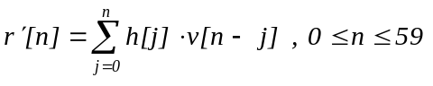 (21)
where v[n] is the excitation to the combined filter S(z) with impulse response h[n] and defined as:
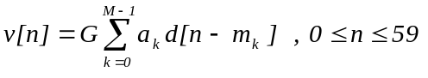 (22)
where G is the gain factor, 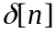 is a Dirac function, 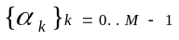 and 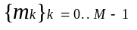 are the signs 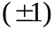 and the positions of Dirac functions respectively and M is the number of pulses, which is 6 for even sub-frames and is 5 for odd sub-frames. There is a restriction on pulses positions. The positions can be either all odd or all even. This will be indicated by a grid bit. So, the problem is to estimate the unknown parameters, 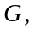, and , that minimize the mean square of the error signal err[n]:
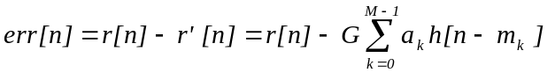 (23)
The parameters estimation and quantization processes are based on an analysis-by-synthesis method. The Gmax parameter is estimated and quantized as follows. First the crosscorrelation function d[j] between the impulse response, h[n], and the new target vector, r[n], is computed:
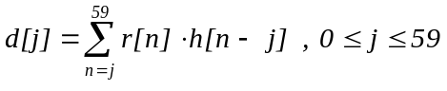 (24)
The estimated gain is given by:
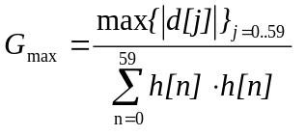 (25)
Then the estimated gain Gmax is quantized by a logarithmic quantizer. This scalar gain quantizer is common to both rates and consists of 24 steps, of 3.2 dB each. Around this quantized value, 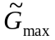, additional gain values are selected within the range [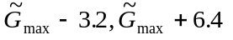]. For each of these gain values the signs and locations of the pulses are sequentially optimized. This procedure is repeated for both the odd and even grids. Finally the combination of the quantized parameters that yields the minimum mean square of err[n] is selected. The optimal combination of pulse locations and gain is transmitted. 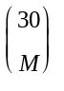combinatorial coding is used to transmit the pulse locations. Furthermore, using the fact that the number of codewords in the fixed codebooks is not a power of 2, 3 additional bits are saved by combining the 4 most significant bits of the combinatorial codes for the 4 sub-frames to form a 13 bit index. The C code provides the details on how this information is packed.
To improve the quality of speech with a short pitch period, the following additional procedure is used. If L₀ is less than 58 for sub-frames 0 and 1 or if L₂ is less than 58 for sub-frames 2 and 3, a train of Dirac functions with the period of the pitch index, L0 or L2, is used for each location 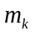 instead of a single Dirac function in the above quantization procedure. The choice between a train of Dirac functions or a single Dirac function to represent the residual signal is made based on the mean square error computation. The configuration which yields the lowest mean square error is selected and its parameter indices are transmitted.

2.16 Low rate excitation (ACELP)

File : EXC_LBC.C | Procedure : search_T0() | Pitch synchronous excitation
File : EXC_LBC.C | Procedure : ACELP_LBC_code() | Computes innovative vector
File : EXC_LBC.C | Procedure : Cor_h() | Correlations of impulse response
File : EXC_LBC.C | Procedure : Cor_h_X() | Correlation of target vector with impulse response
File : EXC_LBC.C | Procedure : D4i64_LBC() | Algebraic codebook search
File : EXC_LBC.C | Procedure : G_code() | Computes innovation vector gain

A 17-bit algebraic codebook is used for the fixed codebook excitation v[n]. Each fixed codevector contains, at most, four non-zero pulses. The 4 pulses can assume the signs and positions given in the following table:
sign | positions
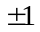 | 0, 8, 16, 24, 32, 40, 48, 56
 | 2, 10, 18, 26, 34, 42, 50, 58
 | 4, 12, 20, 28, 36, 44, 52, (60)
 | 6, 14, 22, 30, 38, 46, 54, (62)
Table 1: ACELP excitation codebook
The positions of all pulses can be simultaneously shifted by one (to occupy odd positions) which needs one extra bit. Note that the last position of each of the last two pulses falls outside the sub-frame boundary, which signifies that the pulse is not present.
Each pulse position is encoded with 3 bits and each pulse sign is encoded in 1 bit. This gives a total of 16 bits for the 4 pulses. Further, an extra bit is used to encode the shift resulting in a 17-bit codebook.
The codebook is searched by minimizing the mean square error between the weighted speech signal, r[n], and the weighted synthesis speech given by
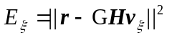 (26)
where r is the target vector consisting of the weighted speech after subtracting the zero-input response of the weighted synthesis filter and the pitch contribution, G is the codebook gain; v is the algebraic codeword at index ; and H is a lower triangular Toeplitz convolution matrix with diagonal h(0) and lower diagonals h(1),..., h(L - 1), with h(n) being the impulse response of the weighted synthesis filter S_{i}(z).
It can be shown that the optimum codeword is the one which maximizes the term
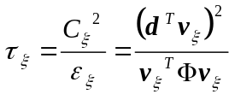 (27)
where 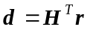 is the correlation between the target vector signal, r[n], and the impulse response, h(n), and 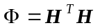 is the covariance matrix of the impulse response. The vector d and the matrix 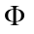 are computed prior to the codebook search. The elements of the vector d are computed by
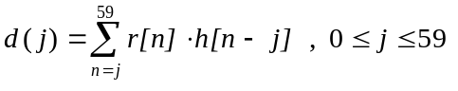 (28)
and the elements of the symmetric matrix 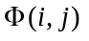 are computed by
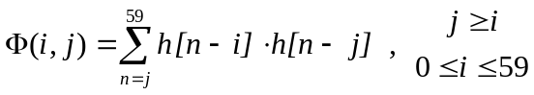 (29)
Note: Only the elements actually needed are computed and an efficient storage has been designed that speeds the search procedure up.
The algebraic structure of the codebook allows for very fast search procedures since the excitation vector v contains only 4 non-zero pulses. The search is performed in 4 nested loops, corresponding to each pulse positions, where in each loop the contribution of a new pulse is added. The correlation in Equation (27) is given by:
(30)
where m_{k} is the position of the kth pulse and 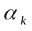 is its sign 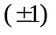. The energy for even pulse position codevectors in Equation (27) is given by:
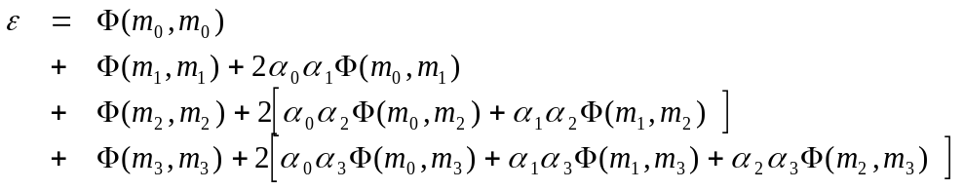 (31)
For odd pulse position codevectors, the energy in Equation (27) is approximated by the energy of the equivalent even pulse position codevector obtained by shifting the odd position pulses to one sample earlier in time. To simplify the search procedure, the functions d[j] and 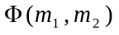are modified. The simplification is performed as follows (prior to the codebook search). First, the signal s[j] is defined and then the signal d’[j] is constructed.
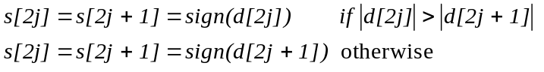 (32)
and the signal d’ is given by d’[j]=d[j]s[j]. Second, the matrix is modified by including the signal information; that is, 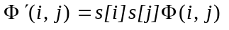The correlation in Equation (30) is now given by:
(33)
and the energy in Equation (31) is given by
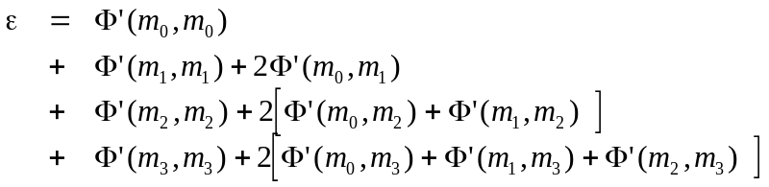 (34)
A focused search approach is used to further simplify the search procedure. In this approach a precomputed threshold is tested before entering the last loop, and the loop is entered only if this threshold is exceeded. The maximum number of times the loop can be entered is fixed so that a low percentage of the codebook is searched. The threshold is computed based on the correlation C. The maximum absolute correlation and the average correlation due to the contribution of the first three pulses, max₃ and av₃, are found prior to the codebook search. The threshold is given by:
thr3 = av3 + (max3 - av3)/2 (35)
The fourth loop is entered only if the absolute correlation (due to three pulses) exceeds thr₃,. Note that this results in a variable complexity search. To further control the search, the number of times the last loop is entered (for the 4 sub-frames) is not allowed to 600. (The average worst case per sub-frame is 150 times.) This can be viewed as searching only 150 x 8 entries of the codebook (ignoring the overhead of the first three loops).
A special feature of the codebook is that, for pitch delays less than 60, a pitch contribution depending on the index PGInd_{i} of the LTP pitch predictor gain vector is added to the code. That is, after the optimum algebraic code v[n] is determined, it is modified by , the values 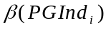 and 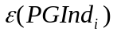 are tabulated and Li being the integer pitch period. Note that prior to the codebook search, the impulse response should be modified in a similar fashion if Li < 60.
The last step, after getting the v[n] sequence, is quantizing the gain G. The gain is quantized in the same way as in the high rate excitation. This is done by stepping through the gain quantization table and selecting the index MGInd_{i} which minimizes the following expression: 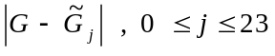.

2.17 Excitation decoder

File : EXC_LBC.C | Procedure : Fcbk_Unpk() | Decode fixed codebook excitation

The decoding of pulses is performed as follows:
1. First the maximum gain G_{max} index is derived using:
(36)
where GSize=24 is the size of the 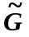table and PGInd_{i} is obtained in section 2.18.
2. The positions of the pulses are decoded using combinatorial decoding where M is either 6 or 5, for the high rate. For the low rate, direct decoding of the position indices is performed.
3. The grid position (even/odd ) is derived from the grid bit.
4. The pulse signs are derived from the sign bits.
5. For the high rate coder, the decoding of the pulse train bit is performed only if L_{i} < 58.
6. Then the v[n] vector is reconstructed using the decoded parameters.
7. Finally, the pitch contribution, u[n], and the pulse contributions, v[n], are summed together to form the excitation vector e[n].

2.18 Decoding of the pitch information

File : EXC_LBC.C | Procedure : Get_Rez() | Gets residual from the excitation buffer
File : EXC_LBC.C | Procedure : Decod_Acbk() | Decodes the adaptive codebook contribution

The decoding of pitch information is performed as described below:
1. First, the lag of pitch predictor for even sub-frames is decoded:
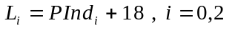 (37)
2. The lag of pitch predictor for odd sub-frames is decoded as follows:
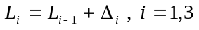 (38)
where 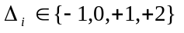.
3. The gain vector of the pitch predictor in ith sub-frame is derived from the gain index GInd_{i}. For the low rate this index contains the information about the pitch predictor gain vector and the index of the gain of the pulse sequence. In this case pitch gain index PGInd_{i} is derived as follows:
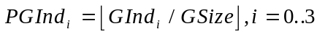 (39)
where 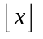indicates the greatest integer 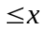. For the high rate, in the case that the condition L_{i} 58 is met, this index is derived in the same manner as described in (39). In the above cases PGInd_{i} is a pointer to 170 entries gain vector codebook. Otherwise, this index is a pointer to 85 entries gain vector codebook and contains an additional information about the impulse train bit. In this case pitch gain index is derived as follows:
(40)
The pitch predictor lag and gain vector are decoded from these indices and utilized for the pitch contribution u[n] extraction as described below. First, a signal e’[n] is defined by
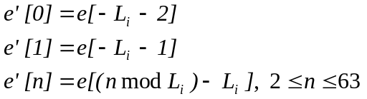 (41.1)
where mod stands for the modulus operation. Then,
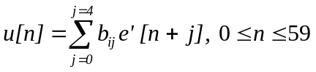 (41.2)

2.19 Memory update

File : LPC.C | Procedure : Upd_Ring () | Memory update

The last task of the ith sub-frame before proceeding to encode the next sub-frame is to update the memories of the synthesis filter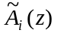, the formant perceptual weighting filter Wi(z), and the harmonic noise shaping filter Pi(z). To accomplish this, the complete response of combined filter Si(z), is computed by passing the reconstructed excitation sequence through this filter. At the end of the excitation filtering, the memory of the combined filter is saved and will be used to compute the zero input response during the encoding of the next speech vector.

2.20 Bit allocation

File : UTIL_LBC.C | Procedure : Line_Pack() | Bitstream packing

This paragraph presents the bit allocation tables for both high and low bit rates. The major differences between two rates are in the pulse positions and amplitudes coding. Also, at the lower rate 170 codebook entries are always used for the gain vector of the long term predictor.
Parameters coded | sub-frame 0 | sub-frame 1 | sub-frame 2 | sub-frame 3 | Total
LPC indices |  |  |  |  | 24
Adaptive code-book lags | 7 | 2 | 7 | 2 | 18
All the gains combined | 12 | 12 | 12 | 12 | 48
Pulse positions | 20 | 18 | 20 | 18 | 73*
Pulse signs | 6 | 5 | 6 | 5 | 22
Grid index | 1 | 1 | 1 | 1 | 4
TOTAL: 189
Table 2: Bit Allocation of the 6.3 kbit/s coding algorithm
*Note: By using the fact that the number of codewords in the fixed codebook is not a power of 2, 3 additional bits are saved by combining the 4 MSB of each pulse position index into a single 13 bit word.
Parameters coded | sub-frame 0 | sub-frame 1 | sub-frame 2 | sub-frame 3 | Total
LPC indices |  |  |  |  | 24
Adaptive code-book lags | 7 | 2 | 7 | 2 | 18
All the gains combined | 12 | 12 | 12 | 12 | 48
Pulse positions | 12 | 12 | 12 | 12 | 48
Pulse signs | 4 | 4 | 4 | 4 | 16
Grid index | 1 | 1 | 1 | 1 | 4
TOTAL: 158
Table 3: Bit Allocation of the 5.3 kbit/s coding algorithm

Name | Transmitted parameters | high rate  # bits | low rate # bits
LPC | LSP VQ index | 24 | 24
ACL0 | Adaptive CodeBook Lag | 7 | 7
ACL1 | Differential Adaptive CodeBook Lag | 2 | 2
ACL2 | Adaptive CodeBook Lag | 7 | 7
ACL3 | Differential Adaptive CodeBook Lag | 2 | 2
GAIN0 | Combination of adaptive and fixed gains | 12 | 12
GAIN1 | Combination of adaptive and fixed gains | 12 | 12
GAIN2 | Combination of adaptive and fixed gains | 12 | 12
GAIN3 | Combination of adaptive and fixed gains | 12 | 12
POS0 | Pulse positions index | 20* | 12
POS1 | Pulse positions index | 18* | 12
POS2 | Pulse positions index | 20* | 12
POS3 | Pulse positions index | 18* | 12
PSIG0 | Pulse sign index | 6 | 4
PSIG1 | Pulse sign index | 5 | 4
PSIG2 | Pulse sign index | 6 | 4
PSIG3 | Pulse sign index | 5 | 4
GRID0 | Grid index | 1 | 1
GRID1 | Grid index | 1 | 1
GRID2 | Grid index | 1 | 1
GRID3 | Grid index | 1 | 1

Table 4: list of transmitted parameters
*Note: The 4 MSB of these codewords are combined to form a 13 bit index, MSBPOS.

2.21 Coder initialization

File : CODER.C | Procedure : Init_Coder() | Coder initialization

All the static coder variables should be initialized to 0, with the exception of the previous LSP vector, which should be initialized to LSP DC vector, p_{DC}.

3. Decoder principles

3.1 General description
The decoder operation is also performed on a frame by frame basis. First the quantized LPC indices are decoded, then the decoder constructs the LPC synthesis filter. For every sub-frame, both the adaptive codebook excitation and fixed codebook excitation are decoded and input to the synthesis filter. The adaptive postfilter consists of a formant and a forward-backward pitch postfilter. The excitation signal is input to the pitch postfilter, which in turn is input to the synthesis filter whose output is input to the formant postfilter. A gain scaling unit maintains the energy at the input level of the formant postfilter.

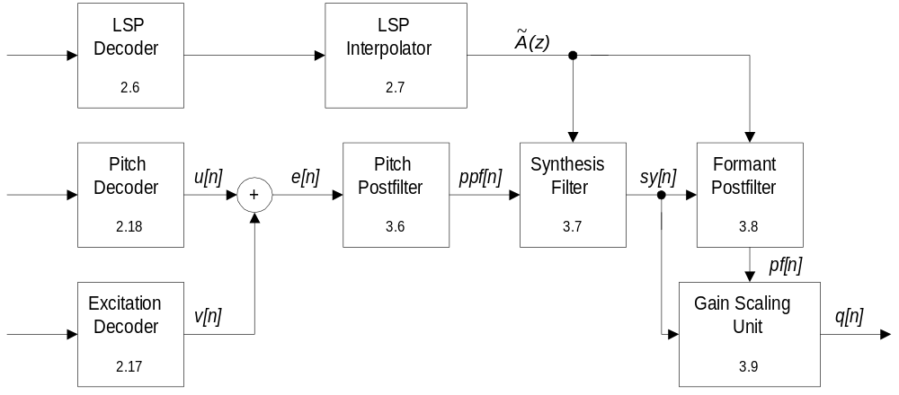
Figure 2. Block diagram of the speech decoder. For each block the corresponding section number is indicated.

3.2 LSP decoder

File : LSP.C | Procedure : Lsp_Inq() | Inverse quantization of LSP

This block is the same as in section 2.6.

3.3 LSP interpolator

File : LSP.C | Procedure : Lsp_Int() | LSP interpolator
File : LSP.C | Procedure : LsptoA() | Converts LSP to LPC coefficients

This block is the same as in section 2.7.

3.4 Decoding of the pitch information

File : EXC_LBC.C | Procedure : Get_Rez() | Gets residual from the excitation buffer
File : EXC_LBC.C | Procedure : Decod_Acbk() | Decodes the adaptive codebook contribution

This block is the same as in section 2.18.

3.5 Excitation decoder

File : EXC_LBC.C | Procedure : Fcbk_Unpk() | Decode fixed codebook excitation

This block is the same as in section 2.17.

3.6 Pitch postfilter

File : EXC_LBC.C | Procedure : Comp_Lpf() | Computes pitch postfilter parameters
File : EXC_LBC.C | Procedure : Find_F() | Forward cross correlation maximization
File : EXC_LBC.C | Procedure : Find_B() | Backward cross correlation maximization
File : EXC_LBC.C | Procedure : Get_Ind() | Gain computation
File : EXC_LBC.C | Procedure : Filt_Lpf() | Pitch postfiltering

A pitch postfilter is used to improve the quality of the synthesized signal. It is important to note that the pitch postfilter is performed for every sub-frame, and to implement it, it is required that the whole frame excitation signal {e[n]}_{n=0..239} is generated and saved. The quality improvement is obtained by increasing the SNR at multiples of the pitch period. This is done in the following way. The postfiltered signal {ppf[n]}_{n=0..59} is obtained from the decoded excitation signal {e[n]} _{n=0..59} as given by the following expression:
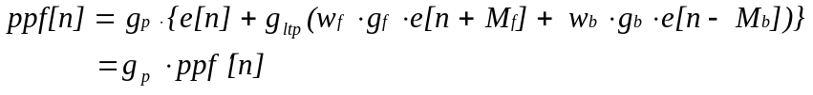 (42)
where e[n] is the decoded excitation signal. The computation of the gains, , and the delays, 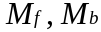, is based on a forward and backward cross correlation analysis. The weights may have the following values: (0,0), (0,1), and (1,0). The delays are selected by maximizing the cross correlations. The cross correlation for the forward pitch lag is given by:
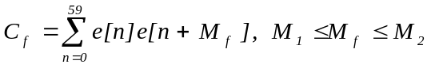 (43.1)
and the cross correlation for the backward pitch lag is given by:
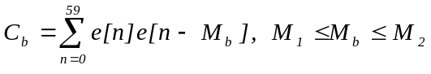 (43.2)
where M₁=L_{i}-3 and M₂=L_{i}+3 and {L_{i}}_{i=0,2} are the received pitch lags for the first and third sub-frames. L₀ is utilized for the first two sub-frames and L₂ for the last two. Note that if one of the maximum correlations is negative or if for some 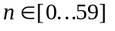there is no sample value 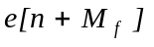 available, then the corresponding weight and delay are set to 0. This makes four possible cases: (0) both maxima are negative and no pitch postfilter weights need to be computed, (1) only the forward maximum is positive, so it is selected, (2) only the backward maximum is positive, so it is selected, or (3) both maxima are positive and the one making the larger contribution is selected. This procedure is described below. For cases (1), (2) and (3), the relevant signal energies (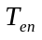, 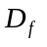 and/or 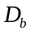) for the optimum pitch lag 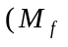 or 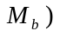are computed according to equations (44.1), (44.2) and (44.3):
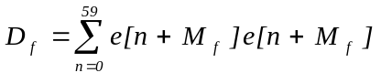 (44.1)
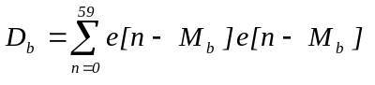 (44.2)
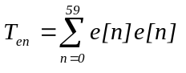 (44.3)
The forward energy is given by:
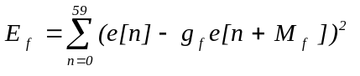 (45.1)
and the backward energy is given by:
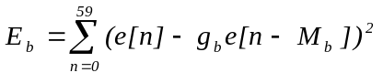 (45.2)
E is minimized by maximizing 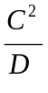. In case (3), the selection between forward and backward is made by selecting the larger of 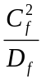 and 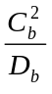. The prediction gain is equal to 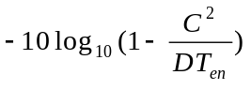. If this gain is less than 1.25 dB, then the contribution is judged to be negligible and no pitch postfilter is used. If a pitch postfilter is used, then the optimum gain is given by:
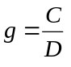 (46)
According to the speech coder bit rate, the optimum gain is multiplied by a weighting factor, 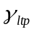, which equals 0.1875 for the high rate and 0.25 for the low rate. Finally, the scaling gain, 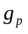, is computed as:
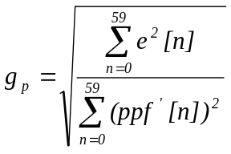 (47)
If the denominator in equation (47) is less than the numerator, the gain is set to 1.

3.7 LPC synthesis filter

File : LPC.C | Procedure : Synt() | Synthesizes reconstructed speech

The 10th order LPC synthesis filter 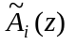 is used to synthesize the speech signal sy[n] from the decoded pitch postfiltered residual ppf[n].
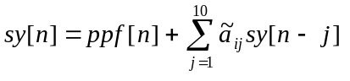 (48)

3.8 Formant postfilter

File : LPC.C | Procedure : Spf() | Formant postfiltering
File : UTIL_LBC.C | Procedure : Comp_En() | Computes synthesized signal energy

A conventional ARMA postfilter is used. The transfer function of the short term postfilter is given by the following equations:
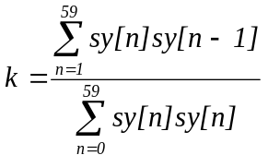 (49.1)
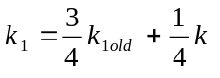 (49.2)
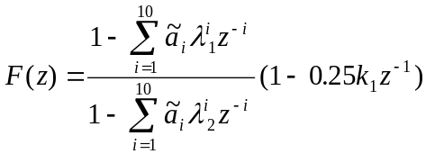 (49.3)
where λ₁=0.65 and λ₂=0.75, k is the first autocorrelation coefficient that is estimated from the synthesized speech sy[n], and 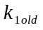 is the value of 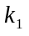 from the previous sub-frame. The postfiltered signal pf[n] is obtained as the output of the formant postfilter with input signal sy[n].

3.9 Gain scaling unit

File : UTIL_LBC.C | Procedure : Scale() | Gain adjustment of postfiltered signal

This unit receives two input vectors, the synthesized speech vector 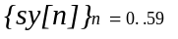 and the postfiltered output vector 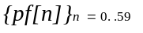. First the amplitude ratio g_{s} is computed, using:
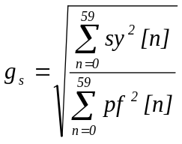 (50)
If the denominator is equal to 0, 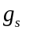 is set to 1.
Then the output vector q[n] is obtained by scaling the postfiltered signal pf[n] and the gain g[n] is updated using the following expressions respectively:
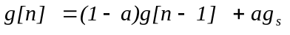 (51)
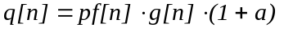 (52)
where α is equal to 1/16.

3.10 Frame interpolation handling

File : EXC_LBC.C | Procedure : Comp_Info() | Computes interpolation index
File : EXC_LBC.C | Procedure : Regen() | Current frame regeneration

This coder has been designed to be robust for indicated frame erasures. An error concealment strategy for frame erasures has been included in the decoder. However, this strategy must be triggered by an external indication that the bitstream for the current frame has been erased. Because the coder was designed for burst errors, there is no error correction mechanism provided for random bit errors. If a frame erasure has occurred, the decoder switches from regular decoding to frame erasure concealment mode. The frame interpolation procedure is performed independently for the LSP coefficients and the residual signal.

3.10.1 LSP interpolation
The decoding of the LSP coefficients in frame interpolation mode is performed in the following way:
1. The vector is set to zero.
2. The predicted vector, 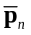, is added to the vector, , and DC vector, , to form the decoded LSP vector,. For generation a different fixed predictor is used: b_{e} = 23/32.
From this point the decoding of the LSP continues as in section 2.6, except that 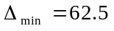Hz, rather than 31.25 Hz.

3.10.2 Residual interpolation
The residual interpolation is performed in two different ways, depending on the last previous good frame prior to the erased frame. The frame is checked with a voiced/unvoiced classifier.
The classifier is based on a cross-correlation maximization function. The last 120 samples of the frame are cross correlated with L₂ 3. The index which reaches the maximum correlation value, is chosen as the interpolation index candidate. Then the prediction gain of the best vector is tested. If this gain is more than 0.58 dB the frame is declared as voiced, otherwise the frame is declared as unvoiced.
The classifier returns 0 for the unvoiced case and the estimated pitch value for the voiced case. If the frame was declared unvoiced, the average of the gain indices for sub-frames 2 and 3 is saved.
If the current frame was marked as erased, and the previous frame was classified as unvoiced, the current frame excitation is generated using a uniform random number generator. The random number generator output is scaled using the previously computed gain value.
In the voiced case, the current frame is regenerated with periodic excitation having a period equal to the value provided by the classifier.
If the frame erasure state continues for the next two frames, the regenerated vector is attenuated by an additional 2.5 dB for each frame. After 3 interpolated frames, the output is muted completely.

3.11 Decoder initialization.

File : DECOD.C | Procedure : Init_Decod() | Decoder initialization

All the static decoder variables should be initialized to 0, with the exception of:
1) Previous LSP vector, which should be initialized to LSP DC vector, p_{DC}.
2) Postfilter gain g[-1], which should be initialized to 1.

4. Bit stream packing
Preliminary note: each bit of transmitted parameters is named PAR(x)_By : where PAR is the name of the parameter and x indicates the sub-frame index if relevant and y stands for the bit position starting from 0 (LSB) to the MSB. The expression PARx_By..PARx_Bz stands for the range of transmitted bits from bit y to bit z. The unused bit is named UB (value=0). RATEFLAG_B0 tells whether the high rate (0) or the low rate (1) is used for the current frame. VADFLAG_B0 tells whether the current frame is active speech (0) or non-speech (1). The combination of RATEFLAG and VADFLAG both being set to 1 is reserved for future use. Octets are transmitted in the order in which they are listed in Tables 5 and 6. Within each octet, the bits are with the MSB on the left and the LSB on the right.

High rate
TRANSMITTED OCTETS | PARx_By, ....
1 | LPC_B5...LPC_B0, VADFLAG_B0, RATEFLAG_B0
2 | LPC_B13...LPC_B6
3 | LPC_B21...LPC_B14
4 | ACL0_B5...ACL0_B0, LPC_B23, LPC_B22
5 | ACL2_B4...ACL2_B0, ACL1_B1, ACL1_B0, ACL0_B6
6 | GAIN0_B3...GAIN0_B0, ACL3_B1, ACL3_B0, ACL2_B6, ACL2_B5
7 | GAIN0_B11...GAIN0_B4
8 | GAIN1_B7...GAIN1_B0
9 | GAIN2_B3...GAIN2_B0, GAIN1_B11...GAIN1_B8
10 | GAIN2_B11...GAIN2_B4
11 | GAIN3_B7...GAIN3_B0
12 | GRID3_B0, GRID2_B0, GRID1_B0, GRID0_B0, GAIN3_B11...GAIN3_B8
13 | MSBPOS_B6...MSBPOS_B0, UB
14 | POS0_B1, POS0_B0, MSBPOS_B12...MSBPOS_B7
15 | POS0_B9...POS0_B2
16 | POS1_B2, POS1_B0, POS0_B15...POS0_B10
17 | POS1_B10...POS1_B3
18 | POS2_B3...POS2_B0, POS1_B13...POS1_B11
19 | POS2_B11...POS2_B4
20 | POS3_B3...POS3_B0, POS2_B15...POS2_B12
21 | POS3_B11...POS3_B4
22 | PSIG0_B5...PSIG0_B0, POS3_B13, POS3_B12
23 | PSIG2_B2..PSIG2_B0, PSIG1_B4...PSIG1_B0
24 | PSIG3_B4...PSIG3_B0, PSIG2_B5...PSIG2_B3
Table 5 : Word bit packing for the high bit rate codec.

Low rate
TRANSMITTED OCTETS | PARx_By, ....
1 | LPC_B5...LPC_B0, VADFLAG_B0, RATEFLAG_B0
2 | LPC_B13...LPC_B6
3 | LPC_B21...LPC_B14
4 | ACL0_B5...ACL0_B0, LPC_B23, LPC_B22
5 | ACL2_B4...ACL2_B0, ACL1_B1, ACL1_B0, ACL0_B6
6 | GAIN0_B3...GAIN0_B0, ACL3_B1, ACL3_B0, ACL2_B6, ACL2_B5
7 | GAIN0_B11...GAIN0_B4
8 | GAIN1_B7...GAIN1_B0
9 | GAIN2_B3...GAIN2_B0, GAIN1_B11...GAIN1_B8
10 | GAIN2_B11...GAIN2_B4
11 | GAIN3_B7...GAIN3_B0
12 | GRID3_B0, GRID2_B0, GRID1_B0, GRID0_B0, GAIN3_B11...GAIN3_B8
13 | POS0_B7...POS0_B0
14 | POS1_B3...POS1_B0, POS0_B11...POS0_B8
15 | POS1_B11...POS1_B4
16 | POS2_B7...POS2_B0
17 | POS3_B3...POS3_B0, POS2_B11...POS2_B8
18 | POS3_B11...POS3_B4
19 | PSIG1_B3...PSIG1_B0, PSIG0_B3...PSIG0_B0
20 | PSIG3_B3...PSIG3_B0, PSIG2_B3...PSIG2_B0
Table 6 : Word bit packing for the low bit rate codec.

5. ANSI C code
ANSI C code simulating the dual rate encoder/decoder in 16 bit fixed point arithmetic is available from ITU-T. The following table lists all the files included in this code.
File name | Description
TYPEDEF.H | data type definition is machine dependent
CST_LBC.H | definition of constants for G.723
LBCCODEC.C | main program for G.723 speech codecs
LBCCODEC.H | functions prototypes
CODER.C | G.723 speech encoder for the two bit rates
CODER.H | functions prototypes
DECOD.C | G.723 speech decoder for the two bit rates
DECOD.H | functions prototypes
LPC.C | linear predictive analysis
LPC.H | functions prototypes
LSP.C | line spectral pair related functions, quantizer
LSP.H | functions prototypes
EXC_LBC.C | adaptive and fixed (MP-MLQ, ACELP) excitation
EXC_LBC.H | functions prototypes
UTIL_LBC.C | miscellaneous functions (HPF, pack, unpack, I/O…)
UTIL_LBC.H | functions prototypes
TAB_LBC.C | tables of constants
TAB_LBC.H | external declaration for constant tables
BASOP.C | fixed point arithmetic and logical operation
BASOP.H | functions prototypes
Table 7: list of software filenames

6. Glossary
This is a glossary containing the mathematical symbols used in the text and a brief description of what they represent.

Symbol | Description
y[j] | input speech samples
s[j] | input speech frame of 240 samples
x[j] | highpass filtered speech frame
R[j] | autocorrelation function, n=0,1,...,10
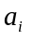 | LPC coefficient vector of sub-frame i
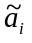 | quantized LPC coefficient vector of sub-frame i
p’ | DC-removed LSP vector
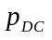 | long-term DC vector of LSP values
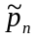 | decoded LSP vector for frame n
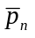 | DC-removed predicted LSP vector
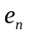 | residual LSP error vector for frame n
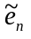 | quantized value of
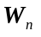 | diagonal weighting matrix for LSP quantization
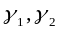 | weights for perceptual weighting filter, 0.9, 0.5
W_{i} | formant perceptual weighting filter for sub-frame i
f[n] | formant perceptually weighted speech
L_{OL} | open loop pitch period estimate
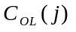 | open loop pitch estimate crosscorrelation criterion function
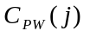 | harmonic noise shaping pitch estimate crosscorrelation criterion function
 | harmonic noise shaping filter gain
L | optimal lag for harmonic noise shaping filter
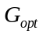 | optimal gain for harmonic noise shaping filter
E | energy of weighted speech signal
P_{i} | harmonic noise shaping filter for sub-frame i
S_{i} | combined harmonic and formant weighting and synthesis filters for sub-frame i
h[n] | impulse response of combined filter
z[n] | zero input response of combined filter
w[n] | harmonic noise weighted speech
t[n] | target vector
p[n] | pitch predictor contribution vector
r[n] | residual signal vector
r’[n] | filtered excitation vector
v[n] | fixed codebook excitation vector
M | number of pulses
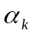 | sign of pulse k
m_{k} | position of pulse k
d[n] | crosscorrelation function of h[n] and r[n]
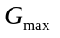 | estimated gain of pulses for high rate
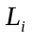 | pitch lag for sub-frame i
H | lower triangular Toeplitz convolution matrix with diagonals h[n]
 | covariance matrix formed by H^{T} H
max₃ | maximum correlation of 1st 3 pulses for low rate
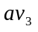 | average correlation of 1st 3 pulses for low rate
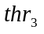 | threshold for correlation of 1st 3 pulses for low rate
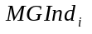 | maximum gain index of sub-frame i
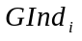 | gain index of sub-frame i
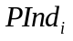 | pitch index of sub-frame i
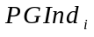 | pitch lag index of sub-frame i
GSize | size of excitation gain codebook, 24
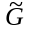 | quantized gain
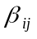 | pitch predictor gain vector
u[n] | adaptive codebook excitation vector
e[n] | decoded combined excitation vector
ppf[n] | pitch postfiltered excitation signal
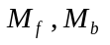 | optimal forward and backward pitch postfilter lags
ppf’[n] | unnormalized pitch postfiltered excitation signal
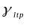 | gain weighting factor, 0.1875 or 0.25
 | pitch postfilter scaling gain
, | optimal forward and backward gains for pitch postfilter
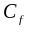, | forward and backward excitation crosscorrelations
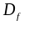,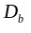 | forward and backward excitation energies
E_{f}, E_{b} | forward and backward energies for pitch postfilter
T_{en} | energy of excitation signal
sy[n] | LPC synthesized speech signal
pf[n] | formant postfiltered signal
q[n] | output speech signal
g[n] | formant postfilter gain signal
 | interpolated reflection coefficient for tilt compensation filter
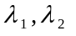 | weights for formant postfilter, 0.65, 0.75
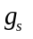 | amplitude ratio of sy and pf vectors
 | 0.0625 in gain scaling unit
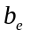 | fixed predictor for LSP interpolation during frame erasure concealment, 23/32
Table 8 - Glossary of symbols in the text

