Digital test vectors for the dual rate LBC G.723.1 speech coder

Date : March 18, 1996, updated November 5, 1996

1. Introduction.
This document describes the digital test sequences that have been designed for the verification of the main body G723.1 speech coder implementations, and gives information on the way to use them.

2. Design of the digital test vectors.
In order to test the encoder and decoder at the two bit rates, five types of test vectors were designed. The digital test sequences are signals chosen or designed to verify the compliance of any fixed point implementation of the G.723.1 speech codec to the Recommandation. They are first able to reflect the maximum (non exhaustive) set of possible conditions in which the coder or decoder will have to operate. The design procedure has tried to insure that any impairment from the bit exact description will affect the result of the output on at least one test sample. These digital test sequences are supposed to be used on a DSP software, a dedicated VLSI or a peculiar fixed point implementation (RISC, WS or PC host machine) of the main body of ITU-T G.723.1 fixed point software. In normal mode of operation, the use of the high-pass filter at the encoder and of the postfilter at the decoder are mandatory according to the terms of the G.723.1 recommendation. Nevertheless, these two filters can be switched on or off by software options in the ANSI C reference software. The use of these options has allowed the CNET designers of the digital test vectors to put the internal state variables of the speech algorithm in conditions met only when these two mandatory filters are switched off. The situation is very similar to the ITU-T LD-CELP G.728 test vectors design. This impacts the basic requirements necessary for any design implementing the G.723.1 speech codec to be able to use the digital test vectors. More precisely, it means that the hardware or software device under test must have the following features :
⇒ Reset command
⇒ Rate command
⇒ High pass switch (for encoder only)
⇒ Postfilter switch (for decoder only).

These remarks are especially important for hardware devices (VLSI) or DSP firmwares which must spare I/O resources to allow the testing of the digital test sequences in real time to insure full compliance with the standard.
The following two schemes summarize the situation for the encoder and decoder under test.

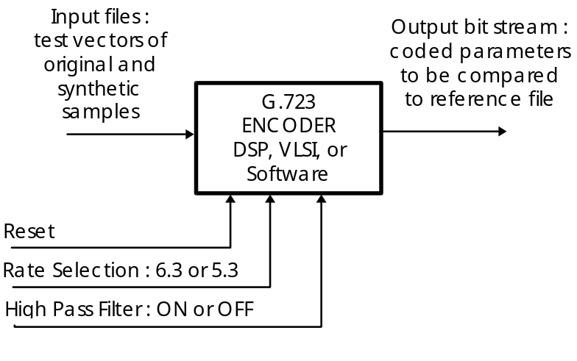
Figure 1.A : Basic configuration for passing the test vectors in encoder mode.

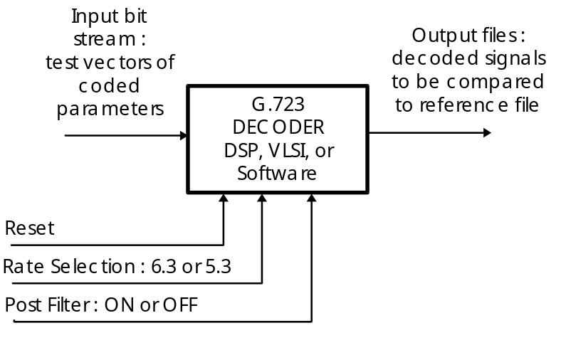
Figure 1.B : Basic configuration for passing the test vectors in decoder mode.

The design of the digital test sequences according to their purpose of covering the widest possible range of input signals and accounting for possible implementation errors has led to the following actions :
⇒ Insertion of flags in every branch of the algorithm,
⇒ Computation of the histograms of the coded parameters,
⇒ Check possible overflows (insertion of flags),
⇒ Test possible implementation errors :
◊ Use of rounding instead of truncation and conversely
◊ Transform inequalities including equality into inequalities not including equality and conversely.
An additional sequence has been designed that tests the procedure introduced at the encoder to avoid a possible explosion of the decoder output in case of encoder-decoder mistracking. This procedure has been called "taming" procedure.
This work has led to the creation of five classes of test files that are :
1) PATHS,
2) OVERFLOWS,
3) CODES,
4) INEQUALITIES,
5) TAMING
The test files names reflect the five classes mentioned above with the following shortcut : PATH.., OVER.., CODE.. , INEQ.. and TAME.. .
The test vectors names also reflect the mode of operation (a C is added to the class name for encoder mode and a D for decoder mode), the bit rate (63 or 53 is added to the previously concatenated name) and the use of the mandatory filters or not (a H is added if the high pass filter is on and a P if the postfilter is on).
The file names extensions reflect their use as test vector files, as reference files, or as Crc files (files containing frame erasure indications) :
- The test vectors for the encoder input use the extension .TIN (for Test vector INput signal).
- The test vectors for the decoder input use the extension .TCO (for Test vector of COded parameters).
- The reference files for the encoder output use the extension .RCO (for Reference for COded parameters).
- The reference files for the decoder output use the extension .ROU (for Reference OUtput signal).
- The Crc files to run the decoder with frame erasure indications use the extension .CRC

3. Description of the five classes of digital test vectors.

3.1. The PATH.. files.
These files were produced by inserting flags in each branch of the algorithm as mentioned above, and checking the flags state on a large variety of signals, in several conditions including decoding with transmission errors.
Portions of signals were selected : speech, sine waves and some of the GSM full rate digital test sequences that were previously designed by CNET. Synthetic signals using sine tones, constant values, impulse noise and white noise filtered by various types of filters were also designed.
All these samples were gathered in four files associated each with a peculiar configuration of encoder-decoder.
Only three remaining branches of the algorithm remain untested, listed below :
1) test on the missing roots in the LSP computations, function AtoLsp() in file lsp.c,
2) the upper LSP bound (not exceeded), in function Lsp_Inq() in file lsp.c,
3) computation of the weighting factors, difference between two consecutive LSP less than 0x2000, function Lsp_Qnt() in file lsp.c.
The resulting PATH.. files are :
1) PATHC63H.TIN (input for encoder, rate 6.3 kbit/s, high pass filter on)
2) PATHC53.TIN (input for encoder, rate 5.3 kbit/s, high pass filter off)
3) PATHD63P.TCO (input for decoder, rate 6.3 kbit/s, post filter on)
4) PATHD53.TCO (input for encoder, rate 5.3 kbit/s, post filter off)
And the corresponding output files (or reference files) are :
1) PATHC63H.RCO (output of encoder, rate 6.3 kbit/s, high pass filter on)
2) PATHC53.RCO (output of encoder, rate 5.3 kbit/s, high pass filter off)
3) PATHD63P.ROU (output of decoder, rate 6.3 kbit/s, post filter on)
4) PATHD53.ROU (output for encoder, rate 5.3 kbit/s, post filter off)
Notice that the file PATHD63P.TCO has to be processed with the file PATHD63P.CRC to obtain PATHD63P.ROU.

3.2. The OVER.. files
The previously mentioned PATH.. files check most of the overflow (or underflow) situations that may be encountered. However it has been found necessary to add some specific test files to track remaining overflow situations not tested by the PATH.. files. This has led to the design of the four following test files :
1) OVERC63.TIN (input for encoder, rate 6.3 kbit/s, high pass filter off)
2) OVERC53H.TIN (input for encoder, rate 5.3 kbit/s, high pass filter on)
3) OVERD63P.TCO (input for decoder, rate 6.3 kbit/s, post filter on)
4) OVERD53.TCO (input for encoder, rate 5.3 kbit/s, post filter off)
The corresponding output files (or reference files) are :
1) OVERC63.RCO (output of encoder, rate 6.3 kbit/s, high pass filter off)
2) OVERC53H.RCO (output of encoder, rate 5.3 kbit/s, high pass filter on)
3) OVERD63P.ROU (output of decoder, rate 6.3 kbit/s, post filter on)
4) OVERD53.ROU (output for encoder, rate 5.3 kbit/s, post filter off)
Even if it cannot be insured that the whole set of test sequences cover all the possible overflow situations, it can be stated that the more common overflow situations are tested.

3.3. The CODE.. files
The purpose of the CODE.. test files is to force the encoder to select all possible coded parameters and for the decoder to check the proper decoding of all coded parameters.
First, the coded parameters values obtained with the previous PATH.. and OVER.. files have been studied, showing that codes were missing only for three types of parameters :
⇒ the pulse positions,
⇒ the LTP values,
⇒ the three tables of quantized LSP.
Faced to the problem of pulse positions it was found that the number of pulse positions combinations is too high to include their whole set into test vectors of reasonable size. Hence the combinations of the pulse positions generated by the test sequences do not scan their whole domain. However each pulse position is encountered in the processing of the encoder test vectors, including the virtual positions (60 to 63) involved by the low rate codebook.

Some pitch delays (from 142 to 145) are not selected by the encoder on the PATH.. and OVER.. test files but it can be shown that those lags cannot be picked up by the Pitch selection procedure.

For the LSPs quantization, the histograms of the 3 sub-vectors codes were first calculated on the PATH.. and OVER..files, showing that a large number of them were missing. A design procedure was derived that has allowed a strong reduction of the unsolicited codes number, and portions of signals extracted from a large database were also selected. At the time the test sequences were made, no LSP sub-vector code was missing.
Yet modifications brought to the algorithm later caused the number of missing LSP codes to be (on the whole set of test sequences) of :
1 for 1 first sub-vector (65)
and 4 for the 2nd one (31, 168, 203, 204).
Due to the same reason, there is one unsolicited long term gain vector in the table AcbkGainTable170 : vector 98.
All the gain vectors of the table AcbkGainTable085 are present.

This work results in the following unique test file :
1) CODEC63.TIN (input for encoder, rate 6.3 kbit/s, high pass filter off)
The corresponding output file (or reference file) is :
1) CODEC63.RCO (output of encoder, rate 6.3 kbit/s, high pass filter off)

3.4. The INEQ.. files
To test whether inequalities including the equality (≤ or ≥ ) have not been transformed into strict inequalities (< or >), or conversely, several versions of the software, each modifiying one inequality, were built. Like for CODE.. and OVER.. ,the previously designed test vectors (PATH.., OVER.. and CODE..) were used as starting point of the study. Then the direct examination of the inequalities has allowed the suppression of some of them, unable to cause any change. Once again, a large data base was processed and finally two test files were built, reducing to 10 the number of untested inequalities. The two files are :
1) INEQC53.TIN (input for encoder, rate 5.3 kbit/s, high pass filter off)
2) INEQD53.TCO (input for decoder, rate 5.3 kbit/s, post filter off)
The corresponding output files (or reference files) are :
1) INEQC53.RCO (output of encoder, rate 5.3 kbit/s, high pass filter off)
2) INEQD53.ROU (output of decoder, rate 5.3 kbit/s, post filter off)

The 10 inequalities that remain untested are all in the exc_lbc.c file :
⇒ function Estim_Pitch() : inequalities 2 and 7
⇒ function Find_Best() : inequalities 3 and 6
⇒ function Cor_h() : inequality 1
⇒ function D4i64_lbc() : inequality 12
⇒ function Comp_Info() : inequalities 2 and 4
⇒ function Comp_Lpf () : inequality 2
⇒ function Get_Ind() : inequality 1

3.5. The TAME.. files.
To test the taming procedure, another test sequence has been designed. Since this procedure lies on 2 techniques, the encoder test sequence is composed of 2 parts, each part dedicated to one of those 2 techniques (see function Test_Err() in exc_lbc.c):
- 1st part : the sine wave detection is not active but the excitation error exceeds the threshold,
- 2nd part : the sine wave detection is active.
At the decoder, the erasure of the first frame (in TAMED63P.CRC) would cause instabilities at the decoder output in the absence of the encoder taming procedure.

4. How to use the G.723.1 test vectors.

4.1. Detailed description of all test vectors and reference files.
This paragraph lists all the test vectors for the encoder and for the decoder with the selected bit rate and the correct options to apply. The following table presents all the possible configurations :
Test vectors | cod/decod | bit rate | HP filter | postfilter | CRC file | reference file
PATHC63H.TIN | coder | 6.3 | ON | N.A. | N.A. | PATHC63H.RCO
PATHC53.TIN | coder | 5.3 | OFF | N.A. | N.A. | PATHC53.RCO
PATHD63P.TCO | decoder | 6.3 | N.A. | ON | PATHD63P.CRC | PATHD63P.ROU
PATHD53.TCO | decoder | 5.3 | N.A. | OFF | None | PATHD53.ROU
OVERC63.TIN | coder | 6.3 | OFF | N.A. | N.A. | OVERC63.RCO
OVERC53H.TIN | coder | 5.3 | ON | N.A. | N.A. | OVERC53H.RCO
CODEC63.TIN | coder | 6.3 | OFF | N.A. | N.A. | CODEC63.RCO
INEQC53.TIN | coder | 5.3 | OFF | N.A. | N.A. | INEQC53.RCO
INEQD53.TCO | decoder | 5.3 | N.A. | OFF | None | INEQD53.ROU
TAMEC63H.TIN | coder | 6.3 | ON | N.A. | N.A. | TAMEC63H.RCO
TAMED63P.TCO | decoder | 6.3 | N.A. | ON | TAMED63P.CRC | TAMED63P.ROU

Table 1. : Configuration of test vectors.

The next tables give the size in bytes of all the test vectors, Crc files and reference files.

File names | number of frames | size in bytes
PATHC63H.TIN | 1019 | 489 540
PATHC53.TIN | 1028 | 493 440
INEQC53.TIN | 63 | 30 240
CODEC63.TIN | 313 | 150 240
OVERC63.TIN | 20 | 9 600
OVERC53H.TIN | 21 | 10 080
TAMEC63H.TIN | 100 | 48000

Table 2. : Size in bytes of test vectors for encoder mode.

File names | number of frames | size in bytes
PATHC63H.RCO | 1019 | 24456
PATHC53.RCO | 1028 | 20560
INEQC53.RCO | 63 | 1260
CODEC63.RCO | 313 | 7512
OVERC63.RCO | 20 | 480
OVERC53H.RCO | 21 | 420
TAMEC63H.RCO | 100 | 2400

Table 3. : Size in bytes of reference files for encoder mode.

File names | number of frames | size in bytes
PATHD63P.TCO | 100 | 2 400
PATHD53.TCO | 4 | 80
OVERD63P.TCO | 33 | 792
OVERD53.TCO | 26 | 520
INEQD53.TCO | 2 | 40
TAMED63P.TCO | 100 | 2400

Table 4. : Size in bytes of test vectors for decoder mode.

File’s name | number of frames | size in bytes
PATHD63P.CRC | 100 | 200
TAMED63P.CRC | 100 | 200

Table 5. : Size of Crc files for decoder mode.

File’s name | number of frames | size in bytes
PATHD63P.ROU | 100 | 48 000
PATHD53.ROU | 4 | 1 920
OVERD63P.ROU | 33 | 15 840
OVERD53.ROU | 26 | 12 480
INEQD53.ROU | 2 | 960

Table 6. : Size in bytes of reference files for decoder mode.

4.2 Example of test program.
The following listing gives the content of a MS/DOS batch file which can test all the test vectors with the ANSI C G.723.1 speech codec software.

Rem ==============================================================
Rem Batch file to exercise the test vectors
Rem of the dual Rate LBC g.723.1 speech coder
Rem The G723.1 executable is named lbccodec.exe
Rem ==============================================================
echo off
Rem
Rem ==============================================================
Rem Processing of the encoder test vectors
Rem
Rem Test vector Name I Nb of frames I Size in bytes
Rem --------------------------------------------------------
Rem PATHC63H.TIN I 1019 I 489540
Rem PATHC53.TIN I 1028 I 493440
Rem OVERC63.TIN I 20 I 9600
Rem OVERC53H.TIN I 21 I 10080
Rem CODEC63.TIN I 313 I 150240
Rem INEQC53.TIN I 63 I 30240
Rem TAMEC63H.TIN I 100 I 48000
Rem
Rem output reference I Size in bytes
Rem -------------------------------------------
Rem PATHC63H.RCO I 24456
Rem PATHC53.RCO I 20560
Rem OVERC63.RCO I 480
Rem OVERC53H.RCO I 420
Rem CODEC63.RCO I 7512
Rem INEQC53.RCO I 1260
Rem TAMEC63H.RCO I 2400
Rem
Rem Files with extension *.PCO have to be compared with
Rem files with extension *.RCO after processing
Rem
Rem ==============================================================
echo on
lbccodec -c -r63 PATHC63H.TIN PATHC63H.PCO
lbccodec -c -r53 -Noh PATHC53.TIN PATHC53.PCO
lbccodec -c -r63 -Noh OVERC63.TIN OVERC63.PCO
lbccodec -c -r53 OVERC53H.TIN OVERC53H.PCO
lbccodec -c -r63 -Noh CODEC63.TIN CODEC63.PCO
lbccodec -c -r53 -Noh INEQC53.TIN INEQC53.PCO
lbccodec -c -r63 TAMEC63H.TIN TAMEC63H.PCO
echo off
Rem
Rem ==============================================================
Rem Processing of the decoder test vectors
Rem
Rem Test vector Name I Nb of frames I Size in bytes
Rem ----------------------------------------------------------
Rem PATHD63P.TCO I 100 I 2400
Rem PATHD53.TCO I 4 I 80
Rem OVERD63P.TCO I 33 I 792
Rem OVERD53.TCO I 26 I 520
Rem INEQD53.TCO I 2 I 40
Rem TAMED63P.TCO I 100 I 2400
Rem
Rem output reference I Size in bytes
Rem -------------------------------------------
Rem PATHD63P.ROU I 48000
Rem PATHD53.ROU I 1920
Rem OVERD63P.ROU I 15840
Rem OVERD53.ROU I 12480
Rem INEQD53.ROU I 960
Rem TAMED63P.ROU I 48000
Rem
Rem Crc file I Size in bytes
Rem -------------------------------------------
Rem PATHD63P.CRC I 200
Rem TAMED63P.CRC I 200
Rem
Rem Files with extension *.POU have to be compared with
Rem files with extension *.ROU after processing
Rem
Rem ==============================================================
echo on
lbccodec -r53 -d -Nop INEQD53.TCO INEQD53.POU
lbccodec -r53 -d -Nop OVERD53.TCO OVERD53.POU
lbccodec -r63 -d OVERD63P.TCO OVERD63P.POU
lbccodec -r53 -d -Nop PATHD53.TCO PATHD53.POU
lbccodec -r63 -d -fPATHD63P.CRC PATHD63P.TCO PATHD63P.POU
lbccodec -r63 -d -fTAMED63P.CRC TAMED63P.TCO TAMED63P.POU

After processing this batch file, the user must compare all the .POU obtained files with the .ROU reference files and the .PCO obtained files with the .RCO references files.

