Structural Analysis of the Curated Epstein Files Knowledge Graph
Implementation + Deliverables Pack
Prepared for network analysis coursework
Dataset source: rhowardstone/Epstein-research-data
Date: 25 March 2026

Important framing: this report analyzes the structure of documented associations in a public-records dataset. Graph links, co-occurrence, and centrality are treated as dataset relationships, not as proof of wrongdoing.

1. Project aim
This submission implements a full graph-analysis workflow using the curated knowledge graph files from the Epstein research data repository. The goal is to answer a neutral network-analysis question: which entities occupy the most central positions, how the network breaks into communities, and how the empirical graph differs from common synthetic network models.

2. Dataset used
Files used in the implementation: knowledge_graph_entities.json and knowledge_graph_relationships.json. The repository describes these as a curated subset of entities and manually verified relationships intended for structured analysis.
Field | Value
Raw entity rows | 606
Raw relationship rows | 2302
Cleaned nodes after exact canonical merge | 546
Cleaned edges | 1730
Largest connected component nodes | 450
Largest connected component edges | 1728

3. Research question
What structural patterns emerge in the curated Epstein Files knowledge graph, and which entities occupy the most central bridge positions across communities?

4. Method
- Load and parse the curated entity and relationship JSON files.
- Extract metadata such as entity type, mention counts, and person-role labels where available.
- Apply a conservative cleaning step by merging exact canonical-name duplicates only.
- Build an undirected weighted graph from the relationship table.
- Focus the main structural analysis on the largest connected component.
- Compute degree, weighted degree, betweenness, closeness, eigenvector centrality, PageRank, and clustering.
- Detect communities with Louvain modularity optimization.
- Compare the empirical graph with matched Erdős–Rényi, Barabási–Albert, and Watts–Strogatz graphs.
- Export figures and tabular deliverables for inclusion in the report or appendix.

5. Key summary metrics
Metric | Value
Connected components | 95
Largest component density | 0.0171
Average degree (largest component) | 7.68
Average clustering (largest component) | 0.663
Transitivity | 0.082
Diameter | 4
Average path length | 2.098
Detected Louvain communities | 11
Louvain modularity | 0.312
Interpretation: the largest component is sparse in global density but locally clustered. That combination is consistent with a network that has short paths and dense neighborhood structure, rather than a purely random graph.

6. Centrality results
Weighted degree was used as the main visibility measure, while betweenness highlights bridge-like nodes. The table below lists the top nodes by weighted degree in the largest connected component.
Rank | Name | Weighted degree | Betweenness | Community
1 | JEFFREY EPSTEIN | 9167 | 0.6144 | 2
2 | GHISLAINE MAXWELL | 1479 | 0.2475 | 1
3 | Richard Kahn | 1075 | 0.0204 | 4
4 | LEON BLACK | 848 | 0.0089 | 2
5 | Larry Visoski | 824 | 0.0164 | 3
6 | Sarah Kellen | 729 | 0.0283 | 3
7 | Boris Nikolic | 715 | 0.0224 | 2
8 | Emmy Tayler | 623 | 0.0457 | 1
9 | Marcinkova, Nadia Nadia | 617 | 0.0046 | 3
10 | Lesley Groff | 561 | 0.0886 | 4
Figure 1. Top 10 nodes by weighted degree.
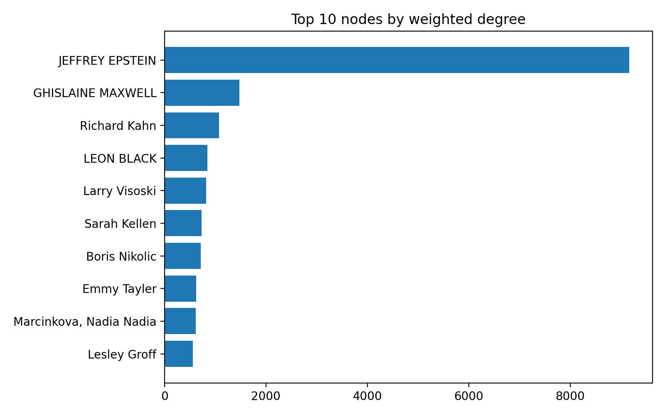
Figure 2. Degree distribution of the largest connected component.
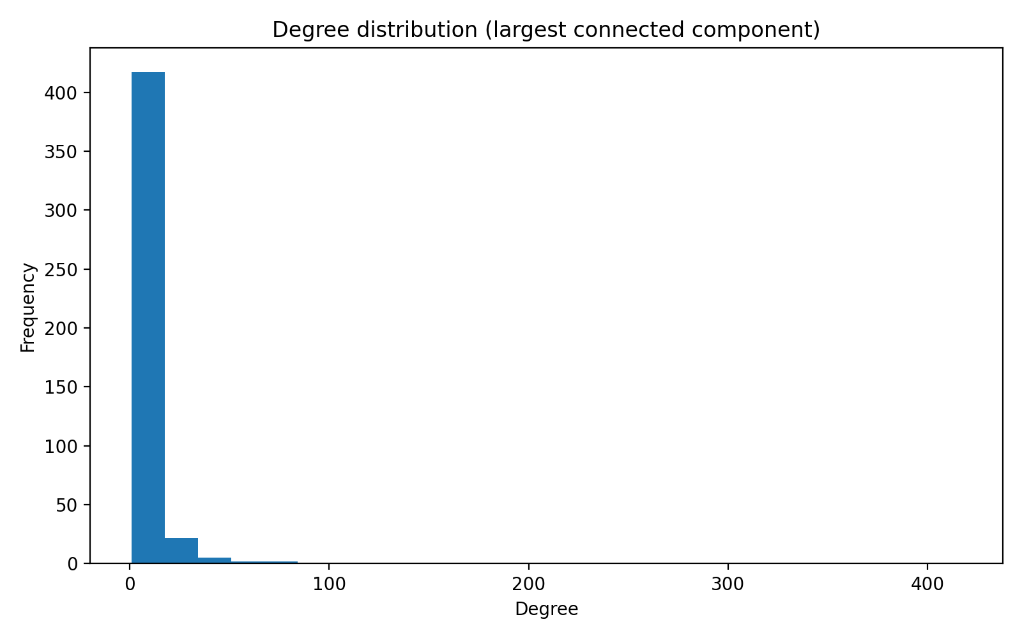

7. Community structure
Louvain community detection identified 11 communities in the largest connected component. The largest few communities account for most of the graph, while smaller communities likely reflect specialized substructures.
Community | Nodes | Density | Top connector
1 | 163 | 0.044 | GHISLAINE MAXWELL
2 | 144 | 0.018 | JEFFREY EPSTEIN
3 | 73 | 0.120 | Larry Visoski
4 | 28 | 0.127 | Richard Kahn
5 | 14 | 0.242 | Celina Midelfart
6 | 9 | 0.556 | Elizabeth Elizabeth
7 | 6 | 0.800 | Andy Stewart
8 | 5 | 1.000 | Anna Molova
Figure 3. Community size distribution.
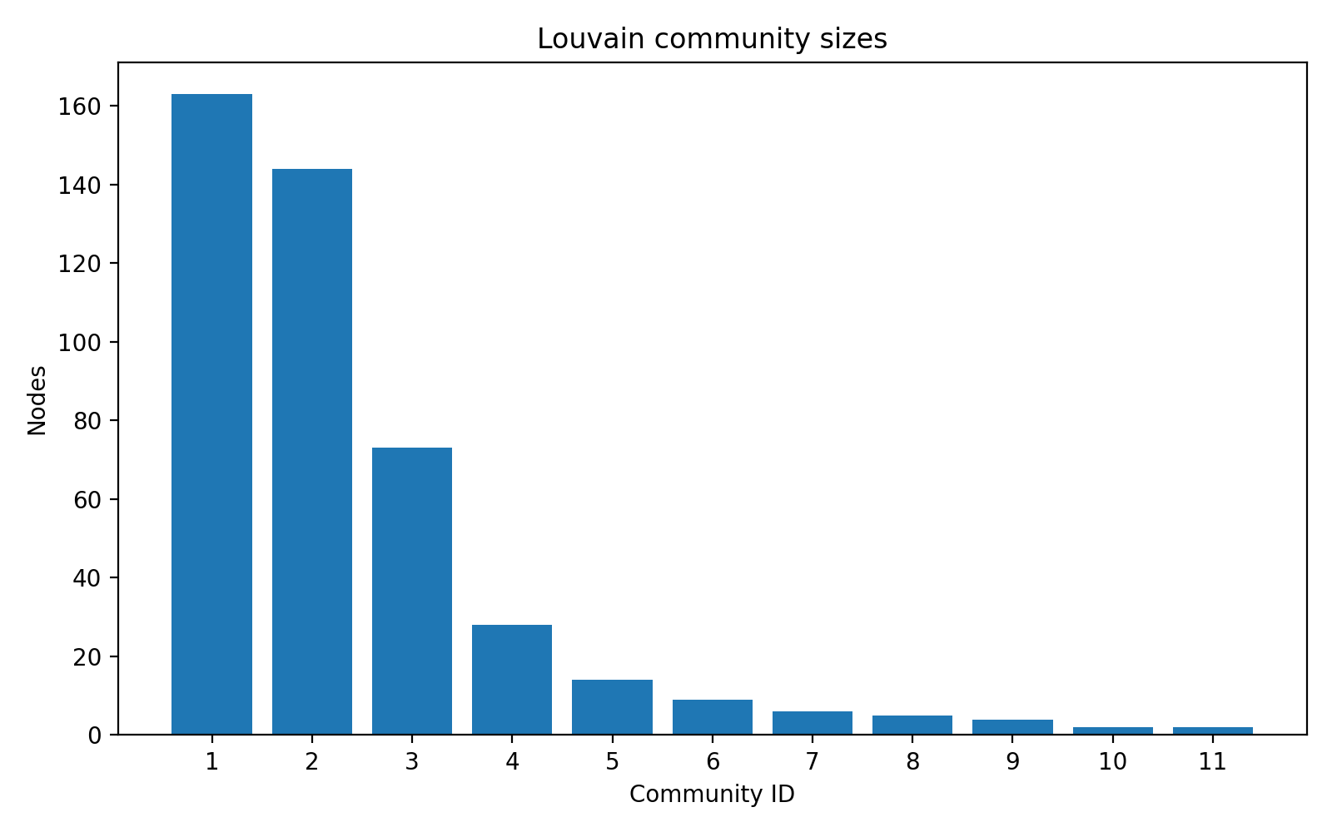
Figure 4. Largest-component subgraph using the top 120 nodes by weighted degree.
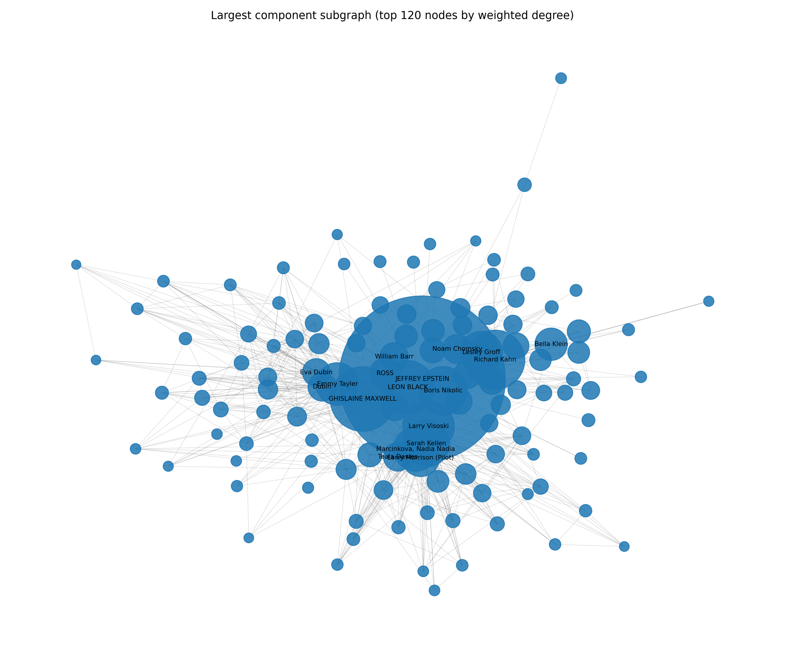

8. Empirical vs synthetic graph comparison
To situate the network structurally, the empirical graph was compared with three matched families: Erdős–Rényi (random), Barabási–Albert (preferential attachment), and Watts–Strogatz (small-world).
Graph | Avg degree | Avg clustering | Diameter (LCC) | Avg path length (LCC)
Empirical | 7.68 | 0.663 | 4 | 2.098
ER | 7.68 | 0.018 | 6 | 3.220
BA | 7.93 | 0.059 | 5 | 2.887
WS | 8.00 | 0.504 | 8 | 4.598
The empirical graph shows much higher clustering than the ER and BA baselines while keeping short paths, which suggests a stronger small-world character than a purely random or simple preferential-attachment structure.
Figure 5. Structural comparison with matched synthetic graphs.
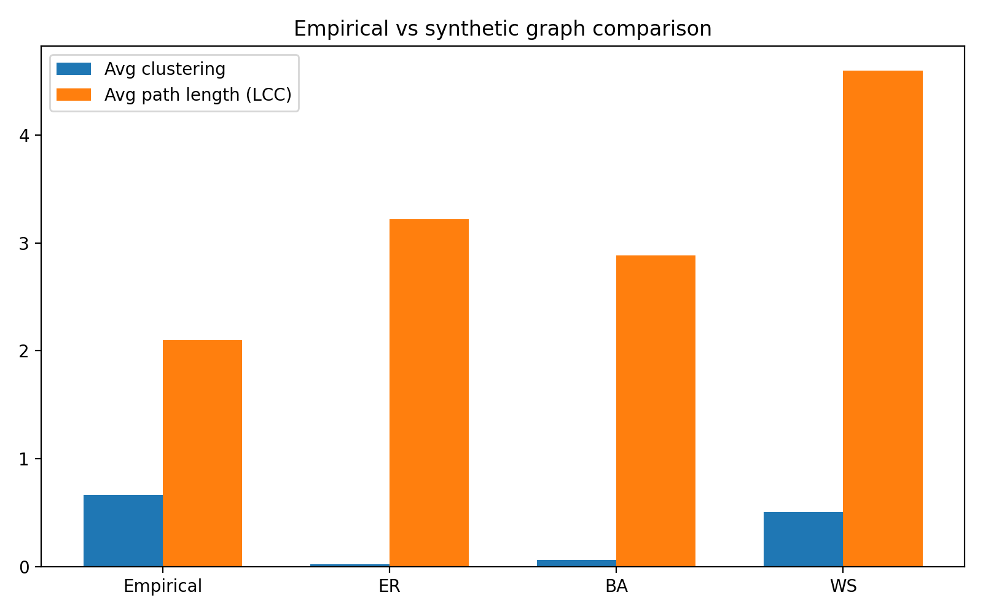

9. Deliverables included
- Python implementation script
- Source data copies used for the run
- Summary metrics CSV
- Full centrality ranking CSV
- Community summary CSV
- Relationship-type counts CSV
- Synthetic graph comparison CSV
- Six PNG figures
- Submission-ready DOCX report
- Submission-ready PDF report

10. Limitations
- This implementation uses the curated knowledge graph only, not the full OCR corpus.
- A conservative duplicate-merge rule was used; ambiguous aliases were not aggressively resolved.
- An undirected weighted graph was used for comparability and simplicity, even though the source includes typed relationships.
- Any interpretation must remain descriptive: graph position reflects the dataset structure, not legal culpability.

11. Reproducibility
Run `python3 -m pip install -r requirements.txt` and then `./run_analysis.sh` from the project root. The analysis script regenerates the CSV tables and PNG figures in the outputs folder.

