Kapunga Rice Project Limited
Transforming Agriculture, Empowering Communities
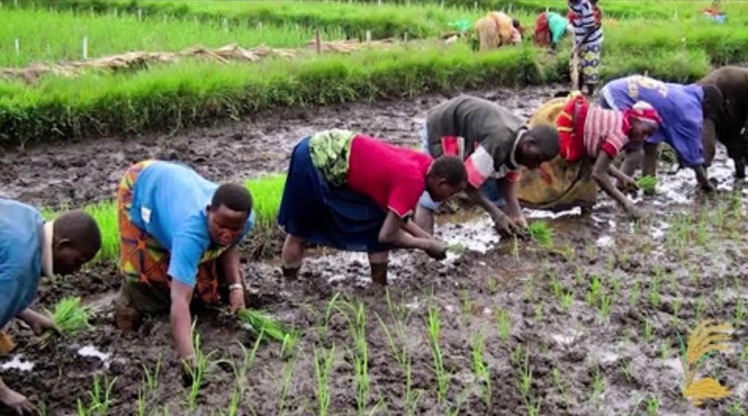
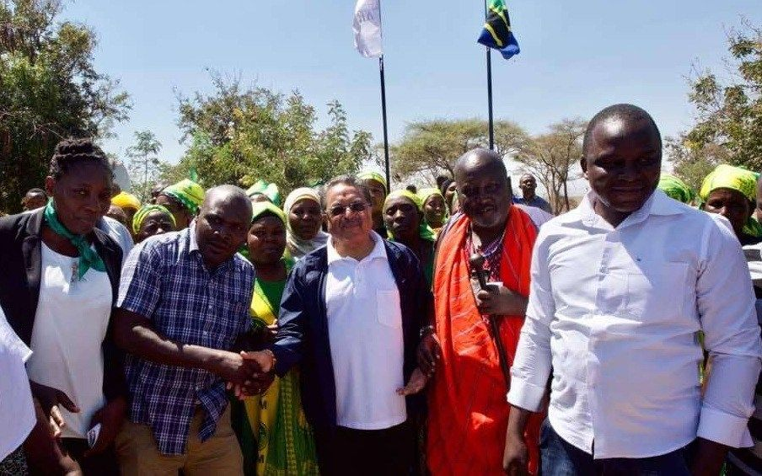
Rice for Africa from Africa

Executive Summary
Rice has become one of the most vital staples for Africa, yet it is also one of its most imported commodities. Despite possessing abundant arable land and water, Africa continues to rely on external sources for over 60% of its rice consumption. This heavy import dependency, costing the continent over USD 7 billion annually, leaves it vulnerable to global market volatility, food insecurity, and escalating trade imbalances.
The Kapunga Rice Project Limited (KRPL), located in the Mbeya region of Tanzania, stands as a transformative model of how Africa can achieve food sovereignty through local innovation, private sector participation, and community-centered approaches. Once a degraded and underutilized farm under the National Agriculture and Food Corporation (NAFCO), the 7,850hectare Kapunga farm was privatized in 2006. KRPL, under the leadership of Shri Mahesh Patel of the Export Trading Group (ETG) and Empowering Farmers Foundation (EFF), acquired the farm and converted it into one of Africa’s most successful agricultural revitalization projects while 2,350 hectares were given back to the villagers for them to do farming.
KRPL not only restored the land but also redefined what inclusive agribusiness could look like. By introducing advanced technology, irrigation systems, modern rice varieties, and mechanization, it transformed yields from a mere 800 kg/ha to over 7 tons/ha. Beyond yield, KRPL uplifted entire communities: building schools, hospitals, roads, and water systems; creating employment; empowering women farmers; and strengthening linkages with financial institutions. Today, KRPL is both a symbol of Africa’s untapped potential and a blueprint for replicable agricultural transformation across the continent. KRPL believed in joining hands, hence supported farmers with the help of their outgrowers schemes. They made sure that the support includes all the farming related activity training and facilities like land and nursery preparation, irrigation, agricultural inputs availability, financial loan support and finally procurement of rice for better market linkages to achieve the desired result of uplifting farmers’ life as well as supporting whole community.
This success story explores KRPL’s journey—from its inception and challenges to its remarkable transformation—capturing farmer voices, community impact, comparative insights, and lessons learned. It underscores how patience, innovation, and inclusivity can turn abandoned land into a beacon of prosperity.

Problem Statement
Rice is a vital staple for billions worldwide, underpinning both daily nutrition and global food security. Annual global milled rice production has steadily grown, averaging 506.76 million tonnes (MMT) between 2015 and 2024, and reaching a record high of nearly 540.83 MMT in 2024/25 thanks to major producers like India and China, who together contribute 55% of total output. Looking ahead, international forecasts anticipate global production will climb to about 598 MMT by 2034, spurred largely by improved yields across Asian countries. The rice trade is expanding at 1.5% per annum and reaching around 65 MMT annually by 2034; this global abundance contrasts sharply with regional disparities, especially in Africa.
Africa’s dependence on rice imports remains acute despite advances in domestic production. The continent currently produces only 40% of the rice it consumes but imports the remaining 60%—about 25 MMT annually, costing US$7 billion on average. While the rice-growing area in Africa expanded almost 40% over the past decade, average yields are just 2.4 t/ha, significantly lower than Southeast Asia’s 4.3 t/ha or South Asia’s 3.7 t/ha. Most African rice is cultivated under rain-fed conditions, leaving farmers at the mercy of erratic weather and pests, a situation compounded by limited irrigation, suboptimal inputs, and weak extension services. Consumption is forecast to jump from 42 MMT in 2021–2023 to 54 MMT by 2032–2034—representing nearly 28% of global consumption growth—with imports rising 53% to 38 MMT as demand growth far outpaces local output.
Africa’s struggle to balance rice supply with demand is notable given its abundant—but underutilized—natural resources, including land and water. The continent possesses a substantial share of the world’s uncultivated arable land, much of which remains unexplored for rice cultivation. Experts suggest that, with investment in irrigation, improved rice varieties, mechanization, and postharvest infrastructure, Africa could feasibly produce enough rice to feed itself and even become a net exporter. Achieving self‑sufficiency, however, requires not only technical reforms and improved productivity but also supportive policies to attract private sector investment and strengthen extension services. Harnessing Africa’s untapped agricultural potential thus represents both an opportunity and an imperative for reducing vulnerability to global market shocks and securing food sovereignty for future generations. Agriculture only can drive 40+ Sub-Saharan Countries out of poverty to become Middle Income Economy. KRPL is one such initiative.

Background & History
Shri Mahesh Patel was seeking a location where he could access good agricultural land, a supportive government, and a cooperative rural community. Tanzania was favorably positioned for all three conditions. In Tanzania, rice accounts for a fifth of cereal consumption. Throughout the 1970s, various agricultural government parastatals were created. These included the National Agriculture and Food Cooperation (NAFCO), the National Ranching Company (NARCO), the Dairy Farming Company (DAFCO), and the National Milling Corporation (NMC). In 1977, NAFCO established Mbarali Rice Farm in the Usangu Plains in the Mbeya region, an upper catchment of the Great Ruaha River (GRR). The farm was divided into three estates: the Kapunga Rice Project, Mbarali Estate, and Madibila Rice Plantation.
The collapse of NAFCO in the 1990s left Tanzania’s large farms idle and communities vulnerable. Kapunga farm was no exception. Transferred to the Presidential Parastatal Sector Reform Commission (PSRC) for divestiture, the farm was contested by local farmers who resisted privatization. Eventually, in 2006, KRPL acquired the 7,850-hectare farm, including 3,000 hectares of developed land for farming and 4,850 hectares of undeveloped land. Shri Mahesh Patel gave 2,350 hectares land back to the villagers for them to do the farming. From remaining 5,500 hectares, 3,500 hectares were irrigated and 2,000 hectares were rain-fed. At that time, there were nearly four million households growing food crops on their small plots, typically ranging from half to two hectares.
When KRPL took over, the land was overrun with weeds, irrigation was nonfunctional, the rice mill was in ruins, and the local community was impoverished. With no water systems, electricity, or infrastructure, farming was near impossible. Local trust was low, and skepticism was high.
Despite these challenges, KRPL embarked on a bold vision: to rehabilitate the farm, introduce inclusive farming models, and integrate smallholder farmers into a profitable, sustainable rice ecosystem. Not only related to the farming activities but also with a vision to uplift the local community as well from their distress and availability of the basic facilities.
KRPL was very clear with its target of achieving more yield per hectare of rice by using outgrowers schemes, good agricultural practices (GAP), mechanized equipments backed by technology, and a hand holding execution team.

Vision and Objectives
Kapunga Rice Project Limited (KRPL) was envisioned as a transformative force for agriculture in the Kapunga village and beyond. The project was conceived with a deep commitment to revitalize the region’s agricultural potential through large-scale, sustainable, and inclusive farming models that empower communities and strengthen food systems.
KRPL’s mission is to build a resilient and modern agricultural ecosystem that ensures food security, enhances farmer livelihoods, promotes innovation, and drives comprehensive rural prosperity. By combining modern technology, local participation, and environmental stewardship, KRPL aims to stand as a model for sustainable agricultural transformation across Africa.
As Shri Mahesh Patel aptly states:
“Our future is to make KRPL a beacon for Africa’s agricultural renaissance — a living example of how innovation, inclusion, and integrity can together reshape rural economies.”
Shri Mahesh Patel

Objectives
KRPL’s development framework is built around a set of clear, actionable, and community-centered objectives designed to create long-term impact:
- Rehabilitate and Restore Farmland: KRPL focuses on bringing underutilized and degraded land back into productive use through land levelling, canal rehabilitation, and infrastructural upgrades. By improving irrigation networks and ensuring efficient water distribution, formerly low-yield areas are transformed into fertile, high-performing agricultural zones.
- Establish Modern, High-Yield Rice Farming Systems: The project introduces structured, large-scale farming systems that combine advanced irrigation, improved seed varieties, and mechanized cultivation. This approach ensures uniformity in operations and significantly boosts per-hectare productivity compared to traditional methods.
- Integrate and Empower Smallholder Farmers: Smallholder farmers form the backbone of the KRPL model.
- Through the Outgrower Scheme, these farmers are fully
- integrated into the production ecosystem, gaining access to
- resources, inputs, and support services that were previously
- unavailable. This integration fosters inclusion, shared growth, and
- collective success.
- Strengthen Farmer Capacity and Skills: KRPL conducts extensive training programs on Good Agricultural Practices (GAP), modern agronomy, and sustainable water management. These capacity-building initiatives empower farmers to adopt new technologies and techniques with confidence, leading to consistent improvements in yield and quality.
- Leverage Modern Technologies: By employing GPS-guided machinery, digital monitoring tools, and scientific soil and water management practices, KRPL embeds technology at every stage of the value chain.
- Promote Sustainable Agricultural Practices: Sustainability lies at the core of KRPL’s operations. Through responsible water use, soil conservation, and ecological preservation, the project safeguards natural resources while achieving higher productivity. These measures ensure that gains are not only immediate but also durable over time.
- Catalyze Rural Development and Job Creation: The project creates direct and indirect employment opportunities — from farm operations and logistics to processing and marketing — driving broader rural development.
- Demonstrate Scalable Agricultural Models: KRPL aims to serve as a replicable model for large-scale, modern rice cultivation. By showcasing successful interventions at Kapunga, it demonstrates how strategic investment, technology adoption, and farmer partnerships can be scaled to other regions facing similar challenges.
- Drive Social and Economic Upliftment: At the heart of the initiative is a strong focus on improving livelihoods. Through increased yields, stable market access, training, and community engagement, KRPL contributes to raising household incomes, enhancing food security, and improving overall living standards in the region.
- Ensure Long-Term Food Security: By combining technology, sustainability, and farmer empowerment, KRPL is working to ensure consistent rice production, contributing to both national and regional food security goals.

President’s Message
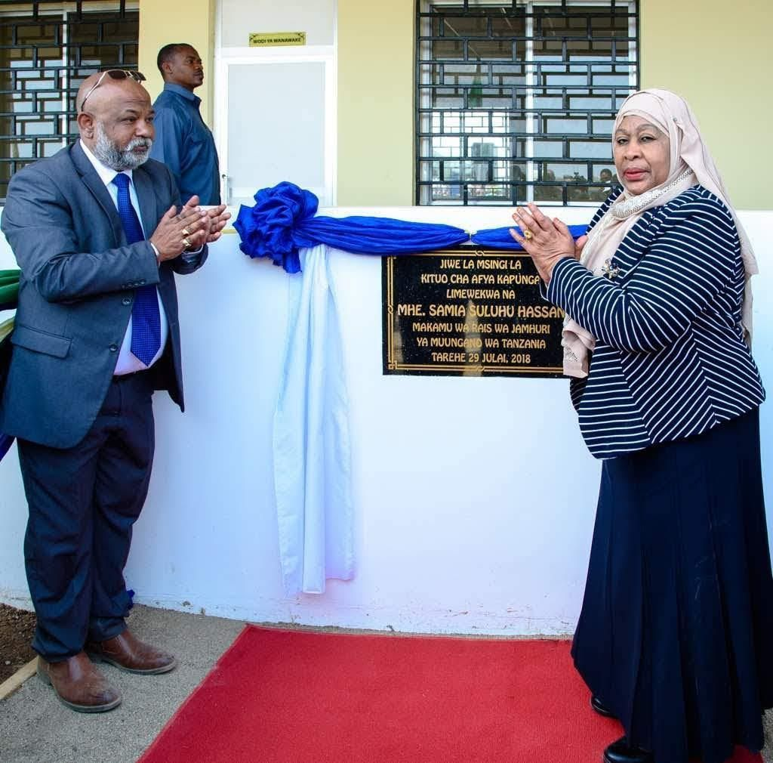
“I am deeply impressed by the Kapunga Rice Project’s dedication to sustainable agriculture and its strong contribution to the local economy. The innovative farming practices nurtured through the outgrowers scheme, the commitment to environmental stewardship, and the positive impact on the community truly set this farm apart as a model for progress.”
Mama Samia Suluhu Hassan while addressing villagers during her visit to Kapunga Farm and Rice Mill

Chairman’s Message
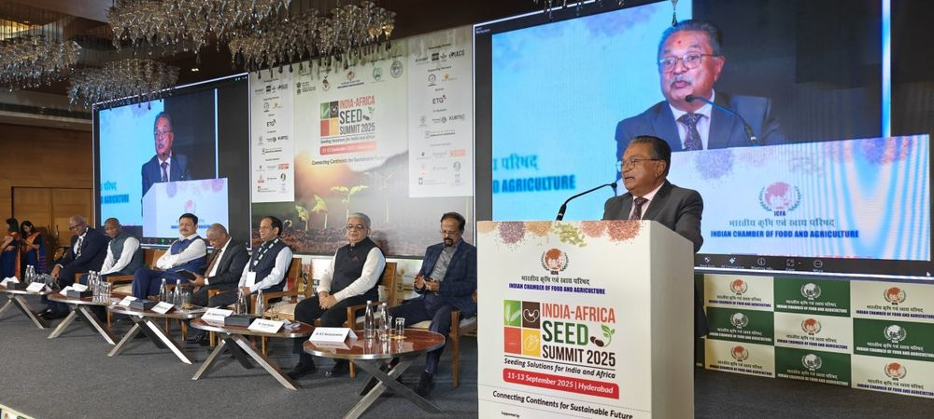 | 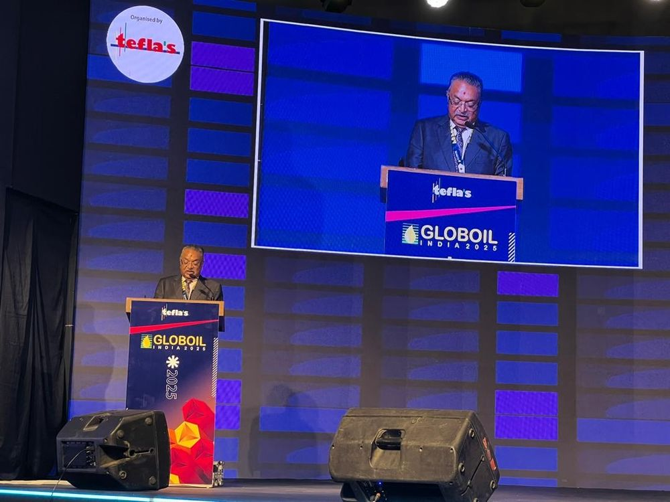

“At KRPL, our journey has been one of resilience, innovation, and inclusivity. From humble beginnings, we have built a model that demonstrates how technology, community engagement, and sustainable farming can work together to achieve impact. We are grateful to the government, development partners, and the communities who stood with us. Our future is to make KRPL a beacon for Africa’s agricultural renaissance.”
Shri Mahesh Patel, Chairman of Export Trading Group (ETG), and Empowering Farmers Foundation (EFF)

How KRPL Did It

Operational Challenges
- Farm in a degraded conditions with grass all over it and movement of animals everywhere.
- Non-availability of electricity and water.
- Non-operational and pathetic condition of the Rice Mill.
- Non-availability of heavy machineries or equipment and vehicles.
- Resistance from local people and media on land claiming.
The Kapunga region was once characterized by low farming income and poor yields, with agriculture heavily dependent on rain-fed practices. Farmers had little access to reliable irrigation, which limited productivity and reduced opportunities for growth. Recognizing both the potential of the land and the challenges faced by local communities, KRPL introduced an Outgrowers Scheme to transform rice farming in the region.
Under this initiative, KRPL brought 3,500 hectares of irrigated land into organized production, while an additional 1,500 hectares remained under rainfed conditions. A major breakthrough came from the company’s success in securing adequate water supplies from river inlet and outlet systems, which made large-scale irrigation possible. This irrigation network enabled the conversion of the land into 590 well-demarcated plots of six hectares each, ensuring both efficiency and equity in land distribution.
The Outgrowers Scheme extended far beyond land allocation. KRPL actively built relationships with thousands of smallholder farmers in the surrounding areas, encouraging them to participate and benefit from the project. Farmers received improved seeds, modern agricultural technologies, and training in Good Agricultural Practices (GAP). As a result, productivity soared—where one hectare earlier produced only around 800 kilograms of rice, yields increased dramatically to over 7 tons per hectare by 2021.
A key driver of this success was the integration of mechanization and precision farming. The project deployed high-end farm machinery, digital monitoring tools, and scientific soil management techniques, ensuring consistent crop health and efficiency across the farming cycle. Partnerships with government research institutions, most notably the Dakwa Agriculture Research Institute, strengthened the program by providing access to high-quality seed varieties such as Super Saro 5.
Equally important, KRPL embedded sustainability principles into its operations. By focusing on soil health, responsible water use, and ecological balance, the project ensured that yield improvements were not just short-term gains but would remain sustainable in the long run. This holistic approach has helped transform Kapunga into a model of modern rice farming in Africa, improving farmer incomes, strengthening food security, and fostering community development.

KRPL’s Technology Involvement
- GPS-guided John Deere Tractors (18 ha/day capacity): Equipped with advanced GPS navigation, these tractors are capable of covering up to 18 hectares per day, enabling highprecision land preparation. Their use significantly reduces time and labor requirements while ensuring uniform leveling and ploughing, which are crucial for optimizing water use and achieving consistent crop establishment across large fields.
- GPS-guided John Deere Combine Harvesters (18–24 ha/day capacity): These state-of-the-art combine harvesters, integrated with GPS guidance, bring efficiency and accuracy to the harvesting process.
- Capable of covering 18 to 24 hectares per day, they ensure
- minimal grain loss, precise cutting, and faster turnaround times
- during peak harvest periods, which is especially critical for largescale commercial rice operations.
- Kubota Harvesters (6–9 ha/day capacity): Compact and efficient, Kubota harvesters are ideal for maneuvering in smaller plots and more challenging terrain. With a daily capacity of 6 to 9 hectares, they complement larger machines by ensuring that no areas are left unattended, thereby increasing overall operational flexibility and harvesting speed.
- Kubota Transplanter (6 ha/day capacity): The Kubota transplanter enhances precision in rice seedling placement, with a working capacity of 6 hectares per day. This mechanization step ensures uniform plant spacing, improved crop establishment, and better yields while significantly reducing the manual labor traditionally required for transplanting.
- Filkin 1000-liter Boom Sprayer (18–24 ha/day capacity): The Filkin boom sprayer, with its 1,000-liter tank and highcoverage boom, can efficiently spray 18 to 24 hectares per day.
- This allows for timely and even application of fertilizers and crop
- protection products, improving pest and disease management
- while conserving water and inputs through targeted spraying.
- Caterpillar Excavator for Canal Lining (500–600 m/day capacity): A Caterpillar excavator is deployed for lining irrigation canals, working at a pace of 500 to 600 meters per day. This critical infrastructure development ensures efficient water distribution, minimizes seepage losses, and strengthens the irrigation network, thereby enabling reliable water supply for large-scale farming.
- Buhler Rice Mill (8 silos, 40 tons/day capacity with packaging): The Buhler rice milling facility, equipped with eight storage silos and a 40-ton-per-day processing capacity, integrates milling and packaging functions in one system. This ensures not only high throughput but also quality consistency and reduced post-harvest losses. The modern milling setup allows the project to handle large volumes efficiently, meeting both domestic and export market standards.
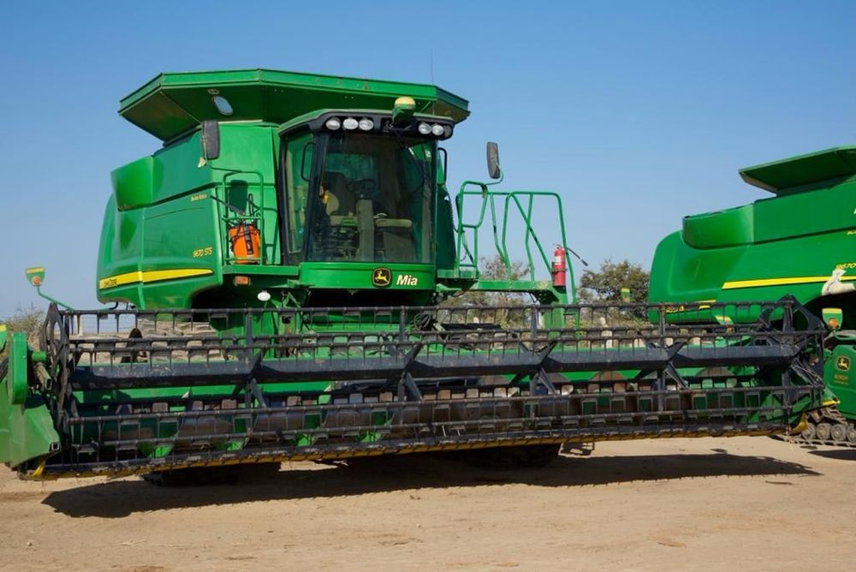 | 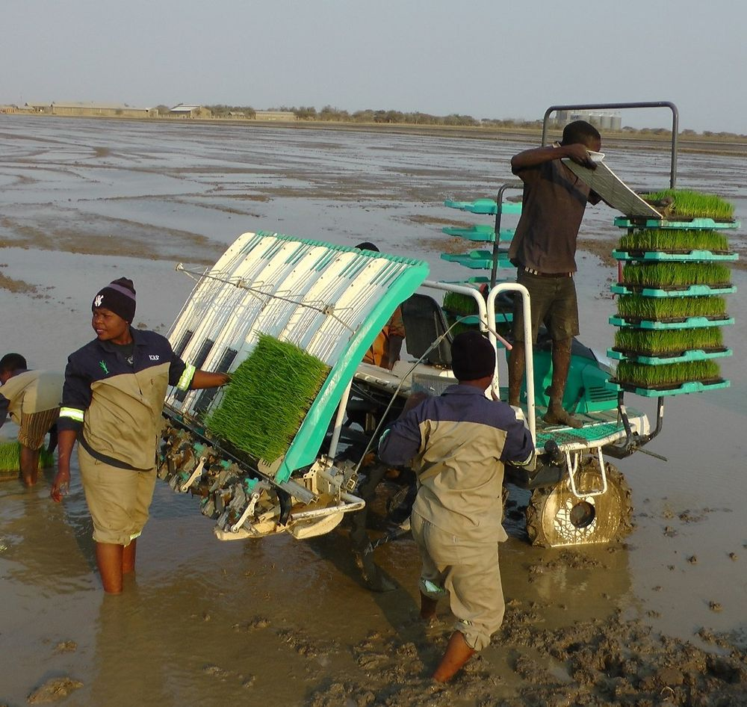

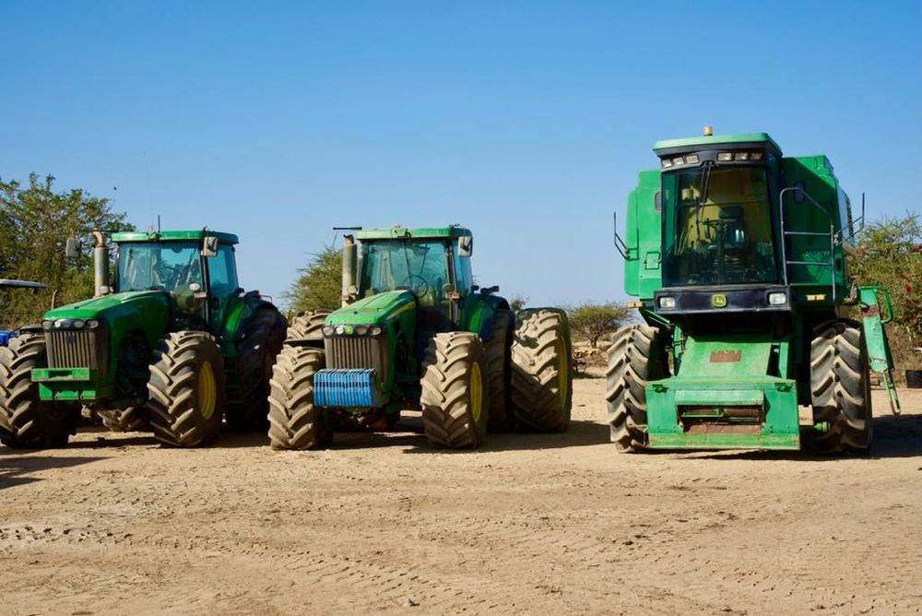 | 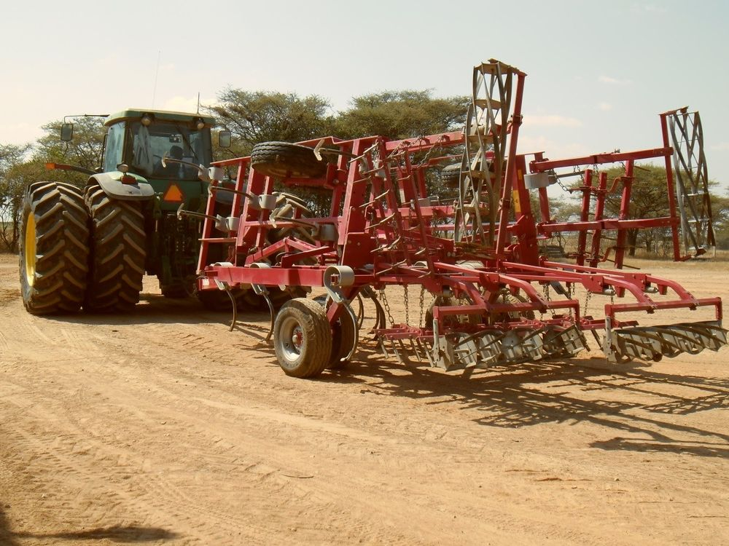

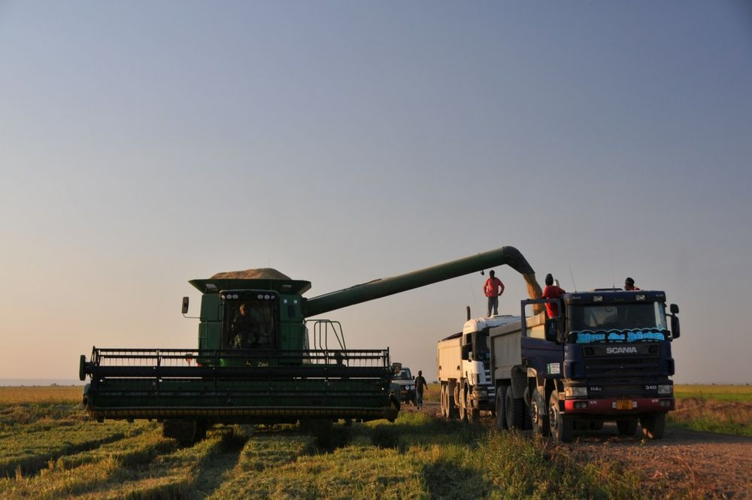 | 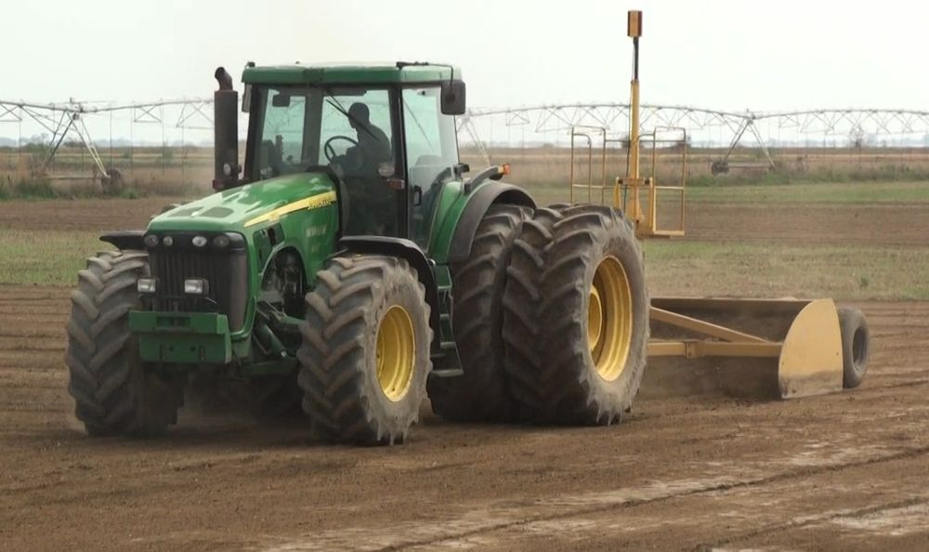

Water Management
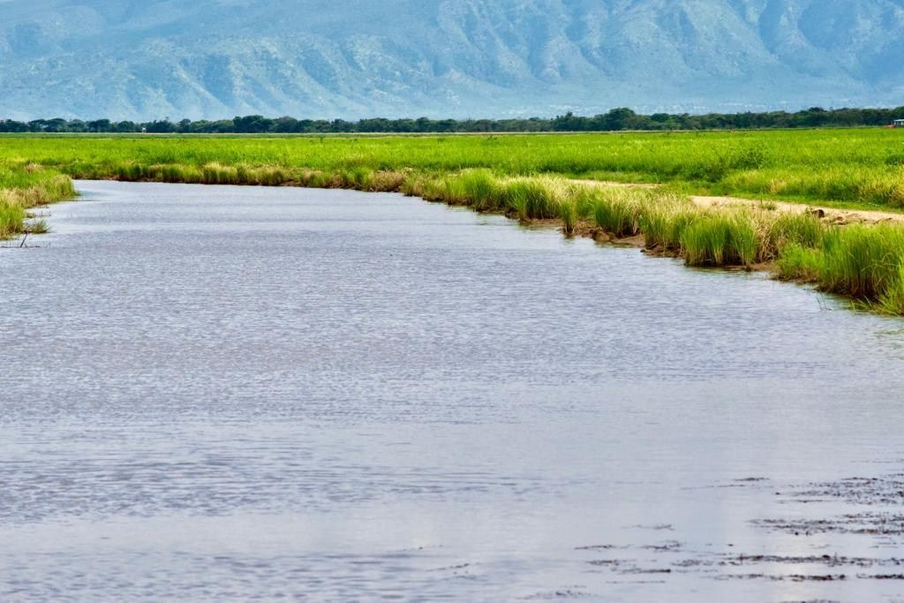
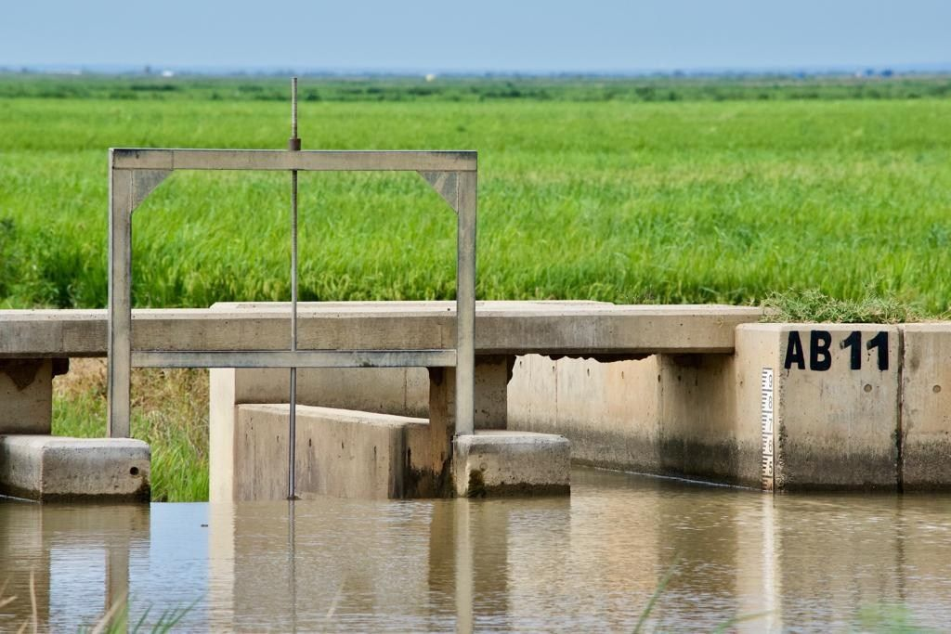
The image illustrates the robust water management infrastructure established by KRPL, which ensures a continuous and reliable supply of irrigation water to the farm as well as to the surrounding communities. A key element of this system is the use of weir gates strategically positioned to regulate water flow. These gates enable precise control over the distribution of water from the main source, ensuring that the extensive network of irrigation canals is consistently supplied to meet the needs of 3,500 hectares of cultivated land. At the same time, KRPL has prioritized community well-being by guaranteeing that water remains available for domestic and livelihood uses for nearby villages.
In addition to physical infrastructure, KRPL has integrated digital communication and operational planning into its farming model. The team has introduced a digitized push notification system that proactively informs farmers about upcoming agricultural activities well in advance. Through this system, farmers receive timely alerts regarding scheduled irrigation cycles, fertilizer applications, and pesticide spraying, enabling them to prepare accordingly. This structured and technology-enabled communication helps reduce delays, improve coordination, and ensure that critical farming operations are carried out efficiently and uniformly across all plots.

Nursery Preparation
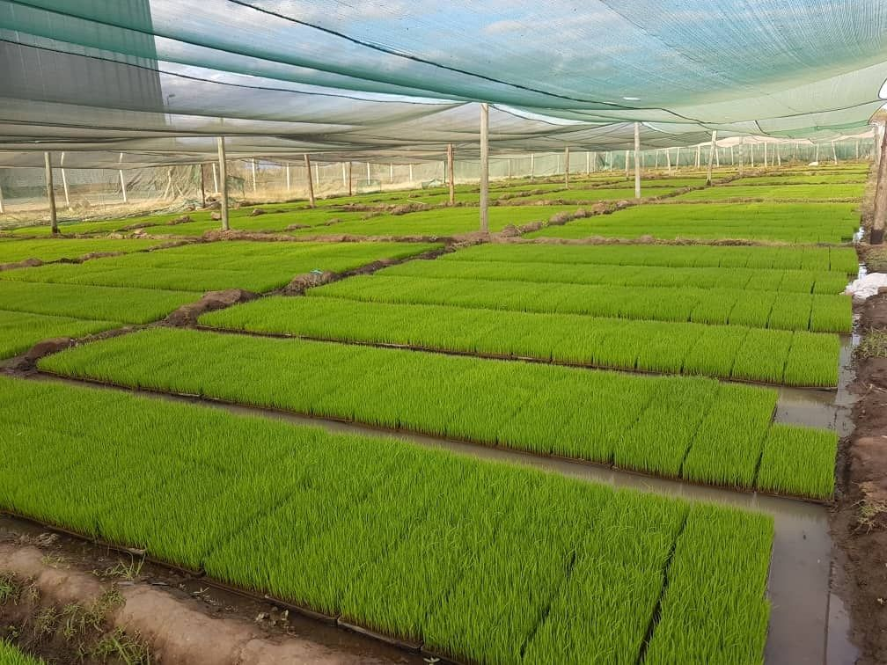
KRPL has mechanical transplanting which was adopted over a 6-hectare plot using 250 kg of Saro 5 seed. The seed was first sown in a 500 square meter area and nurtured for 25 days in 1,600 trays, ensuring uniform and vigorous seedling growth. This process enabled precise and efficient planting, minimizing transplant shock and supporting better crop management. The mechanized approach not only speeds up transplanting and reduces labor costs, but also improves plant spacing for optimal water and nutrient use. Ultimately, this method is linked to higher yields and healthier crops, highlighting its effectiveness in modern rice cultivation.

Rice Milling Extraction
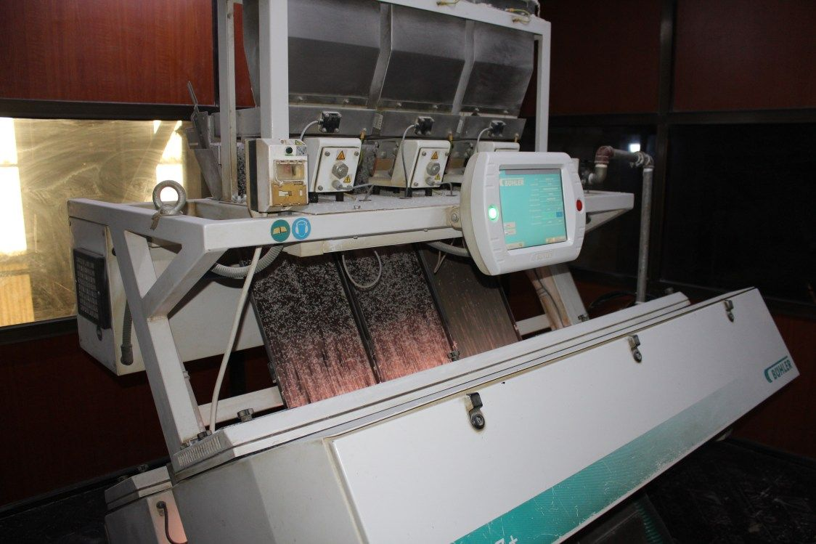
For paddy milled: 100 kg
Paddy input | 100.00 kg | Percentage
Rice standard (20% broken) | 61.28 kg | 61.28%
Broken | 4.33 kg | 4.33%
Fines | 3.37 kg | 3.37%
Bran | 7.25 kg | 7.25%
Total production | 76.23 kg | 76.23%
Rice waste, husk and dust | 23.77 kg | 23.77%
Total output | 100.00 kg | 100.00%

KRPL’s Outgrowers Scheme
- The participation fee of 1 plot for the outgrowers is USD 1400 and they are given 660 kg of seeds for 1 plot.
- Sowing Period: November to January AND Harvest Period: April to July Outgrowers were given specific planting schedule to support them with desired outcome.
- KRPL provides quality agri-input as per the requirement designed by their agronomist team during the cultivation cycle.
- KRPL also buys back the paddy from the outgrowers and support them with weigh scale and transport to the Rice Mill of KRPL.
- The earning by selling paddy to KRPL is adjusted against the inputs purchased by the outgrowers.
- KRPL sales the processed paddy as Kapunga Rice brand wherein 80% of the sales is domestic and remaining 20% is exports to the nearby east African countries (Malawi, Kenya, Zambia, Uganda, etc.).
- KRPL has made sure that there are Women Farmer Leaders to lead women farmers in supporting them to uplift their life and income through this project. KRPL has 76 women farmers associated in this project.
- KRPL gives opportunity to African people in being workers for this project and in the peak season, almost 3000 workers per day is required for all these plots. Average earning for a labor per season is USD 4 for working in 20X20 m plot size.
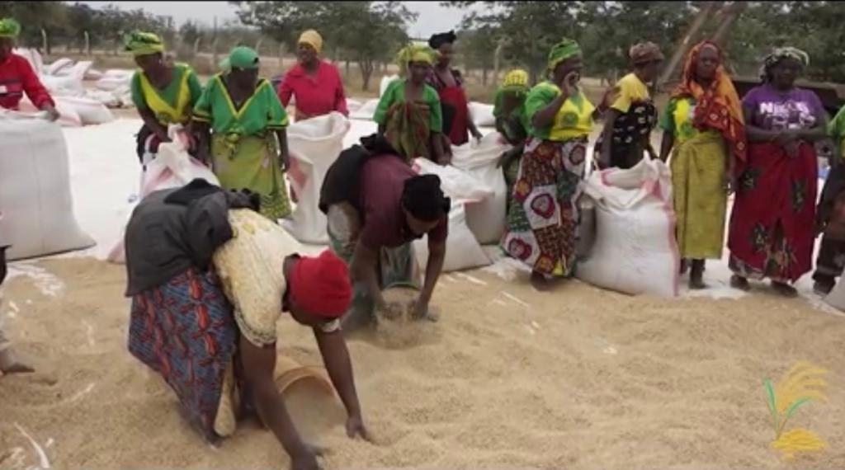

Rice Production Value Chain
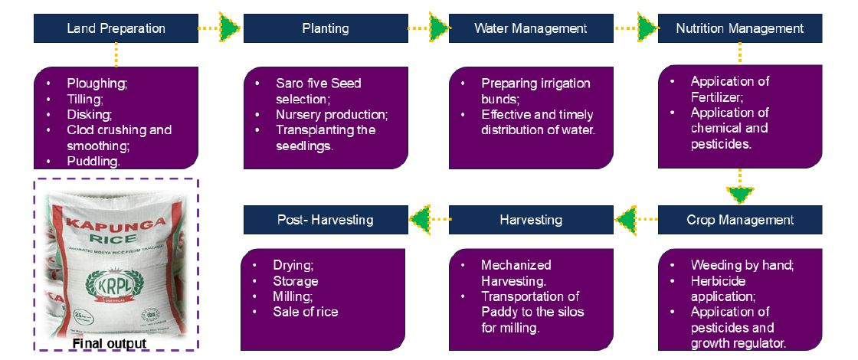
KRPL execution team had mase sure that each of the above activity will surely require to hand hold the farmers to achieve the desired target. So, their operational and agronomist teams worked tirelessly with the farmers at each and every stage mentioned above to make sure there is no gap in doing desired activity as decided in the form of Good Agricultural Practices (GAP). When the fertilizers or the chemical pesticides were required, KRPL team urged to have a standard quality products keeping in mind only one goal of higher and better yields along with better prices for farmers. That is why KRPL has also partnered with other inputs providers along with ETG’s best product supplies.
To create a local and international market keeping exports in mind, KRPL very precisely planned the final product packaging with different SKUs.
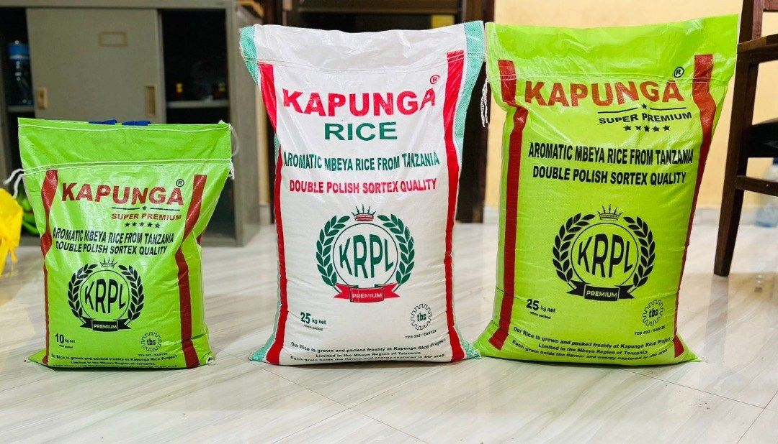

Yield & Impact
Through adoption of advanced technologies, yields significantly improved compared to baseline production (From 800 kg/ha to 7 ton/ha).
Mechanization with tractors, harvesters, and irrigation systems increased efficiency. KRPL increased their per day earning from average USD 1 to USD 15.
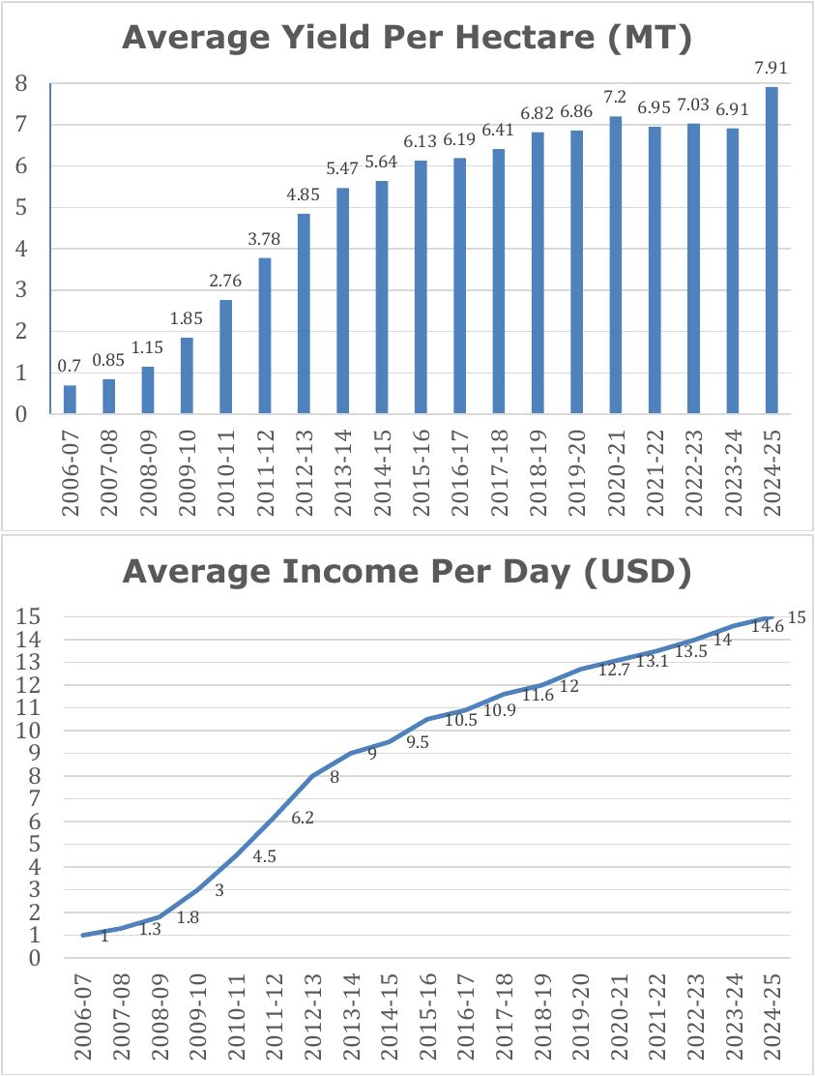

Community Transformation
Before 2006, Kapunga and its neighboring hamlets were living in near isolation, cut off from the benefits of modern development. The area was marked by severe neglect — no proper roads, no electricity, and limited access to clean water. People often had to walk long distances for their daily needs, whether to fetch water, reach markets, or access basic healthcare and education. The lack of essential infrastructure made life extremely difficult, trapping the community in a cycle of poverty and underdevelopment.
The establishment of Kapunga Rice Project Limited (KRPL) became a turning point in this story. From its very inception, KRPL was not just about growing rice — it was about growing opportunities. The project brought life back to the region by creating a foundation for economic revival and social progress.
Through its operations, KRPL generated both direct and indirect employment opportunities for local residents, empowering hundreds of families who had previously struggled to find stable livelihoods.
Recognizing that true development extends beyond employment, KRPL launched several training and skill development programs targeting local youth and women. These initiatives equipped them with the knowledge and confidence to participate actively in modern agriculture, entrepreneurship, and service sectors. Over time, many individuals leveraged these skills to start their own small businesses — from local shops and motels to rice mills and storage godowns — fostering a vibrant rural economy that continues to expand organically around the project.
KRPL’s community-oriented approach also placed strong emphasis on social infrastructure development. The company built a fully equipped hospital that now serves over 18,000 inhabitants across Kapunga and nearby villages, ensuring access to reliable healthcare where none existed before. Additionally, it established a school providing education to more than 400 students, creating opportunities for the next generation to learn, grow, and dream beyond the limits once imposed by poverty.
Beyond these contributions, KRPL also took up community rehabilitation initiatives, including the complete restoration of the Chimala Police Station and the construction of a borewell for drinking water, providing safe water access to local households. What began as a modest project with fewer than 50 farmers has now grown into a strong network of over 300 farmers, reflecting the deep trust and participation KRPL has built within the community. The transformation extended to infrastructure as well — the development of roads in and around Kapunga, initiated to support the project’s logistics, has in turn revolutionized mobility for the villagers.

Hospital
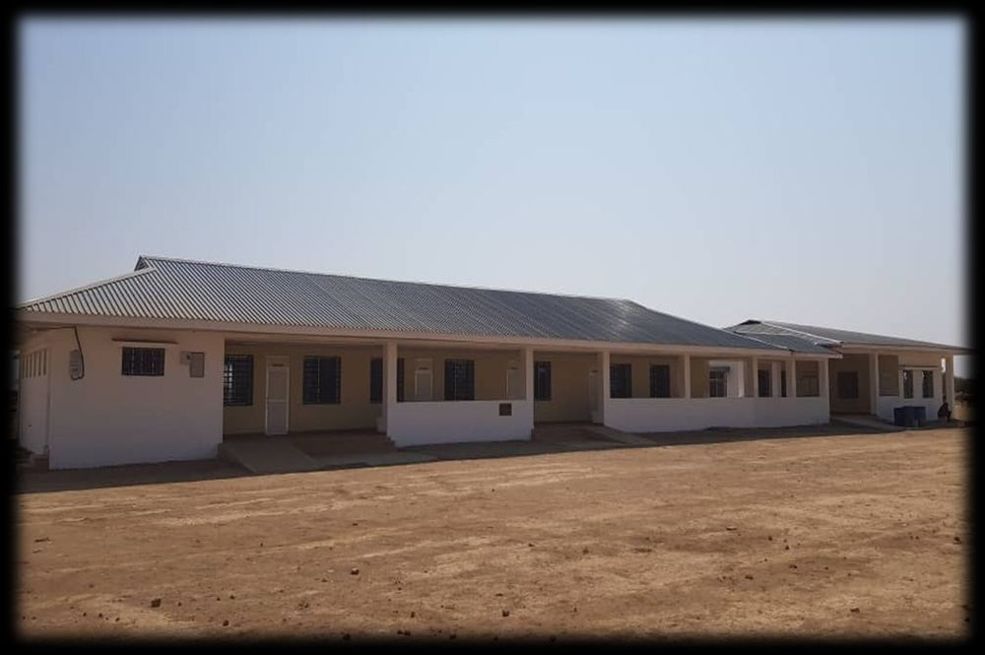 | 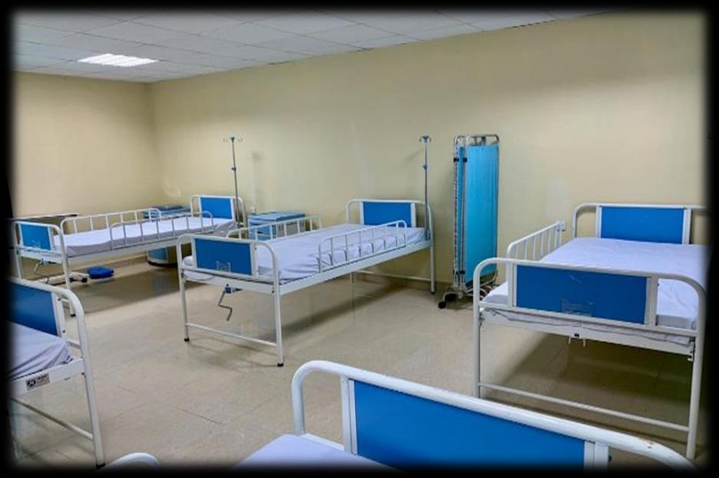

School
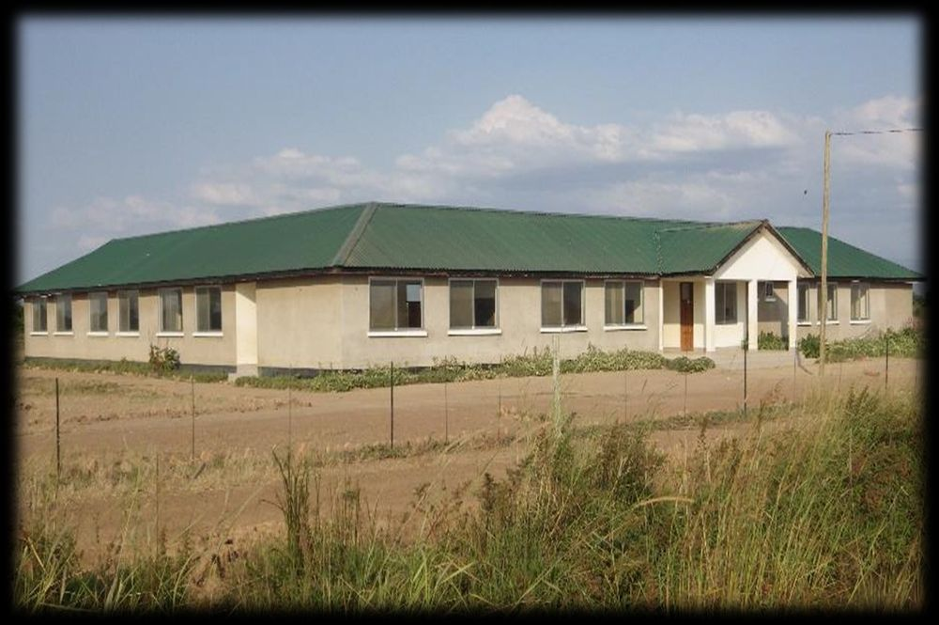 | 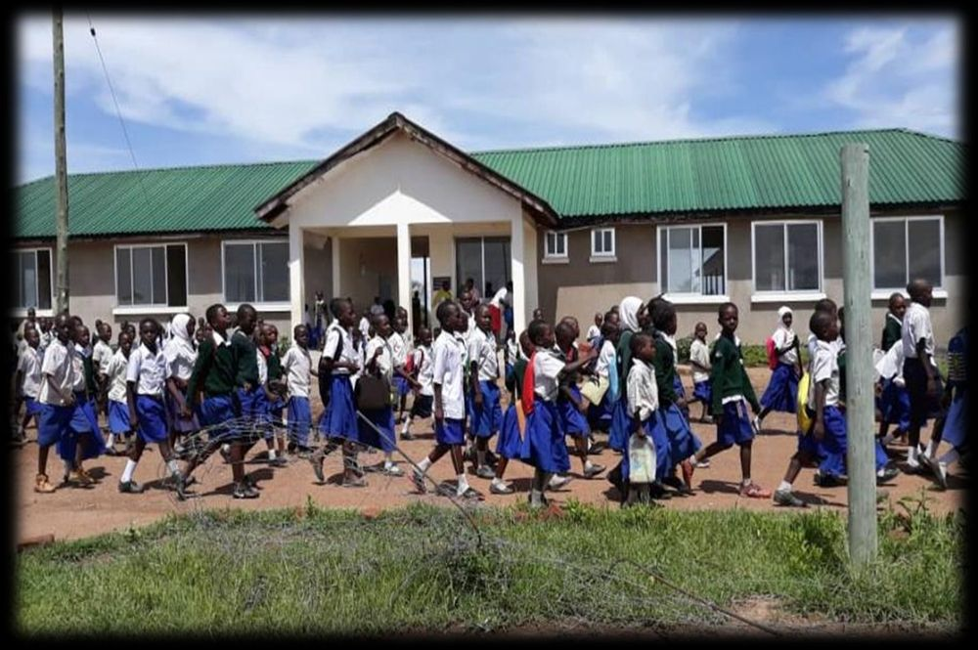

Police Station and Borewell
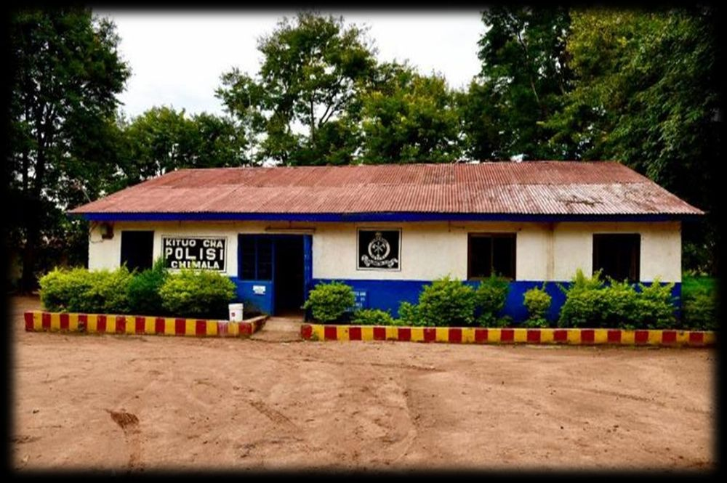 | 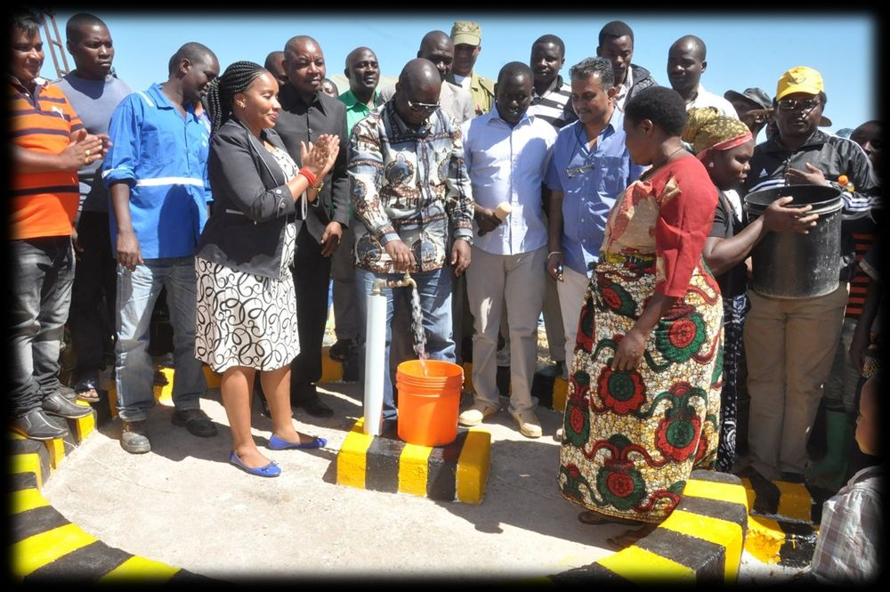

Voices from the Ground

Stumai Tandila
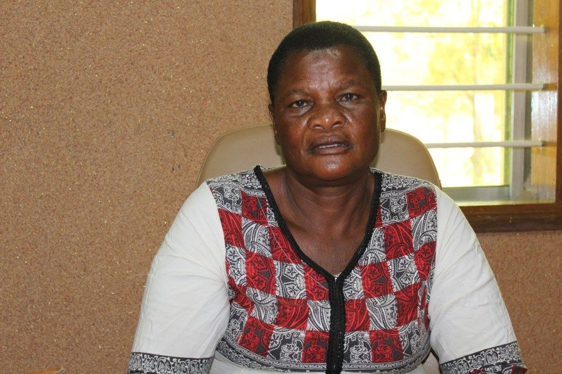
She joined the Kapunga Rice Project in 2008, when average yields in the region were still modest. Through consistent participation in the project’s training programs and adoption of improved farming practices, she steadily transformed her agricultural performance. Her yields rose from 3.3 tons per hectare at the start to an impressive 8 tons per hectare, marking a remarkable journey of progress. On one of her best-performing plots, she even achieved 10 tons per hectare, making her the highest-yielding woman farmer involved in the entire project — a milestone that highlights both her dedication and the effectiveness of the support she received. This agricultural success translated into tangible improvements in her personal and family life. With her increased income, she was able to build a house in Chimala, providing her family with a stable and improved living environment. Encouraged by her progress, she is now constructing a second house in Mapogoro, reflecting her growing economic confidence and aspirations for the future.
Her achievements also extended to her children’s education. The additional income from her farming allowed her to enroll her children in a private school, ensuring they receive better educational opportunities than were previously available to her family. Recognizing her potential and reliability, KRPL supported her in securing a loan of USD 12,000 from CRDB Bank. This financial assistance enabled her to further invest in her farming operations and household development, reinforcing her as a role model for other farmers in the community.

Nuhu Mdeka
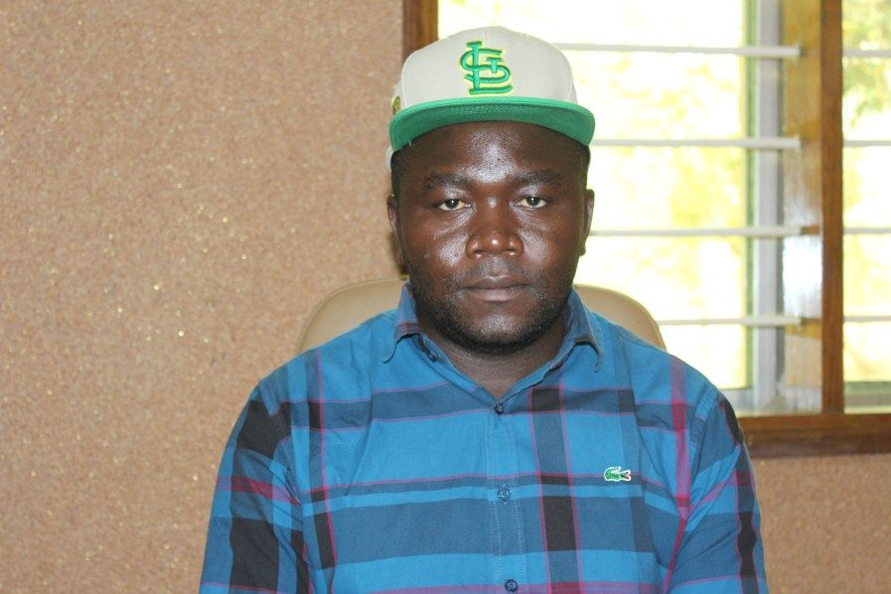
He expressed his deep gratitude to KRPL for giving him the opportunity to participate in the project when it was first launched in 2019. At that time, he was introduced to improved farming practices, irrigation facilities, and highquality inputs under the Outgrower Scheme. His very first season with KRPL turned out to be a transformative experience, as he achieved an impressive yield of 8 tons per hectare, far exceeding what he had been able to produce earlier through traditional rain-fed methods.
Encouraged by this success, he decided to expand his involvement in the project over the following years. Today, he cultivates 15 plots under the scheme, and his growing expertise and adoption of modern techniques have enabled him to diversify his operations. He now owns a rice mill and a storage godown in Kapunga, which allows him not only to process his harvest efficiently but also to add value and manage his produce more strategically.
Through consistent hard work, adoption of Good Agricultural Practices (GAP), and leveraging KRPL’s support systems, he has emerged as one of the leading farmers in the region. His achievements culminated in earning the distinction of being the highest yield achiever, recording an extraordinary 12.61 tons per hectare — a benchmark for other farmers in the Outgrower network. His journey stands as a testament to how access to technology, irrigation, and structured support can empower farmers to scale their operations and significantly improve their livelihoods.

Women Farmers of Kapunga
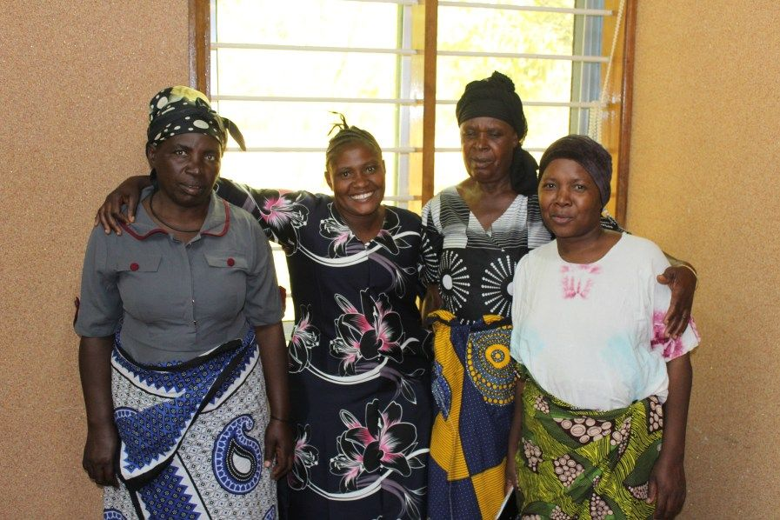
A remarkable example of the Kapunga project’s impact can be seen in the journey of a group of 12 women farmers who joined the Kapunga farm in 2019. At the time, they were struggling with limited income opportunities, barely earning enough to meet their families’ daily needs. Access to resources, training, and land was minimal, leaving them dependent on irregular and lowpaying activities that offered little hope for improvement. Upon joining the Outgrower Scheme at Kapunga, these women were allocated farmland and received support in the form of improved seed varieties, training in modern agricultural techniques, and access to irrigation infrastructure. Over time, they applied these new skills effectively, adopting Good Agricultural Practices (GAP) and integrating modern farming tools into their operations. Their hard work and the support system provided by KRPL led to a significant increase in productivity. Yields improved from an average of 6 tons per hectare to 7.5 tons per hectare, demonstrating not only the potential of the land but also their growing expertise and commitment. This increase in production translated directly into higher incomes, which brought about meaningful changes in their personal lives. For the first time, they were able to enroll their children in private schools, ensuring access to better education and opening new opportunities for the next generation.
Encouraged by their success and with growing confidence, the group is now requesting an additional plot of land to expand their farming operations. Their goal is to further increase their productivity and income, reinforcing the positive cycle of empowerment, financial stability, and community development that the Kapunga project seeks to foster.

Nuhu Sabai Nimrad
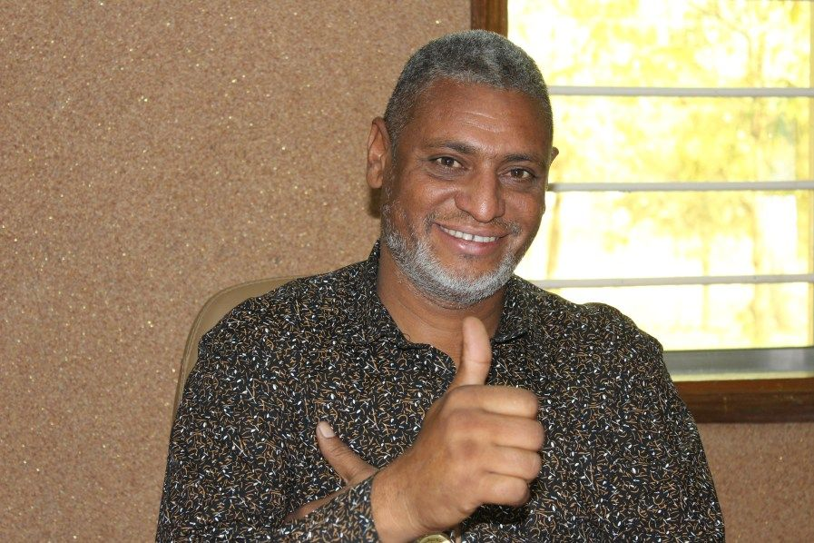
He joined the Kapunga Rice Project in 2017, starting his journey with just two plots under cultivation. Over the years, through consistent effort, strategic reinvestment, and the support of the project’s ecosystem, he has expanded his operations to 10 plots, reflecting both his entrepreneurial mindset and confidence in the model. Today, he manages a team of eight workers, demonstrating how participation in the project has created not only personal growth but also local employment opportunities.
Since joining the project, he has achieved a remarkable 22% increase in yield, a testament to the impact of improved seeds, irrigation facilities, and modern farming practices introduced through the Kapunga scheme. Although he owns 30 acres of land near his residence, he prefers to farm at Kapunga, where the combination of reliable irrigation, access to modern equipment, and structured support systems allows him to earn significantly higher returns than on his home farm.
The improved income from Kapunga farming has also enabled him to diversify and invest in downstream activities. He has established his own rice mill and storage godown, allowing him to process and store produce efficiently, thereby capturing greater value from the rice value chain. Recognizing his growing scale and reliability, NMB Bank extended him a loan of USD 200,000, which he used to purchase vehicles and farming equipment to further strengthen his operations. His journey illustrates how structured agricultural interventions, when combined with entrepreneurial initiative, can transform small farmers into successful agribusiness operators.

Simple Adam
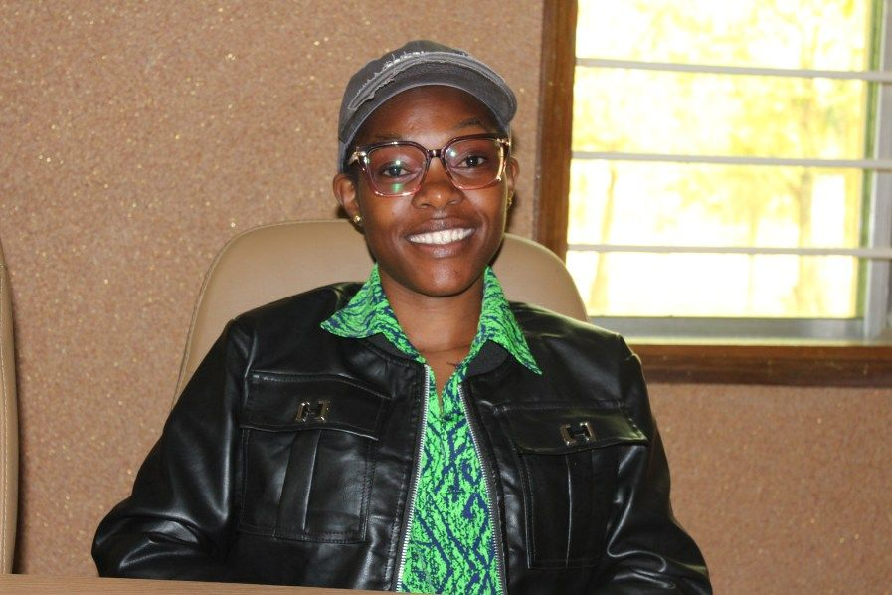
She joined the Kapunga Rice Project in 2019, beginning her journey with the responsibility of managing two agricultural plots, supported by a team of two workers. From the very beginning, she embraced modern farming techniques and the structured systems introduced by KRPL. Her dedication and willingness to adapt to improved practices quickly began to yield results.
Since joining, she has consistently achieved average yields of 8–9 tons per hectare, a remarkable improvement compared to the traditional yields in the region. This steady increase in productivity has not only enhanced her agricultural performance but has also transformed her personal and family life. With the significant rise in her earnings, she has been able to enroll her children in a private school, ensuring they receive quality education and better future opportunities. She has also constructed a new home and opened a small shop in Kapunga, diversifying her household income and improving her family’s standard of living.
Before joining the Kapunga farm, she earned approximately USD 160 per year in her previous government job, which barely covered basic expenses. Today, through her work with the project, her annual income has risen to around USD 16,000, a hundredfold increase that has brought financial independence, security, and a sense of empowerment. Her story stands as a powerful example of how structured farming systems, modern technology, and farmer engagement can transform lives in rural communities.

Joseph Seleli
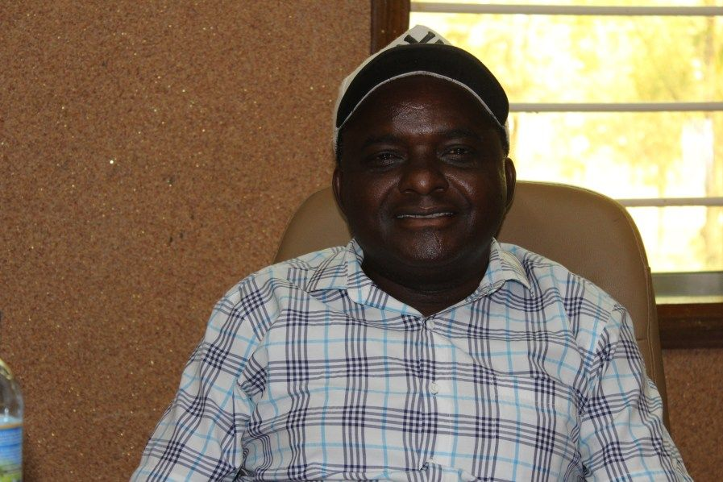
When he first joined the Kapunga Rice Project in 2009, his farming output stood at a modest 2 tons per hectare, reflecting the low productivity typical of the region at the time. Over the years, through a combination of dedicated effort, improved farming techniques, and the support provided by KRPL, he has steadily increased his yields. This year, his performance reached an impressive 11 tons per hectare, marking a remarkable transformation in both productivity and economic well-being.
He currently cultivates five plots of land, and this expansion, coupled with the surge in yields, has translated into an increase of nearly 60% in his overall earnings. This enhanced income has enabled him to make tangible improvements to his quality of life. With the profits generated from his farming activities, he has been able to build a house for his family, purchase an additional plot of land, and establish a small shop in Kapunga, diversifying his income sources and creating a more stable financial future.
KRPL has played a pivotal role in facilitating this growth story. Recognizing his potential and commitment, the project supported him in securing a loan of USD 12,000 from CRDB Bank. This financing enabled him to invest in critical farming inputs and assets, further improving his operational capacity and productivity. His journey is a powerful testament to how access to improved technology, training, and financial support can transform smallholder farmers into successful agri-entrepreneurs, creating ripple effects of prosperity within the community.

Gervas Mwinuka
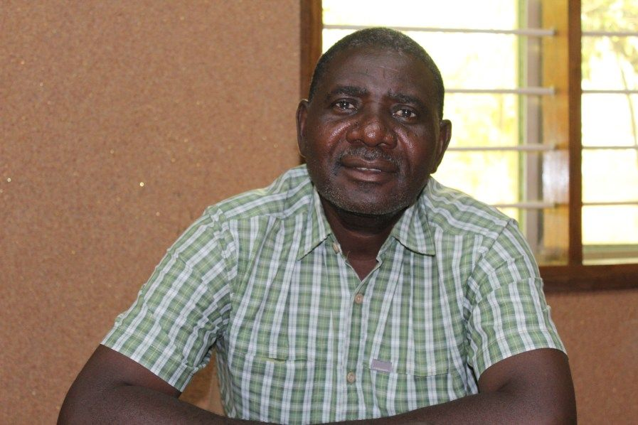
He began his journey with just a single plot in 2007, entering the Kapunga rice farming initiative with cautious optimism. Over the years, through dedication and the structured support of the KRPL outgrower model, his farming operations have grown steadily. Encouraged by the success of his initial efforts, he has since acquired an additional plot, effectively doubled his cultivated area and expanded his capacity to produce rice at a commercial scale.
The transformation in his productivity has been remarkable. From an initial yield of just 3 tons per hectare, his output has soared to 10 tons per hectare this year, reflecting the impact of modern farming practices, access to improved inputs, and better water and mechanization systems facilitated through KRPL’s program. This dramatic yield improvement has not only enhanced his income but also significantly elevated his family’s quality of life. For him, the most meaningful outcome of joining the Kapunga project goes beyond just increased production. The financial stability generated through higher yields enabled him to send his son to India for higher education, a personal milestone he deeply values and attributes to his engagement with the project.
To further build his farming capacity, KRPL supported him in securing a USD 20,000 loan from the Tanzania Agricultural Development Bank (TADB). This financing allowed him to purchase a tractor, giving him greater independence and efficiency in managing his fields. Looking ahead, he is determined to continue this path of growth and self-reliance—his next ambition is to purchase a combine harvester, which will enable him to harvest on his own and further expand his operational capabilities.

Suleiman Kapalamba
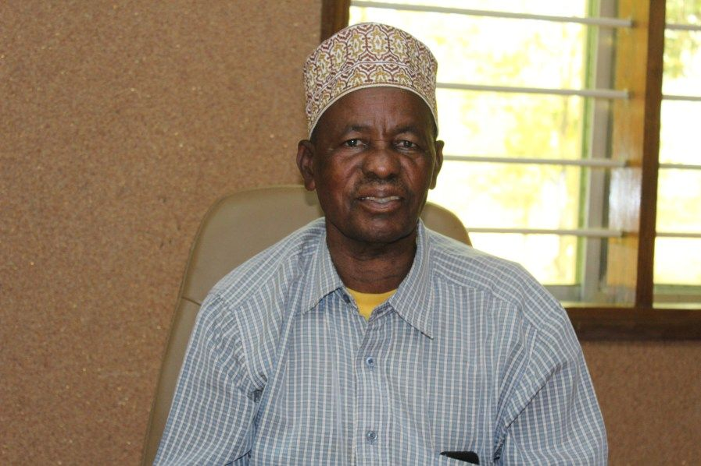
He began his journey with KRPL in 2018, starting modestly with the cultivation of just one plot of land. Over the years, through consistent effort, adoption of improved practices, and active participation in the Kapunga rice farming ecosystem, his involvement has grown steadily. Today, he manages four plots, marking a significant expansion in his farming operations. A crucial factor in this growth has been the support and active involvement of his son, who has joined him in farming, making it a multi-generational family enterprise.
Between 2018 and 2025, his yields have increased by 25%, a clear indicator of the positive impact of KRPL’s interventions, including access to quality inputs, irrigation, and modern farming technologies. This increase in productivity has translated into substantial improvements in household income, enabling him to make important personal investments. With the earnings generated from his Kapunga farm, he has been able to purchase his first car and construct a family home, both of which stand as tangible symbols of his economic progress and improved quality of life.
Financial empowerment has also played a pivotal role in his journey. With KRPL’s guidance and support, he has been able to access formal credit from NMB Bank multiple times, starting with a loan of USD 7,000 and gradually increasing to USD 20,000. This progressive increase in credit reflects both his growing capacity to manage larger farming operations and the trust he has built with financial institutions over time. His story is a powerful example of how structured support, access to resources, and commitment can together drive meaningful economic transformation for smallholder farmers.

Voices from the Stakeholders

Edgar Gabriel Mbepera - Head Master of Kapunga B School
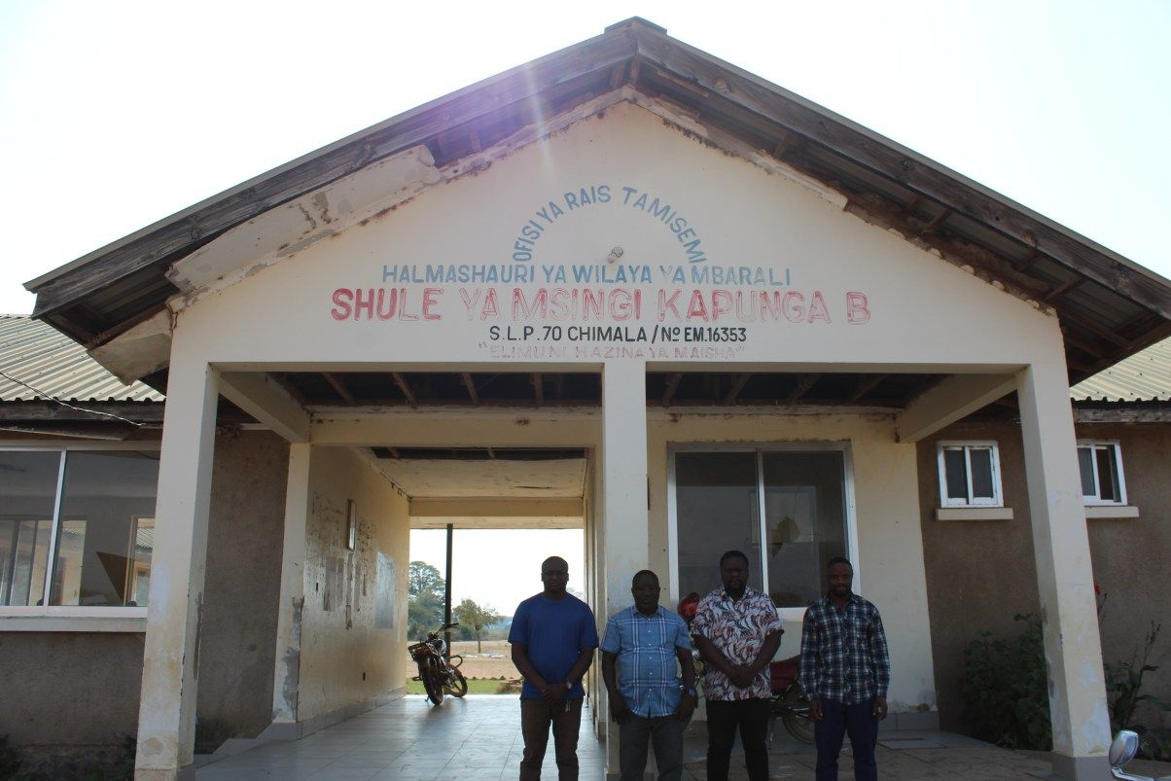
He has served as the headmaster since 2018, overseeing a thriving school built on seven acres of land. The Kapunga Rice Project has made a significant impact in the area by making education much more accessible to local children, who previously had to walk five kilometers for school but now only travel up to three kilometers. This school now serves four hamlets in Kapunga village, drawing in 406 students from pre-primary to Standard 7. One of its greatest strengths is that children actively help their parents learn, fostering a powerful culture of education in the community. The surrounding villages have transformed into vibrant centers of trade and opportunity, with families increasingly investing in their children’s education. Seasonal employment opportunities linked to the rice project have also improved livelihoods for thousands, further supporting family stability and children’s attendance. Many parents, empowered by the progress in the village, have begun to participate themselves in literacy programs, and the overall confidence in the community has grown as a result. This school stands as a testament to how local partnerships and agricultural development contribute to the brighter future of Kapunga’s youth.

Mussa Charles Kihwelo – Medical Officer at the Hospital
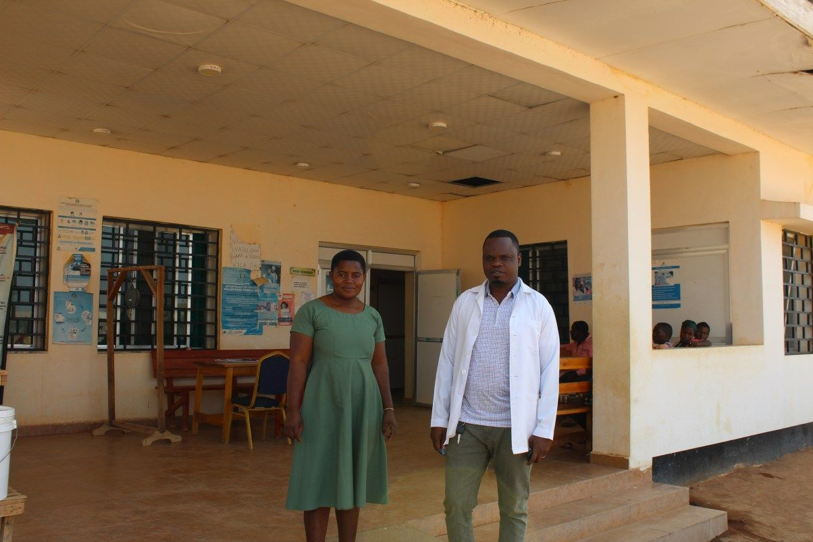
The hospital, established in 2020 on a 7.5-acre site, has become an essential lifeline for the local population. By providing care to around 18,000 people across seven nearby hamlets, it has transformed access to health services that were previously out of reach. With its 25-bed facility, the hospital now safely manages an average of 56 deliveries each month, making maternal care much more accessible for families. Before this hospital was built, residents had to travel 26 kilometers to Chimala for even minor operations and childbirth, a journey that was often challenging and costly. The hospital’s presence not only offers medical assistance closer to home, but also brings comfort, security, and improved health outcomes to the entire community. It has become like a center for health education, teaching families about disease prevention and hygiene practices. This has led to a noticeable decrease in preventable illnesses and improved overall well-being. The hospital’s dedicated health staff are respected community members, known for their approachable care and reliability.

Dickson Luvanda – Chief of the Chimala Police Station
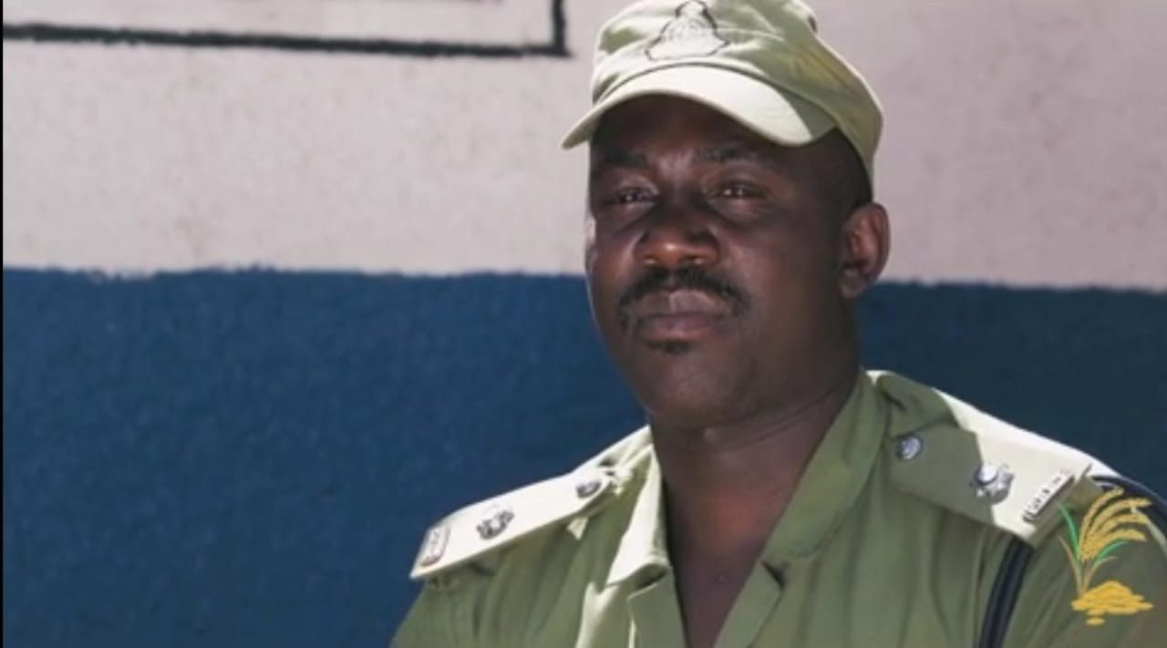
He and on behalf of the police force of Mbarali district, would like to express their gratitude towards the whole management of Kapunga Rice Project for the great help they have done to them by rehabilitating their police station with doors, windows, toilets, and color work. This police station which caters to almost 9-10 thousand people in 4 wards of Mbarali district.

Elias Makile – Chairman of Mapogoro Village
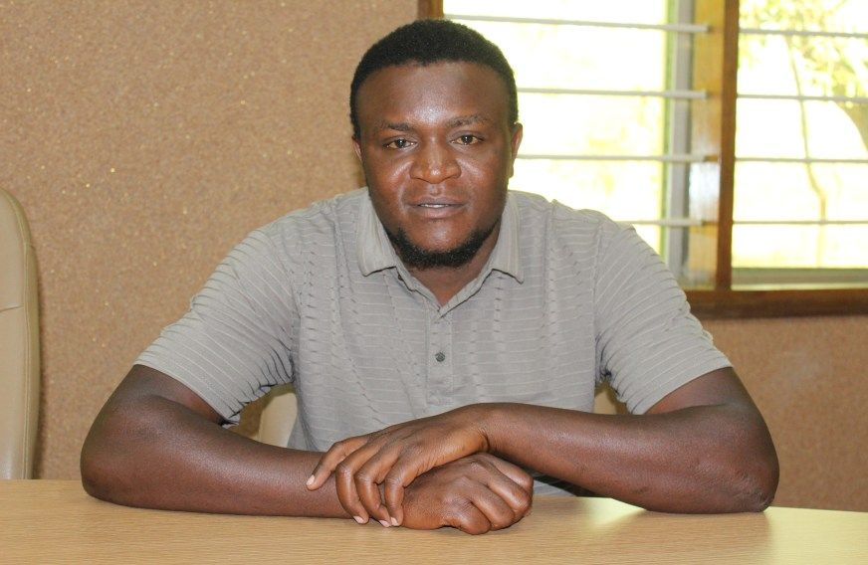
The Kapunga Rice Project has empowered thousands of farmers to increase their incomes through improved farming techniques. It has also spurred local entrepreneurship, with many people opening shops and businesses that support their families financially. The project contributed to building village roads, enhancing transport and connectivity. Importantly, it has enabled many families to afford private education for their children, reflecting the overall upliftment of the community's economic and social well-being.

Hamis S. Mbinga – Bank Manager at CRDB Bank
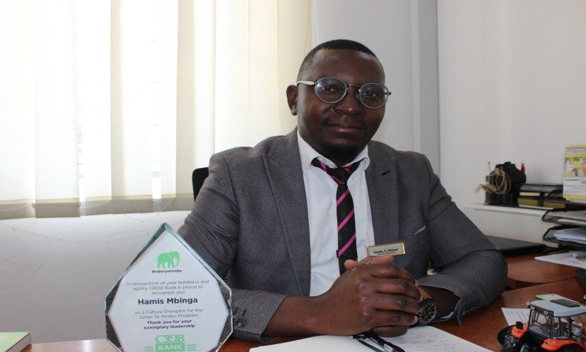
Since 2014, CRDB Bank has proudly partnered with Kapunga Rice Project Limited (KRPL) to support the transformation of rural farming communities through accessible and well-structured financial services. Over the years, this collaboration has enabled the bank to facilitate loans and financial assistance to more than 3,000 farmers, providing them with the necessary capital to invest in farms, agricultural inputs, and productive assets. These loans have been instrumental in helping farmers expand their cultivated areas, adopt modern farming techniques, and purchase essential equipment that boosts both productivity and profitability.
A defining feature of this partnership is CRDB’s flexible one-year repayment structure, which is well aligned with the agricultural cycle. This arrangement allows farmers to repay their loans after harvesting, when they have sufficient cash flow. The reliability and success of KRPL’s farming model have resulted in high repayment rates, reinforcing CRDB’s confidence in rural lending. By combining robust financial support with KRPL’s technological and operational excellence, the two institutions have created a model that strengthens both the agricultural sector and the rural financial ecosystem.
Beyond the farm, this partnership has had a multiplier effect on the local economy. As farmers’ incomes have grown, many have reinvested in their communities by starting small businesses such as shops, restaurants, and hotels, contributing to local employment and services. This broader economic activity has enhanced the resilience and vibrancy of rural communities in the Kapunga region. CRDB’s involvement has not only strengthened its position locally but also nationally. Thanks to this collaboration, CRDB ranks first in Mbarali District and an impressive fourth at the national level in loan collection performance.

Emmanuel Olotui – Assistant Manager at NMB Bank
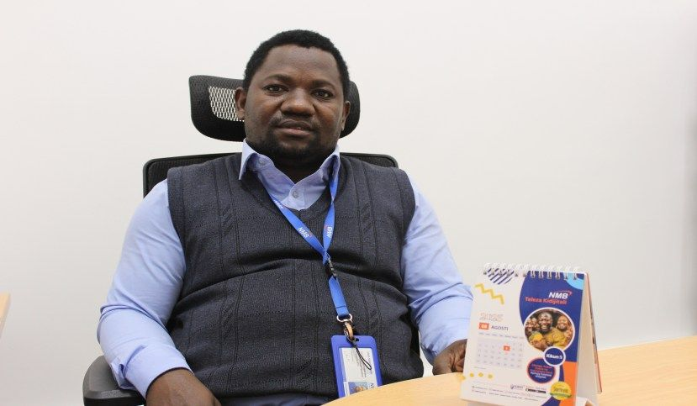
NMB Bank has played a pivotal role as a long-term financial partner of KRPL, supporting the transformation of the Kapunga rice farming ecosystem. Since July 2014, NMB has been working closely with KRPL to enable farmers to access much-needed financing that fuels both agricultural productivity and livelihood improvements. Over the years, the bank has extended its services to more than 1,200 farmers, providing them with targeted financial products that address their specific needs within the rice value chain.
Through this partnership, NMB offers loan packages starting from USD 2,000, which serve as critical capital for smallholder farmers. These funds are typically used for the purchase of essential farm assets, such as equipment and improved inputs, as well as to adopt modern farming practices that boost productivity. The availability of accessible and affordable credit has empowered farmers to make timely investments in their fields, bridging a key gap that often limits smallholder growth.
In addition to providing credit, NMB has collaborated with leading crop insurance companies to introduce comprehensive risk mitigation solutions.
These insurance products are designed to shield farmers against climaterelated risks, including droughts, floods, and crop diseases, which are increasingly common due to changing climatic conditions. By combining financial access with climate risk protection, NMB and KRPL have created a holistic support framework that enables farmers not only to expand their operations but also to do so with a greater sense of security and resilience. This integrated approach has strengthened farmer confidence, improved repayment behavior, and created a more stable agricultural financing ecosystem, ensuring that the partnership contributes meaningfully to the longterm sustainability of rice farming in the Kapunga region.

Comparative with other Countries and Projects
GIZ along with private partners implemented Better Rice Initiative Asia (BRIA) across South-East Asia countries like Indonesia, Philippines, Vietnam, and Thailand in phases from 2013-2017 and 2018-2022 by leveraging technology and by engaging with more than 50,000 farmers where on an average income of increase was more than 20%. Such a huge project like BRIA with heavy investments, partners and technology was able to increase the existing yield in these countries at an average of 40%.
The Competitive African Rice Initiative (CARI), launched in 2013, has operated in Nigeria, Burkina Faso, Tanzania, and previously Ghana, with the mission to improve climate-smart, smallholder rice production and drive collaboration between farmers and the private sector. By the end of Phase II in 2021, CARI trained over 195,000 smallholder farmers in Good Agricultural Practices and more than 172,000 in Farmer Business School programs, with upwards of 143,000 farmers integrated into the rice value chain through partnerships with off-takers. The initiative resulted in irrigated yield gains of 185%.
The Regional Rice Value Chain Development Project (RRVCDP), implemented in The Gambia, Senegal, Sierra Leone, Guinea (Conakry), and Niger, targets over 87,000 smallholder farmers, including 40,000 women and youth in The Gambia and 7,000 in Sierra Leone. The project has increased rice yields by 30–50% and improved farmers’ incomes per hectare by up to 69%.
KRPL’s farmers have achieved an average yield of 7.2 t/ha with this model in comparison of other Rice growing countries like Thailand at 3 t/ha, Philippines at 3.95 t/ha, Indonesia at 5.2 t/ha, and Vietnam at 5.69 t/ha. KRPL had also outclassed the average yield of Mbeya region as well as Tanzania by far.
Compared to such projects or initiatives, KRPL has managed to increase the yield up to 800% of its farmers and almost 1400% increase in the per day income. KRPL has achieved this yield increase in the Kapunga region by working closely with 300+ farmers. Along with improving farming income, KRPL has made sure that the community benefits (by preparing Hospital, School, Roads, Borewell, etc.) for making people self-sufficient which should be the aim to start such type of projects.
Understanding Africa makes you work better in Africa, KRPL has been able to achieve that under leadership of Mahesh Patel, a visionary born in Africa working for Africa, and who understands Africa!!

Recognition
The Kapunga Rice Project has received high-level national and international recognition for its transformative work in sustainable agriculture and rural development. One of the most notable visits was by Her Excellency, President of the United Republic of Tanzania, Mama Samia Suluhu Hassan, who personally toured the Kapunga farm. During her visit, the President praised the farm’s unwavering commitment to sustainable agricultural practices and its substantial contribution to the local economy. She interacted warmly with villagers and participating farmers, acknowledging the remarkable progress they had achieved through their active involvement in the Outgrowers Scheme. Her Excellency highlighted how the adoption of innovative farming techniques, improved seed varieties, and structured irrigation practices had empowered local communities, increased productivity, and set a strong example for agricultural transformation in the country.
The farm has also hosted a number of distinguished international dignitaries and development partners, further underlining the significance of the Kapunga model. Among the visitors was Mr. Roeland Van de Geer, the former European Union Ambassador to Tanzania, who expressed deep appreciation for the scale and organization of the farming system. Similarly, His Majesty King Imwiko Lubosi of Zambia and his entourage visited the farm to understand firsthand how the Outgrowers Scheme had been implemented. Their interest reflected the growing recognition of Kapunga as a model for scalable, inclusive, and high-yield rice cultivation that could inspire similar initiatives across the region. Additionally, senior officials from DFID (UK Department for International Development) and AgDevCo undertook visits to study the operational and developmental aspects of the project. They were particularly impressed by the seamless integration of smallholder farmers with modern commercial agriculture, the clear improvements in yield, and the measurable rise in farmer incomes. Across all these visits, the common theme was admiration for how effectively the Outgrowers Scheme had been structured, supported, and executed, turning Kapunga into a thriving agricultural hub and a benchmark for future rural development initiatives.
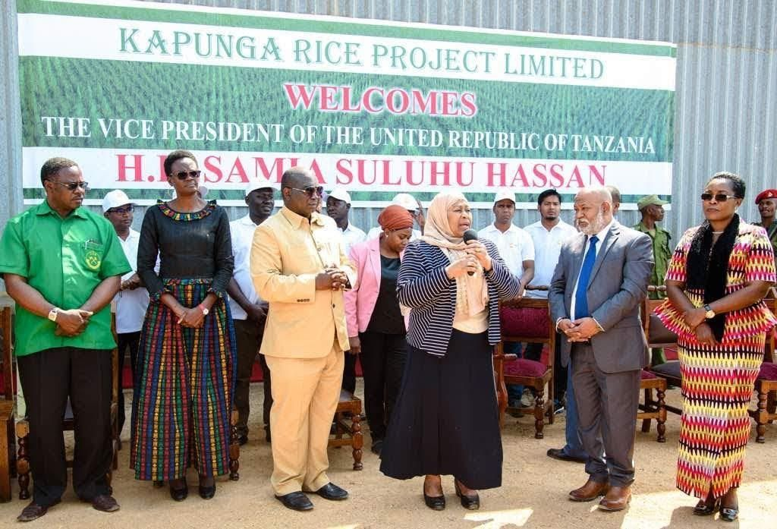

Lessons Learned
Achieving sustained success in African agriculture is not a quick or onedimensional effort; it requires a deep, nuanced understanding of local realities combined with a long-term strategic commitment. While the continent possesses vast tracts of fertile, arable land, these natural advantages are often offset by financial limitations, inadequate infrastructure, and limited access to affordable capital. Rural communities face persistent unemployment, which fuels migration to urban centers, draining rural areas of vital human resources and creating additional challenges for agricultural continuity. Moreover, the financial returns on large-scale agricultural investments typically take 7 to 8 years to materialize, requiring patience and stable, committed capital.
In this environment, effective on-ground execution becomes paramount.
Agricultural initiatives must be built on strong community participation and local ownership, ensuring that interventions are not externally imposed but instead are rooted in the social and economic fabric of the region. This localized, inclusive approach is the cornerstone of successful, sustainable development.
Projects such as KRPL serve as powerful examples of how this approach can yield transformative results. Through steady engagement over a decade, KRPL has demonstrated that patience, persistence, and collaboration with local communities can fundamentally reshape livelihoods. By combining technical innovation with social partnerships, the project underscores that sustainable agricultural development in Africa depends on consistent, hands-on involvement, tailored to the unique socio-economic conditions of each region. This long-term, embedded model provides a blueprint for how agricultural investments can thrive, deliver lasting impact, and catalyze rural transformation across the continent.

Future Vision
Looking ahead, KRPL plans to replicate this model, diversify into new crops like Pulses and Oilseeds. KRPL would like to invite those who are interested in investing in Africa for agriculture to the Kapunga Farm to see how a strong vision backed by precise execution and patience can create magic on the land. As African proverb says “Patience can cook a stone.” And of course, KRPL strongly supports “Seeing is Believing.”

Opportunity for India
India’s food security needs for pulses like tur and urad can be efficiently met in Africa, where yields require only 40% of the effort per hectare compared to India, supported by India’s strong agronomy expertise. With India dependent on cooking oil imports, African land offers huge potential—such as Tanzania’s Dodoma–Singida belt, where 1 million hectares could yield 4 million tons of sunflower in five years, producing about 2 million tons of oil, with soybean as a rotation crop. This model can be replicated in Zambia, Malawi, and Mozambique. Notably, while India’s highlands yield is up to 5 tons of paddy per hectare, Zanzibar farmers already achieve 7–8 tons and can cultivate two seasons due to superior land quality.

Call on Indian Government and Industry Leaders
Start thinking about agriculture differently, with a sense of urgency. Systemic support is required. Privileges need to be granted to smallholder farmers such that their lives can be improved. Support them with financial linkages through banks and microcredit entities in rural areas. Provide long-term financing solutions. Increase import duties. Allow for the creation of a vibrant value chain with processing outlets and factories.
“KRPL is sowing more than seeds—when intelligence meets the farmer’s hand, it nourishes more than crops—it sustains an ecosystem where families thrive, communities share, and a teacher and a doctor stand alongside the harvest.”

