Skid Violation — normalized

Header
Field | Value
Record type (group / type / subtype / category) | <gap>
Workflow name | Skid Violation Workflow
Workflow tasks | Inspection, Reinspection, Payment
Inspection group | <gap>
Inspection types | San Skid Inspection, San Skid Reinspection
Fee schedule | <gap>
ASI groups and fields | Billing Status (value: Billed; full value list <gap>); Appeal/Assessment flag field name <gap> (values: Under Appeal, Assessment Issued)
Child record types | Scattered Litter/Debris Request, City Property Cleanup Request
Scripts and batch jobs | ASA, IRSA, WTUA, PRA, nightly past-due batch

Table A — Inspection types and results
Inspection type | Result value | Result group | Schedules what | Offset + anchor | Assign to
San Skid Inspection | No Violation | — | None | — | —
San Skid Inspection | 1-4 cubic yards | — | San Skid Reinspection | +5 calendar days, anchor = inspection result date | <gap>
San Skid Inspection | 4+ cubic yards | — | San Skid Reinspection | +5 calendar days, anchor = inspection result date | <gap>
San Skid Inspection | Immediate – 1-4 cubic yards | — | San Skid Reinspection | Next business day, anchor = inspection result date | <gap>
San Skid Inspection | Immediate 4+ cubic yards | — | San Skid Reinspection | Next business day, anchor = inspection result date | <gap>
San Skid Inspection | Refer to DNS | — | None | — | —
San Skid Inspection | City Property – Illegal Dumping | — | None | — | —
San Skid Inspection | Duplicate | — | None | — | —
San Skid Inspection | Void | — | None | — | —
San Skid Reinspection | Collected | — | None | — | —
San Skid Reinspection | Done by Owner | — | None | — | —
San Skid Reinspection | Not Collected | — | None | — | —
Initial inspection isn’t a result-driven row. On record creation (and not flagged Duplicate), San Skid Inspection itself is scheduled for the next business day from record creation and assigned to the Sanitation Inspector role. Everything above governs results, not the record’s first inspection — see Table E.

Table B — Workflow status routing
Task | Status | Next task | Record disposition | Child record created
Inspection | No Violation | Terminal | Closed | None
Inspection | 1-4 cubic yards | Reinspection | In Progress | None
Inspection | 4+ cubic yards | Reinspection | In Progress | None
Inspection | Immediate – 1-4 cubic yards | Reinspection | In Progress | None
Inspection | Immediate 4+ cubic yards | Reinspection | In Progress | None
Inspection | Refer to DNS | <gap> | In Progress | Scattered Litter/Debris Request
Inspection | City Property – Illegal Dumping | <gap> | In Progress | City Property Cleanup Request
Inspection | Duplicate | Terminal | Closed | None
Inspection | Void | Terminal | Closed | None
Reinspection | Collected | Payment | In Progress | None
Reinspection | Done by Owner | Terminal | Closed | None
Reinspection | Not Collected | Terminal | Closed | None
Payment | Paid | Terminal | Closed | None
Payment | Past Due | Payment | In Progress | None
Payment | Appealed | <gap> | In Progress | None
Payment | Assessed | <gap> | In Progress | None
The diagram states “(Do not close record)” explicitly for both Appealed and Assessed — disposition is a stated fact here, not the derived default. Next task is still <gap>: “Under Appeal” and “Assessment Issued” read as status labels the diagram draws next to the status, not task names, and nothing routes onward from either.

Table C — Status side effects
Task | Status | Fee action | ASI update | Notification | Trigger type
Inspection | Duplicate | None | None | None | Event, if within 7 days; otherwise manual
Reinspection | Collected | Add + invoice | Billing Status = Billed | None | Event
Reinspection | Not Collected | None | Comment added (target field <gap>) | Supervisor <gap role>, channel <gap> | Event
Payment | Past Due | Add late fee | None | None | Batch
Payment | Appealed | None | <gap field> = Under Appeal | None | Event
Payment | Assessed | None | <gap field> = Assessment Issued | None | Event
Note the Reinspection/Collected row: the effect updates a workflow task, so the script will fire WorkflowTaskUpdateAfter on the Payment task as a cascade. Guard for it.
“Billing” is modeled here as an ASI update, not a task. The diagram draws it as its own swimlane between Reinspection and Payment, the same visual weight as the three real tasks. ASI updates don’t normally get their own SPROCESS task in Accela, so this is modeled as the Billing Status field changing on Reinspection/Collected — matching the original loose bullet (“Update Billing to Billed”) — rather than as a fourth task. Confirm this reading; see open question 6.

Table D — Fee definitions
Fee code | Fee schedule | Triggering status | Tier basis | Source record/inspection | Invoice on add | Late rule
<gap> | <gap> | Reinspection / Collected | Cubic yards | San Skid Inspection (not the reinspection) | Yes | —
<gap> | <gap> | Payment / Past Due | Flat <gap> | — | <gap> | 37 days, anchor <gap>

Table E — Automation
Trigger | Event or batch | Event name | Condition | Match key | Effect
Record created | Event | ApplicationSubmitAfter | Prior record within 7 cal days | <gap> | If duplicate: set Duplicate, close. Else: schedule San Skid Inspection next business day from creation, assign Sanitation Inspector
Inspection resulted | Event | InspectionResultSubmitAfter | Result value | — | updateTask, scheduleInspection, create child
Reinspection Collected | Event | WorkflowTaskUpdateAfter | Status = Collected | — | Read prior inspection result, addFee, invoiceFee, set Billing Status = Billed, activate Payment (cascades)
Reinspection Not Collected | Event | WorkflowTaskUpdateAfter | Status = Not Collected | — | Add comment, notify supervisor, close record
Payment received | Event | PaymentReceiveAfter | Balance zero <gap> | — | updateTask Payment = Paid, close
Invoice ages 37 days | Batch | <gap> | Unpaid at 37 days | — | addFee late fee, set Past Due
Payment Appealed | Event | WorkflowTaskUpdateAfter | Status = Appealed | — | Set <gap field> = Under Appeal; do not close
Payment Assessed | Event | WorkflowTaskUpdateAfter | Status = Assessed | — | Set <gap field> = Assessment Issued; do not close

Open questions
- Four-level record type, inspection group, and fee schedule are unnamed. Nothing can be configured without them.
- The fee is priced from the wrong inspection. Collected is a San Skid Reinspection result, but the cubic-yard value lives on the original San Skid Inspection. Confirm the script should read back the most recent San Skid Inspection, and state which one wins if a record carries more than one.
- Do the Immediate tiers bill the same as their base results? The spec uses Immediate only to change the reinspection offset and never addresses the fee.
- Duplicate detection has no match key. “Automated if placed within 7 calendar days” does not say what makes two records duplicates — address, location ID, or skid ID — nor whether the 7 days counts from the earlier record’s open date or its inspection date.
- Appeal/Assessment flag has no stated resolution and no named field. Appealed sets a flag to “Under Appeal” and Assessed to “Assessment Issued,” both explicitly not closing the record — but neither the ASI/custom field name nor anything that later resolves the flag (a manual close? a third Payment status?) appears in the source.
- Is Billing a real workflow task, or the diagram’s staging for an ASI update? Modeled here as the Billing Status field changing on Reinspection/Collected, matching the loose spec’s “Update Billing to Billed” — not as a fourth SPROCESS task. The diagram draws it with the same visual weight as Inspection/Reinspection/Payment, so confirm this reading before configuring.
- Refer to DNS and City Property don’t name a next task for the parent. Both create a child record and, absent an explicit close, leave the parent In Progress by default — but no task is named to own the parent afterward, nor whether it waits on the child’s outcome.
- 37 days from when, and who sets Past Due? Invoice date or status-change date, and batch job or clerk.
- “Notify Supervisor” names no recipient and no channel. Needs a user group or module role, and email versus in-platform.
- No path exists for a reinspection that is never resulted.

Diagrams

Workflow state graph
Generated from Table B. The four cubic-yard results collapse into two edges, distinguished only by their scheduling offset. Appealed/Assessed are drawn as self-loops on Payment, the same shape as Past Due — deliberate, since the source states “(Do not close record)” for both but names no next task.
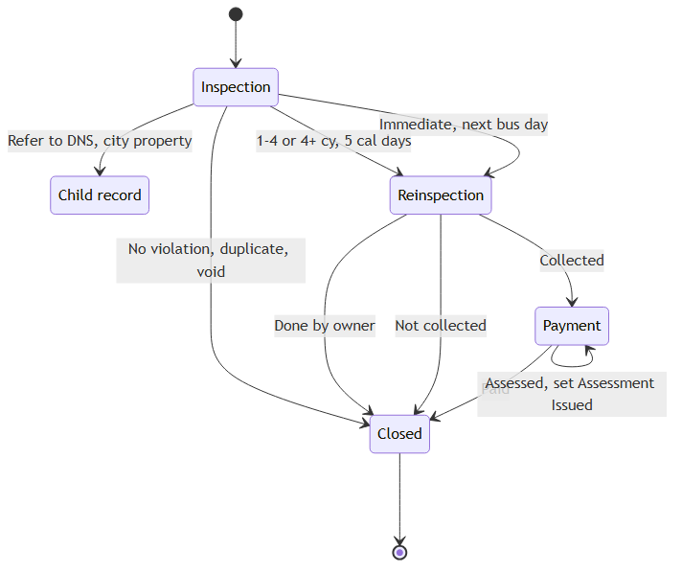
Workflow state graph

Inspection lifecycle
Generated from Tables A + B. Nine result values collapse into three routing classes (close, reinspect, spawn child). The reinspection is a second node rather than a loop back to the first, since it is a different inspection type with a different result set.
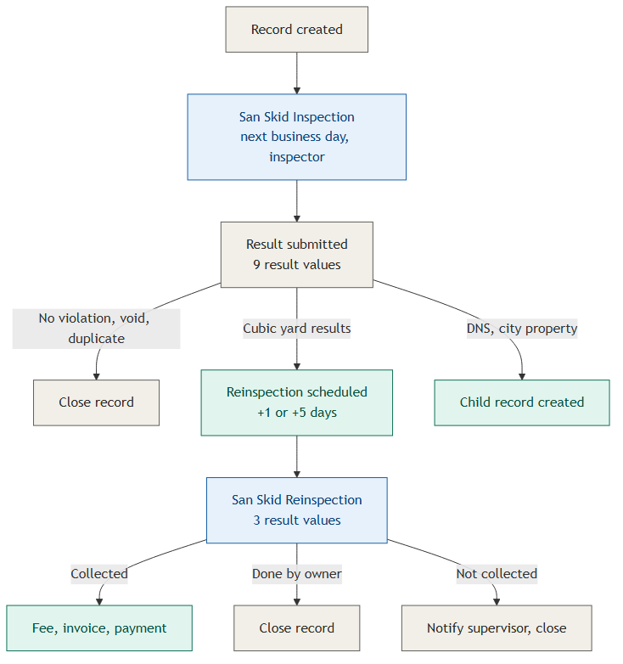
Inspection lifecycle

Event chain
Generated from Table E. Hooks and effects are drawn as two columns rather than a chain, since Accela event scripts don’t compose into a sequence — they are independent hooks that happen to act on the same record. The nightly batch gets its own terminal class so it doesn’t look like an event: the 37-day late fee is not triggered by anything a user does.
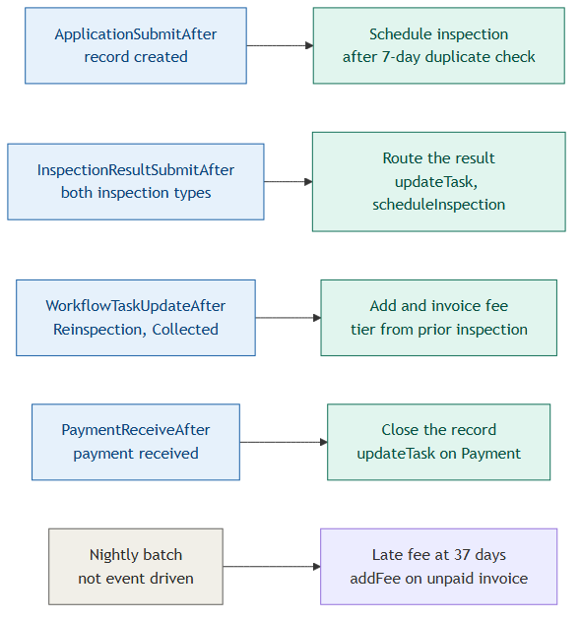
Event chain

