**Freight Management: Predict the cost of shipment**

**Data Understanding**

**Data Needed**:

The following data is needed for the model:

* Order details (Order number, type, date, etc.)
* Item(s) to be shipped details (number, type, quantity, descriptions, etc.)
* Source, Destination
* Other costs (insurance, special packaging, loading/unloading, fuel costs, etc.)
* Actual Freight cost

**Data Given**:

The following data has been given for building the model to predict the cost of shipment:

|  |  |
| --- | --- |
| **File Name** | **Details of the Content/Data** |
| equipmentcodes.csv | Contains the shipment orders details |
| marketzips.csv | Contains the mapping of equipment type code to description |
| regionlookups.csv | Contains the mapping of zip code to market |
| spotfreightdata.csv | Contains the mapping of zip code to region |

“**spotfreightdata.csv**” file content details:

|  |  |
| --- | --- |
| **Field Name** | **Field Details** |
| ORDER_NBR | Order Number |
| EQUIPMENT_TYPE | Equipment type code (or abbreviation). This code helps in identifying the type of the equipment in the shipment and useful in assessing the needful for any special packaging, care during transportation, etc. and would have an impact on the overall shipment cost |
| CUSTOMER_MILES | Distance between source and destination (in miles) |
| WEIGHT | Weight of the shipment |
| ORDER_COST | Shipment order cost **(i.e. the target variable)** |
| FIRST_PICK_ZIP | Pick up (or source) zip code |
| FIRST_PICK_EARLY_APPT | Pick up time slot (earliest) |
| FIRST_PICK_LATE_APPT | Pick up time slot (max by) |
| LAST_DELIVERY_ZIP | Delivery (or destination) zip code |
| LAST_DELIVERY_EARLY_APPT | Delivery time slot (earliest) |
| LAST_DELIVERY_LATE_APPT | Delivery time slot (max by) |
| IS_HAZARDOUS | does shipment or package(s) contains any hazardous item(s) or not. This is an important attribute and useful in assessing the need for any special handling and in turn would have an impact on overall shipment cost |
| CREATED_DATE | Ordered Date |

**Observation / Notes**:

* No. of records (total count) : **37699**
* No.of records with Unique Order number : **25631**
* No. of records with the same order number (duplicate records) : 12068
* No. of records with ‘0’ or ‘NA’ as “CUSTOMER_MILES” : 655
* No. of records with blank “EQUIPMENT_TYPE” : 2101
* No. of records with ‘0’ or ‘NA’ as “WEIGHT” : 3506
* No. of records with ‘0’ or ‘NA’ as “ORDER_COST” : 7734
* No. of records with invalid “FIRST_PICK_ZIP” : 200
* No. of records with invalid “LAST_DELIVERY_ZIP” : 326
* No. of records for which equipment meaning not found : 89
* **No. of records (post removal of above invalid records) left** : **25468**
* To find the mapped market code, use the first 2 or 3 digits of the pickup or delivery zip code and check for the corresponding market code in “marketzips.csv”
* To find the mapped region, use the first 2 or 3 digits of the pickup or delivery zip code and check for the corresponding region in “regionlookups.csv”

**Filtered data sample view:**

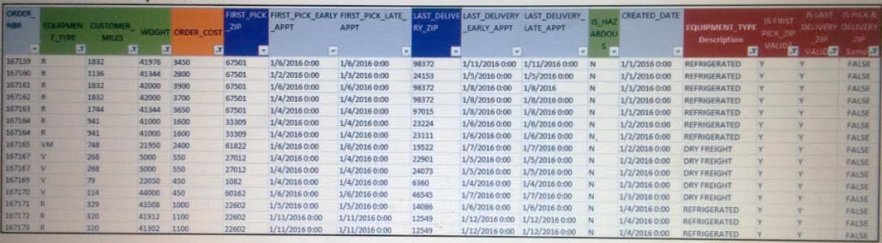

“**equipmentcodes.csv**” file content details:

|  |  |
| --- | --- |
| **Field Name** | **Field Details** |
| EQUIPMENT_TYPE | Equipment type code (for second level category) |
| new abbr | Equipment type code (for first level category) |
| meaning | Description of the equipment type |

**Observation**:

* No. of records with unique mapping of EQUIPMENT_TYPE to meaning : **293**
* No. of mappings not found in this mapping table : **7**

(IMDL, SB, DRAY, VCAR, D-LTL, VS, FT-4)

“**marketzips.csv**” file content details:

|  |  |
| --- | --- |
| **Field Name** | **Field Details** |
| Zips | Zip codes (the first 2 or 3 digits of the zip code) |
| Market | The mapping of the zip to the market |

**Observation**:

* No. of records with unique mapping of EQUIPMENT_TYPE to meaning : 905
* No. of mappings not found in this mapping table : 135

“**regionlookups.csv**” file content details:

|  |  |
| --- | --- |
| **Field Name** | **Field Details** |
| Zip Code | Zip code (the first 2 or 3 digits of the zip code) |
| Region | Contains the region corresponding to the zip code |

**Observation**:

* No. of records with unique mapping of Region to zip code : 906
* No. of unique regions found : 15

**Open questions:**

**spotfreightdata.csv:**

* Contains multiple records with the same order number, equipment type, miles, weight, order cost details but with different first pick up info (i.e. zip, early appt, late appt), last delivery info (i.e. zip, early appt, late appt) and order create date.
  + Are these records about source and destination related updates to the original order record or something else?
  + If these are just the updates to the original order record; then, which one to be considered as the latest one and/or how to identify it (means, any particular field or value to check for the same)

For example:

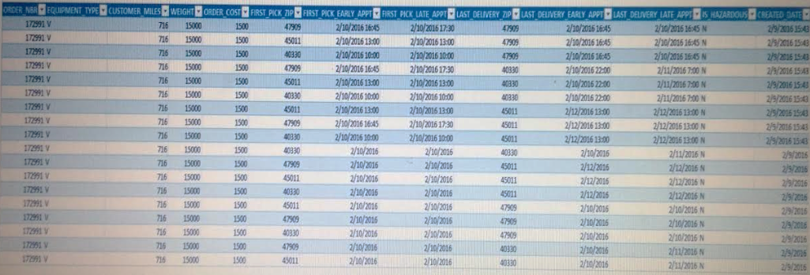

**marketzips.csv:**

* What are these zips and market codes mapping about?
* What is its relation to the shipping cost?

**regionlookups.csv:**

* What are these zips codes (2 digit and 3 digit) about?
* What is the relation of the region to shipping cost calculation?

**References:**

<https://www.melissadata.com/lookups/index.htm>

<http://www.distancecheck.com>

<https://www.melissadata.com/lookups/zipdistance.asp>