**Freight Management: Predict the cost of shipment**

**State-of-the-Art**

**Preface**:

Quickfreight provides the logistic services and,

* It is the middle man between the customer and freight services.
* It charges from the customer and pay to the freight services
* It makes profit/revenue during the transaction (charge from customer, pay to freight service profier)

**Purpose:**

* Given a request from a customer for shipment, proper estimation of freight cost for the carriers to be done to come up with best quote to customer.

**Business Benefits:**

* Enables best price quote to customer
* Reduces revenue leakages
* Increases Margin

**Problem Statement:**

Quickfreight would like to analyze the transportation cost variances and would like to build a tool to estimate the shipment cost given a request for shipment such that, it provides best quote to customer by balancing the shipping cost charged by the freight service provider and by increasing its margin to make good profit out of it.

**Freight (Logistics) Industry & Its Market Trends:**

The freight logistics industry is growing, changing and adapting at a fast and furious rate. The first step in gaining freight logistics insight is to get a sense of the factors around freight shipping logistics that are having such an impact on the business.

Among the significant market trends affecting the logistics industry:

* **Outsourcing**: Manufacturers and e-commerce companies continue to outsource freight and logistics management to specialized firms. Outsourcing enables companies to concentrate on their core strengths and handle logistics more efficiently, improving both margins and customer satisfaction.
* **Globalized economy**: The world is shrinking. Thanks to e-commerce, trade agreements and other factors, goods are being shipped all around the world. This has created great demand for intermodal shipping, with trucks, vans, airplanes and merchant ships working in concert to move materials.
* **E-commerce**: Retail in general may be sputtering, but e-commerce is roaring like Niagara Falls. Pure online companies such as Amazon continue to show impressive growth, and traditional brick-and-mortar retailers are realizing great success from their online operations. The result is a greater demand for integrated logistics and delivery services for items that were purchased only in stores in the past.

**Market Size and some Statistics:**

Globally, the logistics industry is much larger than many people realize. It is one of the largest industries in the world, comprised of 10% of global GDP and with a value surpassing **$4 trillion dollars**.

* Emerging markets like India and China are expected to cause this business volume to rise to far greater heights
* The transportation sector is the largest and fastest growing segment, with an annual growth rate of 7% annually since 2011 — this segment alone is expected to generate **$3.8 trillion in revenue in 2016**
* The large umbrella of “global logistics” is comprised of a wide variety of transportation:
  + **Air freight**: Global value of $70 billion (growing annually at a rate of 5%)
  + **Sea freight**: Global value of $54 billion
  + **Road freight**: Global value of $2 trillion
* Within the U.S., logistics plays an enormous role:
  + The U.S. logistics business represents $1.45 trillion, more than 8% of its GDP.
  + The logistics business is currently about 2/3rd transportation and 1/3rd warehousing.
  + Intermodal freight is the most rapidly growing transportation segment

**The Future: Growth, Contraction or Stagnation?**

Forecasting in the logistics industry is no less challenging than it is in any other business. Despite the very positive changes in the global economy mentioned at the top of this article, significant problems and unknowns are tempering growth and giving cause for concern for freight logistics companies. These challenges include:

* A chronic shortage of drivers in the U.S.
* Political and social turbulence in the U.S. and around the world
* An increasingly complex and burdensome regulatory environment
* Truck capacity issues
* A deteriorating transportation infrastructure
* Old equipment that cannot be replaced or properly repaired due to thin operating profits

But, the predictive analysis of logistics data can be used to transform the way companies do business, particularly in terms of

* Cost Efficiency
* Operational Efficiency
* Dynamic Pricing (on in other words Competitive Pricing)

**Importance or Role of shipping cost for “Dynamic Pricing”:**

Shipment cost is one of the important component in end-product pricing or cost. Calculating shipping costs is not as straight forward as it sounds. Proper calculation of it is so important that, some studies show that 40% of shopping carts are abandoned because of shipping cost is too high.

There are lot of factors (both direct and indirect) influences or impacts shipping cost. A change in one computational ingredient (e.g. increased fuel cost, security-related shipment delay) can have a profound impact on the overall shipping cost and, consequently, the product price.

Price determination should be malleable and based on the real-time cost data. Predictive analysis solutions are capable of factoring cost-sensitive components and using that data, often combined with external dimensional data (e.g. weather patterns and transport time), to accurately predict an optimized price.

This method of dynamic pricing ensures that your logistics operation balances competitive pricing with actual shipping costs.

Next, important thing to understand is: How shipping cost or freight rate is calculated?

But, before getting to the details of it, let’s briefly go through the logistics/transport industry related jargons, terms, abbreviations for better understanding of the domain.

**A short glossary of Freight (Logistics) industry related terms, abbreviations, etc.:**

LPS: Logistic Service Provider

Consignee: the person or company to whom commodities are shipped

Consignor or Shipper: the consumer or business providing goods for shipment

3PL: Third Party Logistics

Freight: goods transported in bulk by truck, train, ship, or aircraft.

Freight Cost: The cost incurred in moving goods. Its includes packing, palletizing, documentation and loading, unloading charges, carriage costs, and marine insurance costs.

Freight companies: are companies that specialize in the moving (or "forwarding") of freight, or cargo, from one place to another. These companies are divided into several variant sections:

**International freight forwarders** – ship goods internationally from country to country

**Domestic freight forwarders** – ship goods within a single country

Some of the most well-known and worldwide companies are: United Parcel Service, Kuehne + Nagel, DHL, Purolator, GlobalTranz, and FedEx

Freight transport is the physical process of transporting commodities and merchandise goods and cargo. The term shipping originally referred to transport by sea, but is extended in American English to refer to transport by land or air (International English: "carriage") as well. "Logistics", a term borrowed from the military environment, is also fashionably used in the same sense.

Difference between Freight and Shipping?

**Shipping** and **freight** can be the transportation of goods either by air, land or water. Although shipping and freight are for the bulk transportation of goods, freight refers to a larger quantity of goods whereas shipping refers to a smaller quantity.

Modes of Shipment: Ground (Truck, Rail), Sea (Ship), Air (cargo aircraft), Intermodal (refers to shipments that involve more than one mode: Truck-Sea-Truck, Truck-Air-Truck, etc.…)

Freight Rate: A freight rate (historically and in ship chartering simply **freight**) is a price at which a certain cargo is delivered from one point to another. The price depends on the form of the cargo, the mode of transport (truck, ship, train, aircraft), the weight of the cargo, and the distance to the delivery destination. Many shipping services, especially air carriers, use dimensional weight for calculating the price, which takes-into account both weight and volume of the cargo.

INCO Terms: INternational COmmerce Terminology (INCO Terms) defines exactly the shipping responsibilities of both the buyer and the seller

Consolidators: a firm which groups together shipments from different companies into a single shipment.

Customs Broker: A person or firm, licensed by the treasury department of their country when required, engaged in entering and clearing goods through Customs for a client (importer).

Freight Forwarder: A freight forwarder is an individual (often referred to as a forwarder and/or forwarding agent) and/or company that helps with the logistics of international shipping. However, they do not ship the goods themselves, instead they contract with international shipping companies to move your goods from point A to B.

NVOCC: A **non-vessel operating common carrier (NVOCC)** is quite similar to a freight forwarder in many ways. NVOCCs, like freight forwarders, do not have ownership of their own vessels. Instead they contract with cargo and shipping companies to perform the actual shipment. They will issue a bill of landing (B/L or BOL) for goods arriving by ship. These are documents that show that the goods have been received for transportation along with their point of origin and destination. NVOCCs focus almost exclusively on ocean based international container shipping, although many will offer services either side of the ocean portion of the shipment.

Bill of Lading (BOL or B/L): A Bill of Lading, also known at BOL or B/L, is a contractual document between carrier and shipper including details of shipment, often used as a receipt given to the person shipping the goods.

Bulk Freight: is a commodity freight that is not packaged and transported in large quantities. It refers to material in either liquid or granular, particulate form, as a mass of relatively small solids, such as petroleum/crude oil, etc...

Customs Broker: A customs broker is a licensed person or company responsible for clearing goods through customs on behalf of importers and exporters, usually businesses.

Drop Deck Flatbed: A drop deck flatbed is a platform semi-trailer with no roof, sides and doors, and it has two deck levels. The floor drops down after it clears the tractor unit. The lower deck allows for hauling taller loads than a regular straight(...)

Flatbed Truck: A flatbed truck (or flatbed lorry in British English) is a type of truck which has an entirely flat, level "bed" body with no sides or roof. This allows for quick and easy loading of goods, to transport heavy loads that are not(...)

Forklift: A forklift is a powered truck used to lift and move goods short distances. Indispensable in manufacturing and warehousing. Also, called a fork truck, a lift truck, or a forklift truck.

Full Truckload (FTL or TL) Shipping: FTL or Full Truckload is the transport of goods that fill up a full truck, or a partial load shipment occupying an entire truck. Bulk foods are typically shipped by FTL. FTL is contracted to one customer.

Less Than Truckload (LTL) Shipping: Less Than Truckload shipping aka LTL is the transport of goods that do not take up the entire available space on the truck. LTL combines shipments from multiple customers. Typically slower delivery time; less expensive

Reefer: A reefer is a refrigerated truck, railroad car or ship. A reefer is an intermodal container (shipping container) used in intermodal freight transport that is refrigerated for the transportation of temperature sensitive

Pallet: Pallet or Skid is a wooden (or sometimes plastic) platform on which boxes or cargo are stacked and sometimes shrink-wrapped. More details: A pallet is a raised platform made of wood, plastic or composite on which freight is(...)

Dimensional weight: is a standard formula used throughout the freight industry that considers a shipments density when determining charges. Transportation charges are based on the gross weight of the shipment or the dimensional weight of the shipment; whichever is greater. Simply put, dimensional weight is when the weight of a package is inappropriately less than the actual size of the package. For example, a box filled with inflated basket balls.

**How Freight rate or cost is determined (influencing factors, the data needed)?**

## Why was it so hard to compute shipping costs? Would a flat rate works?

Let’s look at this with the help of a simple example of an online store. An online store sells 2 products A and B.

product A costs $5 to ship and product B costs $10 ship, so if a customer orders product A and B the shipping is $5+$10 = $15, and that’s the end of the story. Is it?

It works, if one of each of these products are ordered, then the shipping estimate of $15 might seem right, but say you order 50 units of product A, then the shipping estimate would $5 X 50 = $200. This estimate would make customers leave the site and go elsewhere, because $200 is an incredibly inaccurate estimate. Which means flat rate won’t work.

Because, there are lot of factors one must consider to calculate the actual cost and to come up with a competitive pricing. Let’s look at the different factors that influence shipping cost.

# Some of the main factors that are needed and/or influence freight rate are:

* mode of transportation,
* weight,
* size / volume,
* distance (the farther the goods travel the more expensive it will be. Similarly, less frequent routes and especially dangerous ones will cost more)
* points of pickup and delivery,
* the actual goods being shipped
  + Value of goods being shipped: this especially affects insurance premiums charged
  + Types of good being shipped: dangerous goods, perishable goods, and outsized goods will all result in higher rates.
* Others (Feul cost, Freight forwarder charges and fees, Type of packing, Insurance cost, customs duty, etc.…)

All the above factors play their own independent role in determining the price or rate at which the freight will be transported but they are also all interconnected. When determining which mode of transportation will be used to deliver the freight to its destination there are many things which need to be taken into consideration which will influence the freight rate.

Federal, State, and Local authorities all have their own laws and regulations with regards to the size, weight, and type of freight which can be transported on their roads. Transportation of freight by Rail, Water, or air craft all have their own regulations which takes-into account Federal, State, and Local regulations as well as safety concerns which contribute to the rate at which freight is transported.

In general, the more freight you transport, the cheaper it is. This is an important factor in the rate charged to people or companies shipping freight. There are many businesses out there whose sole purpose is to make the transportation of freight cheaper and easier for small businesses and individuals who need to move freight.

Consolidators, customs brokers, freight forwarders, and NVOCC’s can be a factor in determining freight rate because of their experience, business relationships, and the volume at which they operate.

These factors help keep the freight rate down for small businesses and the individual with a shipping need. In the commercial trucking industry, many shippers’ tender loads to freight brokers whose job it is to find qualified carriers to move the freight at an acceptable price for all parties.

Let’s look at briefly how freight rates are determined in US:

The freight industry has established a standard for establishing a freight rate within the United States. This system is known as "Freight Classing" There are 18 different freight classes ranging from a class 55 up to a class 500. All items shipped within the United States via LTL (less than a truck load) freight carrier move under one of these classes. The higher the freight class the higher the rate will be per pound.

NMFC (National Motor Freight Classification) – This is a numeric indicator that specifically identifies each type of product that can be shipped by a LTL carrier. The National Motor Freight Association presets these product classifications quarterly. This number influences the freight rate.

**Prediction Model(s), Measures & Error Metrics:**

Use linear regression analysis to study the transportation cost variances.

Assuming that the dimensions, weight and quantity are major cost drivers regarding transportation for this company, let’s go through the details of the Linear Regression Model to estimate the shipping cost.

Definition of Terms:

Independent variable: a variable that causes, or influences, another variable

Dependent variable: a variable that is caused or influenced by another variable

Mean: the sum of the measures in a distribution divided by the number of measures

Standard deviation: the measure of data variation; the square root of the variance

Empirical rule for normal distributions: the interval from one standard deviation below the mean to one standard deviation above the mean contains approximately 68% of the measurements; the interval from three standard deviations below the mean to three standard deviations above the mean contains approximately all of the measurements.

Allocation: Allocations are used to distribute cost amounts that are posted to a dimension. This enables to credit one dimension and debit the costs to another dimension. It can be only performed on secondary cost categories".

Statistical tools allow measurement and evaluation of the performance in a process to improve its quality and outcome. These tools frequently used to support decision making. "The application of **linear regression analysis** to study transportation cost is a statistical tool, for decision making regarding and estimating transportation cost.

"Cost analysis” can be used to understand the level of resources that are required to operate a logistics system, with the goal of maximizing the desired performance of the system while minimizing the cost of resources.

In transportation, cost analysis is vital to identify the variable changes and the impact. Once the company has this information under control, coming up with cost saving opportunities will be a matter of analysis, creativity and innovation.

The bottom line is that cost analysis is a simple part of good forecasting and accounting practices, which allow to determine the true cost of providing a given unit of service. Accuracy and visibility play an important role when performing such analysis.

## **Linear Regression Analysis:**

Regression analysis is a statistical method that measures the average amount of change in the dependent variable associated with a unit change in one or more independent variables. It Is more accurate than the High-Low method because the regression equation estimates costs using information from all observations; the High-Low method uses only two observations. Inference based on such models is known as regression analysis.

Linear regression analysis is one of the most important and commonly used statistical methods that serve three major purposes: (I) description, (2) control, and (3) prediction.

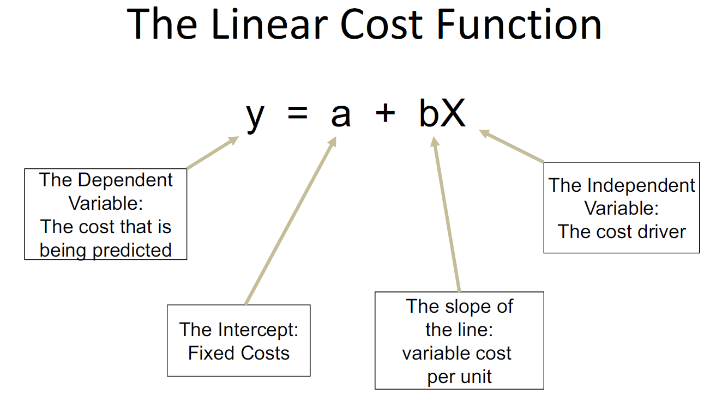

A regression is a test to see if we can predict one variable's value if we know the value of another variable (or variables). Here, we will limit ourselves to linear regressions, which fit the data to a straight line. Regressions are Cartesian geometry, the classical formula Y=a+bX and the X and Y axis chart; where, the X axis is our independent variable, and the Y axis is our dependent variable. Linear regression analyzes the relationship between two variables, X and Y. For each subject or experimental unit, you know both X and Y and you want to find the best straight line through the data. In some situations, the slope and/or intercept have a scientific meaning. In other cases, you use the linear regression line as a standard curve to find new values of X from Y, or Y from X.

The least-squares regression (LSR) method for analyzing mixed costs uses mathematical formulas to determine the regression line that minimizes the sum of the squared “errors.”

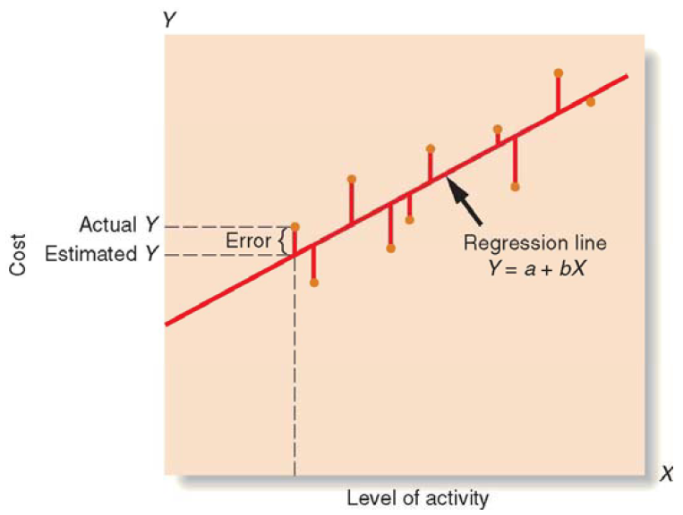

Approach:

The focus will be all the variables that drive transportation costs. Such variables will be analyzed using linear regression and evaluated to come up with the actual facts of costs variances.

Data Needed:

The following data is needed to start with the model:

* Order details (Order number, type, date, etc…)
* Item(s) to be shipped details (number, type, quantity, descriptions, etc…)
* Source, Destination
* Other costs (insurance, special packaging, loading/unloading, fuel costs, etc…)
* Actual Freight cost

Measures:

* Regression Equation
* P-Value
* R2 Value
* Significant Variables
* Collinearity Checks
* Adjusted R2 Value

Error Metrics:

* MSE, RMSE, MAPE

**Other Models:**

“Kevin Andrew Straight” has explored estimation by analogy (EBA) as a means of estimating the cost of international freight consignment. A version of the k-Nearest Neighbors algorithm (k-NN) was tested by predicting job costs from a database of over 5000 actual jobs booked by an Irish freight forwarding firm over a seven-year period. The effect of a computer intensive training process on overall accuracy of the method was found to be insignificant when the method was implemented with four or fewer neighbors. Overall, the accuracy of the analogy based method, while still significantly less accurate than manually working up estimates, might be worthwhile to implement in practice, depending labor costs in an adopting firm.

**References:**

* **Logistics/Shipping Market or Industry**

<http://www.dataiku.com/solutions/industries/transportation/>

<http://www.transitsystems.com/shipping/2016/08/08/freight-logistics-and-market-trends/>

* **Domain specific terms, glossary**

<http://www.mainfreight.com/nz/en/basics/freight-basics-inco-terms.aspx>

<http://www.mainfreight.com/nz/en/basics/freight-basics-glossary-terminology.aspx>

<https://www.freightera.com/blog/freight-terms-glossary/>

<http://moverdb.com/freight-forwarder/>

<https://en.wikipedia.org/wiki/Freight_company>

<http://www.mainfreight.com/nz/en/basics/freight-basics-glossary-terminology.aspx>

<http://www.mainfreight.com/nz/en/basics/freight-basics-glossary-abbreviations.aspx>

* **How Freight is calculated**

<http://blog.ecomsolutions.net/2011/09/how-to-calculate-e-commerce-shipping-cost-algorithms/>

<https://en.wikipedia.org/wiki/Freight_rate>

<https://www.freightera.com/blog/how-freight-rates-are-determined/>

<http://www.selfgrowth.com/articles/what-factors-determine-the-freight-rates-0>

<http://www.mainfreight.com/nz/en/basics/cheap-freight-the-hidden-costs.aspx>

<http://www.dat.com/freight-rates>

<https://www.freightcenter.com/tools/determining-cost>

* **Freight Forecast / Prediction – Models**

**State-of-the art of freight forecast modeling: lessons learned and the road ahead:** <http://link.springer.com/article/10.1007/s11116-010-9281-1>

**A Data Mining Based Method for Route and Freight Estimation (**by Shoaib Bakhtyara, Johan Holmgrena)**:** <http://www.sciencedirect.com/science/article/pii/S1877050915008042>

**Freight Forwarding Cost Estimation – An Analogy Based Approach (**by Kevin Andrew Straight, 2014)**:** <https://www.morebooks.de/store/gb/book/freight-forwarding-cost-estimation/isbn/978-3-659-58859-4>

**ESTIMATING FREIGHT COSTS OVER A MULTI-MODAL NETWORK: AN AUTO INDUSTRY SUPPLY CHAIN EXAMPLE** by Amy Marie Moore

**Guidelines for Assessing Costs in a Logistics System - An Example of Transport Cost Analysis** by Hany Abdallah, 2004

**Linear Regression Analysis to Study Transportation Cost Variances within Divisions of a Company** (by Alejandro Romero Vera, 2008)

* **Others**

<http://ezinearticles.com/?What-is-Freight-Management?&id=2273344>