ISEcp1 TPU examples
From Partridge FEMS Mico Rev 2011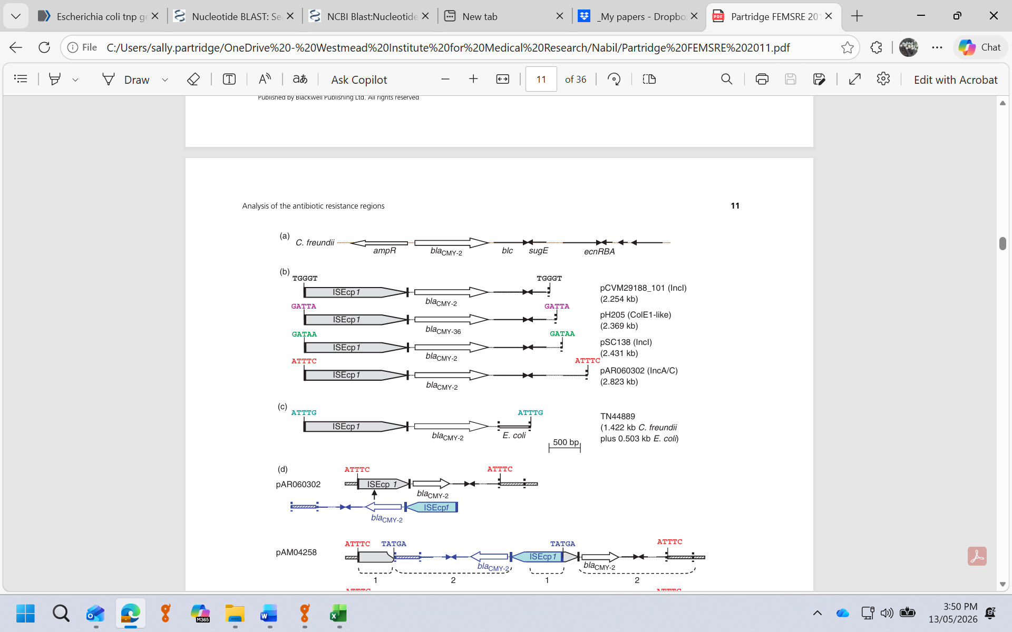
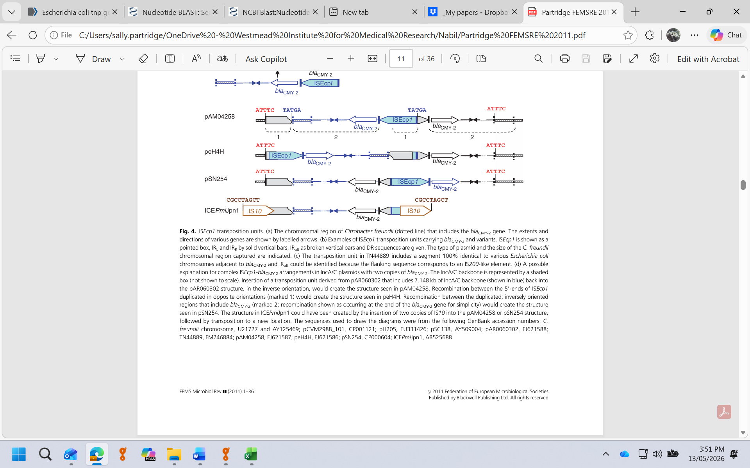

Name | Source/Accession | Notes
ISEcp1 | ISfinder
TPU_CMY-2_3910 | CP001121
TPU_CMY-2_4087 | AY509004
TPU_CMY-2_4479 | FJ621588
TPU_CMY-2_3078+503 | FM246884 | 3078 bp of C. freundii chr + 503 bp E. coli chr
TPU_CMY-31_4025 | EU331425 | ISEcp1-gene spacer is 6 bp shorter
TPU_CMY-36_4025 | EU331426 | ISEcp1-gene spacer is 6 bp shorter

