Common transposons
Tn21
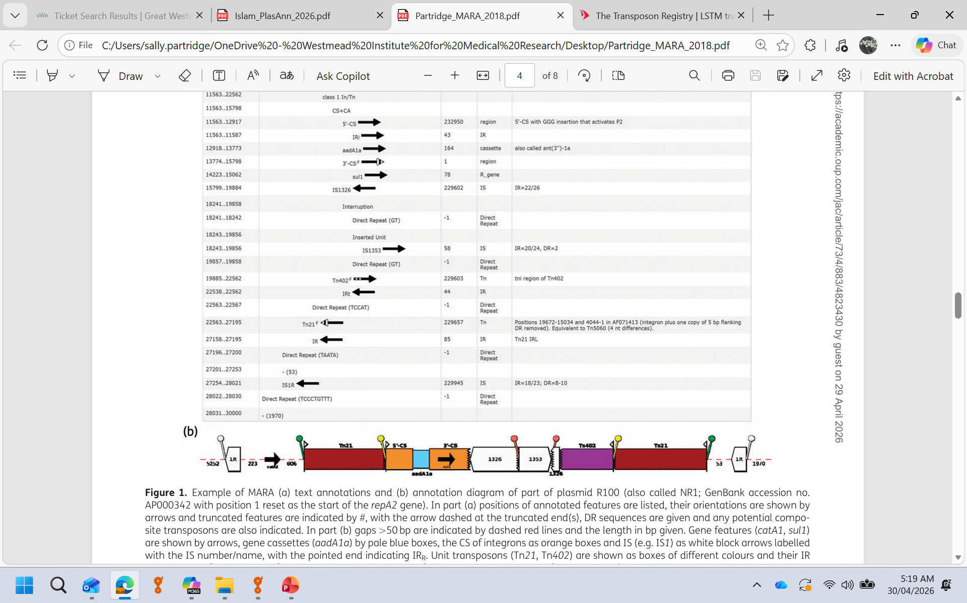
Class 1 integron features included in FASTA are 5′-CS, 3′-CS (orange region is truncated version), complete Tn402tni region (purple region is truncated version), IRi (integrase end) IRt (tni end) at ends of integron (yellow lollipops in diagram).
FASTA includes Tn21_tnp (brown part on left of integron), Tn21_mer (brown part on right), IRL (mer end, on right in above diagram) and IRR (tnp end, on left in above diagram)
(Probably want to include gene cassettes contaiaing AMR genes found by AMRfinder and maybe want to detect different Pc promoter variants in 5′-CS at some point?)

Tn1721
Tn1721=Tn1722 + tet(A) region and partial duplication of tnp region
FASTA file includes entire Tn1721, Tn1722, and extra tet(A)-tnp (region shown on lower diagram below), plus IRL and IRR.
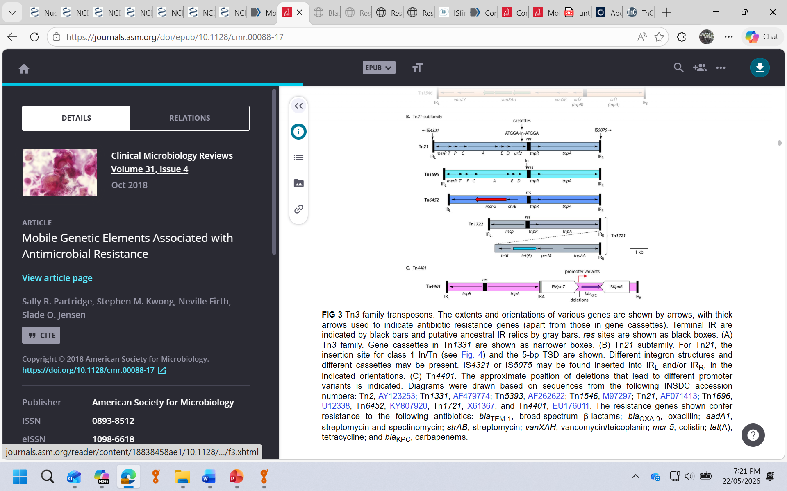
Tn4401
FASTA file includes entire Tn4401 with IS insertions, and broken up as tnp region, bla_{KPC} region and right end, plus IRL and IRR and also ISKpn6 and ISKpn7, which might be useful for testing?
Deletions between ISKpn7 and bla_{KPC} (some around 100 bp) may cause annotation issues, but separate features for different known variants variants could be included


Tn5393
FASTA file includes entire Tn5393 without any insertions (all versions in TnCentral seem to have insertions of IS etc.), IRL, IRR and IRRv – a variant of IRR. I have included 38 bp IR as nthis is the length common to Tn3-family transposons, but technically they are 81 bp for Tn5393.
strA will be annotated as aph(3′′)-Ib and strB as aph(6)-Id by AMRFinder

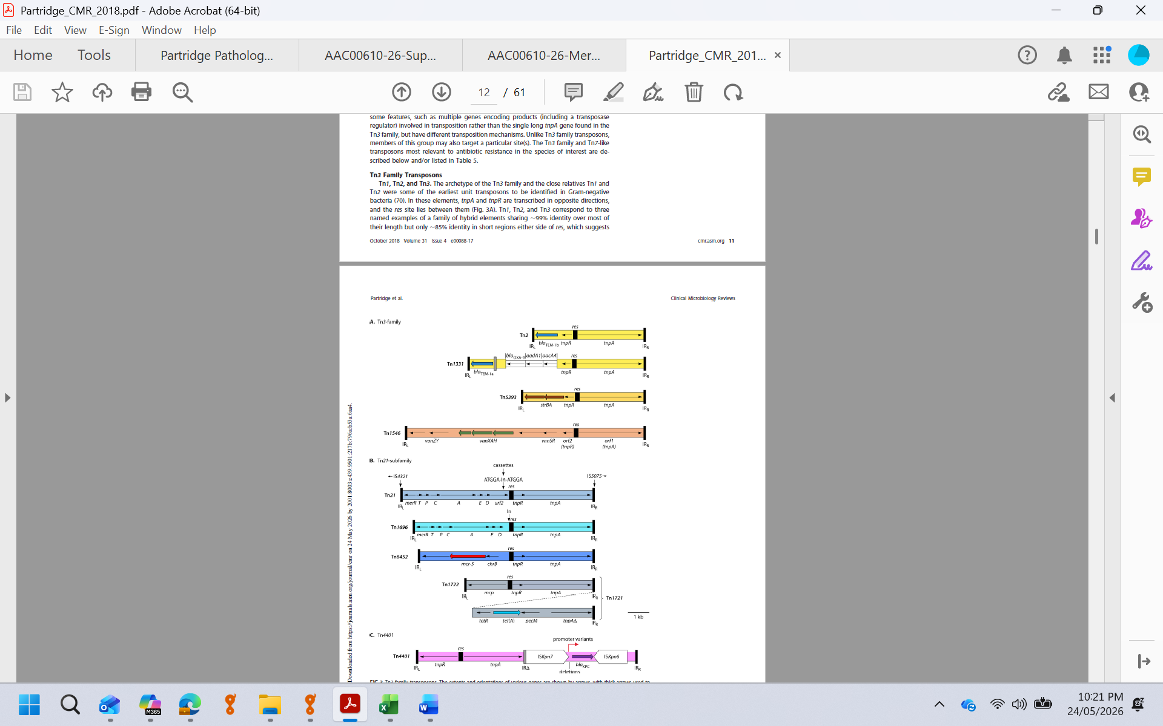

Tn5403
A Tn3-family element that just has tnpA and tnpR genes and does not carry any passenger genes but it is found in multi-resistance regions. Picture from TnCentral
FASTA file includes entire Tn5403, and a single IR sequence – IRL and IRR are identical in this case.

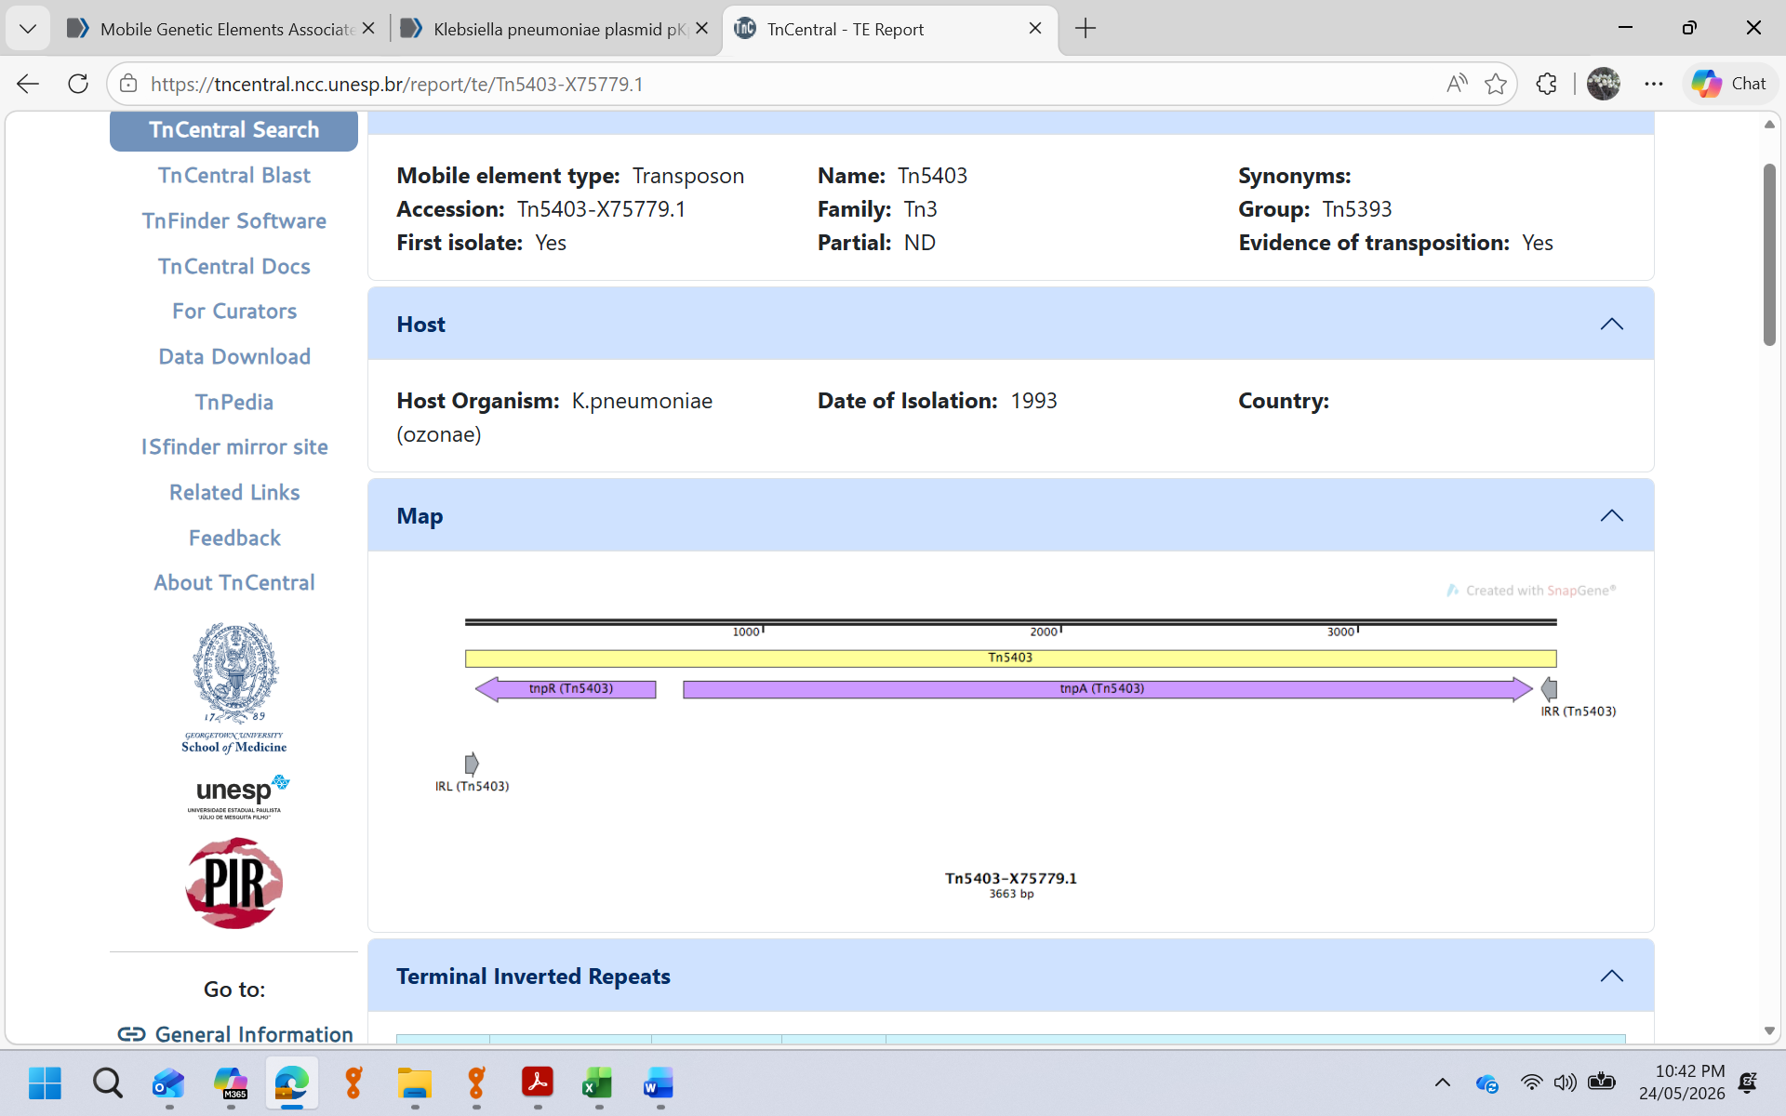

Name | Source/Accession | Notes
5CS_std |  | class 1 integron 5′-CS
5CS_GGG | AF071413 | version of class 1 integron 5′-CS with 3 extra Gs
3CS_2239bp | U12338 | longest version of class 1 integron 3′-CS
IRi | AF071413 | 25 bp IR of class 1 In/Tn at integrase end
IRt | AF071413 | 25 bp IR of class 1 In/Tn at tni end
ISKpn6 | ISFinder | found with Tn4401
ISKpn7 | ISFinder | found with Tn4401
Tn21_IRL | AF071413 | 38 bp IR at mer end
Tn21_IRR | AF071413 | 38 bp IR at tnp end
Tn21_mer | AF071413 | from nt after IRt integron to IRL
Tn21_tnp | AF071413 | IRR to nt before IRi of integron
Tn402_tni | U67194 | complete Tn402 tni (transposition) region (in some In)
Tn1721 | AB366441 | has partial duplication and tet(A) region
Tn1721_IRL | AB366441 | 38 bp IR at mcp end
Tn1721_IRR | AB366441 | 38 bp IR at tnp end (one copy in Tn1722, two in Tn1721)
Tn1721_tet | AB366441 | Tn1721 minus Tn1722
Tn1722 | AB366441 | matches Tn1721 but without duplication or tet(A)
Tn4401 | GU595196 | complete Tn4401
Tn4401_IRL | GU595196 | 40 bp IR at tnp end
Tn4401_IRR | GU595196 | 40 bp IR at ISKpn6 end
Tn4401_KPCregion | GU595196 | region between ISKpn7 and ISKpn6
Tn4401_Rend | GU595196 | region from IRL of ISKpn6 to IRR of Tn4401
Tn4401_tnp | GU595196 | region from IRL of Tn4401 to IRL of ISKpn7
Tn5393 | AF262622 | version with no insertions
Tn5393_IRL | AF262622 | 38 bp IR at str end
Tn5393_IRR | AF262622 | 38 bp IR at tnp end
Tn5393_IRRv |  | variant of IRR found in some sequences
Tn5403_IR | X75779 | IR of Tn5403 – identical at both ends
Tn5403 | X75779 | Tn3 family, no AMR genes

