Sequences to use for Tn1, Tn2 and Tn3

From TnCentral
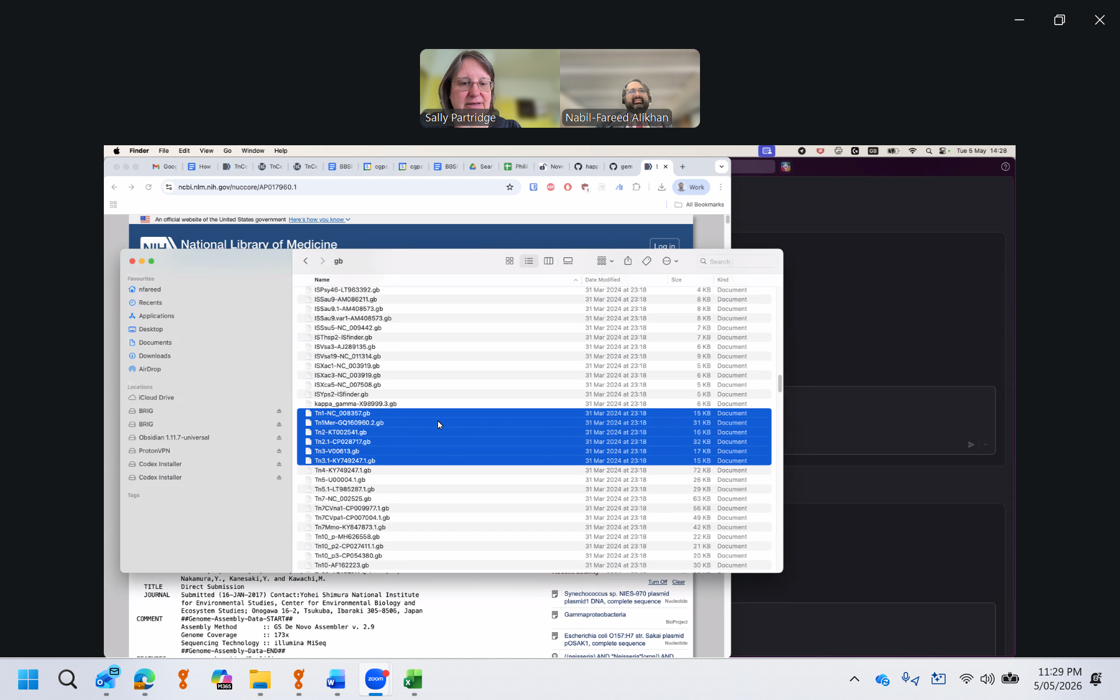

Tn | Source | Accession | Notes
Tn1 | TnCentral | NC_008357=AM261760 | Use for now (10 sequences in GenBank at 100% identity)
Tn1Mer | TnCentral | GQ160960 | Ignore – has a Tn5036-like transposon inserted in it
Tn1 | SP | BN000925 | Only 2x100% in GenBank
Tn2 | SP | AY123253 | Use – my original, published sequence (>100 at 100%)
Tn2 | TnCentral | KT002541 | Identical to AY123253
Tn2.1 | TnCentral | CP028717 | Has ISEcp1 TPU inserted
Tn2a | SP | HM749967 | Variant with blaTEM-1c, called Tn2c in MARA. Add later?
Tn3 | SP | HM749966 | See PMID: 21393132, 99 sequences in GenBank at 100%
Tn3.1 | TnCentral | KT749247 | Identical to HM749966
Tn3 | TnCentral | V00613 | Has 9 bp duplication, only 2 sequences in GenBank

IR
GGGGTCTGACGCTCAGTGGAACGAAAACTCACGTTAAG-Tn
↑ start/end of Tn

