TECHNICAL EVIDENCE REPORT

Automated detection and visualisation
of Tn1, Tn2 and Tn3
Expert rules, real-accession validation, MARA-style locus maps,
MARA tables and hierarchical outputs
Definition set | Software status | Report date | Validation
2026-08-27 | External alpha | 27 August 2026 | 14/14 checks pass

Purpose
This document is the reviewable evidence package: it explains what is run, how the biological rules are specified, and what the program produced from the reviewed accession sequences. The actual figures and tables are embedded in the report.
Scope statement
The validated scope is Tn1, Tn2, Tn3 and the reviewed close definitions listed here. It is not yet an exhaustive replacement for expert MARA annotation across every mobile-element family.

Contents and claims at a glance
Section | Question answered | Evidence
1 | What the tool does | Input, analysis stages, calls and outputs
2 | What is actually run | Built-in BLAST scans; optional ISEScan, AMRFinderPlus and IntegronFinder
3 | Expert-rule architecture | Human-readable YAML, schema validation and extension workflow
4 | Worked Tn1 definition | Grammar, thresholds, exact naming and variants
5 | Validation design | Real positive controls, natural fragments, variants and negative controls
6 | Real-accession evidence | MARA map, MARA table, hierarchy and component ledger for every reviewed definition
7 | Arbitrary-sequence demonstration | Three distinct loci recovered from one 44.6 kb contig
8 | Limitations and next work | What is proven, what remains expert review, and what is not claimed

What this report demonstrates
- An arbitrary multi-FASTA input can be scanned without pre-existing annotations.
- Tn1/Tn2/Tn3 components are detected independently and assembled using an explicit component grammar.
- A complete locus is classified from its component grammar and weighted local component profiles; a whole-element comparison is secondary confirmation.
- Every result can be inspected as a MARA-style map, a MARA table, the original hierarchy view, JSON, GFF3 and CellGen format.
- The seven reviewed accession definitions produce complete component grammars and exact declared calls; pEK499 produces two retained partial Tn2-like fragments rather than an invented complete Tn2.

Important interpretation
The seven exact accession runs are positive controls against the sequences used to define those names. They prove correct rule execution, component recovery and output generation. They do not by themselves estimate sensitivity on a broad independent population. The natural pEK499 fragments, synthetic variation tests and related-element negative controls test behaviour away from exact references.

1. What the tool does
Matryoshka is a per-sequence nested mobile-element annotator. For this report, its validated task is to find Tn1/Tn2/Tn3-group components in a FASTA sequence, assemble candidate loci, assign a reviewed name only when the evidence satisfies the expert rules, and render the same evidence in several complementary formats.

Input to output
Stage | Operation | Why it matters
1 | Read FASTA | One or many contigs or complete sequences; no feature annotation is required.
2 | Detect components | Scan independently for 38 bp terminal inverted repeats, blaTEM, tnpR, res and tnpA.
3 | Assemble loci | Group nearby features and test the required order and orientation on either strand.
4 | Classify by expert rules | Score the detected component profiles and assign a type only when the declared threshold and margin are met.
5 | Compare references | Optionally confirm an exact reviewed definition and record secondary closest-reference context.
6 | Write outputs | JSON, GFF3, CellGen, hierarchy SVG, MARA map, MARA table and proof ledger.

Call classes
Visible result | Meaning
Tn1 / Tn2 / Tn3 or named subtype | Complete component grammar and exact match to a reviewed declared definition.
Tn1-like / Tn2-like / Tn3-like | Complete grammar and a clear best weighted component profile, without requiring a complete-element match.
Tn1/2/3 fragment | At least 400 aligned reference bases, but an end or required component is missing or the grammar is incomplete.
Unresolved Tn1/Tn2/Tn3-group unit | The group grammar is supported but the component-profile score or type margin is insufficient.
No Tn1/Tn2/Tn3 call | Some shared components may still be annotated and drawn, but the element-level rule is not satisfied.

2. What is actually run

Built-in analysis
The command scans independently for the component sequences and assembles their collinear matches across substitutions, insertions and deletions. The expert-rule classifier uses those components to establish the family and type. Under the default validated profile, a separate whole-element comparison is then attached as confirmation or context. The tn123-components profile omits that complete-element lookup entirely.

Optional detector layer
The --detectors option controls additional programs, not the built-in Tn1/Tn2/Tn3 scan. The report bundles were generated with --detectors none, which means ISEScan, AMRFinderPlus and IntegronFinder were not launched. Built-in BLAST detection and the expert-rule classifier still ran. With --detectors available or --detectors all, those programs add broader IS, AMR-gene and integron evidence.
Analysis | Role | Used for this report
BLAST component scan | Detect IRL/IRR, blaTEM, tnpR, res and tnpA independently | Yes; primary
Component assembler | Test count, order, orientation and ends | Yes
Expert-rule classifier | Assign family/type-like, fragment or unresolved result from weighted component profiles | Yes; primary
BLAST whole-locus comparison | Optionally confirm an exact reviewed definition or add closest-reference context | Yes; secondary
Boundary/direct-repeat check | Record evidence immediately outside inferred ends when flanks exist | Yes
ISEScan / AMRFinderPlus / IntegronFinder | Broader optional component discovery | Not launched

Reproducible commands
# Prove discovery without complete-element lookup
matryoshka run arbitrary-demo.fasta --out results/component-only \
--profile tn123-components --detectors none
# Seven reviewed definitions with secondary exact confirmation
matryoshka run matryoshka/references/tn1_tn2_tn3.fasta \
--out results/tn123-reviewed --detectors none
# Export the rules for expert review
matryoshka definitions --format markdown --out tn123-definitions-review.md
Reproducibility metadata
Each result directory includes run.json, the software and definition versions, reference profile, detector selection, input checksum, runtime parameters and a direct index of every MARA map/table pair.

3. How the expert rules are specified
The biological definitions are data, not a collection of element-specific if-statements hidden in the Python source. The authoritative file is matryoshka/tn123_definitions.yaml. A JSON Schema checks its required structure, and the same content can be exported as YAML, JSON or a formatted Markdown review document.

Definition structure
Block | Human meaning
family | Shared biological description, expected terminal-IR length and target-site duplication length.
grammar | Required component counts and forward/reverse order.
component_detection | Identity, coverage, length and chaining thresholds for each component class.
classification | Weighted component-profile type rules, exact-reference confirmation and fragment rules.
types | Canonical Tn1, Tn2 and Tn3 sequences and their annotated component layouts.
definitions | Reviewable named sequences/subtypes, accession provenance, expert description and differences from parent.
related_element_policy | Explicit negative-control policy to prevent shared components being over-named.

Shared Tn1/Tn2/Tn3 grammar
terminal IR -> blaTEM -> tnpR -> res -> tnpA -> terminal IR
38 bp one one one one 38 bp
The reverse-complement copy must contain the corresponding reversed order. This establishes group membership, but it does not distinguish Tn1, Tn2 and Tn3 because their structures and much of their sequence are shared.

Current thresholds
Decision | Rule
Exact declared definition | 100% identity, 100% reference coverage, both ends, zero mismatches/insertions/deletions and complete component grammar.
Rule-based type | Complete grammar; weighted local component score at least 90%; best type exceeds the next by at least 0.5 points.
Component weights | blaTEM 1; tnpR 2; res 3; tnpA 3. The combined profile, rather than a single gene, assigns the type-like call.
Secondary reference | At least 95% identity and 80% coverage; used for context or exact confirmation, never to create the family/type.
Fragment | At least 400 aligned reference bases; retained without a complete name.

4. Worked expert definition: Tn1
Human-readable rule
Call a Tn1-like candidate when the six required components are independently detected in the correct order and their weighted local profiles best support Tn1 above the declared score and margin. Upgrade that call to exact reviewed Tn1 only when an optional secondary comparison is a complete, gap-free and mismatch-free match to NC_008357. The canonical sequence carries blaTEM-2.

YAML representation used by the program
classification:
type_assignment:
method: weighted component profiles
discriminator_role_weights:
blaTEM: 1
tnpR: 2
res: 3
tnpA: 3
minimum_component_profile_score_percent: 90
minimum_type_margin_percent: 0.5
reference_comparison:
role: secondary context after rule-based classification
types:
Tn1:
canonical_reference: Tn1_NC_008357
source_accession: NC_008357
components:
- {role: terminal_IR, name: IRL, start: 1, end: 38}
- {role: blaTEM, name: blaTEM-2, start: 148, end: 1008, strand: '-'}
- {role: tnpR, name: tnpR, start: 1191, end: 1748, strand: '-'}
- {role: res, name: res, start: 1754, end: 1867}
- {role: tnpA, name: tnpA, start: 1911, end: -34, strand: '+'}
- {role: terminal_IR, name: IRR, start: -38, end: -1}
Negative coordinates count from the right-hand end of the reference. This keeps the component layout readable and reusable for definitions of different lengths.

How to add or revise a subtype
- Add the public reference sequence and provenance.
- Add a definitions entry containing the parent type, visible name, accession, review status, expert rule and known differences.
- Declare any reviewed inserted or nested context under additional_features.
- Rebuild the reference FASTA and checksum manifest.
- Add a positive accession test and at least one related-element negative control.
- Rerun the validation ledger and complete output-bundle test.

5. Boundaries, direct repeats and validation design

How direct repeats are detected
For this group, a five-base direct repeat is supporting boundary evidence, not the naming rule. After candidate element ends have been inferred, Matryoshka reads the five bases immediately outside the left end and the five bases immediately outside the right end. An identical pair is reported with sequence and coordinates. If the record ends at the element boundary, the test is marked untestable because the flank is absent. If both flanks exist but differ, the result records that a repeat was searched for and not found.
A five-base repeat can occur by chance. It therefore cannot create a Tn1/Tn2/Tn3 name without the complete component grammar and type-profile evidence.

Validation set
Evidence class | Examples | Purpose
Reviewed exact definitions | NC_008357, AY123253, HM749966, HM749967, CP028717, GQ160960, V00613 | Positive controls for type/subtype execution and output generation.
Natural partial sequence | pEK499, EU935739.1 | Verify that two separated Tn2-related fragments remain partial.
Minor sequence variation | Tn1 with 25 substitutions | Verify a complete non-identical sequence becomes Tn1-like.
Structural variation | Tn2 with an 800 bp insertion | Verify an inserted sequence is retained and the call remains qualified.
Internal deletion | Tn2 with a 300 bp deletion | Verify split component evidence is chained and remains Tn2-like.
Truncation | Tn1 missing 700 left-hand bases | Verify the sequence becomes a fragment rather than exact Tn1.
Related elements | Tn1696, Tn1721, Tn5403 | Verify shared components do not force a Tn1/Tn2/Tn3 name.

Headline result
All 14 real-accession ledger checks and all 23 focused Tn1/Tn2/Tn3 acceptance tests pass. The component-only tests type substituted, inserted and deleted variants without a complete-element lookup. The reviewed inputs receive exact confirmation; the pEK499 loci remain partial; related elements are not misnamed.

Validation ledger
Scenario | Record | Accession | Expected | Observed | Result
reviewed real accession | Tn1_NC_008357 | NC_008357 | Tn1 | Tn1 | PASS
reviewed real accession | Tn2_AY123253 | AY123253 | Tn2 | Tn2 | PASS
reviewed real accession | Tn3_HM749966 | HM749966 | Tn3 | Tn3 | PASS
reviewed real accession | Tn2c_HM749967 | HM749967 | Tn2c | Tn2c | PASS
reviewed real accession | Tn2_1_CP028717 | CP028717 | Tn2.1 | Tn2.1 | PASS
reviewed real accession | Tn1Mer_GQ160960 | GQ160960 | Tn1Mer | Tn1Mer | PASS
reviewed real accession | Tn3_V00613 | V00613 | Tn3 (legacy 9 bp duplication subtype) | Tn3 | PASS
reviewed natural partial fragments | EU935739.1 | EU935739 | generic Tn1/2/3 fragment; closest Tn2 | Tn1/2/3 fragment | PASS
reviewed natural partial fragments | EU935739.1 | EU935739 | generic Tn1/2/3 fragment; closest Tn2 | Tn1/2/3 fragment | PASS
related but different Tn3-family element | Tn1696 |  | no named Tn1/Tn2/Tn3 call; supported fragment permitted | no Tn1/2/3 call | PASS
related but different Tn3-family element | Tn1721 |  | no named Tn1/Tn2/Tn3 call; supported fragment permitted | no Tn1/2/3 call | PASS
related but different Tn3-family element | Tn5403 |  | no named Tn1/Tn2/Tn3 call; supported fragment permitted | no Tn1/2/3 call | PASS
synthetic minor variation | novel_complete_variant |  | Tn1-like, not exact Tn1 | Tn1-like | PASS
synthetic partial sequence | left_truncated_fragment |  | generic Tn1/2/3 fragment; closest Tn1 | Tn1/2/3 fragment | PASS

The machine-readable source is docs/validation/tn123-real-accession-results.tsv. Blank accession/type fields in the related-element rows are intentional: those tests assert that no Tn1/Tn2/Tn3 name is assigned.

6.1 Real accession result — Tn1 (NC_008357)
Input record | Observed call | Coordinates | Whole-locus match | Grammar | Proof
Tn1_NC_008357 | Tn1 | 1–4,949 (+) | 100.0% identity; 100.0% coverage | 6/6 detected; order valid | PASS

Exact, complete, gap-free match to NC_008357 plus complete component grammar.
MARA-style locus map generated from the detected and assembled features for Tn1_NC_008357.
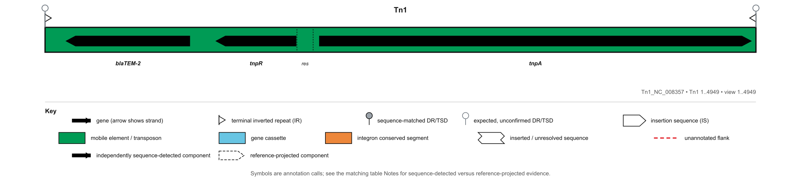
MARA table generated from the same call and evidence ledger.
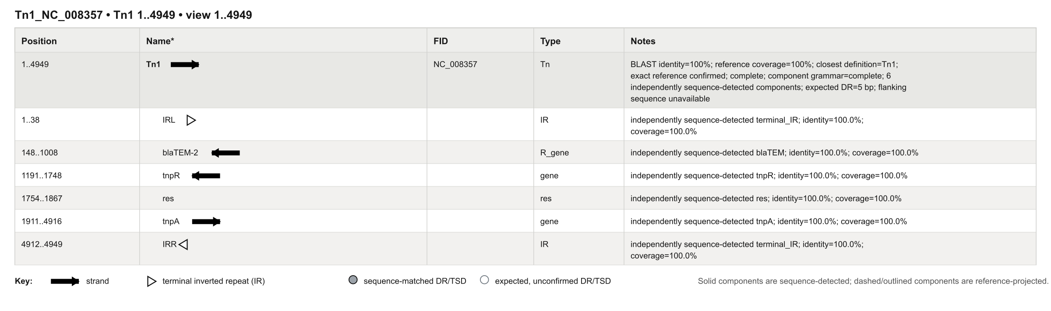

6.1 Evidence detail — Tn1 (NC_008357)
Original scale-accurate hierarchical view. Parent-child nesting is preserved.
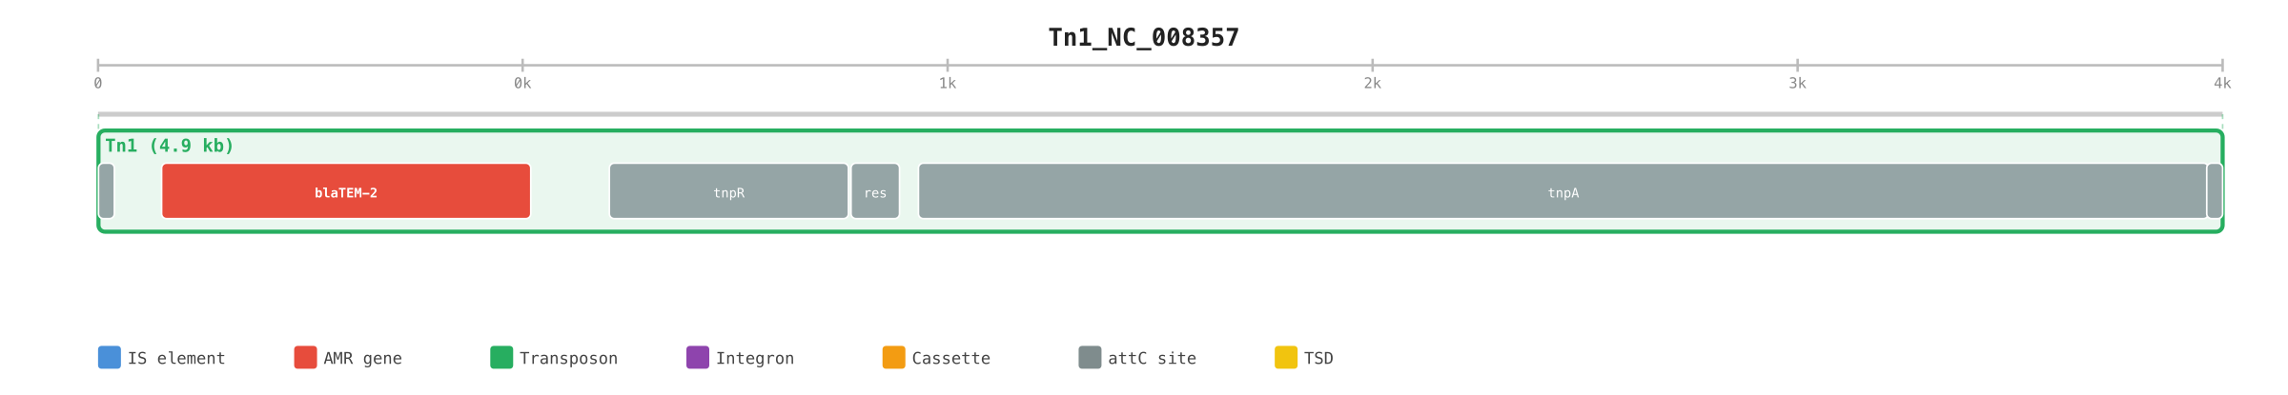
Role | Feature | Coordinates | Strand | Identity | Coverage | Evidence
terminal_IR | IRL | 1–38 | . | 100.00% | 100.0% | sequence_detected
blaTEM | blaTEM-2 | 148–1,008 | - | 100.00% | 100.0% | sequence_detected
tnpR | tnpR | 1,191–1,748 | - | 100.00% | 100.0% | sequence_detected
res | res | 1,754–1,867 | . | 100.00% | 100.0% | sequence_detected
tnpA | tnpA | 1,911–4,916 | + | 100.00% | 100.0% | sequence_detected
terminal_IR | IRR | 4,912–4,949 | . | 100.00% | 100.0% | sequence_detected

Definition: Tn1_NC_008357 (version 2026-08-27). Variant status: exact_reference_confirmed. Reference-projected required components: 0. Context features from the reviewed definition: 0.

6.2 Real accession result — Tn2 (AY123253)
Input record | Observed call | Coordinates | Whole-locus match | Grammar | Proof
Tn2_AY123253 | Tn2 | 1–4,950 (+) | 100.0% identity; 100.0% coverage | 6/6 detected; order valid | PASS

Exact, complete, gap-free match to AY123253 plus complete component grammar.
MARA-style locus map generated from the detected and assembled features for Tn2_AY123253.
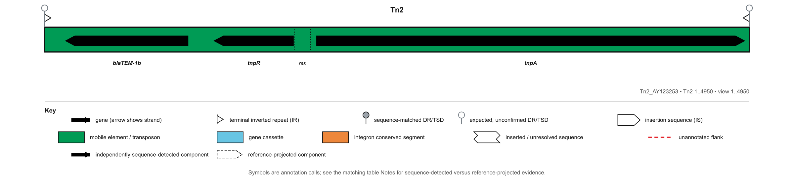
MARA table generated from the same call and evidence ledger.
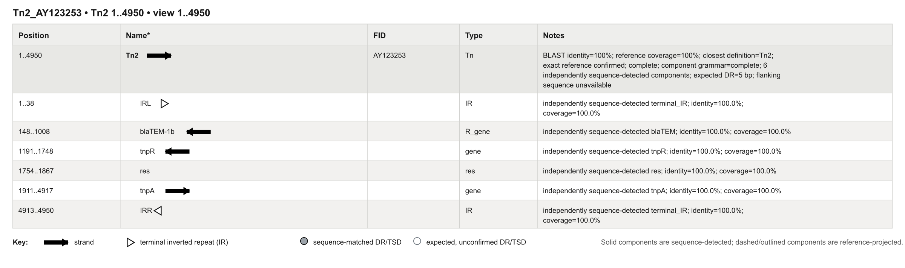

6.2 Evidence detail — Tn2 (AY123253)
Original scale-accurate hierarchical view. Parent-child nesting is preserved.
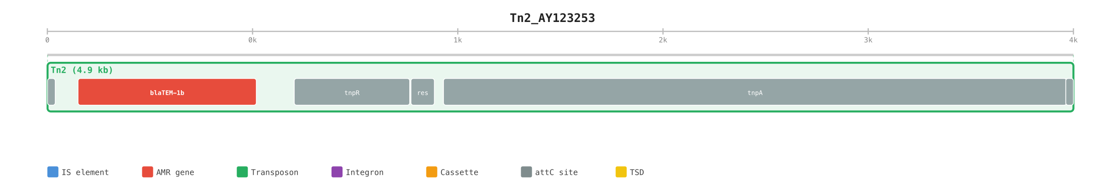
Role | Feature | Coordinates | Strand | Identity | Coverage | Evidence
terminal_IR | IRL | 1–38 | . | 100.00% | 100.0% | sequence_detected
blaTEM | blaTEM-1b | 148–1,008 | - | 100.00% | 100.0% | sequence_detected
tnpR | tnpR | 1,191–1,748 | - | 100.00% | 100.0% | sequence_detected
res | res | 1,754–1,867 | . | 100.00% | 100.0% | sequence_detected
tnpA | tnpA | 1,911–4,917 | + | 100.00% | 100.0% | sequence_detected
terminal_IR | IRR | 4,913–4,950 | . | 100.00% | 100.0% | sequence_detected

Definition: Tn2_AY123253 (version 2026-08-27). Variant status: exact_reference_confirmed. Reference-projected required components: 0. Context features from the reviewed definition: 0.

6.3 Real accession result — Tn3 (HM749966)
Input record | Observed call | Coordinates | Whole-locus match | Grammar | Proof
Tn3_HM749966 | Tn3 | 1–4,948 (+) | 100.0% identity; 100.0% coverage | 6/6 detected; order valid | PASS

Exact, complete, gap-free match to HM749966 plus complete component grammar.
MARA-style locus map generated from the detected and assembled features for Tn3_HM749966.
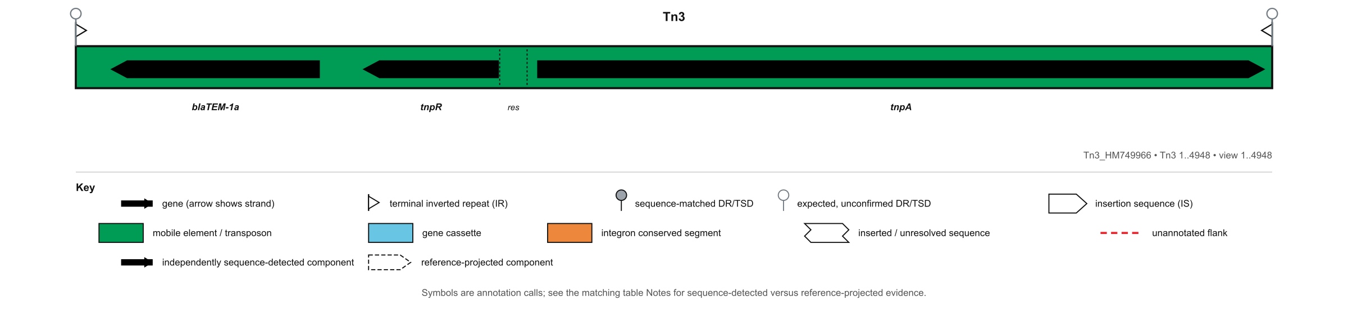
MARA table generated from the same call and evidence ledger.
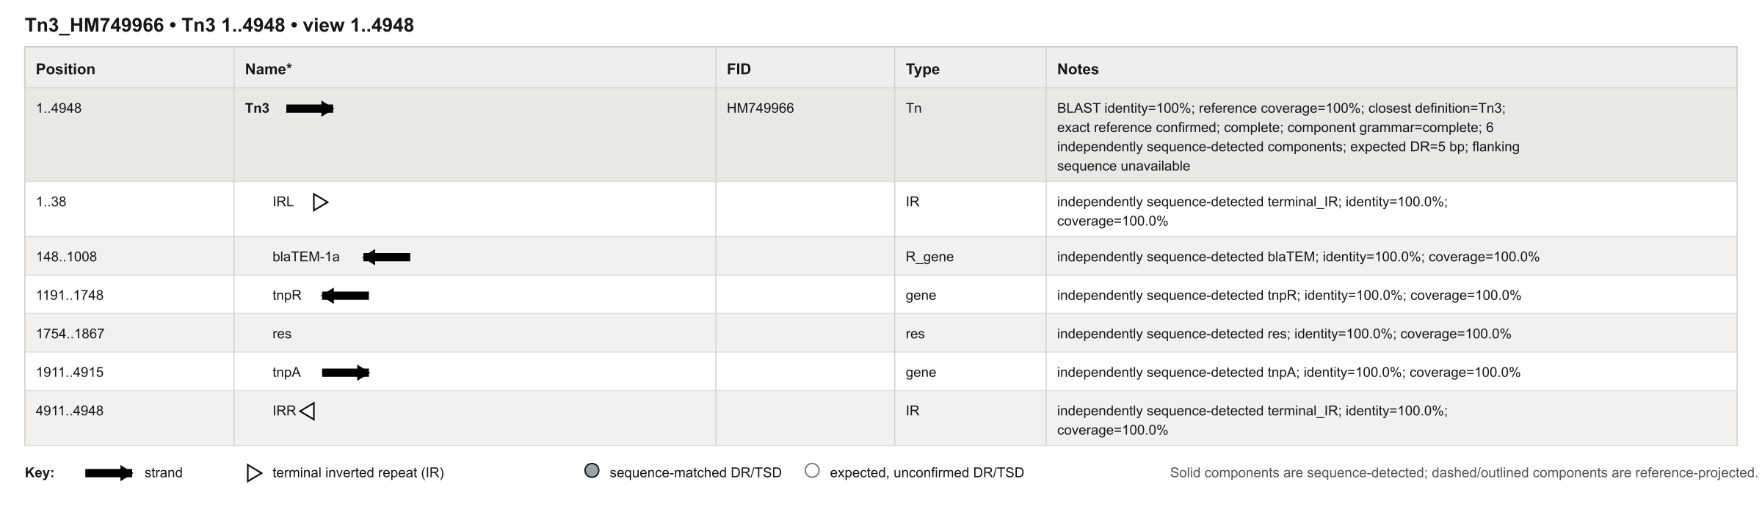

6.3 Evidence detail — Tn3 (HM749966)
Original scale-accurate hierarchical view. Parent-child nesting is preserved.
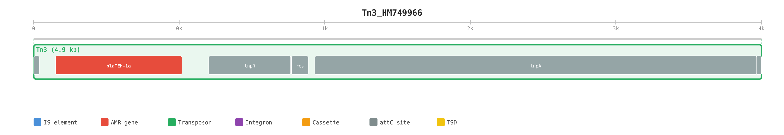
Role | Feature | Coordinates | Strand | Identity | Coverage | Evidence
terminal_IR | IRL | 1–38 | . | 100.00% | 100.0% | sequence_detected
blaTEM | blaTEM-1a | 148–1,008 | - | 100.00% | 100.0% | sequence_detected
tnpR | tnpR | 1,191–1,748 | - | 100.00% | 100.0% | sequence_detected
res | res | 1,754–1,867 | . | 100.00% | 100.0% | sequence_detected
tnpA | tnpA | 1,911–4,915 | + | 100.00% | 100.0% | sequence_detected
terminal_IR | IRR | 4,911–4,948 | . | 100.00% | 100.0% | sequence_detected

Definition: Tn3_HM749966 (version 2026-08-27). Variant status: exact_reference_confirmed. Reference-projected required components: 0. Context features from the reviewed definition: 0.

6.4 Real accession result — Tn2c (HM749967)
Input record | Observed call | Coordinates | Whole-locus match | Grammar | Proof
Tn2c_HM749967 | Tn2c | 1–4,950 (+) | 100.0% identity; 100.0% coverage | 6/6 detected; order valid | PASS

Exact, complete, gap-free match to the 4950 bp Tn2 interval in HM749967. It retains the Tn2 grammar but carries the blaTEM-1c sequence and nine substitutions relative to AY123253.
MARA-style locus map generated from the detected and assembled features for Tn2c_HM749967.
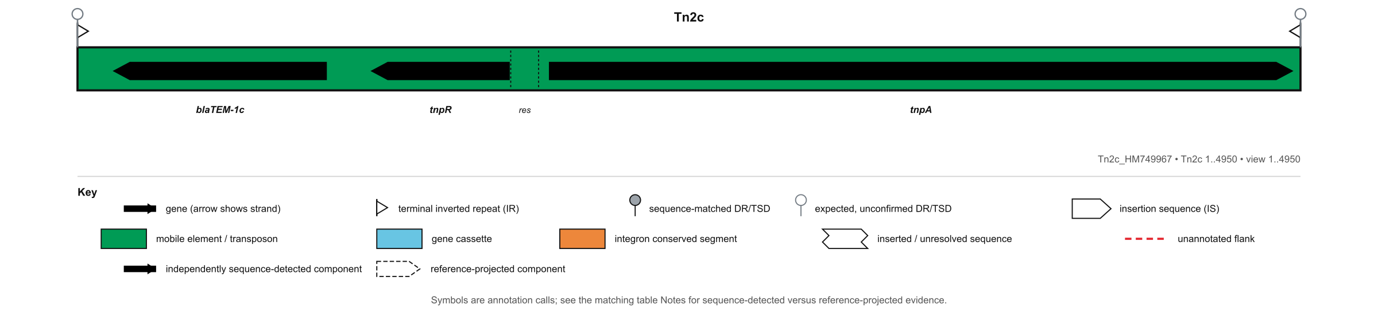
MARA table generated from the same call and evidence ledger.
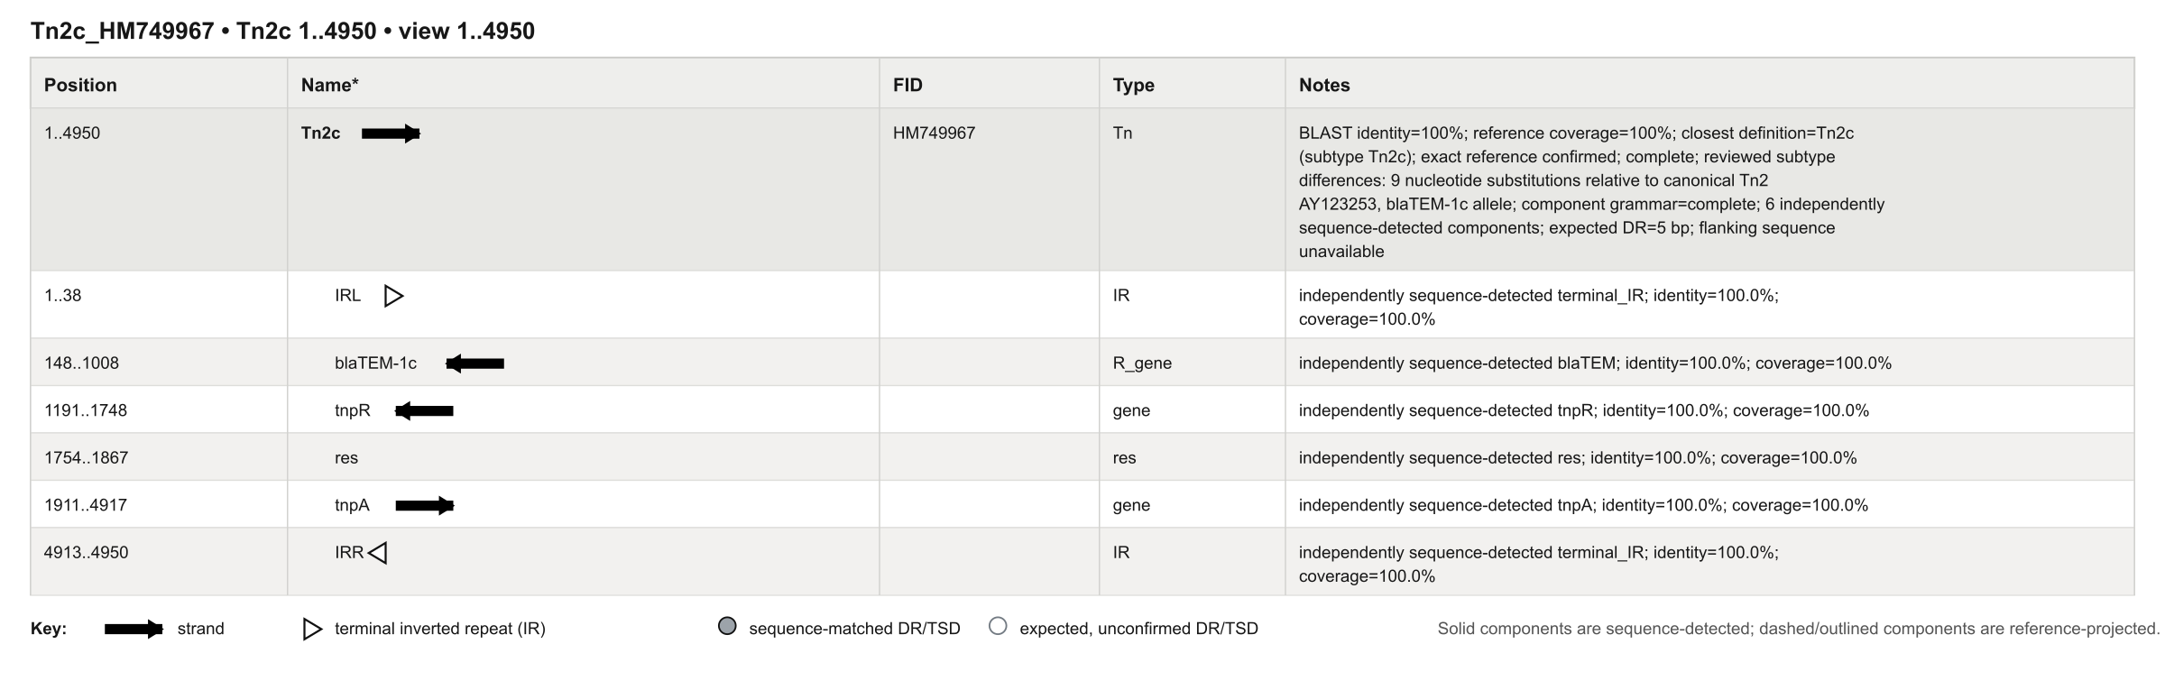

6.4 Evidence detail — Tn2c (HM749967)
Original scale-accurate hierarchical view. Parent-child nesting is preserved.
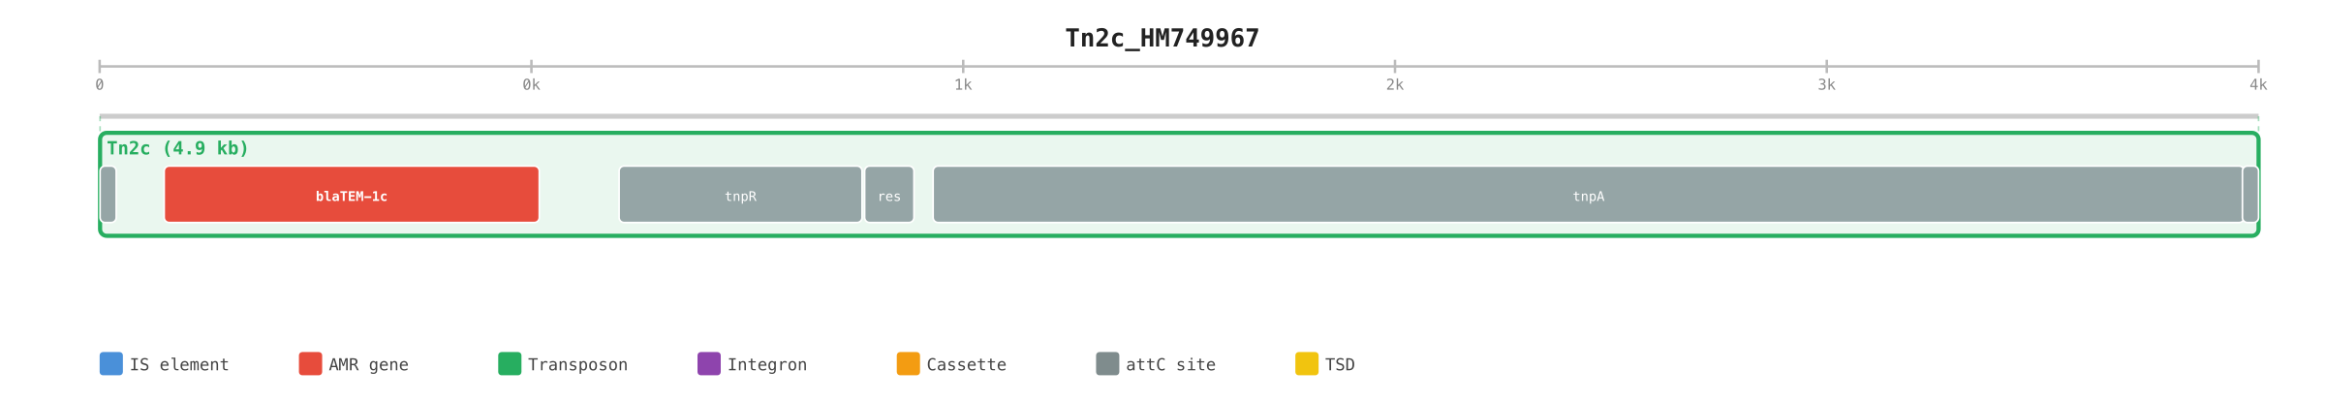
Role | Feature | Coordinates | Strand | Identity | Coverage | Evidence
terminal_IR | IRL | 1–38 | . | 100.00% | 100.0% | sequence_detected
blaTEM | blaTEM-1c | 148–1,008 | - | 100.00% | 100.0% | sequence_detected
tnpR | tnpR | 1,191–1,748 | - | 100.00% | 100.0% | sequence_detected
res | res | 1,754–1,867 | . | 100.00% | 100.0% | sequence_detected
tnpA | tnpA | 1,911–4,917 | + | 100.00% | 100.0% | sequence_detected
terminal_IR | IRR | 4,913–4,950 | . | 100.00% | 100.0% | sequence_detected

Definition: Tn2c_HM749967 (version 2026-08-27). Variant status: exact_reference_confirmed. Reference-projected required components: 0. Context features from the reviewed definition: 0.

6.5 Real accession result — Tn2.1 (CP028717)
Input record | Observed call | Coordinates | Whole-locus match | Grammar | Proof
Tn2_1_CP028717 | Tn2.1 | 1–8,979 (+) | 100.0% identity; 100.0% coverage | 6/6 detected; order valid | PASS

Exact match to the 8979 bp interrupted Tn2 structure extracted from CP028717. The Tn2 backbone is complete, including both terminal IRs, and a 4024 bp ISEcp1-associated region interrupts the sequence between canonical reference positions 124 and 129.
MARA-style locus map generated from the detected and assembled features for Tn2_1_CP028717.
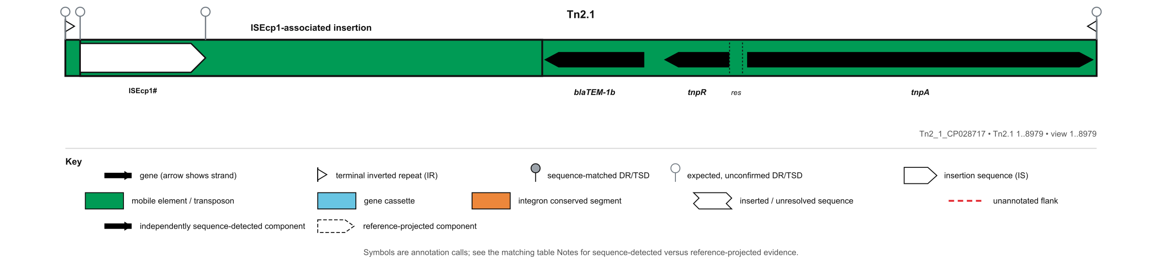

6.5 Continued — Tn2.1 MARA feature table
MARA table generated from the same call and evidence ledger.
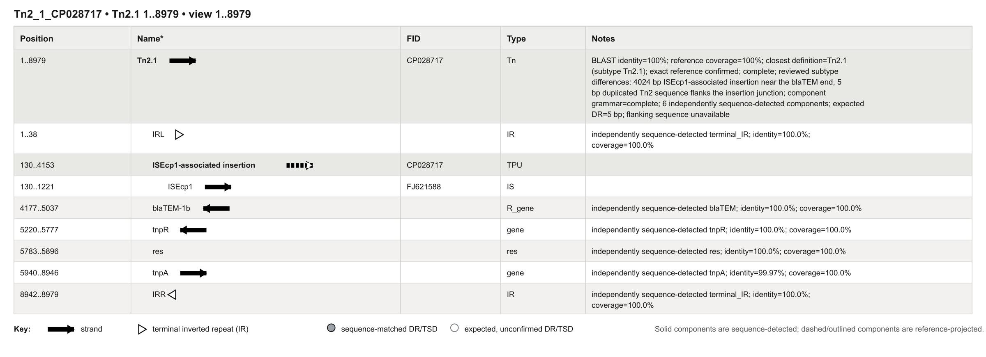

6.5 Evidence detail — Tn2.1 (CP028717)
Original scale-accurate hierarchical view. Parent-child nesting is preserved.
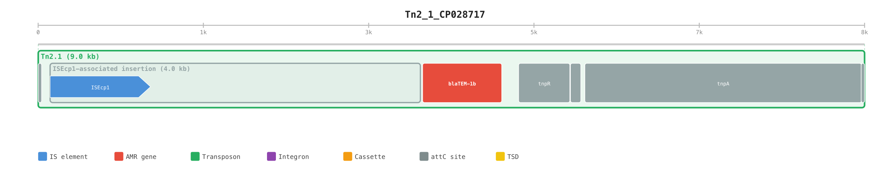
Role | Feature | Coordinates | Strand | Identity | Coverage | Evidence
terminal_IR | IRL | 1–38 | . | 100.00% | 100.0% | sequence_detected
blaTEM | blaTEM-1b | 4,177–5,037 | - | 100.00% | 100.0% | sequence_detected
tnpR | tnpR | 5,220–5,777 | - | 100.00% | 100.0% | sequence_detected
res | res | 5,783–5,896 | . | 100.00% | 100.0% | sequence_detected
tnpA | tnpA | 5,940–8,946 | + | 99.97% | 100.0% | sequence_detected
terminal_IR | IRR | 8,942–8,979 | . | 100.00% | 100.0% | sequence_detected

Definition: Tn2_1_CP028717 (version 2026-08-27). Variant status: exact_reference_confirmed. Reference-projected required components: 0. Context features from the reviewed definition: 2.

6.5 Nested locus — ISEcp1-associated insertion
The interrupted Tn2.1 definition contains a separately indexed ISEcp1-associated locus. It is drawn independently as well as inside the whole Tn2.1 view.
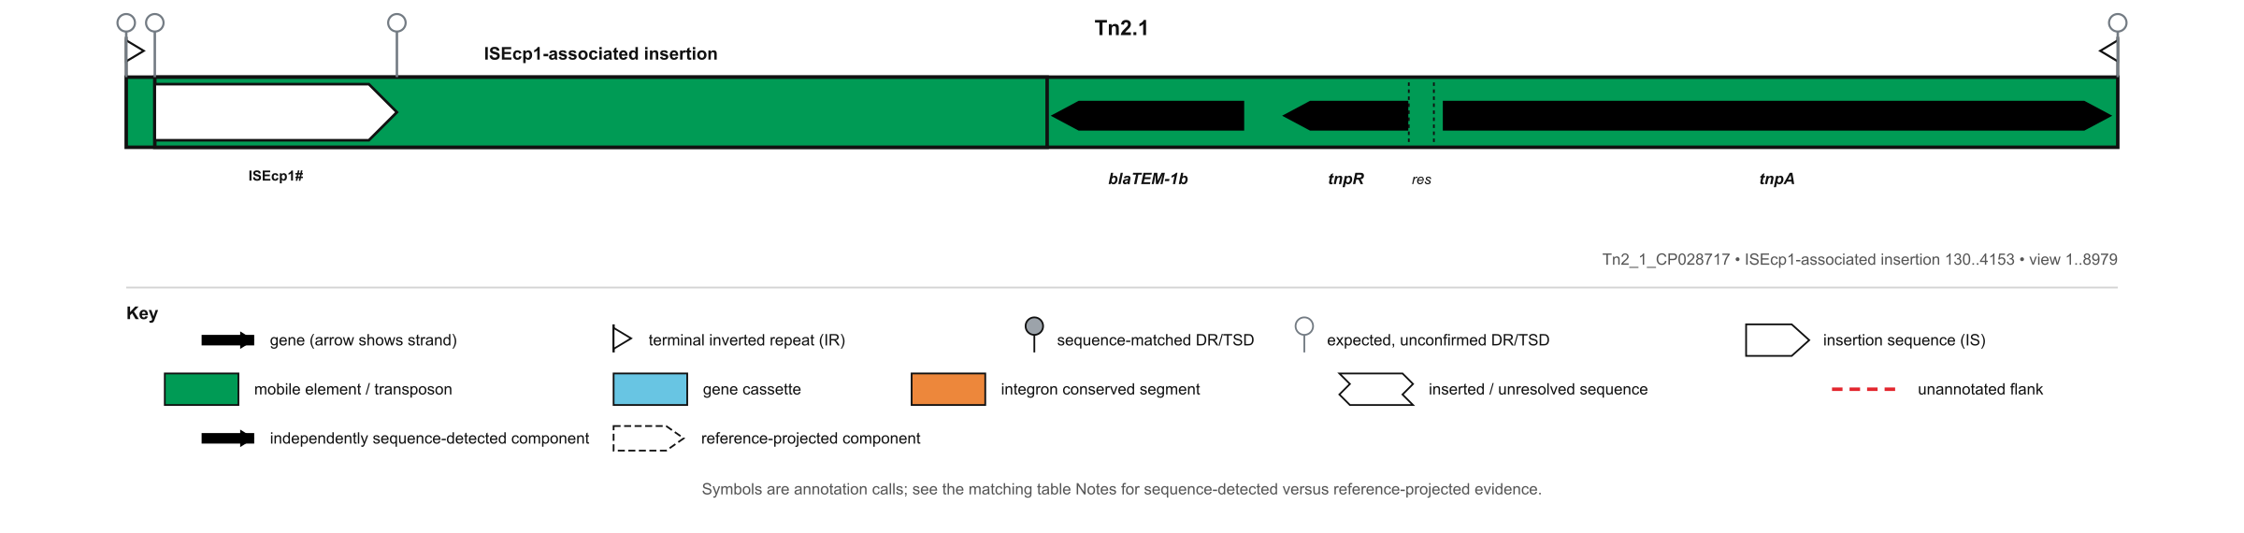
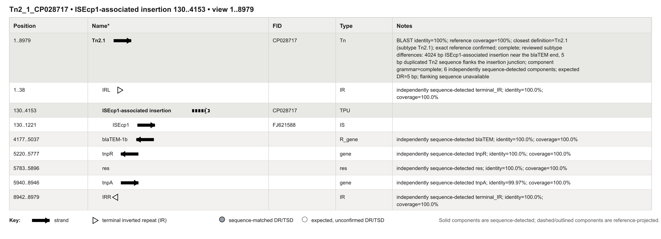

6.6 Real accession result — Tn1Mer (GQ160960)
Input record | Observed call | Coordinates | Whole-locus match | Grammar | Proof
Tn1Mer_GQ160960 | Tn1Mer | 1–10,491 (+) | 100.0% identity; 100.0% coverage | 6/6 detected; order valid | PASS

Exact match to the 10491 bp interrupted Tn1 structure in GQ160960. The outer Tn1 grammar is complete, while a defective 5537 bp Tn5036-like transposon interrupts the Tn1 backbone. This is a named interrupted subtype, not the canonical Tn1 reference.
MARA-style locus map generated from the detected and assembled features for Tn1Mer_GQ160960.
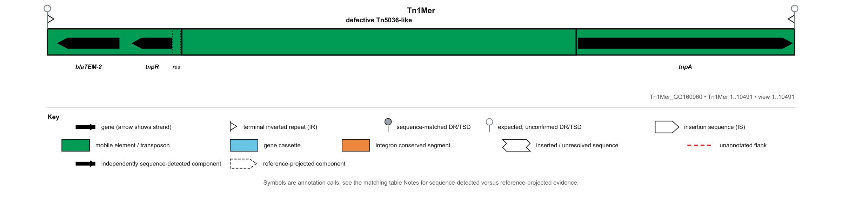
MARA table generated from the same call and evidence ledger.
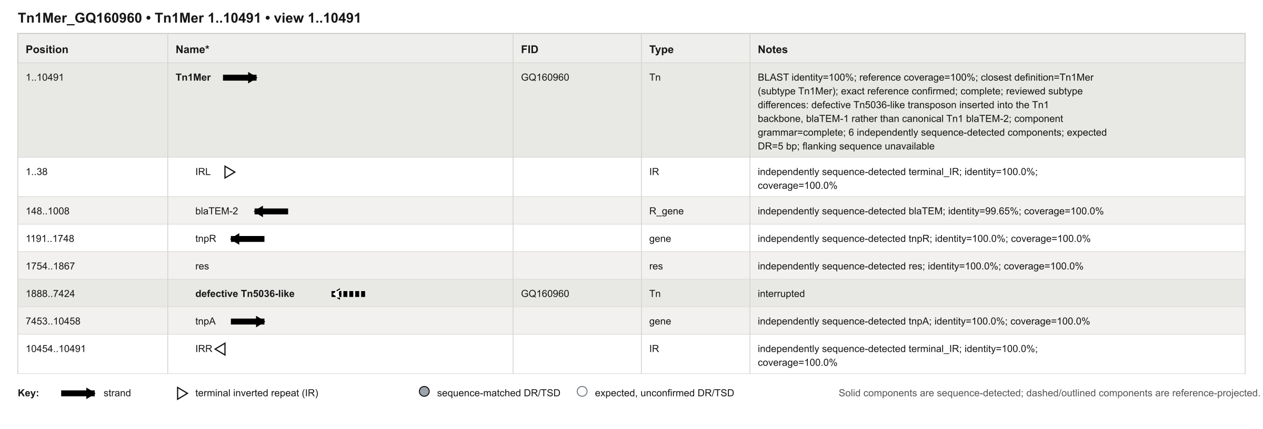

6.6 Evidence detail — Tn1Mer (GQ160960)
Original scale-accurate hierarchical view. Parent-child nesting is preserved.
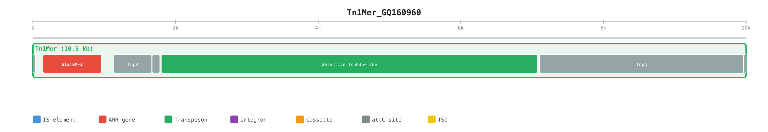
Role | Feature | Coordinates | Strand | Identity | Coverage | Evidence
terminal_IR | IRL | 1–38 | . | 100.00% | 100.0% | sequence_detected
blaTEM | blaTEM-2 | 148–1,008 | - | 99.65% | 100.0% | sequence_detected
tnpR | tnpR | 1,191–1,748 | - | 100.00% | 100.0% | sequence_detected
res | res | 1,754–1,867 | . | 100.00% | 100.0% | sequence_detected
tnpA | tnpA | 7,453–10,458 | + | 100.00% | 100.0% | sequence_detected
terminal_IR | IRR | 10,454–10,491 | . | 100.00% | 100.0% | sequence_detected

Definition: Tn1Mer_GQ160960 (version 2026-08-27). Variant status: exact_reference_confirmed. Reference-projected required components: 0. Context features from the reviewed definition: 1.

6.7 Real accession result — Tn3 (V00613)
Input record | Observed call | Coordinates | Whole-locus match | Grammar | Proof
Tn3_V00613 | Tn3 | 1–4,957 (+) | 100.0% identity; 100.0% coverage | 6/6 detected; order valid | PASS

Exact match to V00613 is Tn3 with the declared 9 bp duplication. It is a recognised Tn3 sequence variant, not an exact match to canonical HM749966.
MARA-style locus map generated from the detected and assembled features for Tn3_V00613.
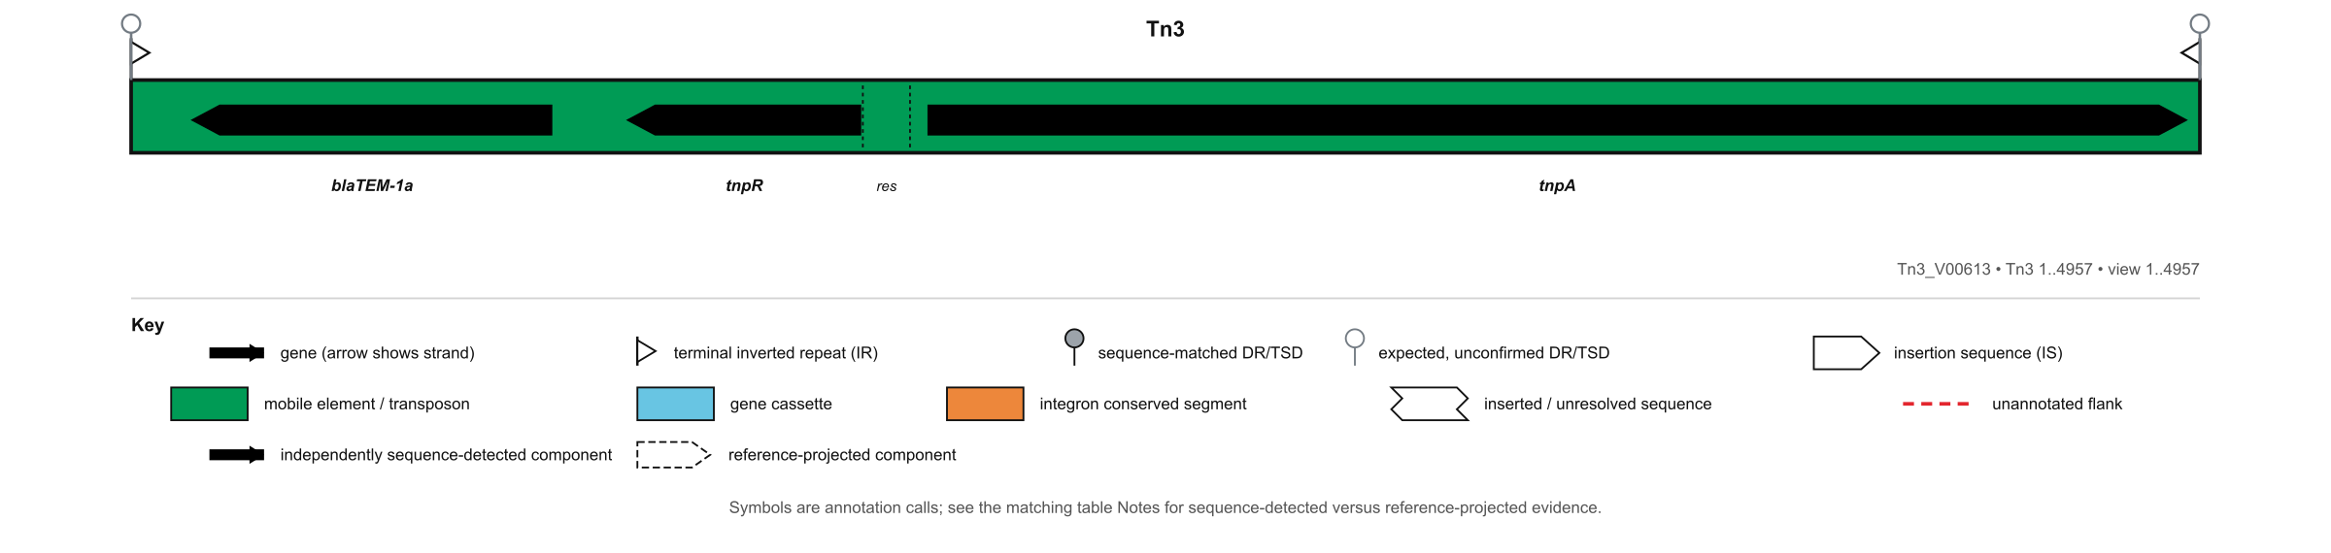
MARA table generated from the same call and evidence ledger.
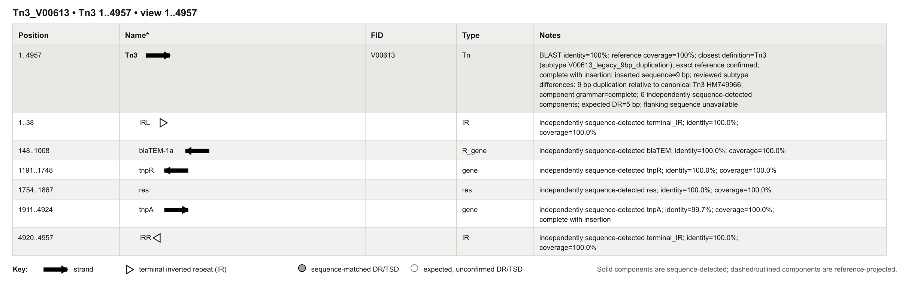

6.7 Evidence detail — Tn3 (V00613)
Original scale-accurate hierarchical view. Parent-child nesting is preserved.
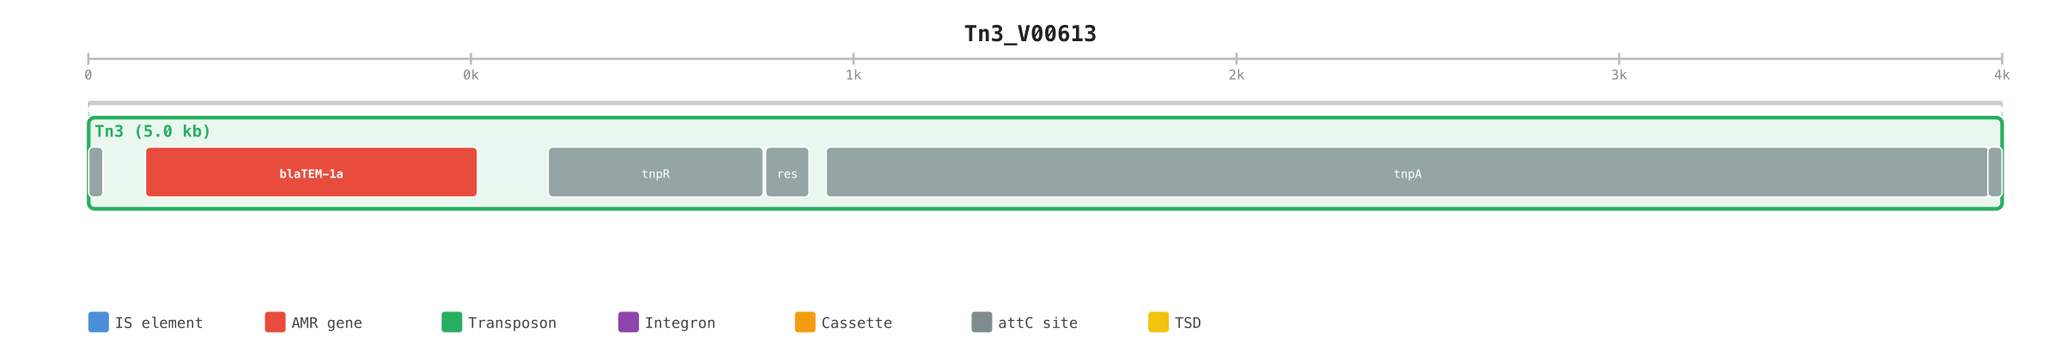
Role | Feature | Coordinates | Strand | Identity | Coverage | Evidence
terminal_IR | IRL | 1–38 | . | 100.00% | 100.0% | sequence_detected
blaTEM | blaTEM-1a | 148–1,008 | - | 100.00% | 100.0% | sequence_detected
tnpR | tnpR | 1,191–1,748 | - | 100.00% | 100.0% | sequence_detected
res | res | 1,754–1,867 | . | 100.00% | 100.0% | sequence_detected
tnpA | tnpA | 1,911–4,924 | + | 99.70% | 100.0% | sequence_detected
terminal_IR | IRR | 4,920–4,957 | . | 100.00% | 100.0% | sequence_detected

Definition: Tn3_V00613 (version 2026-08-27). Variant status: exact_reference_confirmed. Reference-projected required components: 0. Context features from the reviewed definition: 0.

7. Natural partial-fragment result — pEK499 (EU935739.1)
Coordinates | Observed call | Closest type | Reference coverage | Detected required roles | Proof
38,747–40,671 | Tn1/2/3 fragment | Tn2 | 38.89% | blaTEM, tnpR, res | PARTIAL
60,316–62,561 | Tn1/2/3 fragment | Tn2 | 45.37% | tnpA | PARTIAL

This is the key natural-context behaviour: two separated Tn2-related regions are retained independently. Neither contains both terminal ends and all required components, so the software does not join them or call an exact Tn2.
Original hierarchy view for the complete 117,536 bp pEK499 record.
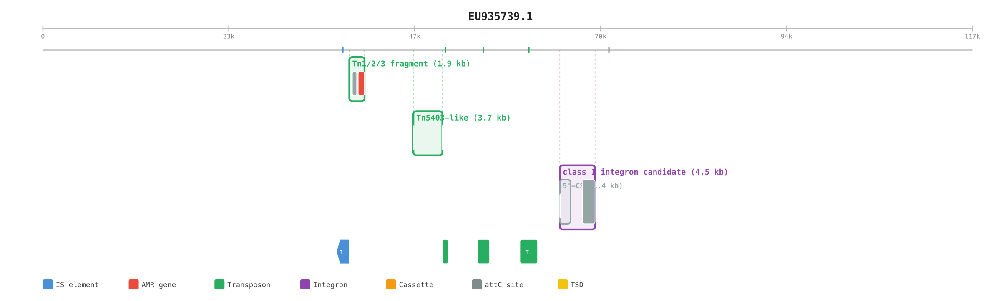

7.1 pEK499 fragment 38,747–40,671
Observed call: Tn1/2/3 fragment; closest reviewed type: Tn2; identity 100.0%; reference coverage 38.89%; proof verdict PARTIAL.
MARA-style locus map. Missing element ends/components remain visibly absent.
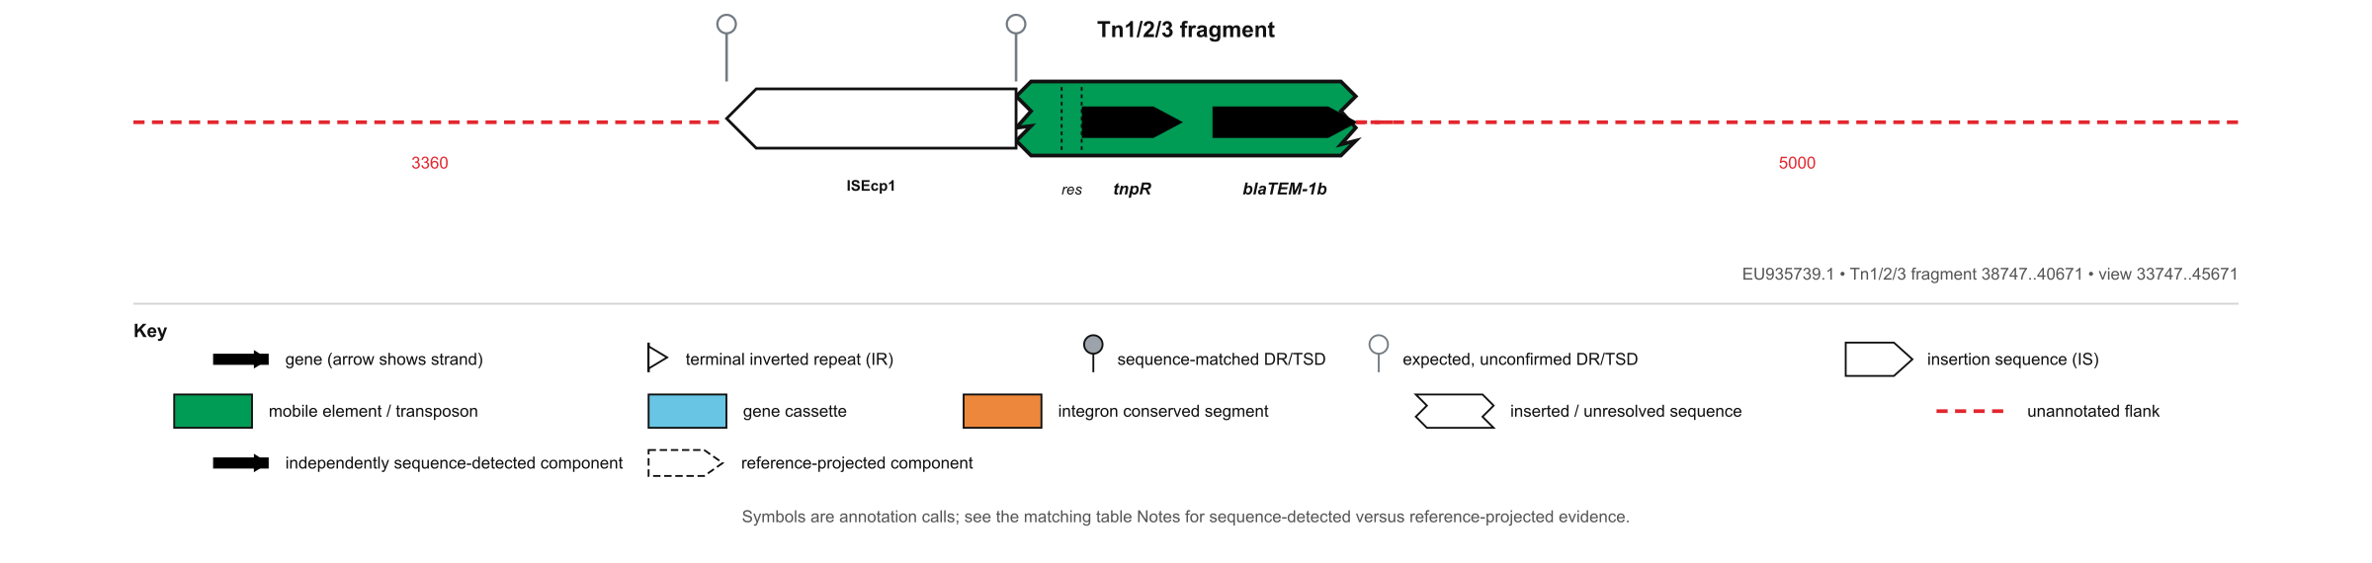
MARA table for the partial call. The partial status and incomplete grammar are explicit.
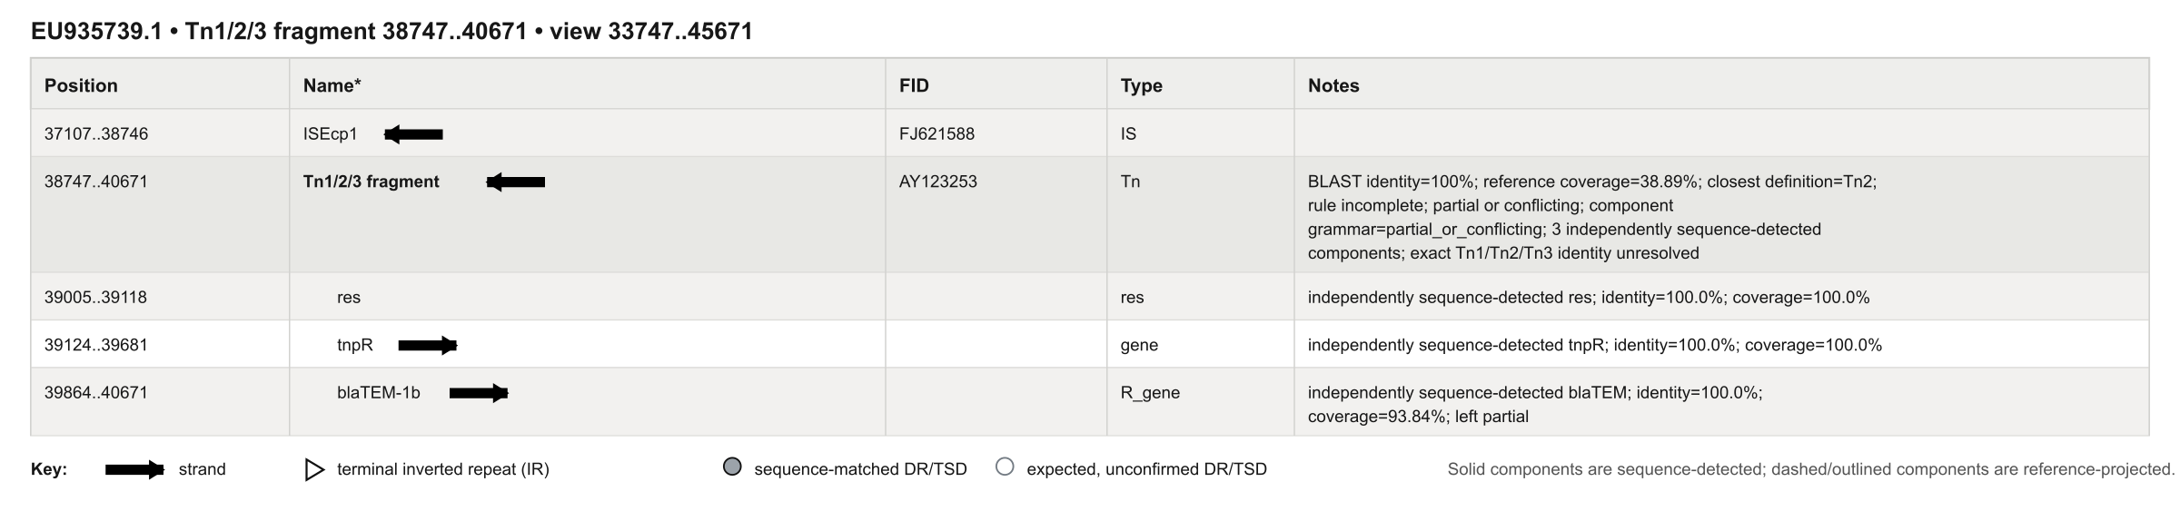

7.2 pEK499 fragment 60,316–62,561
Observed call: Tn1/2/3 fragment; closest reviewed type: Tn2; identity 100.0%; reference coverage 45.37%; proof verdict PARTIAL.
MARA-style locus map. Missing element ends/components remain visibly absent.
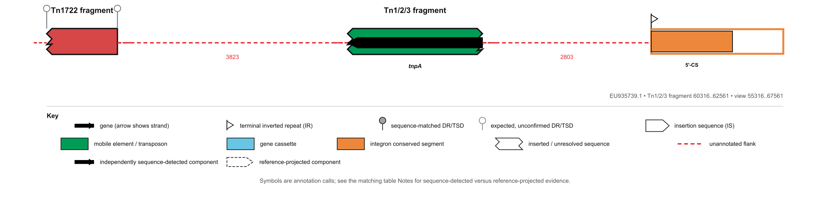
MARA table for the partial call. The partial status and incomplete grammar are explicit.
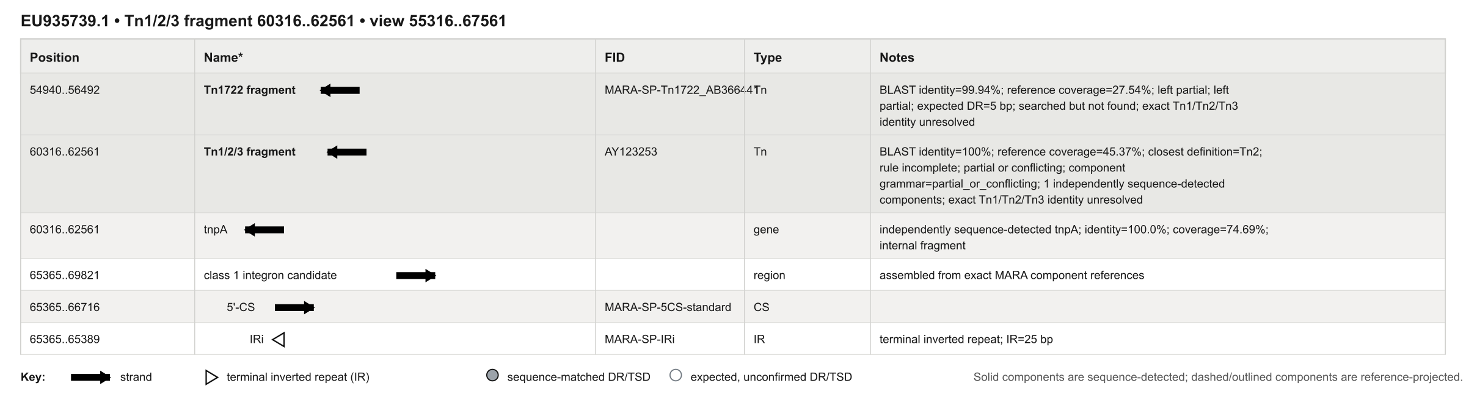

8. Arbitrary-sequence demonstration
A single 44,647 bp contig was constructed with unrelated flanking sequence and three loci: a Tn1-derived sequence with 25 substitutions, a Tn2-derived sequence with an approximately 800 bp internal insertion, and a reverse-complement Tn3-derived sequence. It was processed with --profile tn123-components, which excludes complete Tn1/Tn2/Tn3 reference lookup. Every biological call below therefore comes from detected components and expert rules.
Coordinates | Call | Strand | Rule type | Component score | Whole-element lookup | Proof
8,001–12,949 | Tn1-like | + | Tn1 | 99.592 | none | PASS
19,950–25,699 | Tn2-like | + | Tn2 | 100.0 | none | PASS
31,700–36,647 | Tn3-like | - | Tn3 | 100.0 | none | PASS

Original hierarchy view: all three loci are retained on their shared contig and nested features remain visible.
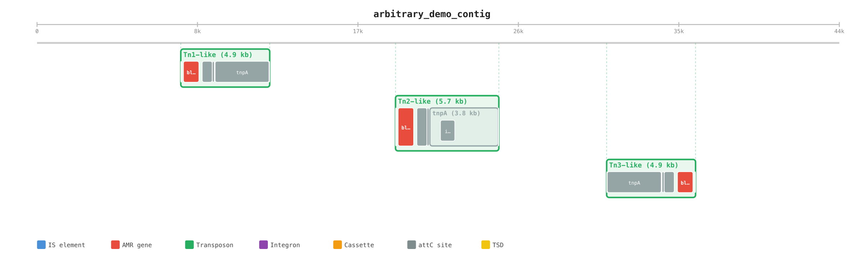

8.1 Arbitrary contig locus — Tn1-like
The component grammar is complete and the expert component-profile rules assign Tn1. No complete Tn1/Tn2/Tn3 reference comparison was run; the visible call is Tn1-like. Insertions and other structural differences are retained from split component alignments and shown in the map/table.
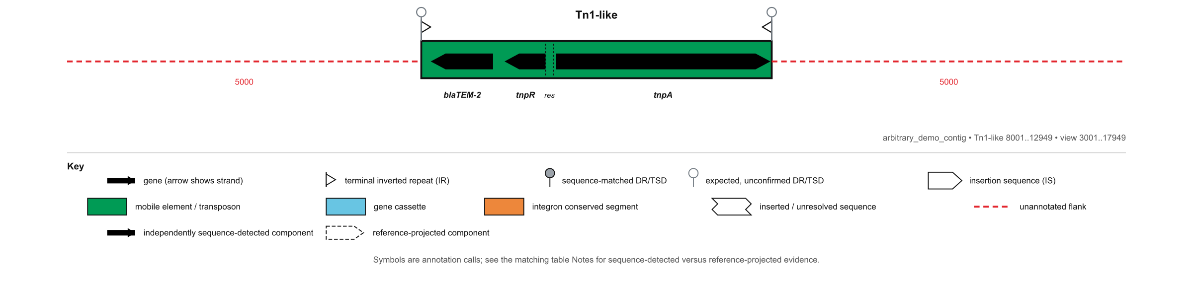
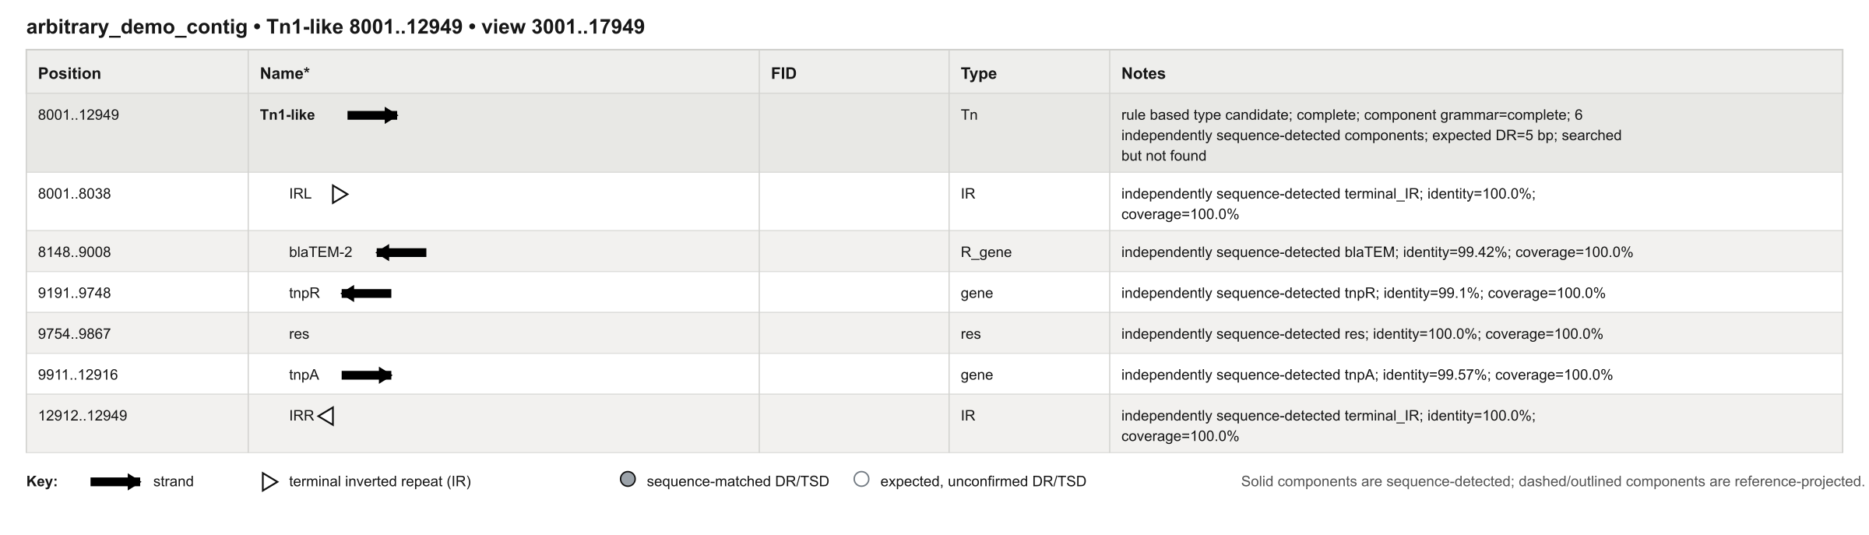

8.2 Arbitrary contig locus — Tn2-like
The component grammar is complete and the expert component-profile rules assign Tn2. No complete Tn1/Tn2/Tn3 reference comparison was run; the visible call is Tn2-like. Insertions and other structural differences are retained from split component alignments and shown in the map/table.
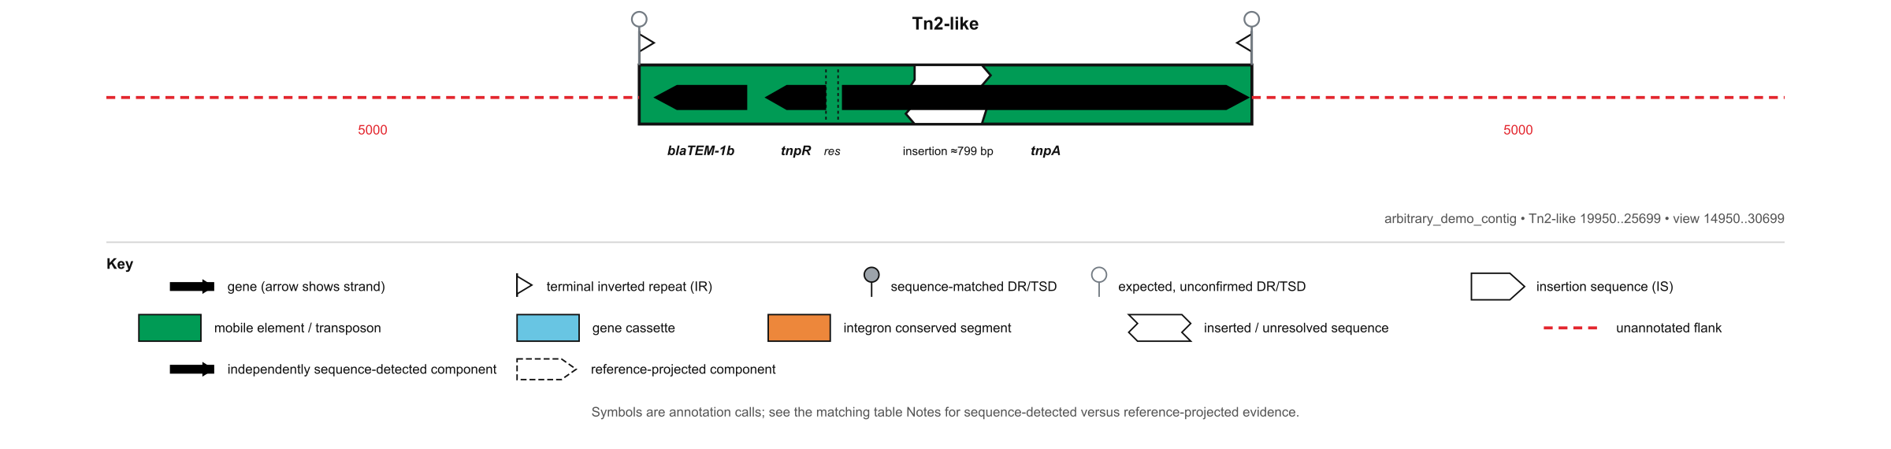
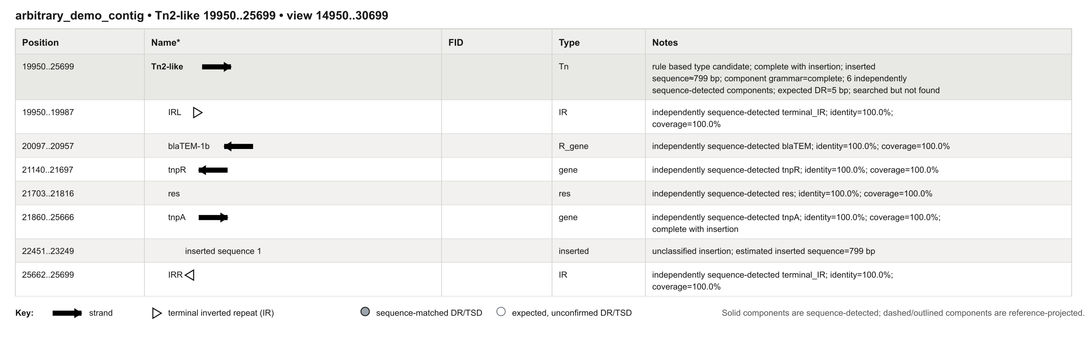

8.3 Arbitrary contig locus — Tn3-like
The component grammar is complete and the expert component-profile rules assign Tn3. No complete Tn1/Tn2/Tn3 reference comparison was run; the visible call is Tn3-like. Insertions and other structural differences are retained from split component alignments and shown in the map/table.
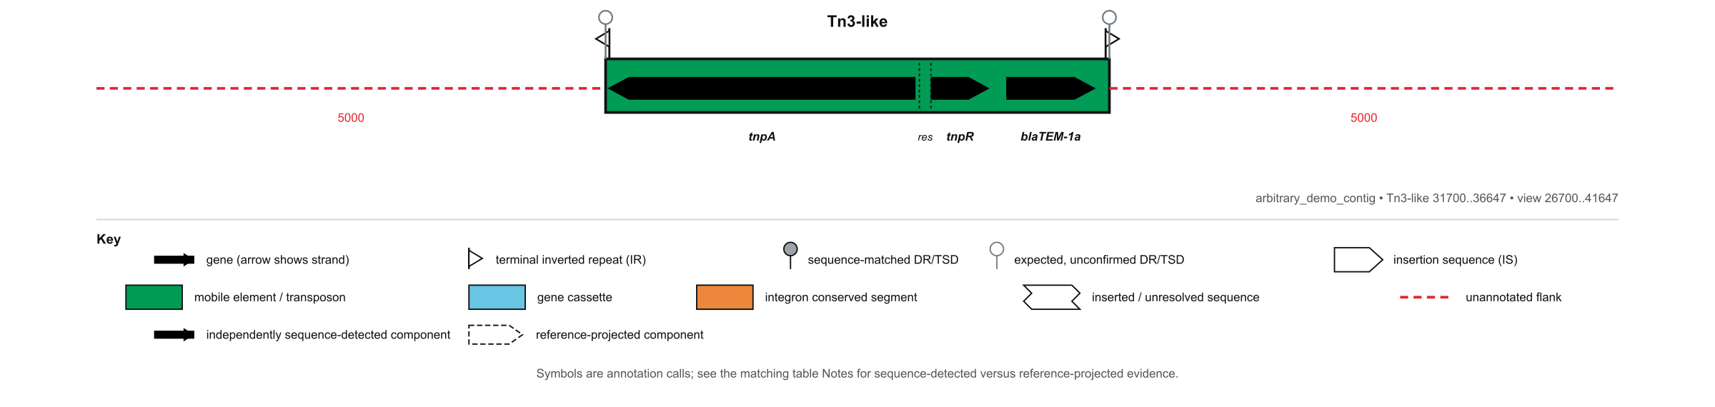
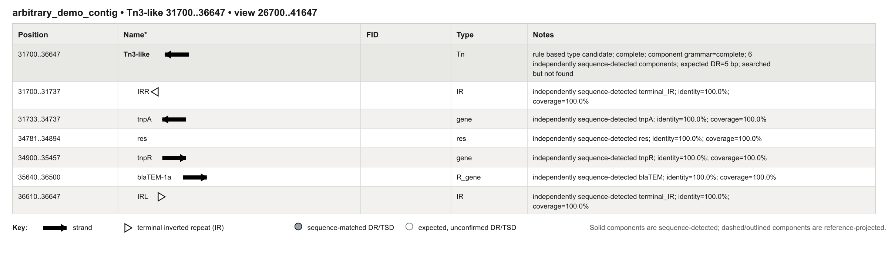

9. Output package and interpretation
Output | Purpose
annotation.json | Complete machine-readable hierarchy, identifiers, coordinates, evidence, definitions and confidence.
annotation.gff3 | Interoperable genomic feature annotation.
annotation.cell | Original nested CellGen/Wolvercote representation.
hierarchy/*.svg | Original scale-accurate parent-child view of the record.
mara/*.svg | Readable locus-centred MARA-style map with its own legend/key.
mara-table/*.svg | MARA-style feature/evidence table for the same locus.
proof/report.html | Linked human-readable evidence report.
proof/proof.json; components.tsv; matches.tsv | Machine-checkable component-to-call ledger.
run.json | Run metadata plus direct paths to every generated locus map and table.

CellGen example
({{}IRL, {}blaTEM-2, {}tnpR, {}res, {}tnpA, {}IRR}Tn1[family="Tn1"])Tn1_NC_008357
The CellGen line carries the same nesting as the hierarchy graphic: the six components are children of Tn1, which belongs to the input record.

How to read the figures
- The MARA locus map prioritises biological readability around one locus.
- The MARA table is the feature-by-feature description, including evidence and call qualification.
- The hierarchy view preserves scale and parent-child nesting across the whole record.
- The proof ledger separates sequence-detected required components from context added from a reviewed subtype definition.
- The legend/key is embedded in every MARA map and table so the symbols are interpretable without prior MARA experience.

10. Limitations and what should happen next
What is proven now
The implementation can recover the defined components, apply reviewable Tn1/Tn2/Tn3 rules, distinguish exact from qualified and partial calls, and generate the complete set of requested outputs on the included controls and demonstrations.
What is not yet proven
- Population-level sensitivity and specificity across a large independent accession panel.
- Exhaustive subtype coverage or complete parity with every component and compound element described across all MARA papers.
- Assigning a new formal element name to a previously undescribed structure without expert review; novel candidates within the defined family are deliberately reported as type-like.
- Target-site duplication evidence when the input sequence ends exactly at the element boundary or lacks sufficient flank.
- Consistent optional-detector availability on every installation; the built-in validated scan is the portable core.
Recommended next validation
Have Sally review the human-readable definitions and the embedded figures; freeze accepted naming decisions; then evaluate a blinded accession set containing true Tn1/Tn2/Tn3 examples, close variants, fragmented assemblies and related Tn3-family elements. Report locus-level precision/recall, boundary error and exact-versus-qualified naming accuracy.

Expert decisions still requested
- Confirm whether HM749967 should be displayed as Tn2c.
- Confirm the preferred name and internal labels for the CP028717 interrupted Tn2.1 structure.
- Confirm whether Tn1Mer is a public named subtype or an interrupted Tn1 example.
- Confirm the preferred wording for V00613 relative to canonical HM749966.
- Supply or approve additional type/subtype definitions and negative controls for the next expansion.

