check site

we have already one old script with custom work.

But i have setup new script now on domain.

But in 1 month or more days later, we will have another next update too.

The first thing I want you to do is the custom work for Referral Leaderboard, Chapters(Country Club, and Numbers.

Sngine have some theme. so admin can select on admin panel.

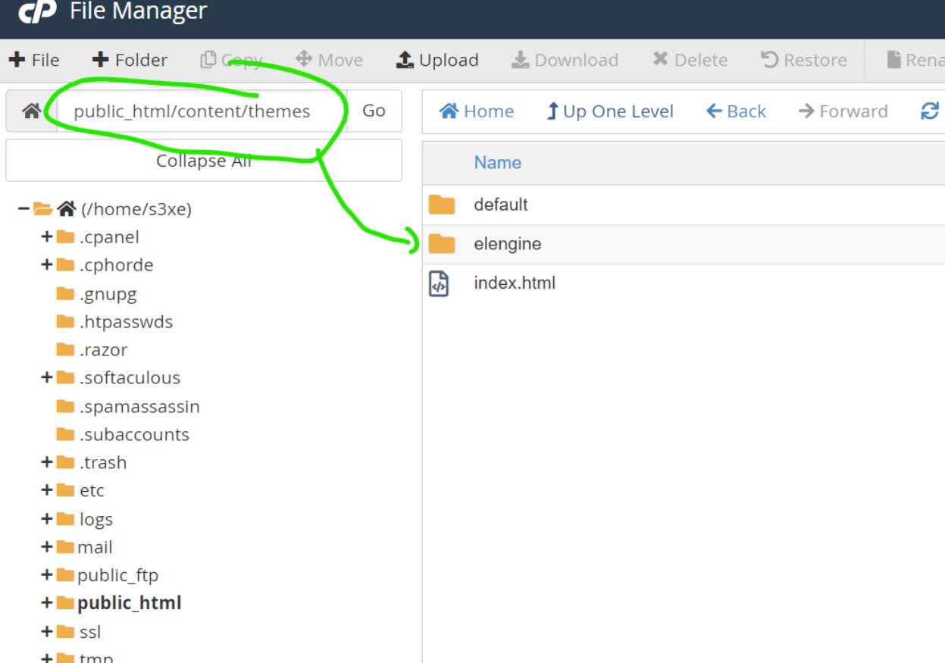

All the new theme info is here

Its really simple using sngine

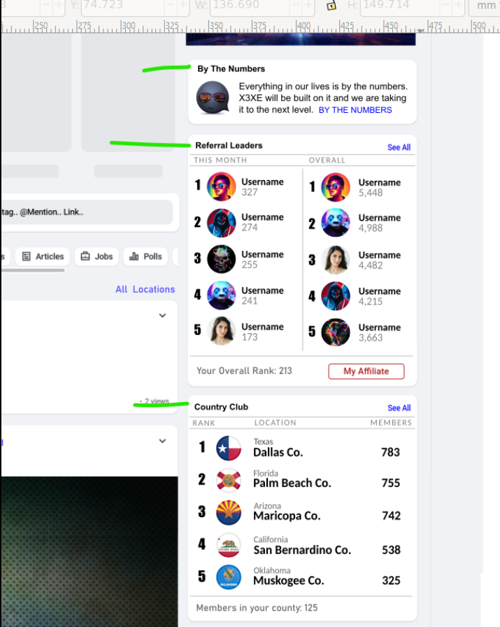

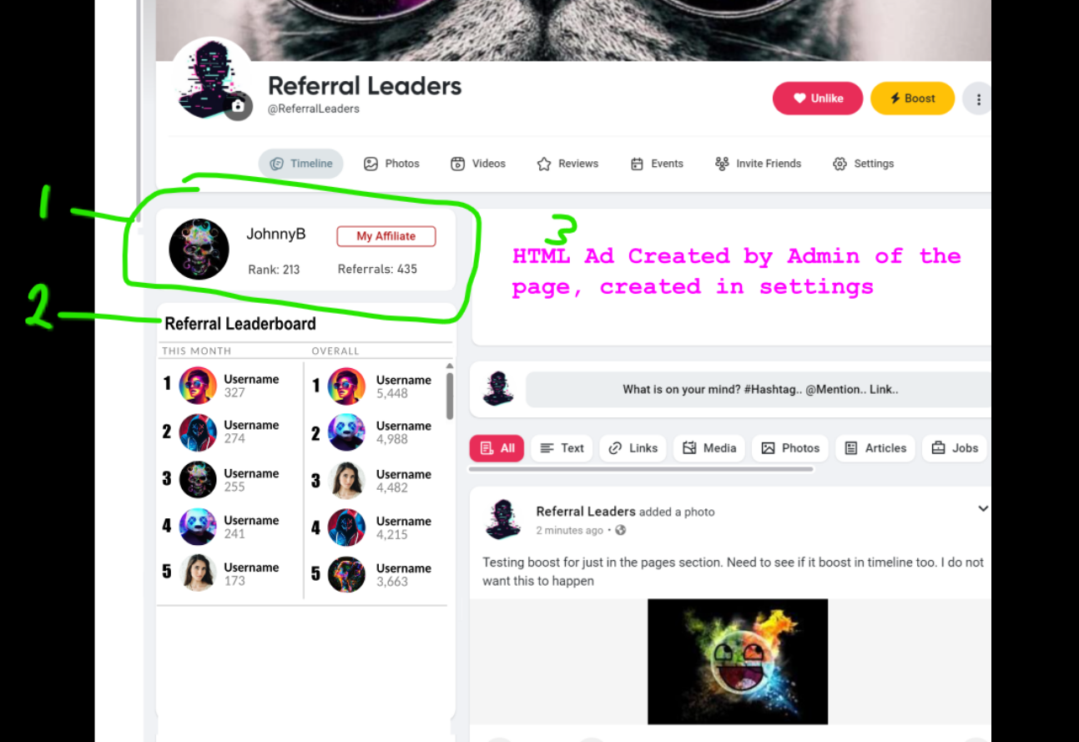

This is how we will do numbers, referrals, and Country Club on the home page. I need you to look at this and let me know if your going to be able to do this

1 2 3 show what I want to add to the pages for numbers, referrals, and country club.

1 shows the users details, avatar, rank, referrals and link to my affiliate. When a user goes to the Referrals leader page... it will show that users details here.

2 shows the details for the leaderboard it will show the top 15 or 20 and scroll for the rest. It only needs to display top 100 referral leaders

3. This will be details added by admin in admin panel and on the page.

================================

I dont think I will be able to complete all the details for this. And I have some questions for you and may need to do a small task first.

1. Country Club is like when we created "Chapters" I dont know if you are going to be doing this work and know what your doing... or if someone else is doing this work and I have to explain everything all over again.

2. I need to know if you can do the State County City feature like I need it done. I will have to fix the details for this to add to this task set

I decided to work with you again because I thought it would be easier to work with since you have done this work before. I thought you would remember how to do your work. Hopefully you will not be completely starting over and having to do the work because we have some done script with some custom work.

the new script was uploaded as a zip

you will see it. it starts with codecanyon and there is not very many zip files, so you download and install in local and see also.

purchase code 366cac43-a898-4e52-814a-5c00515d81f7

this installed on s3xe.com also.

the old script with custom work what another dev worked on is s323.zip

we are going to change Country Club to Chapters so its easier to keep up with

I have been working on the details for about 12 hours. I am still not done.

I have to figure out how to do the States Counties and Cities

I want to use the Location/Countries feature and make it where the drop menu will work and searchable

I will send you some details about what I want in a little while and you can help me figure out how you want to do it

We can get state/county/cities data from s323 zip script

--- I am explaining for more details on state, county, city now.

This is first task sets.

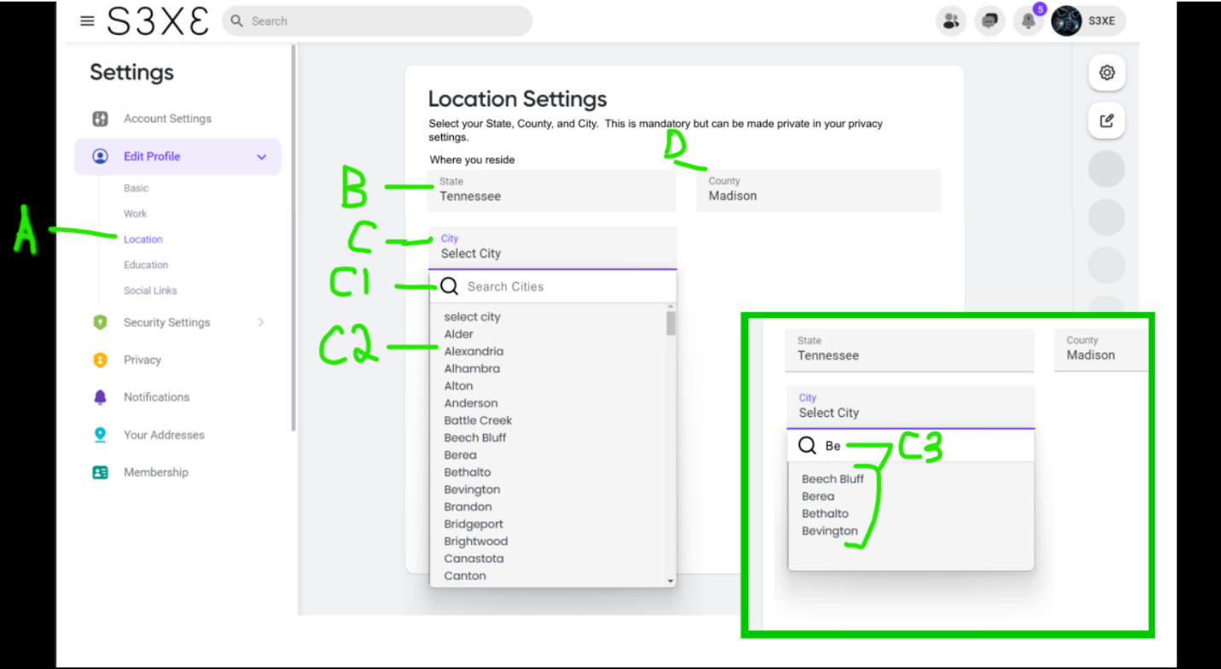

This is how I want the State County City to work. This will have to be done first before the rest of the tasks. This screenshot is an example of how it will work. I will provide more details where the State County City menu needs to be placed.

A. this is where Location for users can change it. The State, County, and City will already be selected when user fills out the start up section.

B. The user can select their State here. Its a basic drop showing all US States

C. The user can select their City here.

C1. There is a search option to narrow down the city they are looking for. The user can choose State and then City or State and then County. If they select State and then City, the County will auto fill.

C2. When the user clicks the drop menu for City it will show all cities available for that State and they can scroll. But there is a lot of cities in some states so we are adding the search feature.

C3. When the user begans to type is will narrow down the cities to match what hey are typing. They can then select from available cities.

D. The County select will work the same as Cities with search in the drop menu. When a user selects a county it will show all cities in that county in the City select. The user has to select State first but can filter results using Cities or counties.

https://www.w3schools.com/howto/tryit.asp?filename=tryhow_css_js_dropdown_filter

This is one example of how the search in drop menu works

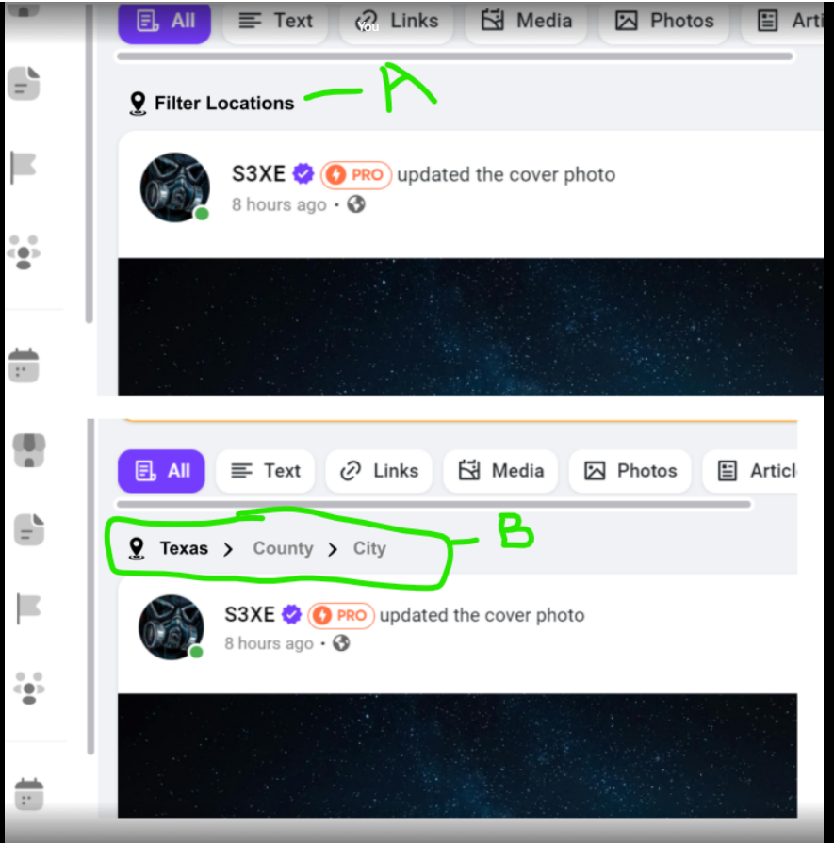

A. The country filter is already a part of the Timeline on homepage. It needs to be changed to State County City

B. This will work the same was as the other State County City drop menus. When a state is selected it will show the state and the option to select the County or City. If City is selected first then County will auto fill. If County is selected then that counties Cities will auto populate.

NOTE: State drop menu will show all states. County and city menus will show the counties and cities with the search filter to narrow down the options.

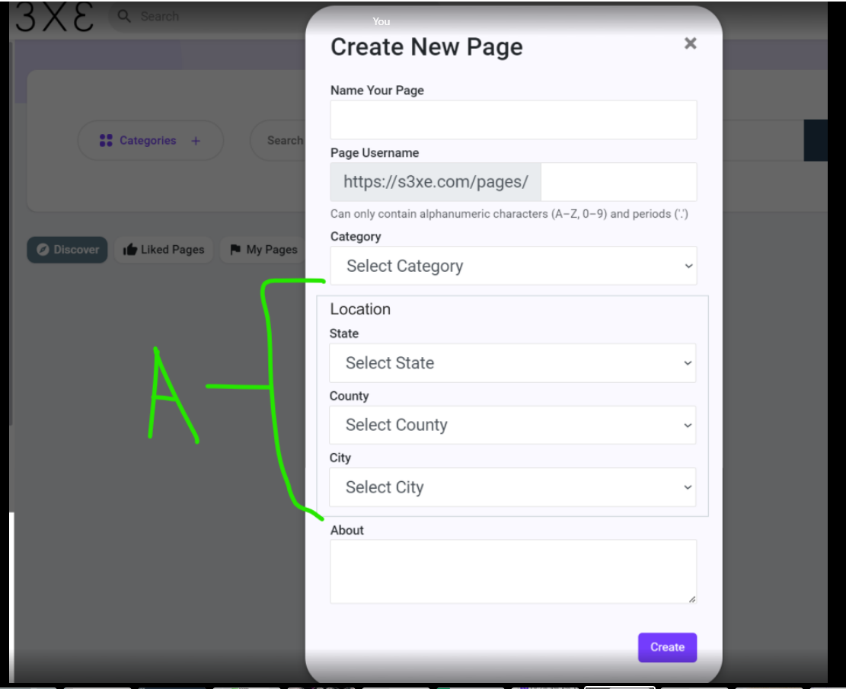

A. Countries is an option in the script for Pages. It needs to be changed to the State County City drop menu

NOTE: I will create details for users to filter Pages by State County City. I would also like this option added to groups

We will be adding State County City filter to "People" search page as well. I need more time to do this.

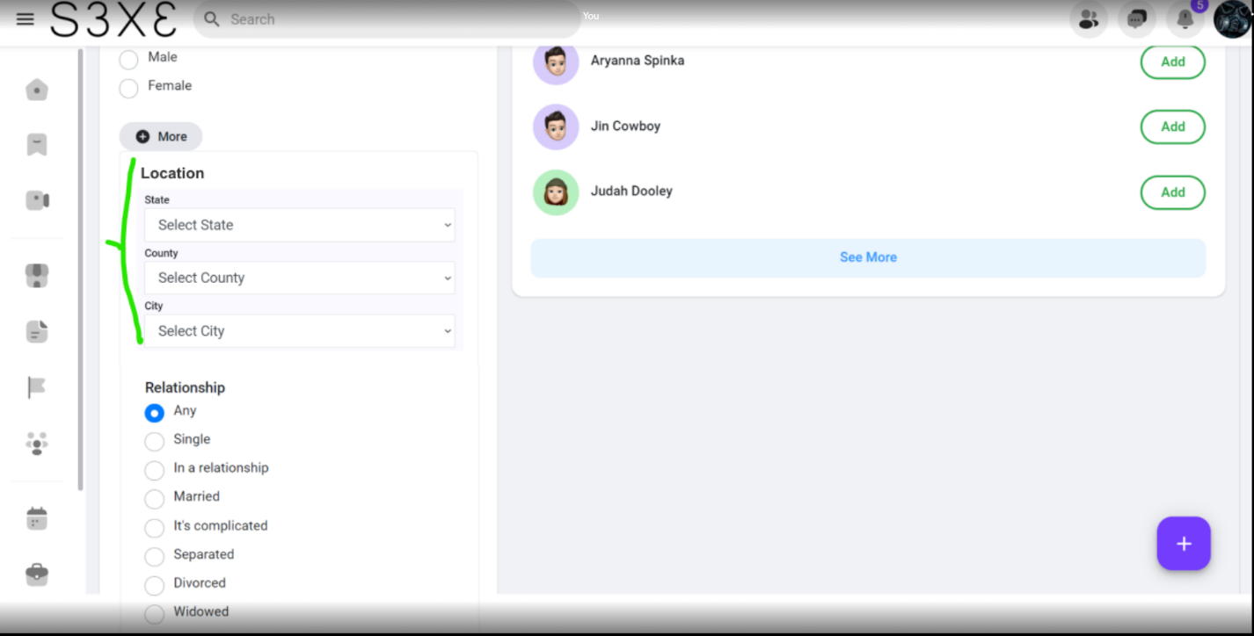

This is people search page.... it needs to go below the more button

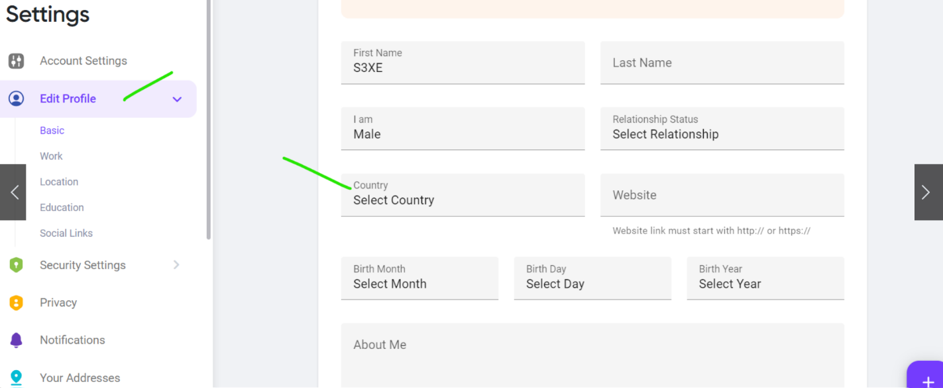

We do not need country here. It can be removed. Location(State County City) will be located in Users Settings - Locations

You can leave that there and Ill use it for something else... but country does not need to function there

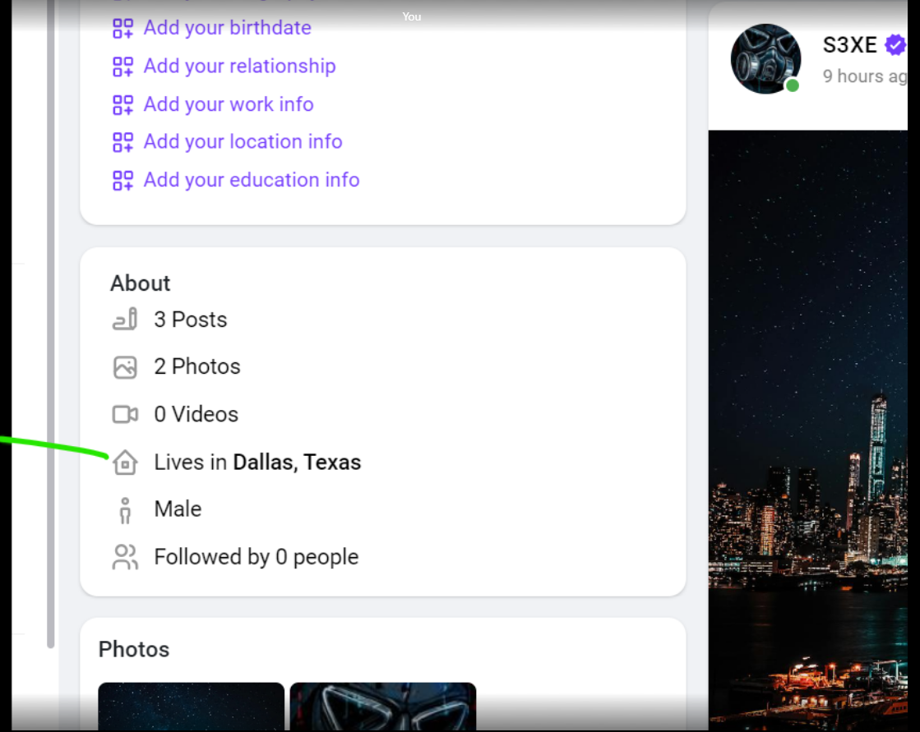

The Users City, State will show here. We are not using the "Current City" in the Locations page. We will be using State County City. That is where the City, State for "Lives In" will go

In the users Location Settings... leave the "Hometown" option

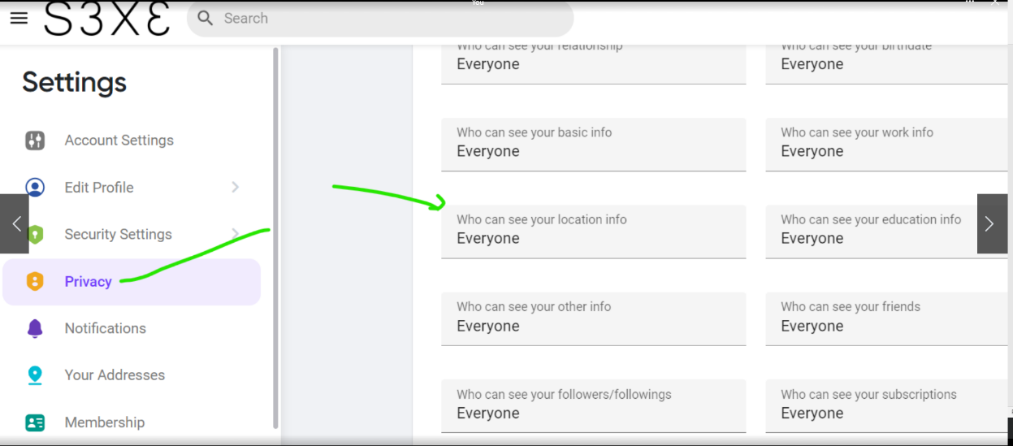

The Privacy filter needs to work for State County City. If its private it will not show up in people search or in profile page

I am not 100% sure where else I will use it. But I need this done so that I can create other details.

I need state flags to show when the user selects their state. you can check this in old script s323 zip if you have access to cpanel, i will send you the flags. We are going to use round flags

I will also create details to show you where the the flags will go.

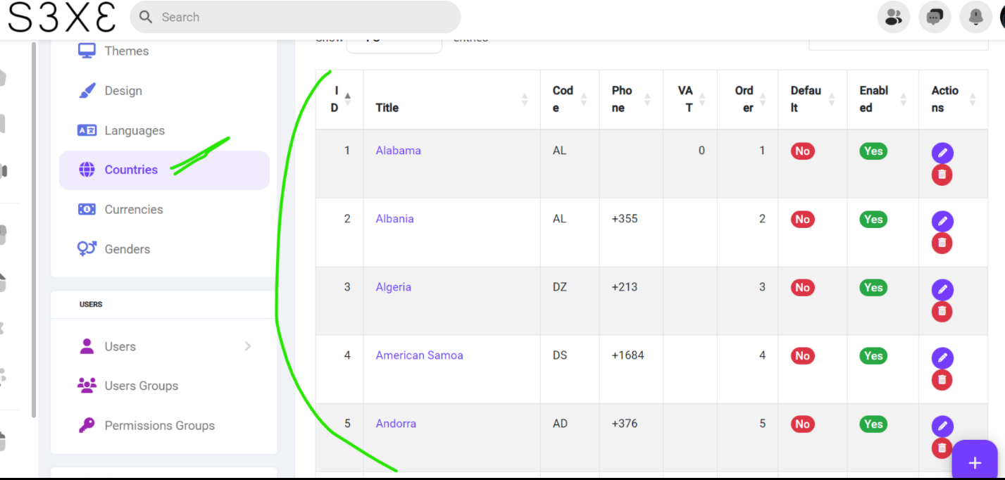

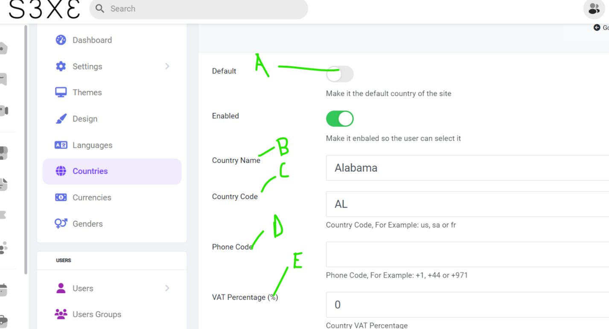

I wanted to know if we could use "Countries" feature to change to States and add the State Abb, flags, counties, cities in here

A. remove this

B. Change this to the State

C. Change this to the states abbreviation

D and E remove......... Add the option to add the states flag, counties and cities

If we can... I can change the Countries to States and remove the remaining countries.

If we use this I would like for the states be added to the First 50 and delete the rest

I will have to do that another time.

More Task details will be provided to you later.