**Indian Prison Statistics**

India is 2nd most populous country and 7th largest country in the world with population of 139.34 crores as of 2021. The administration of prisons is a state subject that falls under item 4 of the State List in the Seventh Schedule of the Indian Constitution. The administration and organization of jails falls solely in the space of the State legislatures, and is administered by the Penitentiaries Act, 1894 and the Jail manuals of the particular state legislatures. The Central Government provides assistance to the states to improve prison security, repair and renovate outdated prisons, develop borstal schools, provide facilities for women offenders, provide vocational training, modernize prison industries, train prison personnel, and construct high-security enclosures. As a result, the states have the primary role, responsibility, and authority to alter the current prison laws, rules, and regulations.

In its decisions on various aspects of prison administration, the Supreme Court of India established three broad principles regarding imprisonment and custody. First of all, a person who is behind bars does not become a non-person. Second, an individual in jail is qualified for all common liberties inside the limits of detainment. Third, there is no avocation for disturbing the enduring currently inborn during the time spent imprisonment. Out of 5,54,000 prisoners, 4,27,000 were awaiting trial, with 24,033 undertrials already in jail for three to five years, according to data from the NCRB for 2021. Of the convicts, only 22% were undertrials, and almost half of the undertrials were in prison for more than two years. Prisons had a 130% occupancy rate. In this visualization dashboard we will be discussing the prisoner in the 28 different states.

**Data Acquisition**

The dataset is available under the license of Government Open Dataset License – India. It can be found on the NCRB – National Crime Record Bureau of India as well.

**Website:** <https://data.gov.in/>

**Data Preparation**

The entire prison and a variety of inmate characteristics are included in this dataset. Understanding the Indian prison system better through this will be beneficial. The dataset consists of 37 separate files which can be joined with the base file named as jail wise population of inmates. The list of the files is mentioned below:

1. Details of Jail wise population of prison inmates
2. Details about the list of jails in India at the end of year 2015.
3. Jail category wise population of inmates.
4. Capacity of jails by inmate population.
5. Age group, nationality and gender wise population of inmates.
6. Religion and gender wise population of inmates.
7. Caste and gender wise population of inmates.
8. Education standards of inmates.
9. Domicile of inmates.
10. Incidence of recidivism.
11. Rehabilitation of prisoners.
12. Distribution of sentence periods of convicts in various jails by sex and age-groups.
13. Details of under trial prisoners by the type of IPC (Indian Penal Code) offences.
14. Details of convicts by the type of IPC (Indian Penal Code) offences.
15. Details of SLL (special & local law) Crime head wise distribution of inmates who convicted
16. Details of SLL (special & local law) Crime head wise distribution of inmates under trial
17. Details of educational facilities provided to prisoners.
18. Details of Jail breaks, group clashes and firing in jail (Tranquillity).
19. Details of wages per day to convicts.
20. Details of Prison inmates trained under different vocational training.
21. Details of capital punishment (death sentence) and life imprisonment.
22. Details of prison inmates escaped.
23. Details of prison inmates released.
24. Details of Strength of officials
25. Details of Total Budget and Actual Expenditure during the year 2015-16.
26. Details of Budget
27. Details of Expenditure
28. Details of Expenditure on inmates
29. Details of Inmates suffering from mental ilness
30. Details of Period of detention of undertrials
31. Details of Number of women prisoners with children
32. Details of Details of inmates parole during the year
33. Details of Value of goods produced by inmates
34. Details of Number of vehicles available
35. Details of Training of Jail Officers
36. Details of Movements outside jail premises
37. Details of Details of electronic equipment used in prison

I have pre-processed these files by cross checking the respective data type, null value detection and most important was joining the file. Each files have column which an be joined by the main file known as jail wise population of inmates. I have used state name and year to join these separate files. I have used the seven different files which can be seen in the below images:

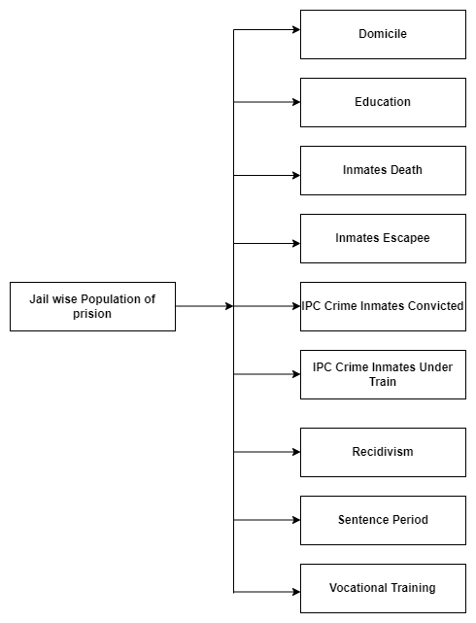

**Exploratory Data Analysis and Visualizations**

1. **Overall Graph – Statewide**

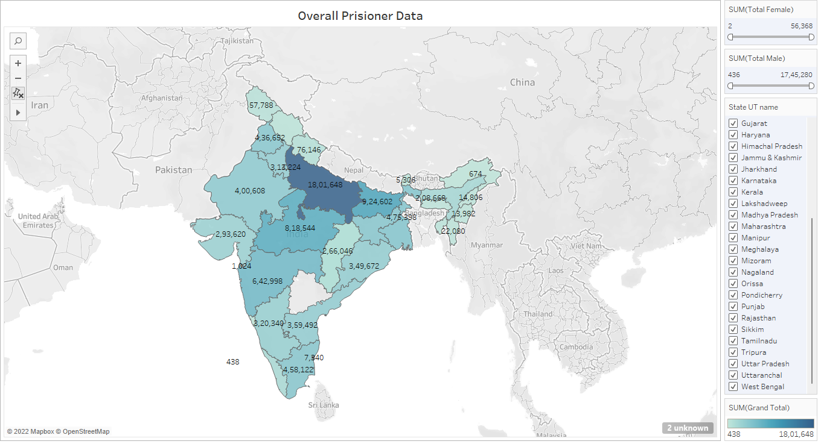

The above graph shows the overall data of prisoner in all over the state as well as the union territories. As we can see that Uttar Pradesh has 18,01,648 highest number of the prisoner in the India whereas the Lakshadweep has 438 the lowest number of prisoners. The graph has option to filter the data based on the states, count of Men and Women in the states. If we narrow down the filer to see the highest women and men prisoner in the state we can see Uttar Pradesh is the states which has highest sum of men and women prisoner count. We can say that Uttar Pradesh is the largest state in India which has highest number of the prisoner count as well as highest number of the individual men and women prisoner.

1. **Type of Prison- Statewide**

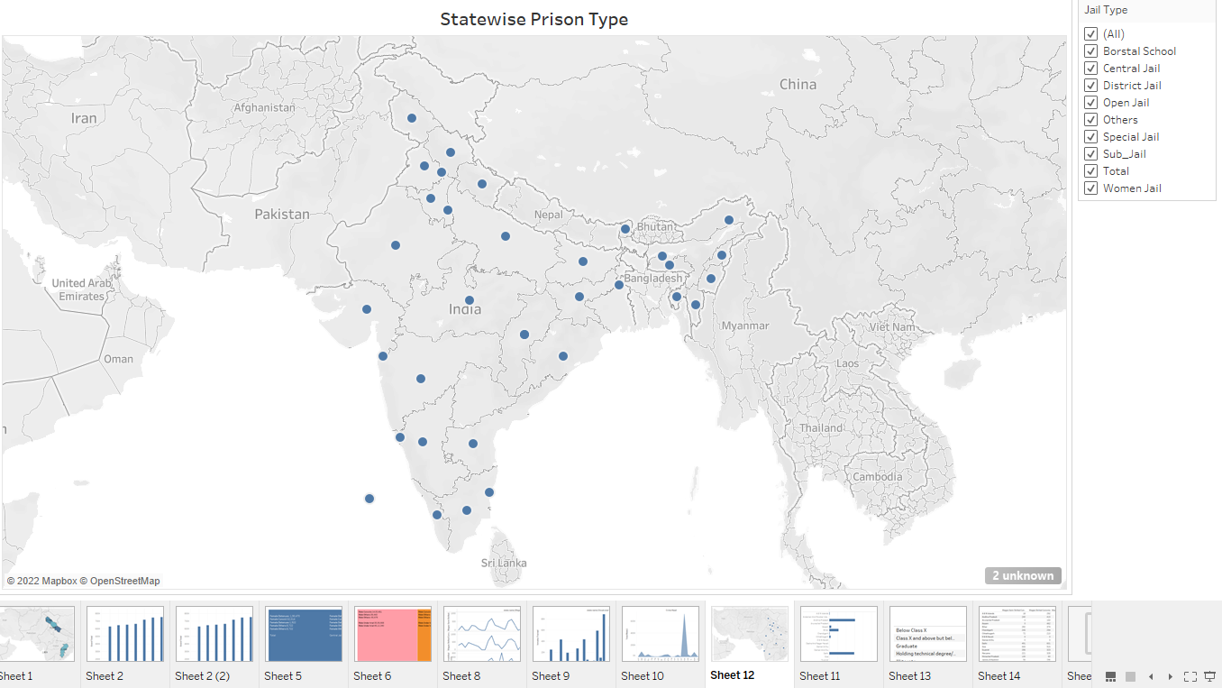

The above graphs show the types of prison Indian states are comprised of as we can see that India has eight types of prison which are Women Jail, Sub Jail, Special Jail, Open Jail, District Jail, Central Jail and Borstal School. All the Indian states as well as Union Territories has one or more types of Jail except Telangana state.

1. **Wages and Education**

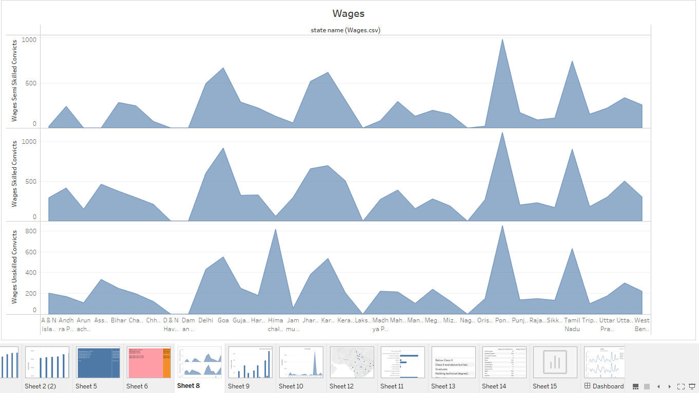

The above area graph shows the wages of the unskilled, semiskilled and skilled convicts for all 29 states. As we can see in the area graphs that for states such as Nagaland, Orissa, Pondicherry, Punjab, Rajasthan, Sikkim, Tamil Nadu, Tripura, Uttar Pradesh, Uttarakhand, and West Bengal has almost same trends for the wages of unskilled,

semiskilled and skilled convicts. For unskilled labors Lakshadweep, Daman and Dew has minimum wages whereas Himachal Pradesh, Karnataka, Pondicherry and Tamil Nadu have highest wages. For Skilled labors Lakshadweep, Daman and Dew has minimum wages whereas Goa, Karnataka, Pondicherry and Tamil Nadu has highest wages similarly for the semi-skilled labors Lakshadweep Daman and Dew has minimum wages whereas Goa, Karnataka, Pondicherry and Tamil Nadu has highest wages.

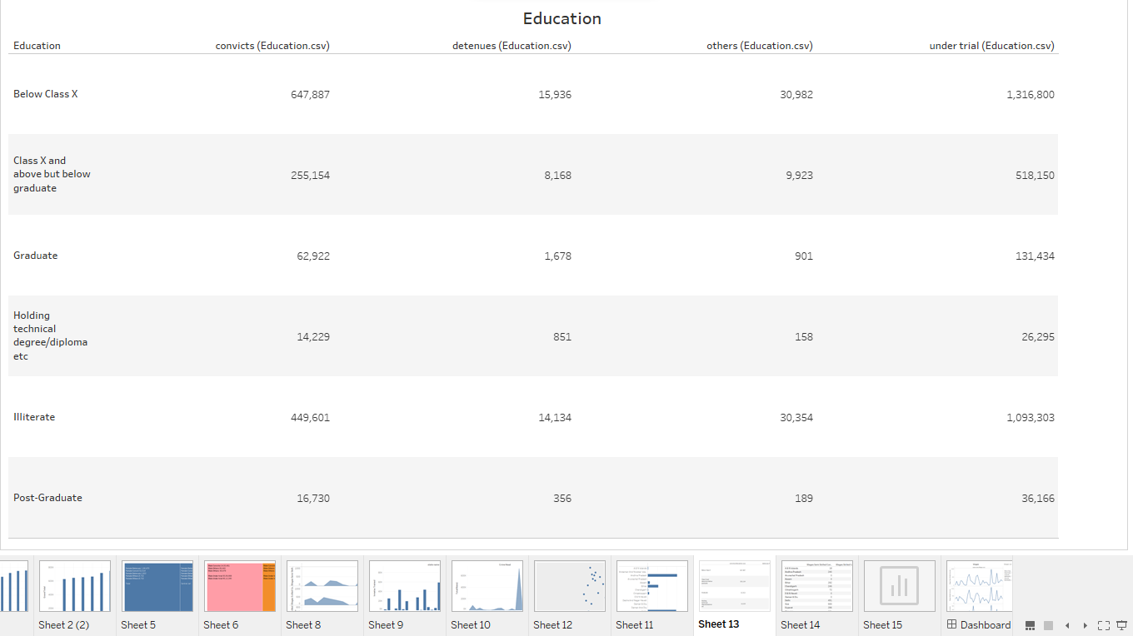

As we can see in the above table that majority of the prisoner who are Convicts, Detainees, Under Trail and Other are Illiterate whereas minority of the prisoner who are Convicts, Detainees, Under Trail and Other are Post Graduates. If we analyze the Convicts column, we can see clearly that the prisoner who are Class X and above but below graduate constitutes 2nd highest prisoners with count of 255,154 whereas Illiterate takes top most position with head count of 49,601. Prisoner with Post Graduates and Technical Degree/Diploma has 16,730 and 14,229 head count whereas Graduate and Below Class 10 has head count of 62,922 and 647,887. For the Detainees column, we can see clearly that the prisoner who are Below Class 10th constitutes highest prisoners with count of 15,936 whereas Illiterate takes 2nd top most position with head count of 14,134. Prisoner with Post Graduates and Technical Degree/Diploma has 356 and 851 head count whereas Graduate and Below Class 10 has head count of 1678 and 8168. For the Under Trails column, we can see clearly that the prisoner who are Below Class 10th constitutes highest prisoners with count of 1316800 whereas Illiterate takes 2nd top most position with head count of1093303. Prisoner with Post Graduates and Technical Degree/Diploma has 36166 and 26295 head count whereas Graduate and Above Class 10 but below Graduate has head count of 131434 and 518150 head count respectively. Similarly for others Below Class X and Class X and below Graduate constitutes 30982 and 9923 prisoner, Graduate and Prisoner Technical and Diploma head count consist of 901 and 158. Finally Illiterate and Post-Graduate make 30354 and 189 head count.

1. **Crime Type – Gender Wise**

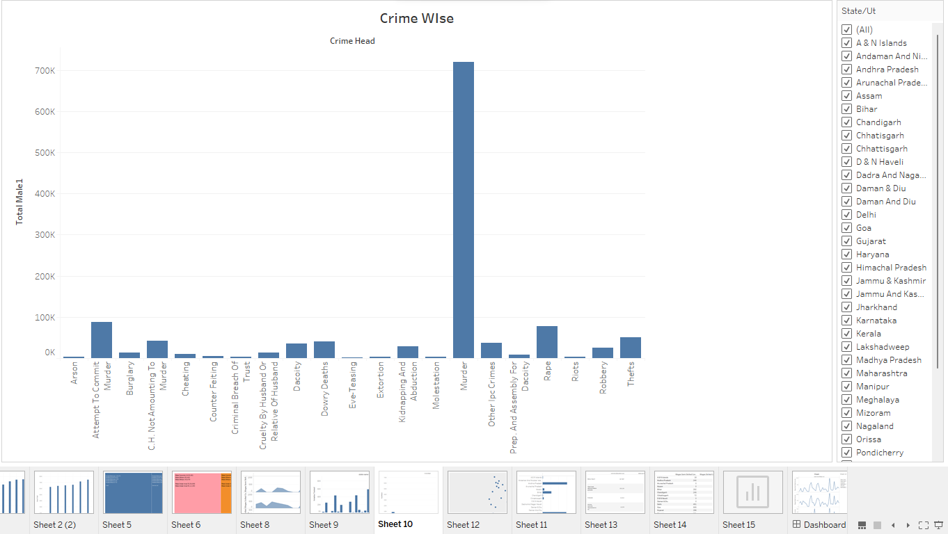

The above graph shows the types of IPC crime committed by the male-convicted prisoner in 29 Indian states. We can clearly see that murder was most committed crime all over the India which has count of 7,19,145 and attempt to murder which has count of 87,103 – 2nd highest crime. Whereas rape one of the most heinous crimes constitutes of 78,335. The dashboard has feature by which we can filter the types of crimes state wise after analyzing 29 states individually also.

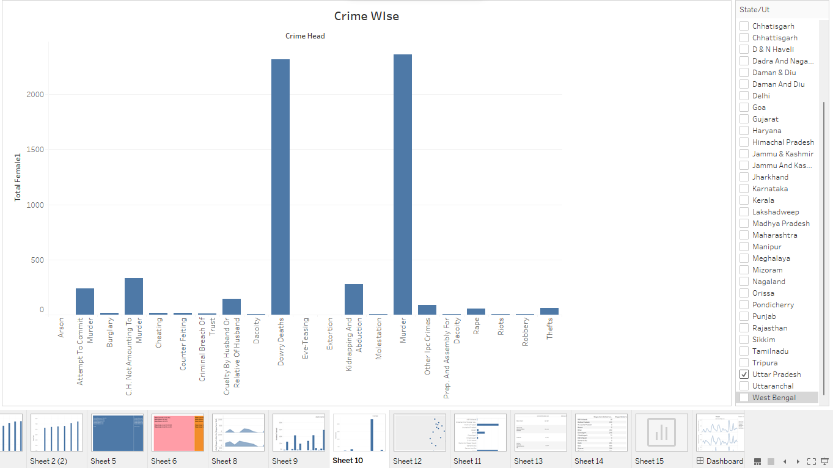

The above graph shows the types of IPC crime committed by the female-convicted prisoner in 29 Indian states. We can clearly see that murder was most committed crime all over the India which has count of 2359 and dowry death which has count of 22314 – 2nd highest crime. Whereas rape one of the most heinous crimes constitutes of 57. Extortion and Eve-teasing are the crimes which are only committed by the male not females. The dashboard has feature by which we can filter the types of crimes state wise after analyzing 29 states individually also.

1. **Yearly wise Prisoner**

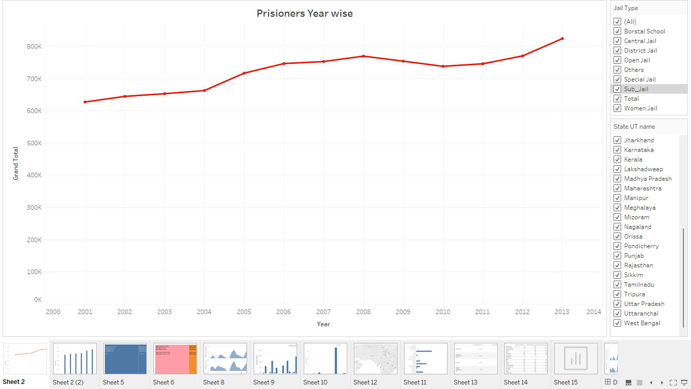

The above line graph depicts the total prisoner year wise in Indian jails Women Jail, Sub Jail, Special Jail, Open Jail, District Jail, Central Jail and Borstal School. As we can clearly see in the line graph that overall, the number of prisoners in the Indian jail has increased overall. During 2009 and 2010 there was decrease in the number of prisoner count but in the year 2010 it started increasing again with the incremental trend. The graph has option to filter the data by jail type and state wise also. In we analyze the trend in Borstal School there was linear decrement in the number of prisoners from the year 2000 to 2005 but from 2005 the number of prisoner decrement sharply till 2007 and increased sharply till year 2008 and then count decreased steadily till 2010. After 2010 it is increasing steadily. For central jail it is in the incrementing steadily throughout the year. The rest of the jail type fare following steady increment in the number of prisoners over the years.

1. **Inmates Trained**

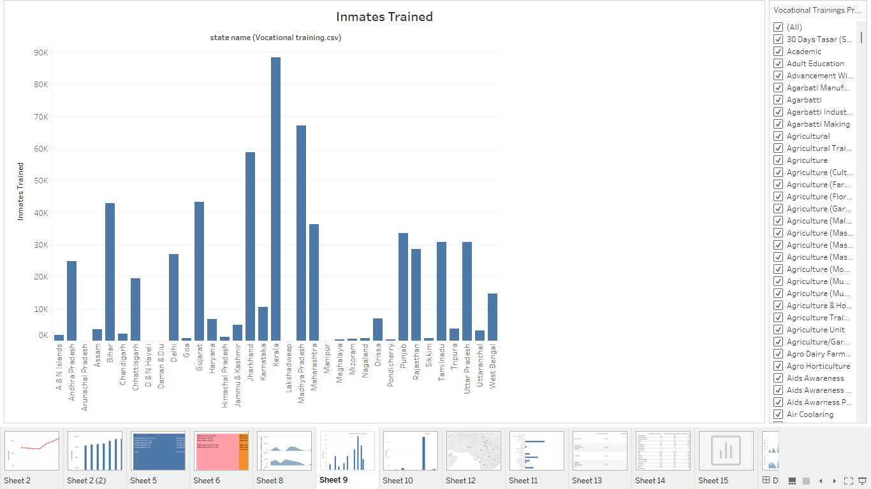

In the above bar graph we can see the number of prisoner trained by the state government during there tenure in the correctional facility so they are able to meet their financial requirement after their release from the prison and they don’t indulge in illegal activities. We can clearly see that Kerala has trained highest number of prisoner which counts to 88,321 followed by Madhya Pradesh with count of 67,173 whereas Manipur has trained only 30 prisoner which is the least among the states.

1. **Dashboard**

The below images show the images of the dashboard created from the above graph.

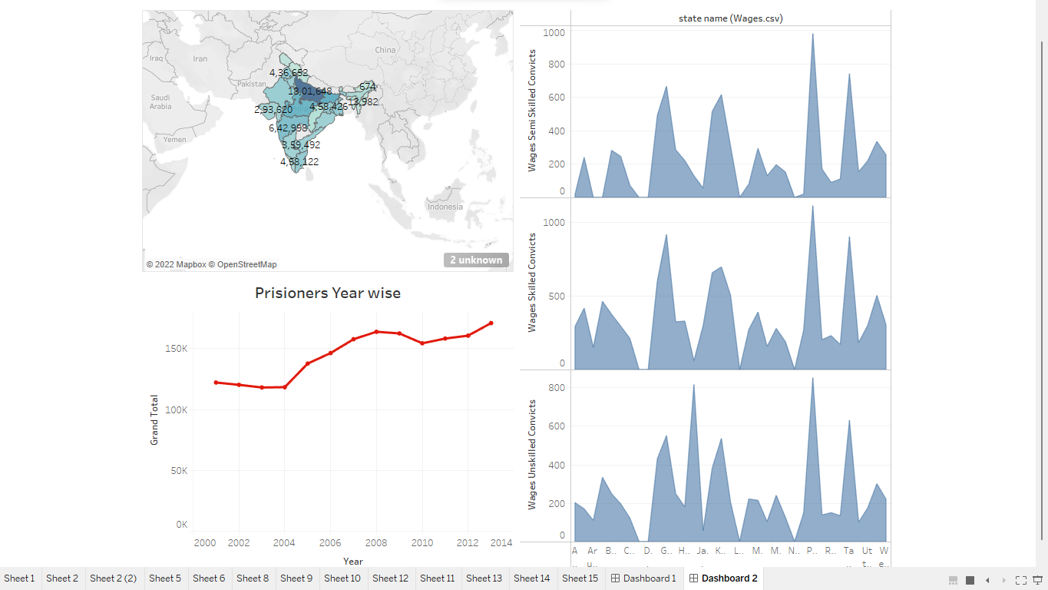

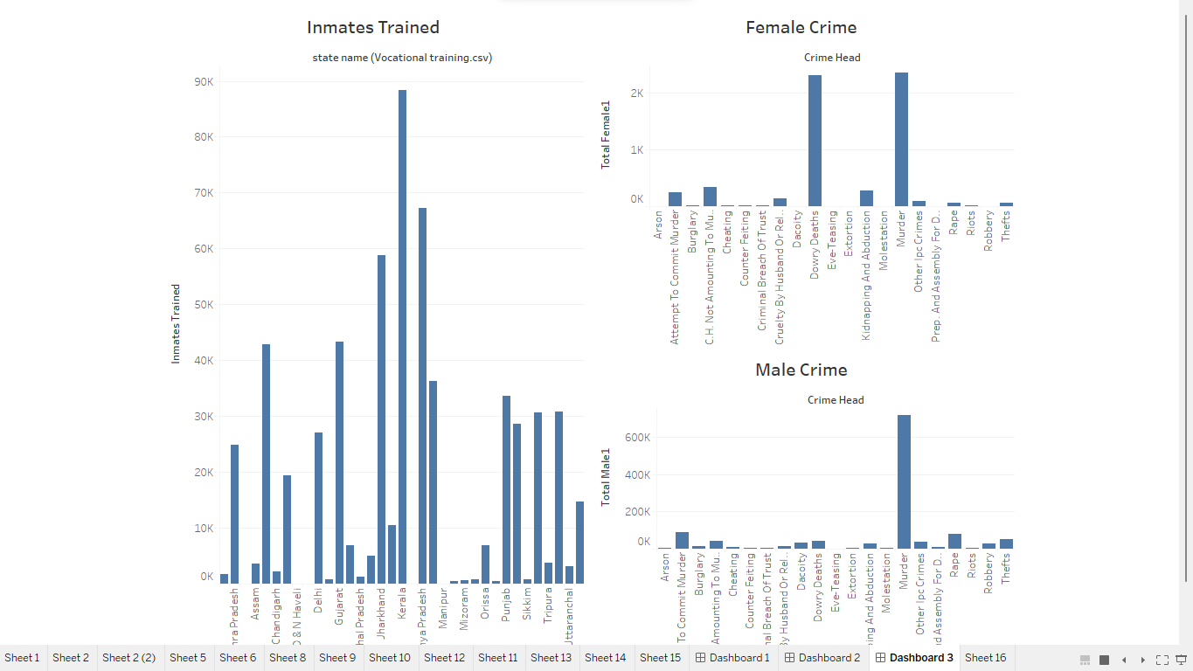

**Conclusion**

To conclude we can say overall the number of the prisoners in Indian correctional facilities has increased where Uttar Pradesh is the states where most of the criminal are locked inside correctional facilities. In India most of the crimes are related to murder attempt to murder and rape. Kerela is the state which has trained its prisoner in very high count so that after getting released from the correctional system the individuals can make their need by the skills they have acquired. Majority of the prisoner are illiterate or they are below class X.