Step 1: Login

To begin using the USAI membership management system, please open a browser and navigate to the following URL: <http://usaipool.org>

Click the Membership link indicated in red below.

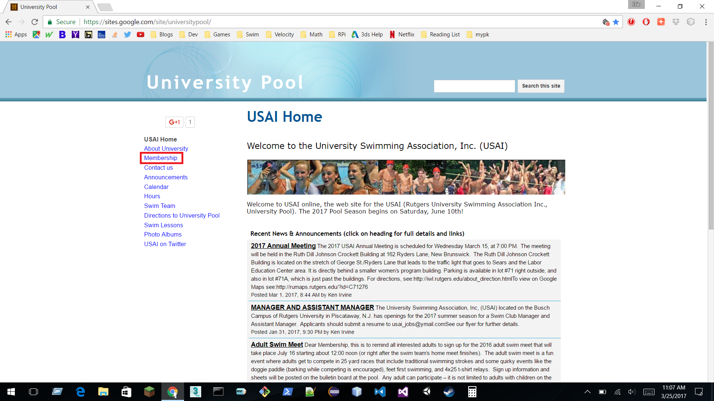

Next, click the Member Login link indicated in red below to navigate to the new membership software.

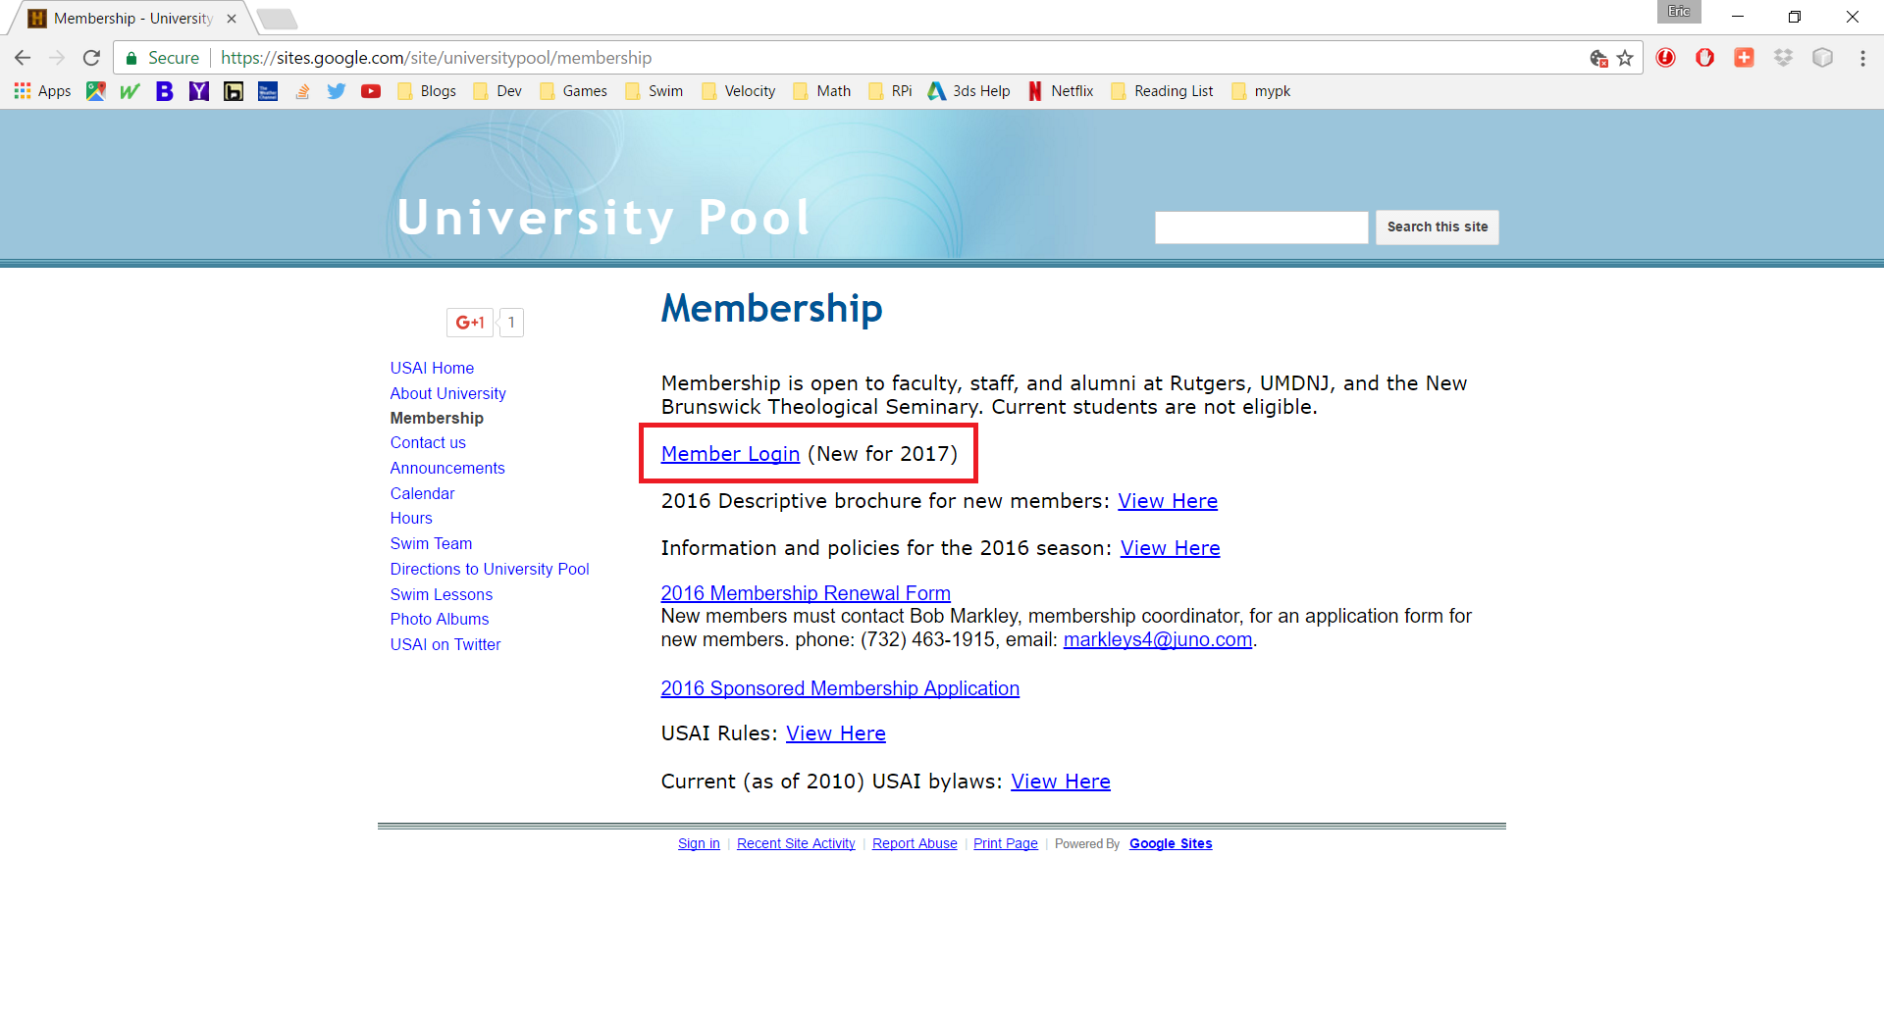

You will be redirected to the USAI esoftplanner.com website where you can manage and pay for your membership in addition to other USAI offerings (e.g. Swim Team, swim classes, guest passes and events).

Enter your Login Name & Password you received via email and click the Login button indicated in red.

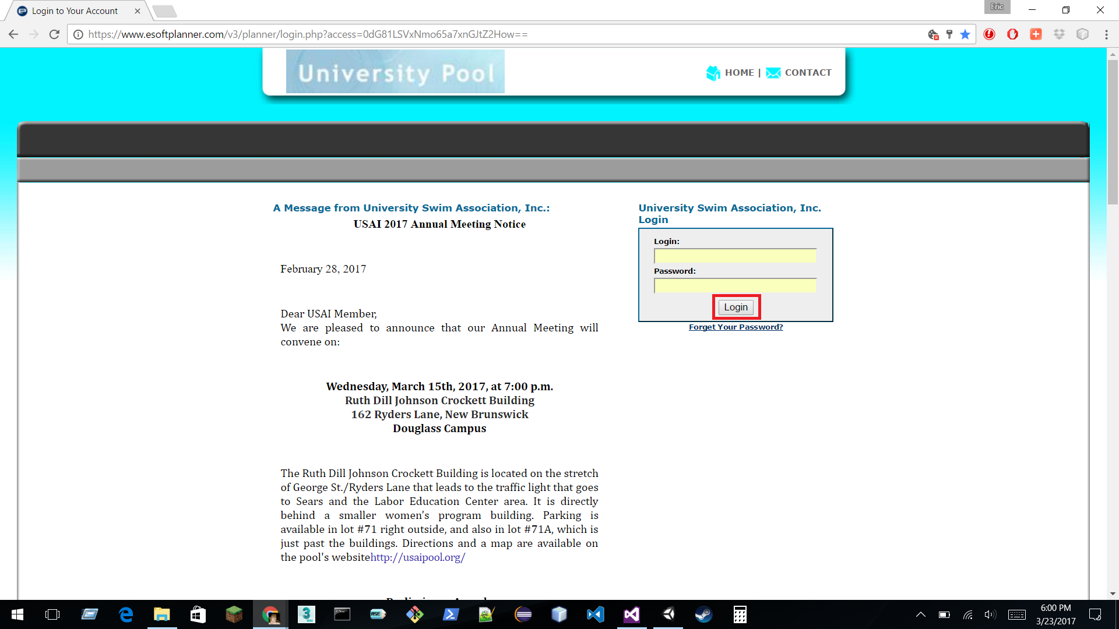

Navigate to your Profile by using the My Account menu and choosing ‘My Profile’, as indicated in red.

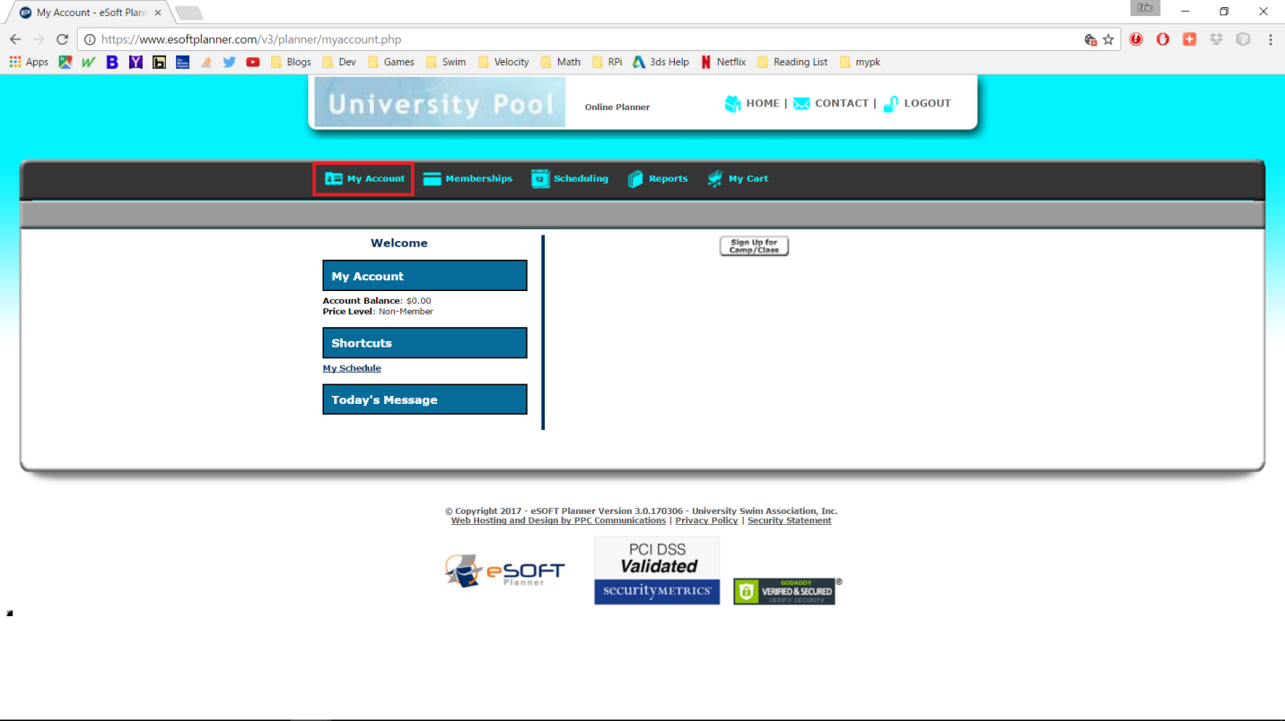

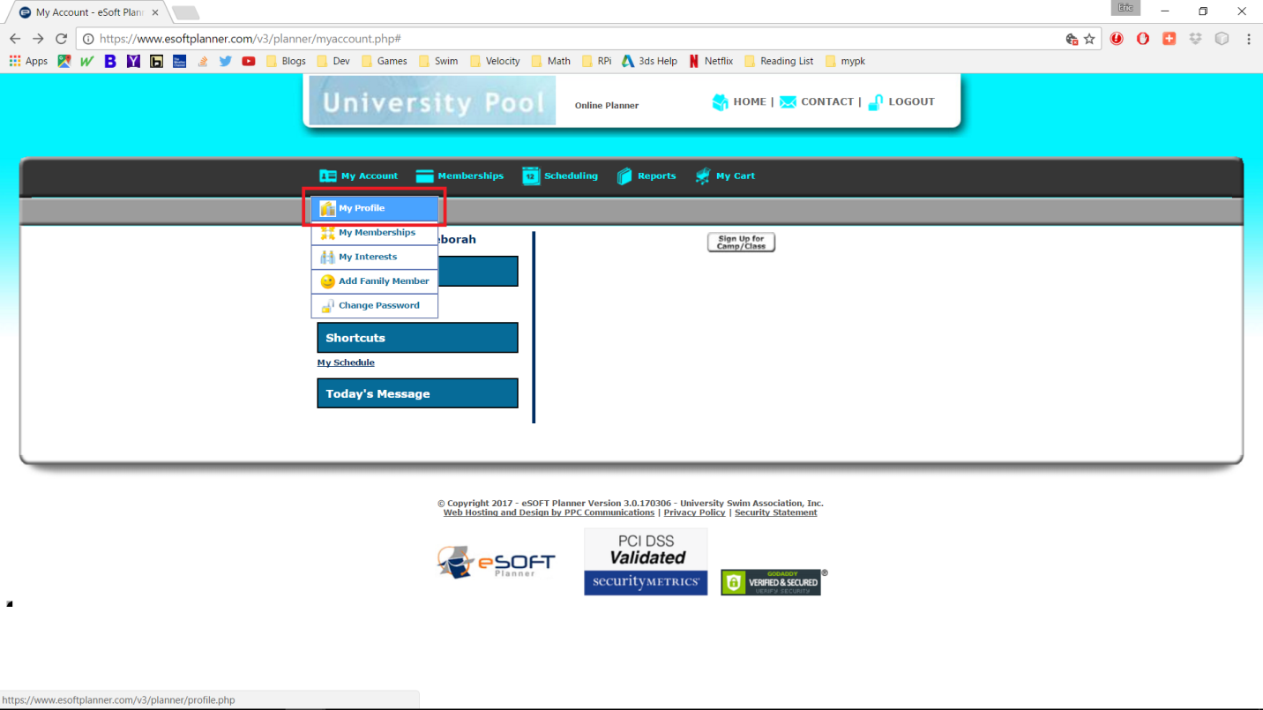

Step 2 – Update your profile information and click ‘Update’ to save your changes.

*Please note, if you wish to receive pool updates via email (i.e. closings, pool events), please check ‘Promotional Emails’, this service will not be used by USAI for any other purposes.

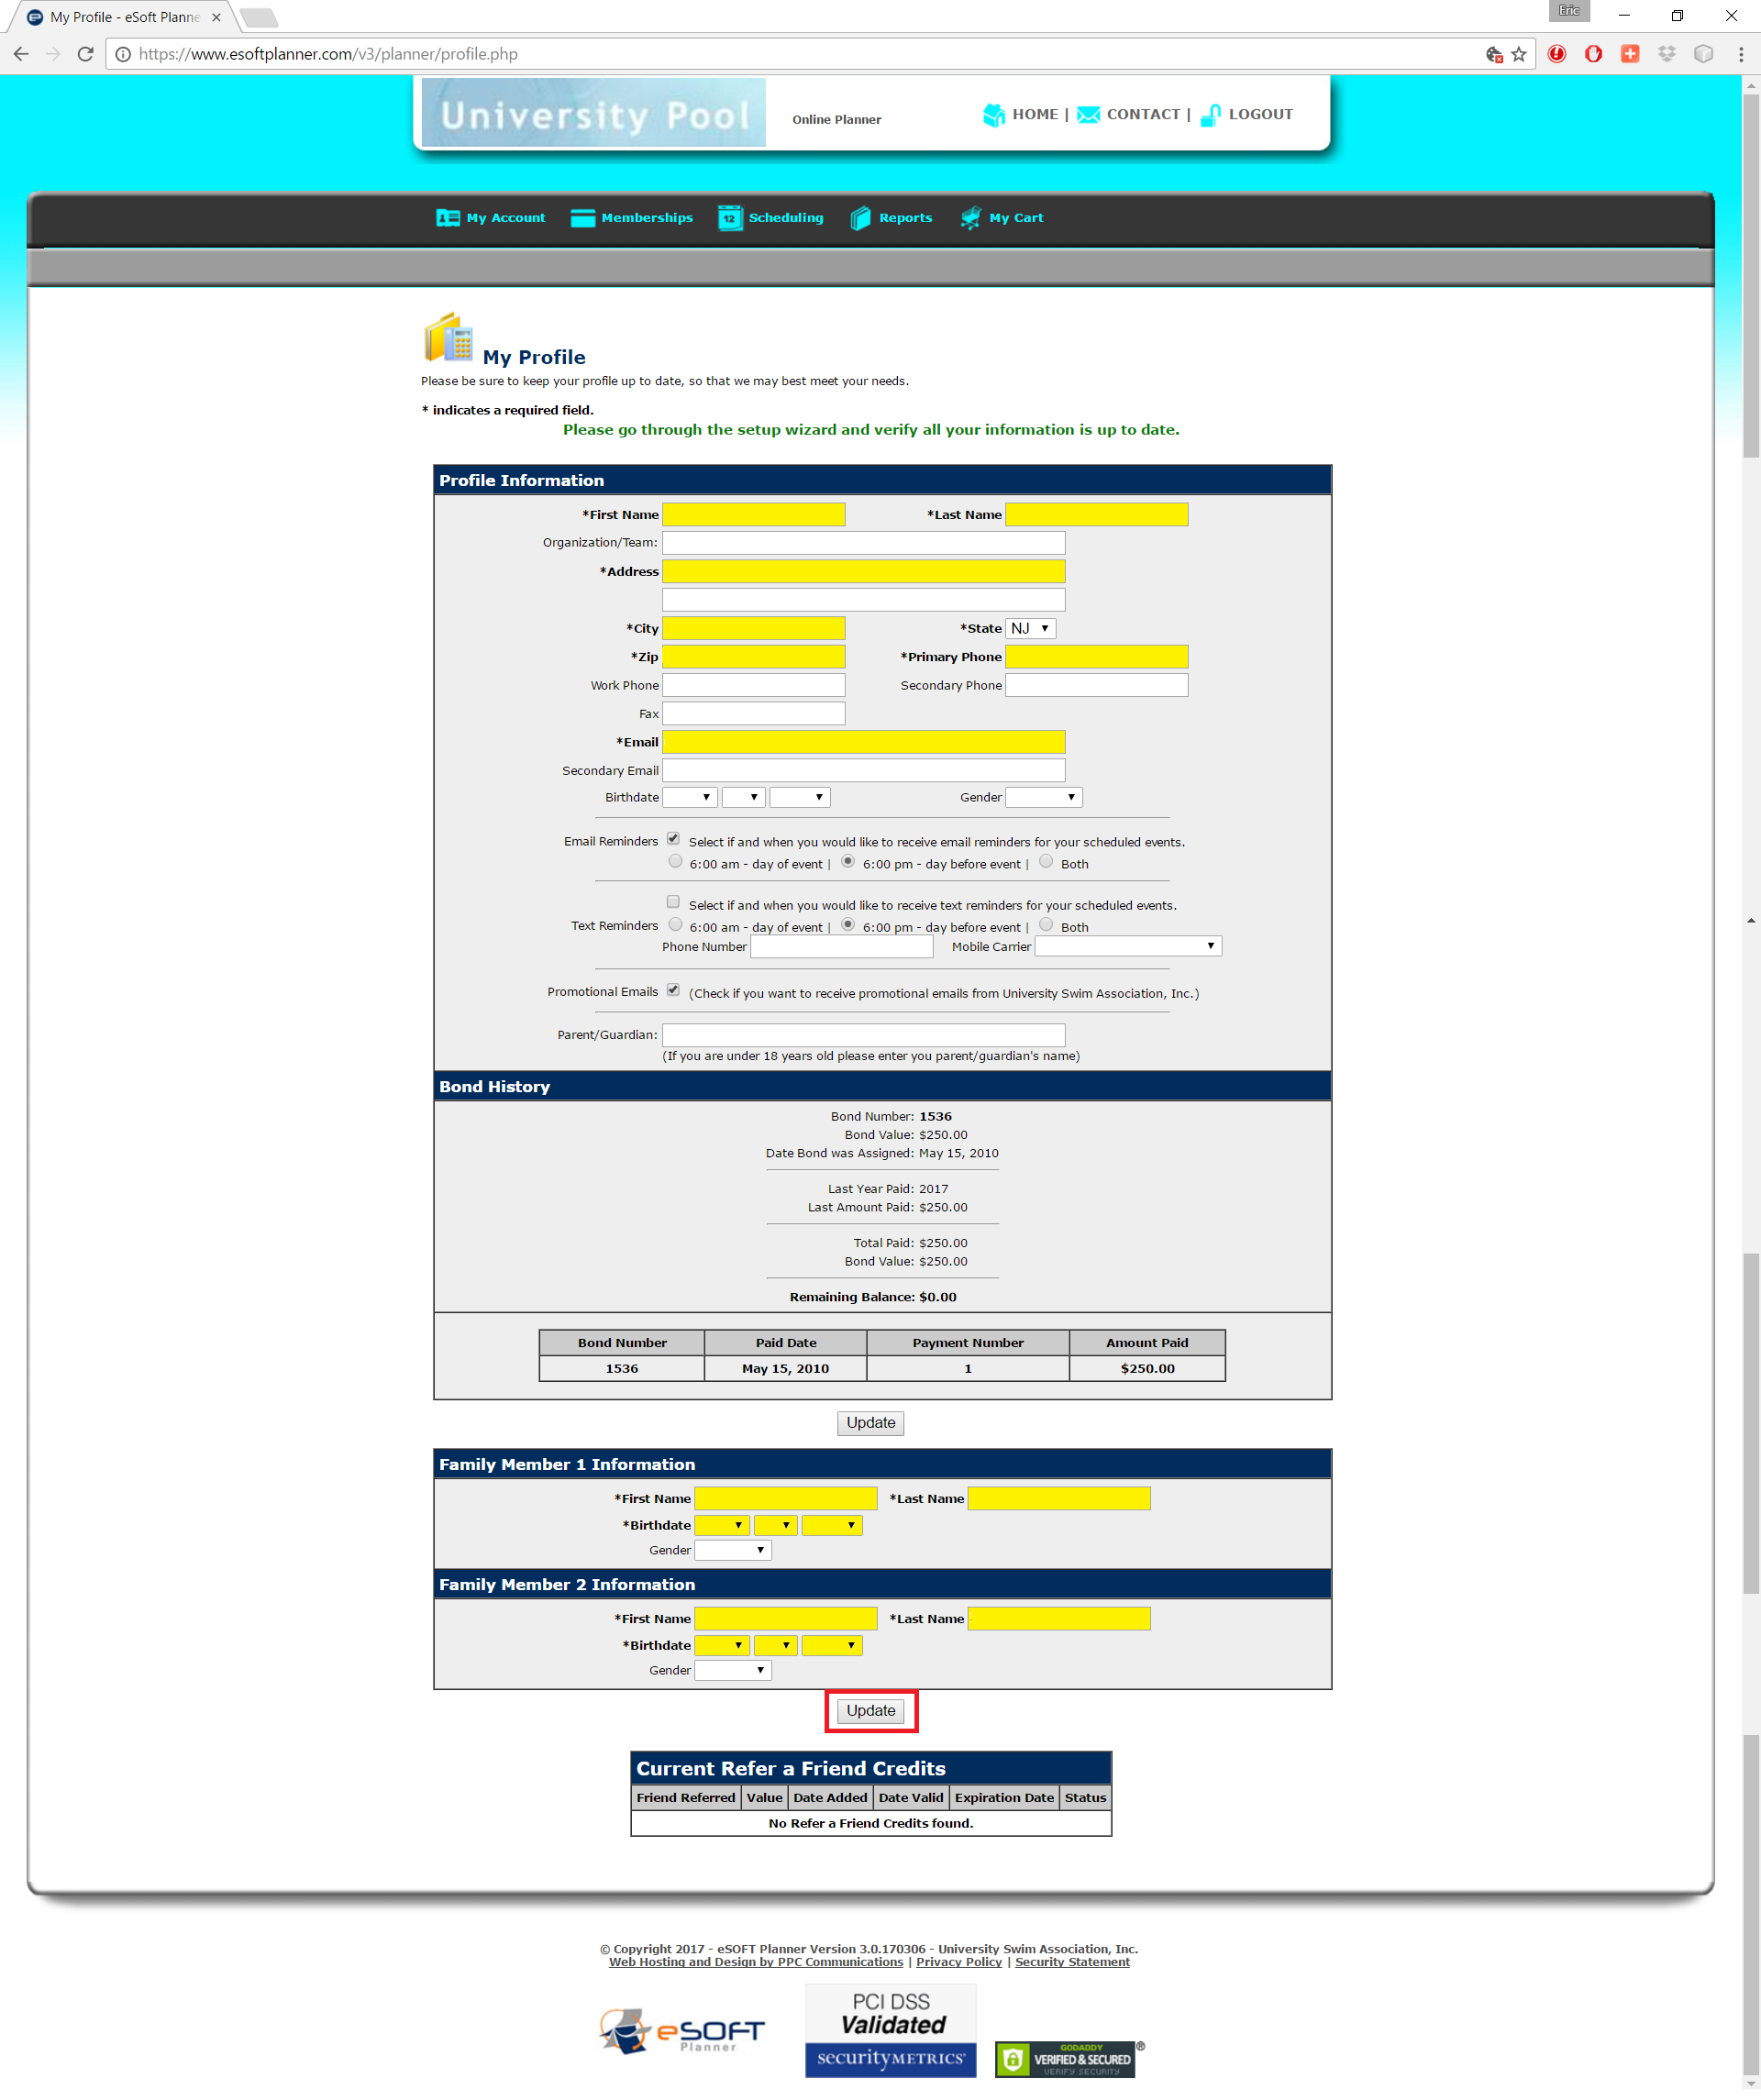

Add Family Members by clicking ‘Add Family Member’ under the ‘My Account’ menu. 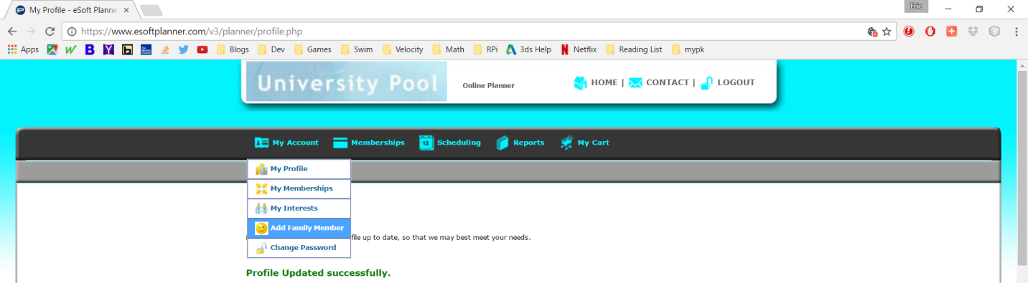

Complete the required fields, then click ‘Add Family Member’ button.

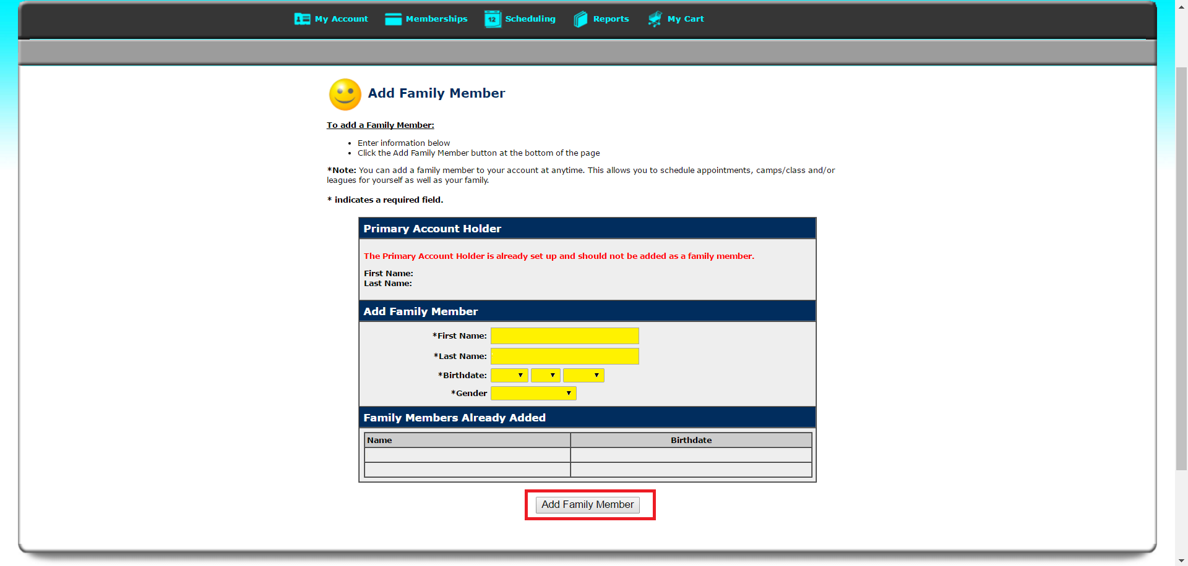

Step 3 – Review and Purchase Membership by navigating to ‘Membership’ indicated in red.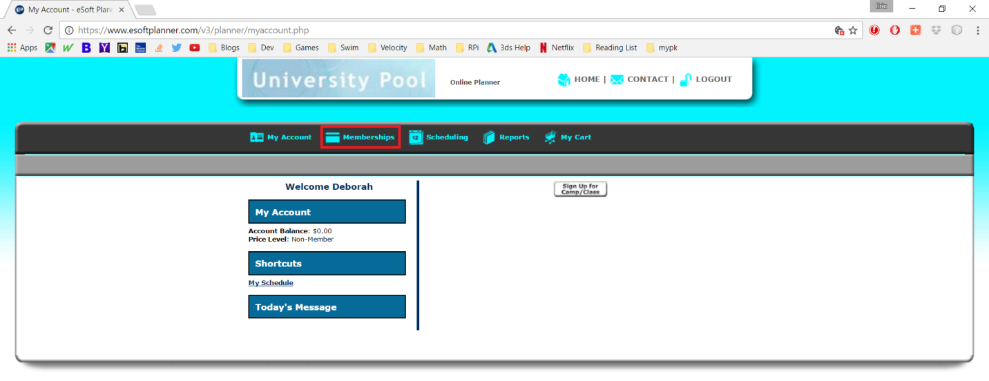

Select ‘Details’ to review a membership or ‘Sign Up’ to continue with your purchase.

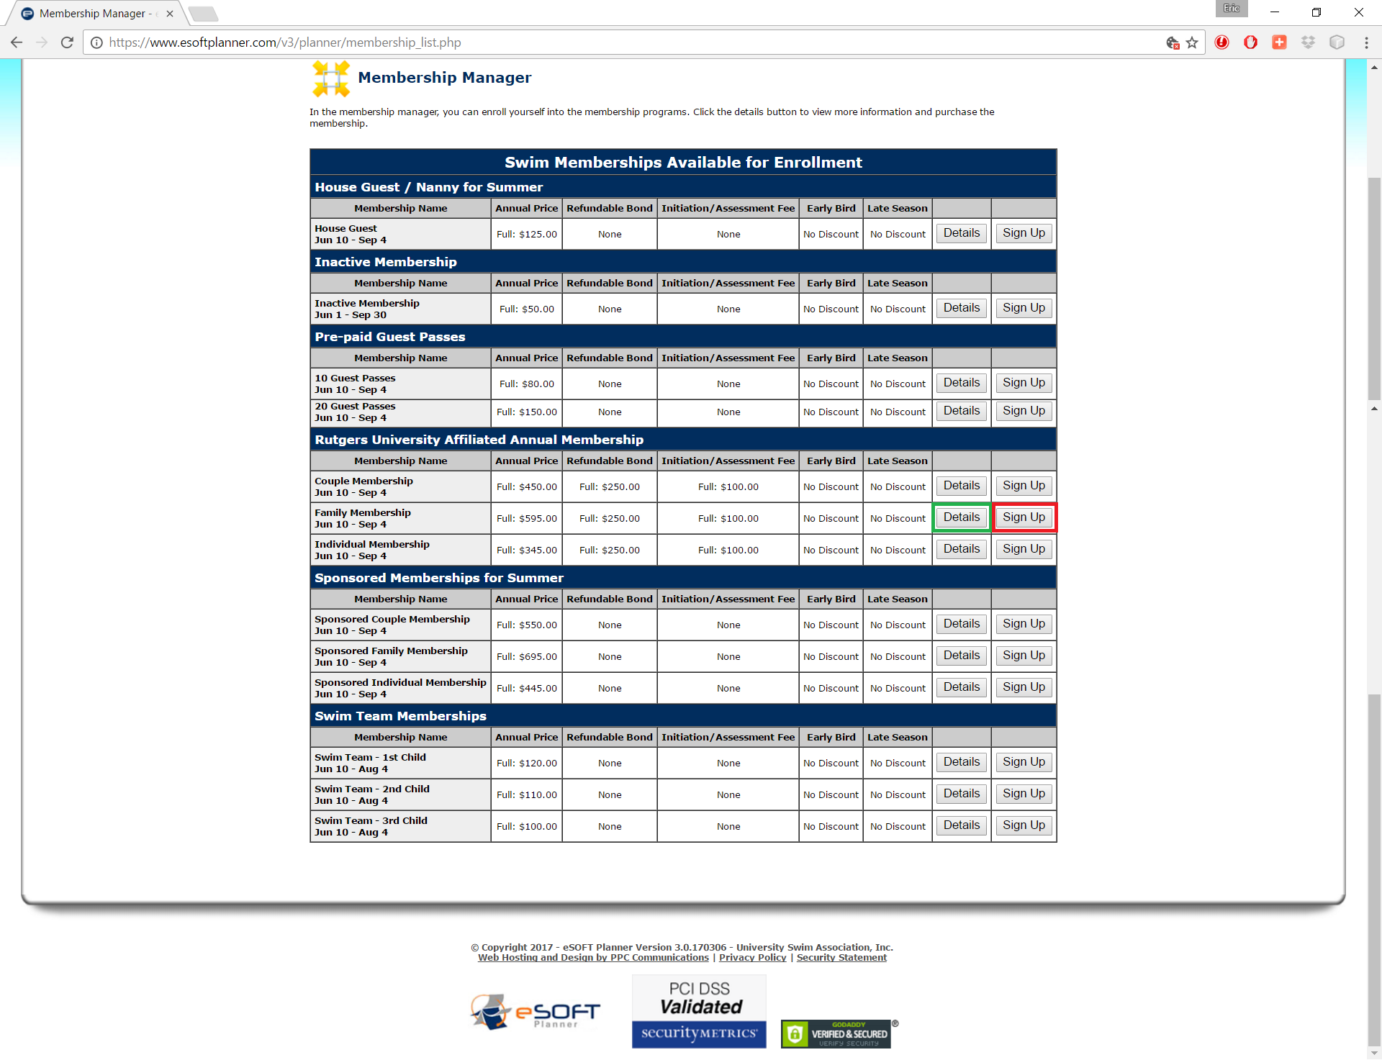

*Family Membership is shown as an example only.

** For ***NEW*** Sponsored Memberships, please contact Membership Chair, Bob Markley.

Membership Details is shown below, to enroll click ‘Purchase Membership’, or you may go ‘Back’ to review a different selection.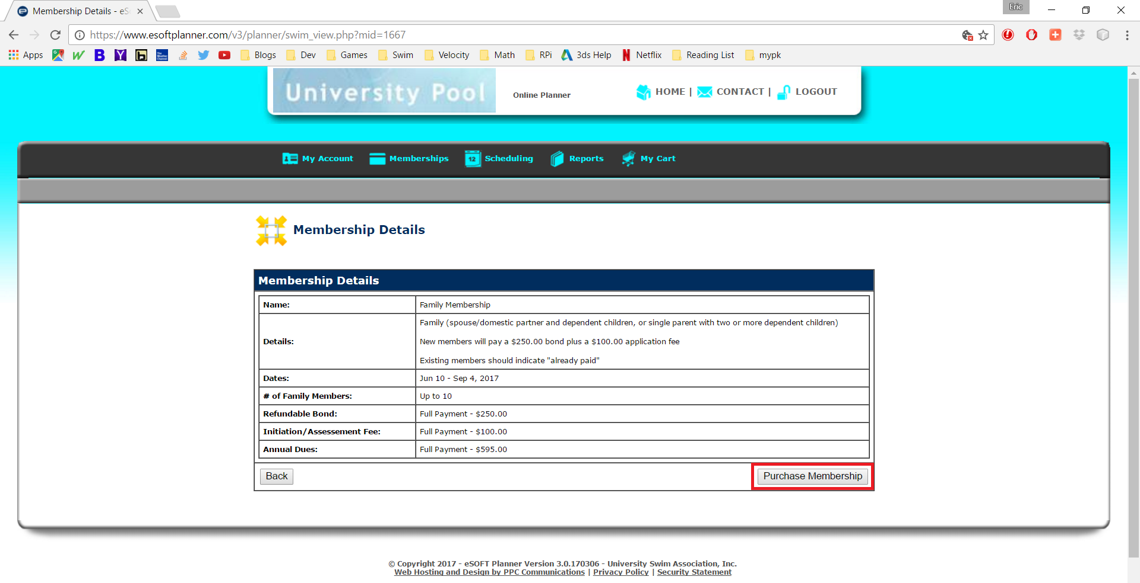

After selecting ‘Purchase Membership’ or ‘Sign Up’, you will continue the process on the Swim Membership Enrollment page. Complete the required fields and click ‘Calculate Totals’, then click ‘Continue to Payment’. 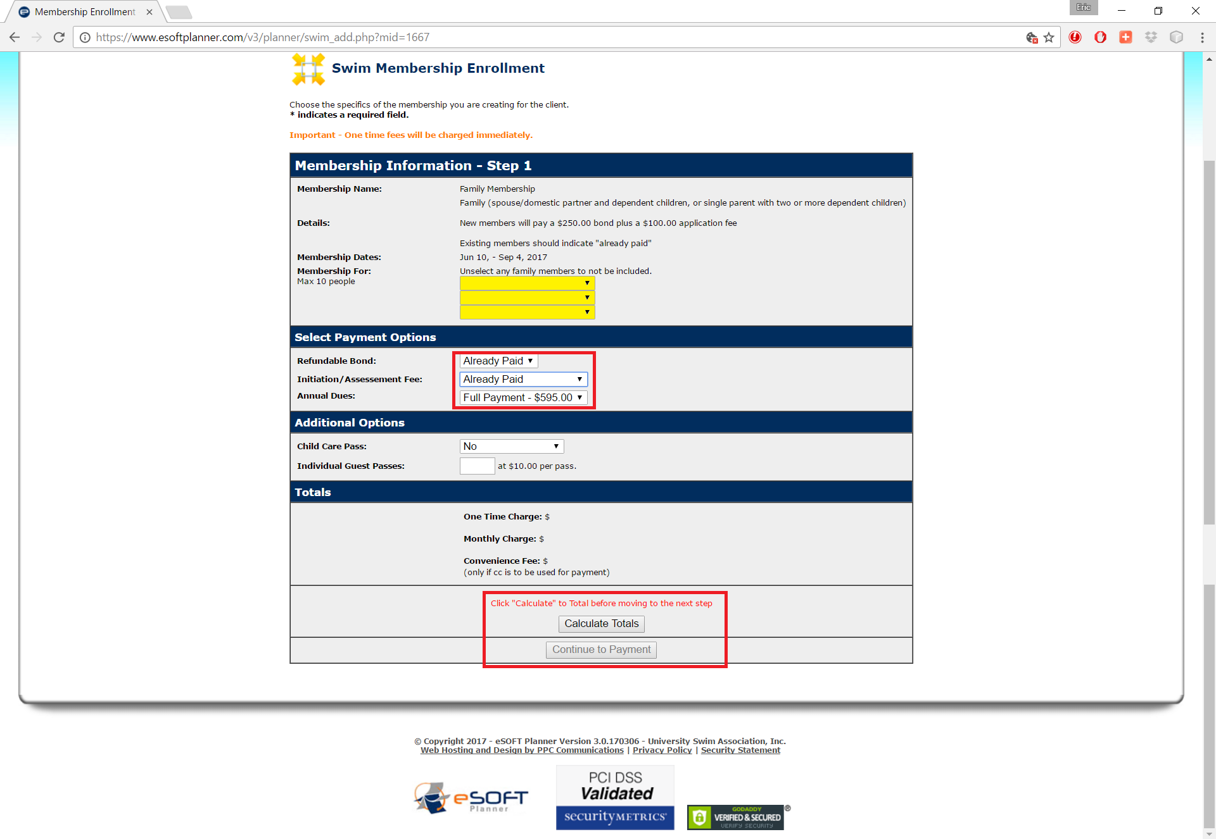

*If you are ***renewing*** your membership and have already paid your Initiation Fee, please select ‘Already Paid’ in the drop down box.

Step 4 – Complete Purchase

Enter your Payment Information into the required fields. Check the box acknowledging acceptance of the Membership Agreement and click ‘Purchase Now’ to complete the process.

