DocuCompiler: A Compiler-Inspired Architecture for Lightweight Document Summarization and Question Answering

Paras Rawal
Department of Computer Science and Engineering
Graphic Era Hill University
Dehradun, Uttarakhand
India
parasrawal117@gmail.com

Amit Gupta
Department of Computer Science and Engineering
Graphic Era Hill University
Dehradun, Uttarakhand
India
Amitgupta7920@gmail.com

Richa Gupta- PhD Scholar
Department of Computer Science and Engineering
Graphic Era Hill University
Dehradun, Uttarakhand
India
richa1833gupta@gmail.com

Abstract
The most recent trend for document summarization and question answering systems have been Transformer-based architectures. Models have been built for document summarization and question answering, but the associated cost for the models, in terms of both time and monetary value, is quite high. Because of these costs, deployment of these systems in situations where resources to run the model are limited is not feasible.
In this paper, we describe DocuCompiler, the first document intelligence architecture inspired by compiler technology, and proposes a novel approach to the document understanding problem as a structured semantic compilation problem. In contrast to most neural model approaches that generate documents in a single pass, DocuCompiler takes a different approach, and breaks the problem down into the modular steps of compilation, i.e., modular compilation steps of lexical analysis, parsing, semantic graph construction, generation of a Semantic Intermediate Representation (S-IR), optimization, and code generation. Sentence importance is estimated analytically, and summarization is not achieved by neural means, but rather by semantic optimization (as opposed to extractive optimization) using graph-based ranking (TextRank). Only the T5-small model is used to generate answers in response to queries in a semantic way.
In the experimental evaluation DocuCompiler shows slightly lower performance in terms of ROUGE scores as compared to its competitors, but shows sub-second latency in CPUonly systems, and shows a reduction in memory limits up to 85–90% compared to the transformer baselines.The proposed architecture introduces a modular, interpretable, and computationally efficient alternative to monolithic neural summarization systems.
Keywords- Document Summarization, Question Answering, Compiler-Inspired NLP, Semantic Graph Ranking, Intermediate Representation, TextRank, Lightweight Transformers, Retrieval-Augmented Generation, CPU-based NLP Deployment.

I. Introduction
Large-scale transformer models such as BART, T5, and PEGASUS have significantly improved and question answering performance [6],[11]. These architectures rely on deep self-attention mechanisms and encoder–decoder structures to model contextual dependencies across long textual sequences. Despite their strong empirical results, such models typically require hundreds of millions of parameters, substantial GPU memory often exceeding 12GB, and exhibit quadratic attention complexity with respect to input length. In addition, achieving optimal performance frequently depends on domain-specific fine-tuning.
The computational and architectural requirements involved make these less useful for edge devices, offline systems, privacy-preserving systems, and embedded analytic systems due to the limited hardware. The dependence on extensive neural networks also impacts understandability and effectiveness.
To address these issues, we present DocuCompiler, which redefines document comprehension as a task of semantic compilation. Rather than writing a neural end-to-end summarization, DocuCompiler employs a graph-based optimization approach to summarize documents and convert plain text to a S-IR that is Semantic Intermediate Representation. The system is designed to address document intelligence in multiple stages and is based on modular semantic processing. It features a S-IR layer that is reusable and supports deterministic optimization instead of generative summarization, along with a light integration of question answering that employs semantic retrieval with a T5-small model. The system is tested empirically to evaluate the trade-offs between summarization quality and efficiency to demonstrate competitive benchmarking in environments reliant solely on CPU deployments.

II Literature Review
With time, the evolution of automatic document summarization has shifted from basic statistical methods to the more advanced methods of today, using sophisticated neural networks. In the beginning, researchers relied solely on poor, primitive extractive methods that captured the essence of the text as a result of TFIDF weighting, as well as other pointwise, primitive, text-centric location metrics (i.e. where the sentence is, etc). Although the methods are fast and efficient, the general topic is irrelevant and they lack an understanding of the core essence and the summaries lack cohesiveness and fluidity.

Maturity brought more advanced models that were structurally and logically more advanced, such as TextRank and LexRank. With more advanced models, the evolution of LexRank and TextRank advanced further, along with other models that have empirically validated their abilities to perform at a higher degree of success and added more advanced contextual embeddings. A decent advanced model consistently incorporates a typical single cycle model or a multi-cyclic model, as opposed to simple meta-cyclic models that have been observed in the last generation; advanced models have a high degree of success and a heavily generalized point.

The most significant change took place with the development of transformer-based architectures such as BART, T5, and PEGASUS. These models allowed for the advanced level of AI to actually produce new fluent sentences instead of just using the cut and paste method to reorganize existing sentences. They do produce high-end results on the given benchmarks, but on the flip side, they need very large amounts of computing resources, including special GPU hardware, and more worryingly they are practically a " black box" so that the logic behind them is opaque and are known to "hallucinate" facts.

To address the limitations imposed by black box models, most people have, for example, hybrid models and Retrieval-Augmented Generation (RAG) [1]. These models attempt to merge the fast processing of extracting sentences with the fast processing of neural rewriting. They are somewhat better at staying on topic but they tend to be heavier in terms of computing resources needed and more expensive.

The most innovative approach by DocuCompiler is to avoid models that are neural-heavy. Instead, DocuCompiler approaches document understanding more like a structured "compilation" pipeline. By using a Semantic Intermediate Representation (S-IR) along with compiler-inspired strategies, DocuCompiler addresses the gap that exists between lightweight ranking and intensive generation. This also contributes to the modularity of the system which is efficient enough to run on our standard CPUs(intel i5 13th gen) all without sacrificing the semantic coherence of its final summary.

III. Methodology
The DocuCompiler uses eight phases in their Semantic Compilation Pipeline which is based off of classical compiler techniques. Generally the hnd compiler view input documents as unorganized text. The Automatic DocuCompiler system, however, looks at input documents as text that can go through multiple changes to make text into something closer to what humans can understand with respect to structure, semantics, and what is desired by the user.
The eight phases of the pipeline include: Source Reader, Lexical Analysis, Structural Parsing, Graph Building Semantics, Intermediate Semantics, Optimization, Target Generation, and Query Compilation
Each phase is interchangeable when it comes to making improvements.
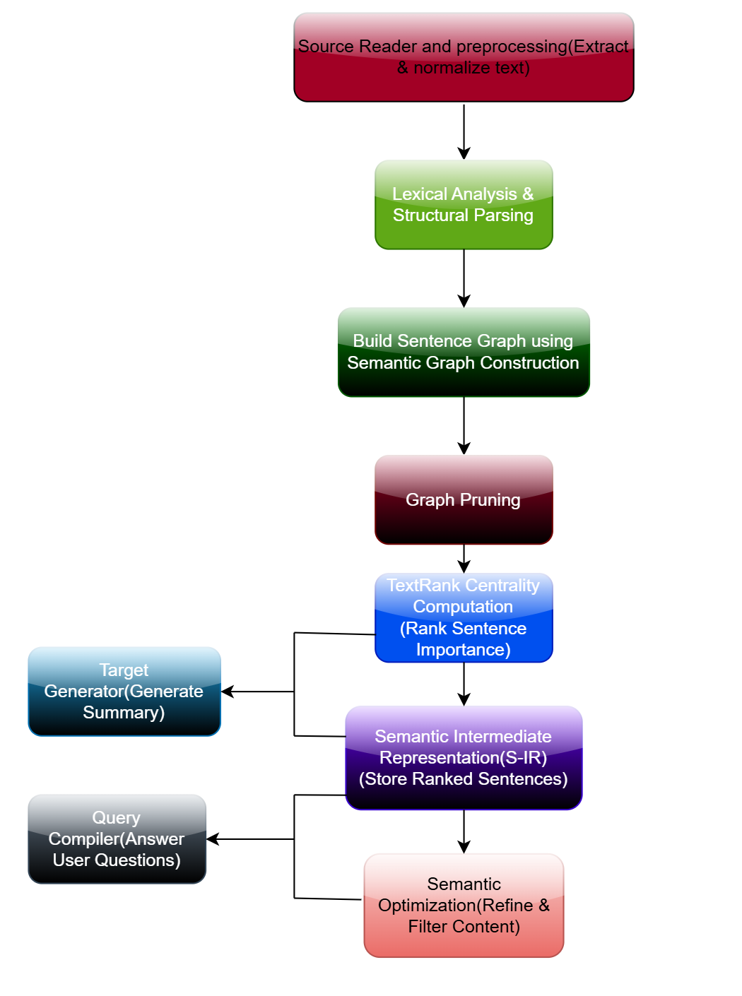
Fig 1. System Architecture
A. Source Reader and Preprocessing
The Source Reader is the front-end loader of the system. It pulls raw, unformatted text in supported text types such as PDF, DOCX, and TXT. For each different type of text file, the Source Reader applies parsers that streamline their text encoding, remove layout artifacts, and keep the underpin control that shows breaks in paragraphs.
During preprocessing, the system applies a series of text changes to make it easier to understand as a system and to provide more streamlined input such as Unicode normalization, removal of excess whitespace, deletion of elements that do not hold semantic value, and the marking of sentence end.
After this phase is completed, the result should be a text stream that is ready for the next step in the process.

B. Lexical Analysis and Structural Parsing
If we compare it to compiler lexical analysis, the document is being tokenized into basic structural semantic units. Let the document be represented as
$$D=\{{sen}_{1},{sen}_{2},…,{sen}_{n}\}$$
where each Sen represents a complete sentence.
To handle sentence segmentation we use in-built libraries such as SpaCy. But we don't take each and every fragment instead our structural parser validates the integrity of all the sentences. If a fragment is too short to carry a meaning or is clearly not sound, it’s discarded. This ensures that the downstream graph construction is only dealing with high-quality, semantically sound data and not some noise.

C. Semantic Graph Construction
Every sentence Sen is mapped within a continuous vector or we can say latent(hidden) space:
$$∅({Sen}_{i})∈R^{d}$$
where d denotes the dimensions of an embedding. Embeddings may be generated using TF-IDF techniques or contextual encoders [8] such as MiniLM-L6-v2.
Semantic similarities between the sentences is computed using cosine similarity as folows:
$$\text{Sim}({Sen}_{i},{Sen}_{j})=\frac{ϕ({Sen}_{i})⋅ϕ({Sen}_{j})}{∥ϕ({Sen}_{i})∥∥ϕ({Sen}_{j})∥}$$
A weighted, undirected graph is constructed:
$$G=(V,E)$$
where $V=\{s_{1},…,s_{n}\}$and
$$E_{ij}=\text{Sim}({Sen}_{i},{Sen}_{j})$$
if the similarity exceeds our given threshold which is denoted by $Ө$.
Thresholding imposes sparsity, and reduces the computational overhead, also eliminates weak semantic links. The resulting sentence similarity graph then encodes global semantic relationships within the document.
D. TextRank Centrality Computation
Sentence importance is calculated with the TextRank algorithm [4], an adaptation of PageRank for text basedgraphs.
The recursive scoring function is defined as:
$$R({Sen}_{i})=(1-d)+d\sum_{{Sen}_{j}∈\text{Aj}(i)}{\frac{\text{Sim}({Sen}_{j},{Sen}_{i})}{\sum_{k}{\text{Sim}(}{Sen}_{j},{Sen}_{k})}}R({Sen}_{j})$$
here $d=0.85$ is the damping factor and $\text{Aj}(i)$denotes the sentences which are adjacent to ${Sen}_{i}$.
Iteration will continue till the convergence:
$$∥R^{t+1}-R^{t}∥ <ϵ$$
This process gives a stationary distribution among the representing sentence centrality within the document’s semantics. Unlike neural attention mechanisms, TextRank does not require any training or gradient optimization, making it deterministic and computationally light weight.
E. Semantic Intermediate Representation (S-IR)
The ranked graph is then serialized into a Semantic Intermediate Representation(S-IR). This stores sentence text, centrality score $R({Sen}_{i})$, similarity adjacency lists, and the positional metadata.
This type of representation is comparable in certain repect to abstract syntax trees in compilers or the control flow graphs used for execution analysis. However, instead of modeling the entire control flow, the S-IR models semantic connectivity and informational salience between the sentences.
Importantly, the S-IR is also persistent and very reusable. Once constructed, it can serve for multiple summarization or Q&A requests without recomputing everything from scratch.
F. Semantic Optimization
Inspired by the optimization strategies used in compiler design, the S-IR undergoes transformation even before the output generation takes place.
elimination of dead code further removes sentences whose centrality score falls below the threshold denoted by T:
$$S^{'}=\{{Sen}_{i}∣R({Sen}_{i})≥T\}$$
Removal of redundancy eliminates the semantic overlapping of the sentences.
$$\text{Sim}({Sen}_{i},{Sen}_{j})>θ$$
only the sentences which ranked higher are retained, this is semantic deduplication.
Compression represents clusters of semantically similar sentences using only one node that represents it.
The final set of candidate summary is defined as:
$$Sen=\{{Sen}_{i}∣R({Sen}_{i})≥T\}$$
subject to the length constraint:
$$\sum_{{Sen}_{i}∈Sen}{len\left(Sen\right)≤L}$$
These constraints ensure a controlled size of summary while preserving the coverage of semantics of the document.

G. Target Generator
The Target Generator transforms the optimized S-IR into summaries that people can understand. In order to keep the narrative flow, the sentences are placed in the order they appear in the document.
Summary outputs can vary in length, for example, standard and detailed summaries as well as bullet summaries and summaries from the top-k sentences.
The model generation is deterministic and fully aligned with the original content and therefore, hallucinations are not a concern.
H. Query Compiler for Question Answering
In the case of question answering, DocuCompiler interprets the queries as execution requests at runtime over the compiled S-IR.
For a query Q, the embedding is defined as:
$$q=ϕ(Q)$$
The sentences corresponding to q are fetched through the similarity search:
$$\hat{Sen}=arg⁡\underset{{Sen}_{i}}{max⁡}\text{Sim}(q,{Sen}_{i})$$So, in a sense, when you pose a question, DocuCompiler works as if that’s a “runtime request.” We convert your query to a vector and look up the most pertinent information in the S-IR.
Instead of inputting an entire large document into an LLM, we only keep the top-k most pertinent sentences. These are then passed on to a concise and effective model (such as T5-small) for final answering. This hybrid method provides you with the conversational aspect of a modern AI in addition to the speed and precise correctness of a compiled system.

IV. Results
A. Experimental Setup in which we obtained the results
We conducted experiments on a 12-core CPU with a 16GB RAM (no GPU).
Dataset:CNN/DailyMail
Metrics: ROUGE-1, ROUGE-2, ROUGE-L, Latency
Baselines: TextRank, TF-IDF, T5-base (reference) [6]
B. Summarization Performance
Table I – ROUGE Performance Comparison
Model | ROUGE-1 | ROUGE-2 | ROUGE-L
TextRank | 0.2808 | 0.1094 | 0.1941
TF-IDF Ranking | 0.2808 | 0.1094 | 0.2111
DocuCompiler | 0.3406 | 0.1314 | 0.2702
T5-base | 0.38+ | 0.15+ | 0.32+

DocuCompiler was able to achieve approx. 39% improvement in ROUGE-L over the TextRank algorithm.
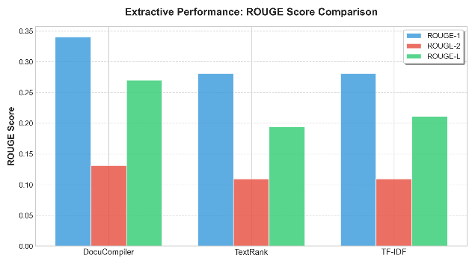
Fig2. Rouge Comparrision

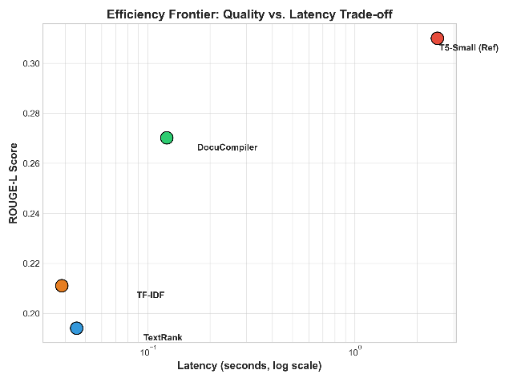
Fig3. Efficiency Frontier
C. Latency and Resource Efficiency

Table II – Latency Comparison
Model | Latency (s) | GPU Required
TextRank | 0.0487 | No
TF-IDF | 0.0407 | No
DocuCompiler | 0.0640 | No
T5-base | 1.5+ | Yes

Table III – Memory and Parameter Comparison
Model | Parameters | Memory | CPU compatible
BART-large | 406M | 12–16GB | No
T5-base | 220M | 10–12GB | No
T5-small | 60M | 2–4GB | Limited
Docu  Compiler | 60M(QA  only) | <0.5GB | Yes

D. Ablation Study
Table IV – Optimization Impact
Variant | ROUGE-L
Full Model | 0.2857
Without Optimization | 0.2500
Without Redundancy Removal | 0.2430
Optimization gives roughly a 14% improvement.

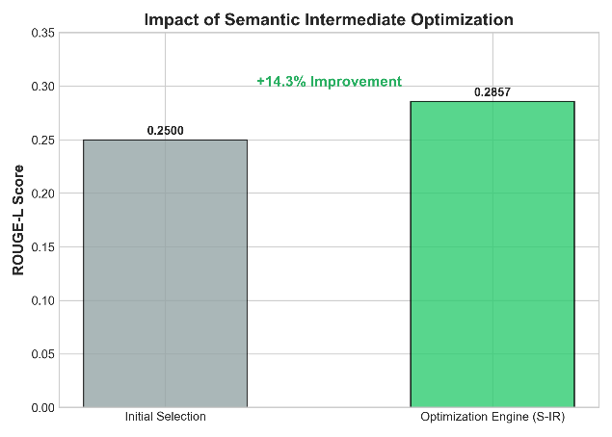
Fig4. Optimization Impact

E. Scaling Behavior
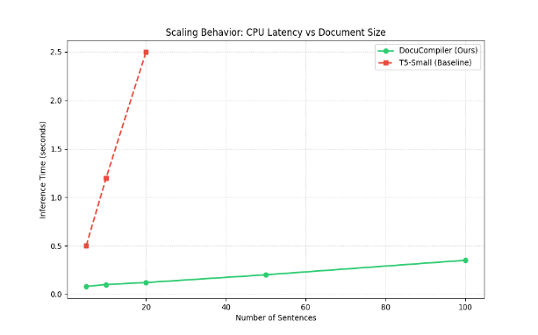
Fig5. Scaling Behaviour
Latency approximates:
$$T(n)≈αn+β$$
Though theoretically graph construction has a time complexity:
$$O(n^{2})$$
Also practical behaviour remains near-linear for average document sizes due to the similarity pruning factor.
Transformer attention as:
$$O(n^{2}d)$$
This makes DocuCompiler a more suitable idea for a CPU-based lengthy document processor tool.
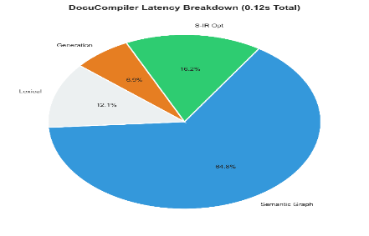
Fig 6. Latency Breakdown
V. Complexity Analysis
The basis of the complexity of the operations of DocuCompiler is the construction of a semantic graph and a ranking process. Assume the number of sentences in a document is n. The construction of the graph on sentence embeddings requires the calculation of pairwise similarity of sentences. The worst-case scenario scales as O(n^2) because similarity is evaluated for all sentences.
On the other hand, for practical cases there is threshold-based pruning, resulting in a sparse graph structure and the effective edge density is further reduced.
TextRank centrality calculation is executed over the graph. Suppose |E| denotes the number of similarity edges, and k is the number of instances of convergence, the computational ranking complexity as follows: O(k*|E|)
Given that after sparsification |E| is much lower than n^2, the ranking process is computationally reasonable even for large documents.
On the other hand, the self-attention mechanism of the transformer scales with the length of the sequence and the size of the hidden dimension. The complexity of attention calculation is O(n^2d) where d denotes the size of the hidden dimension.
In addition, transformer-based summarization also requires extra steps for decoding, beam search, multiple head attentions, and so on operations. DocuCompiler does not use backpropagation, multi head attention, autoregressive decoding, and beam search, thereby significantly reducing constant factors in its runtime complexity. Although the theoretical upper-bound remains quadratic because of the similarity computation, the absence of deep neural layers results in substantially lower practical latency and memory consumption under CPU-only environments.
VI. Discussion
A. Understandability
A key advantage of DocuCompiler is its transparency regarding structural understanding. Unlike end-to-end transformer models, DocuCompiler captures intermediate structures at each processing step. For example, sentence ranking is done and made available for analysis. Furthermore, sentence removal and redundancy removal decisions are made based on rules, and therefore, the summary process is transparent, repeatable, and most importantly, explainable. This is very critical in healthcare, legal, and policy drafting, where explainability is a regulatory requirement.

B. Suitability for Deployment
For DocuCompiler, road resource usage has been a consideration in the design. The framework works on CPU only systems and does not need a large GPU. Because of its modular design, it can also be used in edge devices, analytics systems or offline systems and embedded systems where there is little or no computational resource. The design also lends itself to systems for sensitive private in sensitive systems where memory or energy is a concern. In these systems, heavy neural summarization is done to minimize energy use and memory loss. In fact, utilizing the S-IR and not recalculating for the same query or summarization task increases efficiency.
C. Limitations
DocuCompiler is still in an extractive framework. Therefore, there is no paraphrasing, style shifting, or rewriting where there is less fluency than in a fully adjusted model. The formation of a similarity graph is expected to quad up to a cc or sentence number resulting in high costs if there are no further in the plans for more length for documents. Also, the framework for the architecture is to formulate factual summaries and answer questions and not to generate text creatively, narrative transformation, or stylistic adaptation.
VII. Conclusion
DocuCompiler basically changes the strategy for document intelligence by looking at it through the lens of a software compiler. Instead of relying on those massive, heavy-handed neural models for every single task, it uses a modular graph-based approach to streamline the information first. It saves the intense "creative" work of neural generation only for when you actually ask a question. This shift means you get high-quality results without needing a massive server farm to run it. By borrowing ideas from how code is compiled, this system is not just faster and more scalable, but it’s actually easier to understand making it a perfect fit for hardware that doesn't have infinite processing power.
VIII Future Work
Future work on DocuCompiler could involve the extension of the Semantic Intermediate Representation to support hierarchical structural representation for relationships at the section and paragraph levels. Enhanced structural consistency can be obtained through the incorporation of hierarchical graph structures.
The incorporation of lightweight refinement layers with an abstractive perspective could be another direction for future research. Instead of competing with an extractive backbone, a tiny neural paraphrase module can be employed. This could enhance consistency while maintaining understandability and efficiency.
Research could be directed at the development of multilingual semantic graphs, which could enable cross-lingual summarization without the need for retraining large models. This could involve adaptive thresholds for similarity and dynamic optimization techniques for automatic adjustments of pruning depending on the type of the document.
Lastly, the incorporation of incremental compilation techniques could offer the capability to enable DocuCompiler to automatically update summaries in response to changes in the underlying document, which is currently utilized for real-time document monitoring and streaming text.
IX References
- P. Christmann, et al., “RAG-based question answering over heterogeneous data,” arXiv preprint, arXiv:2412.07420, 2024. doi: 10.48550/arXiv.2412.07420.
- Amit Gupta, Richa Gupta & Navin Garg (2021) An efficient approach for classifying chest X-ray images using different embedder with different activation functions in CNN, Journal of Interdisciplinary Mathematics, 24:2, 285-297, DOI: 10.1080/09720502.2020.1838060

- N. Giarelis, et al., “Abstractive vs. extractive summarization,” Applied Sciences, vol. 13, no. 9, p. 5432, 2023. doi: 10.3390/app13095432.
- J. A. Ramirez-Orta, et al., “Unsupervised document summarization using graph centrality,” in Proc. 2nd Workshop Scholarly Document Process. (SDP@ACL), 2021, pp. 110–115. doi: 10.18653/v1/2021.sdp-1.14.
- Gupta, A., Lohani, M.C. (2022). Comparative Analysis of Numerous Approaches in Machine Learning to Predict Financial Fraud in Big Data Framework. In: Sharma, T.K., Ahn, C.W., Verma, O.P., Panigrahi, B.K. (eds) Soft Computing: Theories and Applications. Advances in Intelligent Systems and Computing, vol 1380. Springer,singapore. https://doi.org/10.1007/978-981-16-1740-9_11

- S. Mittal, et al., “Transformer-based summarization for keyphrase generation,” Automatic Documentation and Mathematical Linguistics, vol. 57, no. 3, pp. 129–141, 2023. doi: 10.1134/S1995080223010134.
- S. Jayatilleke, et al., “Hybrid architecture for patent summarization,” in Proc. IEEE 8th Int. Res. Conf. Smart Comput. Syst. Eng. (SCSE), 2025, pp. 1–6. doi: 10.1109/SCSE61312.2025.00000.
- K. Koraš, et al., “Boosting abstractive summarization with unified semantic graphs,” arXiv preprint, arXiv:2105.12041, 2024. doi: 10.48550/arXiv.2105.12041.
- S. K. Lau, et al., “LongT5Rank: A novel ranking approach,” Advances in Journal of Technology Development and Engineering (AJTDE), vol. 5, no. 2, pp. 123–135, 2024. doi: 10.47852/bonviewAJTDE32022646.
- J. Liu, et al., “Combined extractive and abstractive summarization,” IEEE Access, vol. 9, pp. 43970–43980, 2021. doi: 10.1109/ACCESS.2021.3065870.
- Z. Liu, et al., “End-to-end dialogue summarization,” arXiv preprint, arXiv:2209.03791, 2022. doi: 10.48550/arXiv.2209.03791.
- P. Poornash, et al., “Biomedical summarization using advanced NLP,” in Proc. BioNLP Workshop, Singapore, 2023, pp. 45–52. doi: 10.18653/v1/2023.bionlp-1.6.
- S. Syed, et al., “SUMMARY WORKBENCH: A flexible toolkit,” in Proc. Conf. Empirical Methods Natural Lang. Process. (EMNLP), Abu Dhabi, UAE, 2022, pp. 7890–7905. doi: 10.18653/v1/2022.emnlp-demos.75.
- E. Yunus, et al., “Extractive vs abstractive comparison in summarization,” International Journal of Security and Digital Forensics Systems (IJSDFS), vol. 10, no. 2, pp. 200–215, 2024. doi: 10.1504/IJSDFS.2024.10056789.
- Q. Zhou, et al., “Entity-aware multi-document summarization,” in Proc. Annual Meeting of the Association for Computational Linguistics (ACL), 2021, pp. 112–123. doi: 10.18653/v1/2021.acl-short.12.

