GSM 01.33 V8.0.0 (2000-04)
Technical Report
Digital cellular telecommunications system (Phase 2+);
Lawful Interception requirements for GSM
(GSM 01.33 version 8.0.0)
(formally known as GSM 10.20)



Reference
Lawful Interception (xxx.PDF)
Keywords
<keyword[, keyword]>
ETSI Secretariat
Postal address
F-06921 Sophia Antipolis Cedex - FRANCE
Office address
650 Route des Lucioles - Sophia Antipolis
Valbonne - FRANCE
Tel.: +33 4 92 94 42 00 Fax: +33 4 93 65 47 16
Siret N° 348 623 562 00017 - NAF 742 C
Association à but non lucratif enregistrée à la
Sous-Préfecture de Grasse (06) N° 7803/88
Internet
secretariat@etsi.fr
http://www.etsi.fr
http://www.etsi.org
Copyright Notification
No part may be reproduced except as authorized by written permission.
The copyright and the foregoing restriction extend to reproduction in all media.

© European Telecommunications Standards Institute 2000.
All rights reserved.
Contents
Intellectual Property Rights
Foreword
1 Scope
2 References
3 Definitions and abbreviations
3.1 Definitions
3.2 Abbreviations
4 Telecom interception requirements
4.1 Background
4.2 Background technical requirements
5 General technical requirements for legal interception in GSM/PCN networks
5.1 General principles
5.2 Capability
5.3 Operation
6 Summary of information passed over the X-interface
6.1 Intercept request, set-up details for target (X1)
6.2 Output (from PLMN to RF)
6.2.1 X2, "Network related data"
6.2.2 X3, "Product" (when requested)
7 Interception mechanisms
7.1 Intercept Request Function (X1)
7.2 Interception output, "Product" and "Network related data"
7.3 Delivery mechanisms
7.3.1 Network related data (see subclause 6.2.1)
7.3.2 Product
7.4 Administration mechanism
7.4.1 Security
7.5 Merging and processing of "Product" and "Network related data"
Annex A: Diagram of an example interception technical implementation
Annex B: GPRS and Lawful Interception
B.1 Introduction
B.1.1 Overview
B.1.2 Scope
B.2 Target Identity
B.3 Summary of Information Passed over the X-interface
B.3.1 Intercept Request, Set-up Details for Target (X1)
B.3.2 Output (from PLMN to Requesting Function)
B.3.2.1 X2, "Network related data"
B.3.2.2 X3, "Product" (when requested)
Annex C: Status of Technical Report GSM 01.33

Intellectual Property Rights
IPRs essential or potentially essential to the present document may have been declared to ETSI. The information pertaining to these essential IPRs, if any, is publicly available for ETSI members and non-members, and can be found in ETR 314: "Intellectual Property Rights (IPRs); Essential, or potentially Essential, IPRs notified to ETSI in respect of ETSI standards", which is available free of charge from the ETSI Secretariat. Latest updates are available on the ETSI Web server (http://www.etsi.fr/ipr or http://www.etsi.org/ipr).
Pursuant to the ETSI Interim IPR Policy, no investigation, including IPR searches, has been carried out by ETSI. No guarantee can be given as to the existence of other IPRs not referenced in ETR 314 (or the updates on the ETSI Web server) which are, or may be, or may become, essential to the present document.

Foreword
This GSM Technical Report has been produced by the Special Mobile Group (SMG) of the European Telecommunications Standards Institute (ETSI).
The contents of this report are subject to continuing work within SMG and may change following formal SMG approval. Should SMG modify the contents of this report it will then be released with an identifying change of release date and an increase in version number as follows:
Version 8.x.y
where:
8 indicates GSM Release 1999 of Phase 2+
y the third digit is incremented when editorial only changes have been incorporated in the specification;
x the second digit is incremented for all other types of changes, i.e. technical enhancements, corrections, updates, etc.

1 Scope
This report describes the interface requirements of a mechanism which will deliver intercept from GSM mobile stations, including both speech and data product.
The stage 1 description of Lawful Interception will be specified in GSM 02.33.
The stage 2 description of Lawful Interception will be specified in GSM 03.33.

2 References
This report incorporates by dated and undated reference, provisions from other publications. These normative references are cited at the appropriate places in the text and the publications are listed hereafter. For dated references, subsequent amendments to or revisions of any of these publications apply to this report only when incorporated in it by the amendment or revision. For undated references, the latest edition of the publication referred to applies.
[1] GSM 01.04: "Digital cellular telecommunications system (Phase 2+); Abbreviations and acronyms".

[2] GSM MoU Association document SG09, June 1995
[3] The European Union Council Resolution reference: “International Requirements for The Lawful Interception of Telecommunications” (January 1995), (JAI_24_Rev 2, 8197/2/95)
[4] ITU-T Recommendation G.711: "Pulse Code Modulation (PCM) of voice frequencies".

3 Definitions and abbreviations

3.1 Definitions
A-party: The originating party number.
B-Party: The called party number.
C-Party: A diverted-to party number.
Network related data: Data associated with a call, excluding the actual product such as speech or data.
Product: Data sent or received by a mobile user such as speech or fax or data.
RF: Requesting Function; mechanism owned by an interception authority to set-up and receive the interception product.
Target: An MSISDN (or sometimes IMSI) which is to be made the subject of an interception.
WAN: Wide Area Network, or interconnected LANs providing a computer data network between PLMN elements.

3.2 Abbreviations
In addition to those mentioned below, abbreviations used in this report are listed in GSM 01.04.
CGI Cell Global Identity
FTAM File Transfer Access and Management
GSM Global System for Mobile communications
HLR Home Location Register
IMEI International Mobile station Equipment Identity
IMSI International Mobile Subscriber Identity
ISDN Integrated Services Digital Network
LEA Law Enforcement Agency
MoU Memorandum of Understanding
MoU-SG The MoU Security Group
MS Mobile Station
MSC Mobile-services Switching Centre
MSISDN Mobile Station International ISDN Number
PLMN Public Lands Mobile Network
PSTN Public Switched Telephone Network
RF Requesting Function
SMG Special Mobile Group
SMG-SG The ETSI TC SMG Security Group
SMS Short Message Service
SS Supplementary Service
SS7 Signalling System No. 7
UDI Unrestricted Digital Interface (64 kbit/s ISDN data)

WAN Wide Area Network

4 Telecom interception requirements

4.1 Background
Previous MoU-SG specification SG09 has defined the interception of GSM in general terms. This report will define the X-interface to the Public Lands Mobile Network (PLMN) to support interception.

4.2 Background technical requirements
This report describes the interface to the PLMN, defined as the X-interface. The interface is illustrated in figure 1.
The X-interface is between the Requesting Function (RF) and the PLMN. It is divided into three logical parts:
1) The X1-interface is used to present commands to the PLMN, from an administration centre. This interface is part of the switch management capability, usually over an X.25 interface or Wide Area Network (WAN).
2) The X2-interface receives "Network related data" from the Mobile-services Switching Centre (MSC), in switch management or file output format, probably over an X.25 network or WAN. Alternatively, it may be sent in combination with the ISDN product in the X3-interface described below.
3) The X3-interface receives "Product" (mobile user's speech and data) from the MSC. It is contained within one or more 64 kbit/s channels.
The objective of the X-interface is to allow a standard to be created so that a PLMN consisting of MSCs from different manufacturers may be combined. Although the X1-interface commands may be slightly different for each manufacturer, it should be possible to create a single intelligent system to manage the interface at a low cost, capable of managing all different manufacturers implementations.
Similarly, the outputs defined in the X2 and X3 parts of the X-interface should be capable of processing by the same "Requesting Function".

5 General technical requirements for legal interception in GSM/PCN networks
Figure 1 shows the general system for interception. Technical interception is implemented within a PLMN by special functionality on network elements; primarily the MSCs/VLRs and Home Location Registers (HLRs). Use of the function and delivery of the "Product" from the target is defined by the X-interface.
X-interface
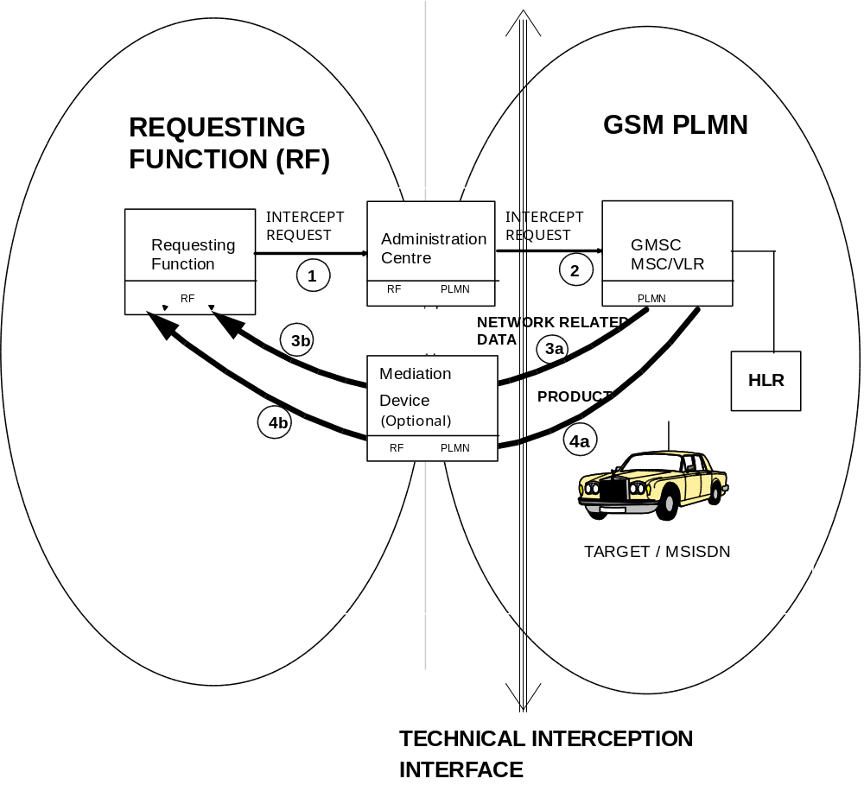
NOTES: 1: Paper or direct request
2: Electronic request
3a and 3b: "Network related data" }Items 3 & 4 may be combined into
4a and 4b: "Product", such as speech and mobile data }a common transport mechanism
X1 = Interface 2
X2 = Interface 3a
X3 = Interface 4a
Figure 1: General specification for interception.

5.1 General principles
The PLMN network should provide access to the "Product" and the "Network related data" of the mobile targets by means of the X-interface. As a minimum requirement the target should be identifiable by the Mobile Station International ISDN Number(s) (MSISDN(s)). There should be provision for unambiguous connection of the "Product" and the "Network related data" to the remote Requesting Functions (RFs). A secure means of administration of the service should be available to the PLMN operator and/or appropriate requesting functions in accordance with national laws.

5.2 Capability
The following minimum capabilities are required:
- it will be possible to support as "Product": speech, user data, fax and SMS, from the interception function;
- roamers from other PLMNs may also be targets;
- mobile originating, mobile terminating, and diversion or multiparty calls will be capable of interception;
- location information.

5.3 Operation
The interception function shall not alter the operation of a target's service or provide indication to any party involved in the call. Output product should be in "clear" form - no GSM radio interface or PLMN generated radio interface encoding or encryption is present (the PLMN cannot remove subscriber encryption). The service should not alter the standard functions of GSM network elements. The "Product" and the "Network related data" shall be delivered as near as possible to the time the call is made.

6 Summary of information passed over the X-interface

6.1 Intercept request, set-up details for target (X1)
Data to be stored for target mobile station:
- MSISDN, or optionally the International Mobile Subscriber Identity (IMSI);
- Connection address for the Requesting Function (RF);
- Type of output:
- "Product" or "Network related data" or both.

6.2 Output (from PLMN to RF)

6.2.1 X2, "Network related data"
- unique reference number for MSC call event;
- MSISDN, (and optionally IMSI, International Mobile station Equipment Identity (IMEI));
- type of call (i.e. originating or terminating);
- A-party number, B-party number;
- C-party (diversion or multiparty numbers);
- start time of call;
- finish time of call (or call duration);
- location information (Cell Global Identity (CGI));
- teleservice or bearer service used, Supplementary Service (SS) used;
- call completion message (giving call release reason).
NOTE 1: The above list is a guide to the information which may be provided by the MSC, but not all the items will be available for every call type.
NOTE 2: Connected party numbers (A-, B- and C-party) may only be available for calls completely contained within ISDN based networks.
NOTE 3: Appropriate "Network related data" should also be output from the MSC for unsuccessful call attempts.

6.2.2 X3, "Product" (when requested)
- "Product": speech, user data, fax, or Short Message Service (SMS);
NOTE: SMS text may be forwarded to the RF by means of the X2-interface mechanism.
- Unique reference number for MSC call event.

7 Interception mechanisms

7.1 Intercept Request Function (X1)
The following basic target administration functions are to be supported:
ADD
- flag a target by MSISDN, or optionally IMSI;
- X2 delivery address, e.g. X.25 or WAN address;
- X3 "Product" delivery address, E.164 address;
- select "Network related data" alone, or "Network related data" and "Product".
REMOVE
- de-flag a target.
SHOW
- list one or more targeted MSISDNs.

7.2 Interception output, "Product" and "Network related data"
The "Product" of the target and connected parties will be additionally connected to an output port of the MSC (for example by means of a three party bridge) which routes the "Product" to an RF, possibly via an optional mediation device. The mediation device provides interface conversion (if necessary) between the PLMN X2- and X3-interfaces and the RF.
Different RFs may require the same information. The mediation device may simultaneously provide multiple output of "Product" and "Network related data" regarding one MSISDN to more than one RF. No information should be passed to the RF about which other RFs are using the information.
Some types of call may require multiple links to the RF, for example Unrestricted Digital Interface (UDI) data services, and optionally in-band data (3.1 kHz) services.

7.3 Delivery mechanisms

7.3.1 Network related data (see subclause 6.2.1)
There are two mechanisms proposed for delivery of "Network related data"; these are:
- ISDN user to user signalling; or
- MSC/HLR file format output, (via an X.25 network using File Transfer Access and Management (FTAM), or WAN).

7.3.2 Product
The "Product" should be passed in ISDN format: i.e. for voice according to ITU-T Recommendation G.711, A-law encoding in one or more 64 kbit/s channels.
For UDI data the output is transparently transmitted in two 64 kbit/s channels.
"Product" (speech and data) should be routed to the RF by E.164 address.
SMS product, exceptionally, will probably be transported according to the mechanism selected for "Network related data".

7.4 Administration mechanism
A secure means of administrating the service by the PLMN operator and/or requesting function is necessary. This mechanism should provide for the addition and removal of subscribers from the marked list by authorised personnel, and a show marked MSISDNs command. Access should be policed by appropriate authentication and audit procedures.

7.4.1 Security
The intercept function must only be capable of being used by authorised personnel. Security functions should provide the following capability (to national requirements):
- security administration to control nominated user access to the function;
- secure data network arrangements between administration centre and MSC/HLR for the intercept function commands;
- security mechanisms to control access to the function should be provided at both the administration centre and MSC/HLR elements;
- secure network arrangements between MSC/HLR and the RF to ensure that "Network related data" and "Product" only reach the appropriate authorities;
- it should not be possible for non authorised personnel to read the target list of MSISDNs;
- an audit log of use of the intercept function (successful or failed should be maintained, accessible only to authorised users;
- no indication whatsoever should be given to any PLMN operative (except authorised personnel) or the target or customer that the intercept function has been invoked on the target.

7.5 Merging and processing of "Product" and "Network related data"
This aspect of the service is not addressed by this report. It is a matter of discussion between relevant authorities and the PLMN operator as to responsibilities for the provision of the mediation device, and the means of handling product at the RF.

Annex A:
Diagram of an example interception technical implementation
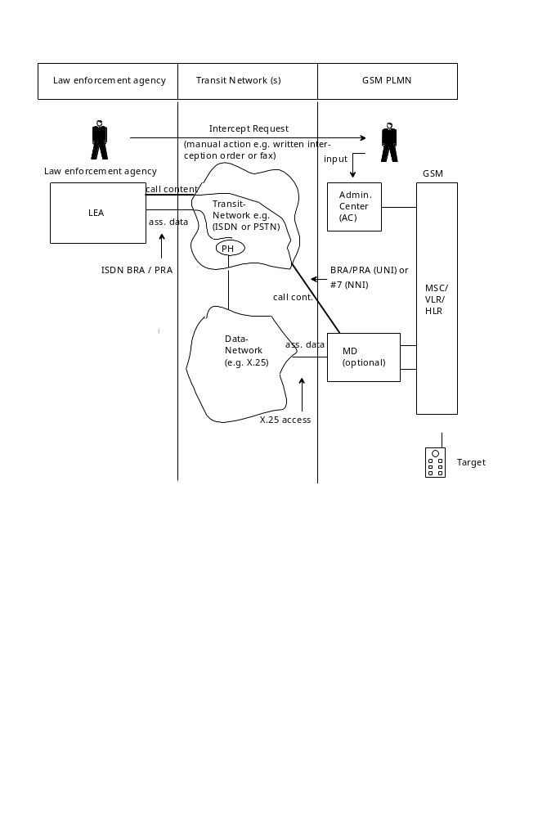

Annex B:
GPRS and Lawful Interception

B.1 Introduction

B.1.1 Overview
The general system for lawful interception in GSM PLMN is similar in both circuit and packet switched services. Technical interception is implemented within a PLMN by special functionality on network elements; primarily the MSCs/VLRs, the GPRS Support Nodes (GSNs) and HLRs. The objective of the X-interface is to allow a standard to be created so that a PLMN consisting of different network elements (GSN, MSC/VLR, HLR) from different manufacturers may be combined.
The interception mechanisms are similar in both circuit and packet switched services, but there are few things that require modifications: The GPRS service brings packet data specific requirements to the information passed over the X-interface. Also the definition of target identity is different in the GPRS service.

B.1.2 Scope
The scope of this annex is to introduce GPRS specific X-interface and identification requirements to this lawful interception report.

B.2 Target Identity
A GPRS subscriber identified by an IMSI (or an MSISDN) shall have a network layer address(es) temporarily and/or permanently associated with it that conforms to the standard addressing scheme of the respective network layer service used. GPRS shall provide a means to interwork with external data networks. The GPRS operator provides an appropriate Packet Data Protocol (PDP) address to the external data network for the subscriber as part of the GPRS subscription. That address can be either dynamic (e.g. the user's IP address is allocated from a pool of unused IP addresses every time the subscriber activates the access to an IP network) or static (e.g. a certain IP address is permanently allocated to a particular subscriber).

B.3 Summary of Information Passed over the X-interface

B.3.1 Intercept Request, Set-up Details for Target (X1)
Data to be stored for target GPRS mobile station:
- IMSI, or MSISDN;
- Connection address for the Requesting Function (RF);
- Type of output:
- "Product" or "Network related data" or both.

B.3.2 Output (from PLMN to Requesting Function)

B.3.2.1 X2, "Network related data"
- unique reference number for PDP context activation;
- IMSI, (and optionally MSISDN, International Mobile station Equipment Identity (IMEI));
- type of packet data transfer (i.e. originating or terminating);
- A-party PDP address, B-party PDP address;
- C-party (diversion or multiparty PDP addresses);
- time of PDP context activation;
- time of PDP context deactivation (or PDP context duration);
- location information (Cell Global Identity (CGI));
- teleservice or bearer service used, Supplementary Service (SS) used;
- PDP used;
- call completion message (giving call release reason);
- timestamp (see subclause B.3.2.2).
The above list is a guide to the information which may be provided by the GPRS service, but not all the items will be available for every call type. Appropriate "Network related data" should also be output from the GPRS service for unsuccessful packet data transfer attempts. For certain protocols like IP, the sender and receiver addresses are always included in the IP packet and do not need to be part of "Network related data".

B.3.2.2 X3, "Product" (when requested)
- "Product": user data or Short Message Service (SMS);
- unique reference number for PDP context activation;
- timestamp on each PDP packet.
At the law enforcement agency the data packets and the "Network related data" can be accurately correlated by copying the timestamp in the data product packet into the timestamp field of the "Network related data" packet. In addition to the timestamp the unique reference number or user identification may be required for correlation. All packet data transmissions to or from the intercept target may be subject to interception regardless of their outcome. For example, when an SMS packet to an MS is intercepted, it is not known whether the packet was actually received by the MS.

Annex C:
Status of Technical Report GSM 01.33
Status
of
Technical Report GSM 01.33
Date | Version | Remarks
 |  | No Phase 1 version
April 1996 | 1.0.0 | To SMG#18 for information
June 1996 | 5.0.0 | TC TR approved by SMG#19
January 1997 | 5.0.1 | TC TR converted to ETR 363
March 1998 | 7.0.0 | CR 01.33-A001r1 (GPRS) approved by SMG#25  TR renamed to GSM 01.33 (as agreed by SMG#22)  Report converted to version 7.0.0 because work item is related to Release 98
April 2000 | 8.0.0 | Release 99 version.
Text and figures: WinWord 7.0
Stylesheet: etsiw_70.dot

