TR 101.186 V6.0.0 (1998-04)
Technical Report
Digital cellular telecommunications system (Phase 2+);
General Packet Radio Service (GPRS)
Requirements specification of GPRS
(GSM 01.60 version 6.0.0)



Reference
DTR/SMG-010160Q (azc03004.PDF)
Keywords
Digital cellular telecommunications system, Global System for Mobile communications (GSM)
ETSI Secretariat
Postal address
F-06921 Sophia Antipolis Cedex - FRANCE
Office address
650 Route des Lucioles - Sophia Antipolis
Valbonne - FRANCE
Tel.: +33 4 92 94 42 00 Fax: +33 4 93 65 47 16
Siret N° 348 623 562 00017 - NAF 742 C
Association à but non lucratif enregistrée à la
Sous-Préfecture de Grasse (06) N° 7803/88
Internet
secretariat@etsi.fr
http://www.etsi.fr
http://www.etsi.org
Copyright Notification
No part may be reproduced except as authorized by written permission.
The copyright and the foregoing restriction extend to reproduction in all media.

© European Telecommunications Standards Institute 1998.
All rights reserved.
Contents
Intellectual Property Rights
Foreword
1 Scope
2 Definitions
3 Requirements Of GPRS
3.1 Primary Requirements
3.2 GPRS Classification
3.2.1 GPRS Access Points
3.2.2 Types Of Service Request
3.2.3 Multiple, parallel GPRS sessions
3.2.4 Simultaneous Use Of Service
3.2.4.1 Definition Of Simultaneous Use Of Service
3.2.4.2 Requirement
3.2.4.3 Degradation with Subscriber Class B
3.2.4.3 Service Types, Subscription Classes And Simultaneous Use
3.2.5 Capacity Required
3.2.6 Channel Independence Of GPRS
3.2.7 GPRS Allocation Flexibility Within A PLMN
3.2.8 Technical Realization of MS Access.
3.2.9 GPRS Communication Resource Utilisation
3.2.10 Application Data Transfer Requirements
3.2.10.1 Format Of Message User Data
3.2.10.2 Types Of Application Messages To Be Supported
3.2.10.3 Point-to-Multipoint Routing Support
3.2.10.3.1 Geographical Area Identity
3.2.11 Service Control Requirements
3.2.11.1 Control Requirements Common To Down/Uplink Services
3.2.11.2 Downlink Control Requirements
3.2.12 Uplink Control Requirements
3.3 Initial Quality Of Service (QoS)
3.3.1 QoS when Interworking
3.3.1.1 X.25 QoS Requirements
3.3.1.2 CLNS QoS Requirements
3.3.1.3 IP QoS Requirements
3.3.2 Maximum Service Delay
3.3.3 Protection (Security Management)
3.3.3.1 Requirement: Network Protection
3.3.3.2 Requirement: User Protection
3.3.4 Success Rate of Point-to-Multipoint Service
3.3.5 Residual Error Rates
3.3.6 Priority
3.4 Phased Implementation
4 GPRS Subscription and Charging Aspects
4.1 Charging aspects
5 GPRS Security Aspects
6 Interworking Requirements
6.1 Service Interworking
6.2 Network Interworking
6.2.1 Interworking with other data networks and other PLMN´s
6.2.2 GPRS Numbering Plan
6.2.3 Addressing/Routing Requirements
6.2.3.1 Point to Point Network Layer Services
6.2.3.2 Point to Multipoint Services
6.3 Interworking for subscriber roaming
7 O & M Aspects
Annex A: Change Record
History

Intellectual Property Rights
IPRs essential or potentially essential to the present document may have been declared to ETSI. The information pertaining to these essential IPRs, if any, is publicly available for ETSI members and non-members, and can be found in ETR 314: "Intellectual Property Rights (IPRs); Essential, or potentially Essential, IPRs notified to ETSI in respect of ETSI standards", which is available free of charge from the ETSI Secretariat. Latest updates are available on the ETSI Web server (http://www.etsi.fr/ipr or http://www.etsi.org/ipr).
Pursuant to the ETSI Interim IPR Policy, no investigation, including IPR searches, has been carried out by ETSI. No guarantee can be given as to the existence of other IPRs not referenced in ETR 314 (or the updates on the ETSI Web server) which are, or may be, or may become, essential to the present document.

Foreword
This ETSI Technical Report (TR) has been produced by the Special Mobile Group (SMG) of the European Telecommunications Standards Institute (ETSI).
This TR contains historical background information and was used in the early developement of GPRS within SMG
The contents of this TS are subject to continuing work within SMG and may change following formal SMG approval. Should SMG modify the contents of this TS it will then be republished by ETSI with an identifying change of release date and an increase in version number as follows:
Version 6.x.y
where:
6 indicates GSM Release 1997 of Phase 2+
y the third digit is incremented when editorial only changes have been incorporated in the specification;
x the second digit is incremented for all other types of changes, i.e. technical enhancements, corrections, updates, etc.

1 Scope
The purpose of this document is to specify the requirements of GPRS, which shall form the basis for further development work on this subject.
This requirements specification is to be used a reference document for the standardisation process and also for the "compliance to requirements check" to ensure compliance of the developed standards with the specified requirements or to enable the documentation of the approved deviations and also the reasons for deviation.
It is neither intended nor necessary to update this document to reflect the actual status of the standardisation work, since the standardisation process
- especially the stage 2 work - may be influenced by implementation and/or technical aspects, which may not be true requirements but rather be, for example, a "temporary aspect or constraint". Additional requirements or refinements to this specification are of course allowed.

2 Definitions
Terms are defined in the TG-GPRS document WD Definitions.

3 Requirements Of GPRS

3.1 Primary Requirements
The primary requirements to be met by GPRS are as follows.
- To enable new and existing applications to be attracted onto GSM.
To achieve this the enhancement of GSM's functional and QoS parameters are vital goals. Applications which could be attracted because packet mode data transmission is provided through GPRS can be classified into horizontal and vertical markets. Requests for enhancements of the functional and performance capabilities of GSM have been received from the following markets:
Horizontal: Wireless Personal Computers
Mobile Offices
Electronic Funds Transfer from Point of Sale (EFTPOS)
Vertical: Road Transport Informatics
Union International de Chemin de Fer (UIC)
Field Service Businesses
Fleet Management
Remote Telematics
Commodity/Supply Logistics
- GPRS shall support both connectionless and connection oriented services.
- To offer a flexible service at low cost to the user.
In order to make the service as cost effective as possible, the impact upon existing investments in GSM architectural entities, their supporting protocols and deployment costs must be kept to a minimum.
- To use scarce network resources as efficiently as possible.
- To support early introduction of GPRS services, without compromise to eventual capacity and performance, through a phased programme of definition and implementation.

3.2 GPRS Classification
GPRS shall provide packet mode transfer for applications that exhibit the following data traffic patterns.
- Frequent transmission of small volumes.
- Infrequent transmissions of small or medium volumes.
The PLMN Operator who offers GPRS shall be responsible for transferring data between the service access points at the fixed side and at the mobile side. The flow of data shall be possible in three scenarios.
- Packets sent from a mobile access point to a fixed network access point.
- Packets sent from a fixed network access point to a mobile access point.
- Packets sent from a mobile access point to a mobile access point via the GSM PLMN infrastructure. This does not exclude an implementation in which MO-MT packets are transferred using the previous two modes.
GPRS shall be distinguished from existing services in two ways.
Firstly, it is required to efficiently use network resources for packet mode applications.
Secondly, new mechanisms are required in order to provide highly standardised, feature-rich services, in which the selection of the QoS parameters can be made by the Service Requesters.
GPRS shall not prevent the user's operation of existing GSM services.
GPRS shall not be used as a basis for packetised speech.
GPRS shall not be used as a basis for services that duplicate, in terms of performance and cost requirements, existing GSM services.

3.2.1 GPRS Access Points
GPRS shall support bearer service access points. Teleservice access points are FFS.
GPRS shall be compatible with the OSI model. It is assumed, for the purpose of this document, that a bearer serviece corresponds to layers 1 to 3 of the OSI model and that a teleservice corresponds to layers 4 to 7 of the OSI model (ref. GSM 02.01). Figure 1 is taken from (GSM 02.01/Figure 1).
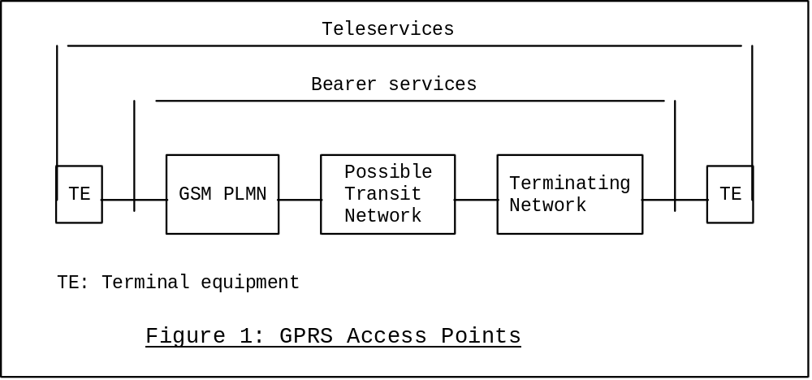

3.2.2 Types Of Service Request
Three types of service request are required
- Broadcast: A point-to-multipoint message sent to "all service subscribers" within an area defined by the Service Requester. It is envisaged that subscription and authentication for this service is limited and strictly controlled.
There is no requirement for providing end-to-end acknowledgement for broadcast service requests.
- Multicast: A point-to-multipoint message sent to "an identified subset of all service subscribers" within an area defined by the Service Requester.
There is a requirement to be able to provide end-to-end acknowledgement for multicast service requests.
- Singlecast: A point-to-point message sent to "a unique subscriber".
The communication characteristics of the various applications to be supported by single cast service request can be divided into the following groups:
Non-dialogue
The transfer of a data packet between the Service Requester and the Service Receiver in which every data packet is independent of the preceding and succeeding one.
Dialogue
There exists a logical relationship between Service Requester and Service Receiver that lasts for a duration of time ranging from seconds to hours.
It is required to provide means for offering attractive services, in terms of costs, functionality and performance, to this broad suite of applications.
An invocation of the three types of service request by a Service Requester is possible from the fixed and mobile access points (see "GPRS Access Points"). Table 1 presents the relationship between service requests and the Service Requester/Receiver.
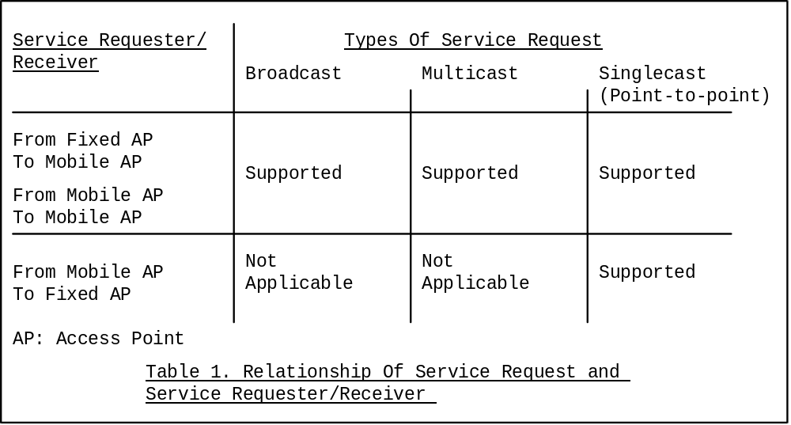

3.2.3 Multiple, parallel GPRS sessions
It shall be possible for a subscriber to set-up multiple GPRS PTP-Dialogue sessions and maintain these over prolonged periods (~ hours) for background type applications. PTP-NonDialogue, PTM-Multicast and/or PTM-Broadcast communications shall be possible during such background multiple GPRS PTP-Dialogue sessions.
In the case of X.25 the concept of switched virtual circuits must be maintained between the GPRS environment and the X.25 fixed network.

3.2.4 Simultaneous Use Of Service
A number of subscription classes are required to grade the relationship between the subscriber and the subscriber's simultaneous use of services. The following subscriber classes are proposed:
Subscriber Class A: Full simultaneous use, maximum throughput (>=9.6kbit/s), no degredation of circuit switched services.
[ Subscriber Class B: Simultaneous use with reduced data-throughput and/or degraded circuit switched services. ] Note: This subscriber class shall be deleted unless commercial justification is provided!
Subscriber Class C: Non-simultaneous use of service.

3.2.4.1 Definition Of Simultaneous Use Of Service
NOTE: This definition of simultaneous use of service applies only to subscriber class A and B.
It shall be possible to place/receive circuit-switched calls (speech or data) during (i.e. in parallel with) transmission/reception of GPRS data.
It shall be possible to transmit/receive GPRS data during (i.e. in parallel with) circuit-switched calls (speech or data).
It shall be possible to transmit/receive an SMS-MO/MT message during the use of any GPRS, even if there is a speech or data call already running in parallel. The SMS message transmission over the air interface and/or GPRS service may be delayed and/or throughput reduced for this to be effected.
It shall be possible to receive an SMS-CB message during the use of any GPRS, providing a speech or data call is not running in parallel. The SMS message transmission over the air interface and/or GPRS service may be delayed and/or throughput reduced for this to be effected.
It shall be possible to monitor GSM Common Control Channel Signalling during any GPRS communication.

3.2.4.2 Requirement
Simultaneous use is required for ptp and ptm service types.

3.2.4.3 Degradation with Subscriber Class B
[ In the case of simultaneous use, a degredation of the specified GPRS maximum data throughput capacity may be acceptable for an MS with a single transceiver [logical channel]. . ]
[ In the case of simultaneous use, a degredation of the circuit switched services may be acceptable for an MS with a single transceiver [logical channel]. . ]
NOTE: Subscriber class B shall be deleted unless commercial justification is provided!

3.2.4.3 Service Types, Subscription Classes And Simultaneous Use
When a subscriber is busy executing a circuit-switched bearer or teleservice and a GPRS service request arrives (i.e. ptp-D, ptp-ND and ptm), GPRS will respond according to the subscriber's subscription class in the following way.
Called Subscriber Circuit Switched Busy | Subscriber  Class A | Subscriber.  Class B | Subscriber  Class C
ptp-ND request | Accepted | Accepted with degredation of QoS | Rejected
ptp-D request | Accepted | Accepted with degredation of QoS | Rejected
ptm request | Accepted | Accepted with degredation of QoS | Rejected  (data lost)

Where, the above terms are defined in the following way.
Accepted: The service request is fully executed to the service QoS requirements.
Accepted with degredation of QoS: The service request is fully executed to the service QoS requirements except that the maximum throughput may be reduced.
Rejected: When a service request is received (also from an external network) and cannot be fully executed within the interworking requirements, the service request shall be rejected in a manner conformant with the interworking network.

3.2.5 Capacity Required
In response to customer-driven capacity requirements and in order to be compatible with dedicated packet-switched data networks, it is required that the upper limit of the data transfer capacity that GPRS provides to a service request is at least that of a FR TCH.

3.2.6 Channel Independence Of GPRS

It is required that the packet multiplexing mechanisms developed for GPRS are independent of a given channel type. It shall be possible to operate GPRS over low and high capacity channels. These may be existing and/or future channels whose capacities are as yet unspecified (e.g. two time-slots or an entire 200kHz carrier).

3.2.7 GPRS Allocation Flexibility Within A PLMN
The radio resources offered to GPRS shall be configurable by the PLMN operator, by O + M or other means, without interruption to the service . A PLMN operator may allocate radio resources on a region-to-region basis and/or over time. Resources can then be allocated according to network aspects and application related requirements.
The GPRS MS shall be able to adapt, through a process of self regulation, to the configured radio resources as part of the normal operation of GPRS.

3.2.8 Technical Realization of MS Access.
The technical realization should provide for the routing of packets between the MS and a new element of the PLMN (possibly a new IWF). The use of diverse types of channel should be considered, including signalling channels, to provide a range of service levels.
The technical realization of the GPRS radio part shall support battery saving. However, battery saving may not be compatible to the high performance requirement on delay presented in the section "Maximum Service Delay"

3.2.9 GPRS Communication Resource Utilisation
It shall be possible to respond to local data traffic conditions adaptively. GPRS shall include the functionality to increase or decrease the amount of radio resources allocated to GPRS on a dynamic basis. The criteria used to decide on dynamic changes of the GPRS part of the radio resource should not be specified. Thus, only the necessary procedure, including radio protocol and timers, needed to perform the change of radio resource shall be specified within the ETSI specifications.
Within GPRS the dynamic allocation of the radio resource for bursty or lengthy file transfer applications shall be such that it can be controlled by the network operator.

3.2.10 Application Data Transfer Requirements
GPRS shall fulfil the following high level requirements:
- GPRS should be compatible with existing data networks and applications. It should be possible to use existing applications (including applications using ´X.25 Fast Select´) over GPRS with little or no change.
- GPRS should comply with industry standard interfaces and protocols for data communications.
- GPRS should minimise the impact on the end systems.
- GPRS should provide the ability to maintain a connection oriented virtual circuit upon change of cell within a PLMN but not when transiting from one PLMN to another PLMN. The support of roaming between PLMN´s is required.
- Any established SVC must be torn down on failed handover, IMSI detach or loss of coverage.

3.2.10.1 Format Of Message User Data
The user data is to be transmitted as an octet string between GPRS's access points, and is not interpreted by the GSM PLMN.

3.2.10.2 Types Of Application Messages To Be Supported
In order to utilise network resources as effectively as possible, an application should only use the capacity that it requires. There is no typical message size for all applications. A limitation of the maximum message length is not foreseen.
For guidance, the following two general types of application message that the service is required to support are described.
Structured Data Message Lengths
Measuring, "form filling", "Point of sale" applications typically transmit small amounts of highly structured data, e.g., defined field service codes or reference numbers. Very little free text is used. These applications transmit very short messages between 30 and 60 bytes in length.
Unstructured Data Message Lengths
These applications typically send larger amounts of "free text", or diagrams, ranging from 140 bytes to 450 bytes, and occasionally beyond, depending upon the application.

3.2.10.3 Point-to-Multipoint Routing Support
For point-to-multipoint service requests which are executed on the basis of "where" a subscriber is, rather than "who" a subscriber is, the following two "identities" are necessary.

3.2.10.3.1 Geographical Area Identity
A Geographical Area Identity is required to support "Geographical Routing".

3.2.11 Service Control Requirements

3.2.11.1 Control Requirements Common To Down/Uplink Services
GPRS requires the following control.
- It shall be possible to validate a service request against the Service User´s subscription profile.

3.2.11.2 Downlink Control Requirements
The Service Requester of a GPRS service in the downlink direction requires,
- The Service Receiver of a point-to-multipoint service request must be able to filter out packets at a network level, through use of the Packet Identities, which are of no interest either because they are for a service for which no subscription is held, or the packet belongs to a sub-group within the offered application service which is of no interest. It is required that the MS-Application resources shall not be utilized for this function.
- As an option scheduling of point-to-multipoint packets within the GPRS network may be required. This includes controllable transmission repetition rates, the deactivation of obsolete packets and the notification of adverse network conditions if necessary.

3.2.12 Uplink Control Requirements
The Service Requester of a GPRS service in the uplink direction requires,
- Robust radio channel access mechanisms which allow the allocation of resources in a fair way taking into account possible priorities and which are able to cope with overload situations.

3.3 Initial Quality Of Service (QoS)
There is not one single optimal QoS profile for all applications, only an optimal QoS profile per application. Therefore, in order that PLMN Operators may offer flexible, customised service packages that accurately meet the QoS requirements of an application, it is required that GPRS parameterise central QoS variables where feasible. This Requirements document concentrates upon the Initial Requirements for GPRS. See Section "Phased Definition and Implementation" for more details on the phases of GPRS.
The following service delay classes (SD-Class), [this is FFS], are introduced:
- SD-Class 1: Predictive service - expedited
- SD-Class 2: Predictive service - regular
- SD-Class 3: Best effort service - expedited
- SD-Class 4: Best effort service - regular
- SD-Class 5: Best effort service - unspecified delay
A predictive service is characterized by "soft" service delay boundaries with a only a small variability in the delay requirements allowed.
A best effort service is characterized by a minimal guarantee on the service delay thus allowing a large actual variation.

3.3.1 QoS when Interworking
The purpose of this section is to define the QoS requirements placed on the GPRS bearer service when interworking with external packet data networks and protocols.
The GPRS QoS values refer to the GPRS bearer service between service access points.
For clarity and information only, typical expected end-to-end values (i.e. including external network values) are included where available

3.3.1.1 X.25 QoS Requirements
Table: GPRS and End-to-End Capabilities
Function | Attributes |  | Required GPRS - QoS capabilities | End - to - end QoS capabilities
Speed | NC Esablishment | Mean Delay  95% delay  Fail Probability | tbd  tbd  tbd | tbd  < 1 secondh  tbd
 | NC Release | Mean Delay  95% delay  Fail Probabiity | tbd  tbd  tbd | tbd  < 1 second I  tbd
 | User data | Peak bit ratea |  | >=9.6 kbps, 98% busy hour.
 | throughput | Mean bit rateb |  | >=9.6 kbps, 98% busy hour.
 | Transfer delay (T)c | Mean delay (ms) | SD-Class 1 - 5: tbd
 | T = RA + RT + NT | 95% delay (ms) | SD-Class 1 - 5: tbd | 0.5 seconds
 | Radio channel | Mean delay (ms) | SD-Class 1 - 5: tbd
 | access delay (RA) | 95% delay (ms) | SD-Class 1 - 5: tbd
 | Radio channel transit delay (RT)d (ms) |  | tbd
 | Network transit | Mean delay (ms) | tbd (ref.X.135)
 | delay (NT) | 95% delay (ms) | tbd (ref.X.135)
Accuracy | Residual error | Lost data probability | tbd (ref.X.135)
 | rates | Corrupt data probabilitye | compatible with X.25 layer 3
 |  | Duplicate data probability | compatible with X.25 layer 3
 |  | Out of sequence probability | compatible with X.25 layer 3
Dependability | QoS negotiation failure ratef | tbd
 | QoS non-compliance rateg | tbd
 | Service availability | tbd (ref X.137)
 | Mean time between service outages (hours) | tbd (ref.X.137)
 | Mean service outage duration (hours) | tbd (ref.X.137)
 | NC Resilience | Disconnect Probability | tbd | tbd
 |  | Reset Probability | tbd | tbd

NOTE: QOS parameters derived from ISO8348:1993 - NC Protection, NC Priority, and Maximum acceptable cost - omitted as not relevant.
a. Peak bit rate: the maximum bit rate offered to the user [for a given period (tbd)] for the transfer of data.
b. Mean bit rate: the average bit rate to the user.
c. Transfer delay: the sum of radio channel access delay (RA), the radio channel transit delay (RT) and the network transit delay (NT). All delay values assume a user data length of 128 octets.
d. Radio channel transit delay: assumes a maximum user data transfer rate of [tbd] for a full rate dhannel.
e. Corrupt data probability: the probability that data will be delivered to the user with an undetected error.
f. QoS negotiation failure rate: the probability that the user requested QoS will be denied.
g. QoS non-compliance rate: the probability that the network will fail to provide the agreed QoS to the user.
h. NC Establishment ( Call set-up): time to establish a connection-oriented call between an MS and a host in the external X.25 network.
i. NC Release ( Call tear down): time to disconnect a connection-oriented call between the MS and a host in the external X.25 network.

3.3.1.2 CLNS QoS Requirements
Table: GPRS and End-to-End Capabilities
Function | Attributes |  | Required GPRS - QoS capabilities | End - to - end QoS capabilities
Speed | Transfer delay (T)c | Mean delay (ms) | SD-Class 1 - 5: tbd | tbd
 | T = RA + RT + NT | 95% delay (ms) | SD-Class 1 - 5: tbd | tbd
 | Radio channel | Mean delay (ms) | SD-Class 1 - 5: tbd | tbd
 | access delay (RA) | 95% delay (ms) | SD-Class 1 - 5: tbd | tbd
 | Radio channel transit delay (RT)d (ms) |  | tbd | tbd
 | Network transit | Mean delay (ms) | tbd | tbd
 | delay (NT) | 95% delay (ms) | tbd | tbd
Accuracy | Residual error | Lost data probability | tbd | tbd
 | rates | Corrupt data probabilitye | tbd | tbd
 |  | Duplicate data probability | tbd | tbd
Dependability | QoS negotiation failure ratef |  | tbd | tbd
 | QoS non-compliance rateg |  | tbd | tbd
 | Service availability |  | tbd | tbd
 | Mean time between service outages (hours) |  | tbd | tbd
 | Mean service outage duration (hours) |  | tbd | tbd

NOTE: QOS parameters derived from ISO 8348:1993 - Protection, Priority, Cost Determinants - omitted as not relevant.
a. Peak bit rate: the maximum bit rate offered to the user [for a given period (tbd)] for the transfer of data.
b. Mean bit rate: the average bit rate to the user.
c. Transfer delay: the sum of radio channel access delay (RA), the radio channel transit delay (RT) and the network transit delay (NT). All delay values assume a user data length of 128 octets.
d. Radio channel transit delay: assumes a maximum user data transfer rate of [tbd] for a full rate dhannel.
e. Corrupt data probability: the probability that data will be delivered to the user with an undetected error.
f. QoS negotiation failure rate: the probability that the user requested QoS will be denied.
g. QoS non-compliance rate: the probability that the network will fail to provide the agreed QoS to the user.
h. NC Establishment ( Call set-up): time to establish a connection-oriented call between an MS and a host in the external X.25 network.
i. NC Release ( Call tear down): time to disconnect a connection-oriented call between the MS and a host in the external X.25 network.

3.3.1.3 IP QoS Requirements
Table: GPRS and End-to-End Capabilities
Function | Attributes |  | Required GPRS - QoS capabilities | End - to - end QoS capabilities
Speed | Transfer delay (T)c | Mean delay (ms) | SD-Class 1 - 5: tbd | tbd
 | T = RA + RT + NT | 95% delay (ms) | SD-Class 1 - 5: tbd | tbd
 | Radio channel | Mean delay (ms) | SD-Class 1 - 5: tbd | tbd
 | access delay (RA) | 95% delay (ms) | SD-Class 1 - 5: tbd | tbd
 | Radio channel transit delay (RT)d (ms) |  | tbd | tbd
 | Network transit | Mean delay (ms) | tbd | tbd
 | delay (NT) | 95% delay (ms) | tbd | tbd
 | Throughput | Peak bit ratea | tbd | tbd
 |  | Mean bit rateb | tbd | tbd
Accuracy | Residual error | Lost data probability | tbd | tbd
 | rates | Corrupt data probabilitye | tbd | tbd
 |  | Duplicate data probability | tbd | tbd
Dependability | QoS negotiation failure ratef |  | tbd | tbd
 | QoS non-compliance rateg |  | tbd | tbd
 | Service availability |  | tbd | tbd
 | Mean time between service outages (hours) |  | tbd | tbd
 | Mean service outage duration (hours) |  | tbd | tbd

NOTE: QOS parameter derived from RFC 791- Precedence - omitted as not relevant.
a. Peak bit rate: the maximum bit rate offered to the user [for a given period (tbd)] for the transfer of data.
b. Mean bit rate: the average bit rate to the user.
c. Transfer delay: the sum of radio channel access delay (RA), the radio channel transit delay (RT) and the network transit delay (NT). All delay values assume a user data length of 128 octets.
d. Radio channel transit delay: assumes a maximum user data transfer rate of [tbd] for a full rate dhannel.
e. Corrupt data probability: the probability that data will be delivered to the user with an undetected error.
f. QoS negotiation failure rate: the probability that the user requested QoS will be denied.
g. QoS non-compliance rate: the probability that the network will fail to provide the agreed QoS to the user.
h. NC Establishment ( Call set-up): time to establish a connection-oriented call between an MS and a host in the external X.25 network.
i. NC Release ( Call tear down): time to disconnect a connection-oriented call between the MS and a host in the external X.25 network.

3.3.2 Maximum Service Delay
The maximum service delay of a packet routed through a single GSM PLMN without use of a transit network, between the GPRS access point, that the application can tolerate. This figure is the absolute value the application sees, and is the sum of transmission delays (including call set-up, if applicable) across the radio path, between network entities and interworking overheads. It is a requirement that the service delay for GPRS is competitive with existing data networks, both proprietary and standardized.
Table 3 presents the required service delay figures as indicated by a preliminary study of potential applications. Additional levels of performance and/ or parameters may be added if necessary.
For the purpose of this comparison the service delay is referred to the delay between GPRS access points for a message length of 500 Bytes. Note that the Service Delay is reduced for messages of shorter length.
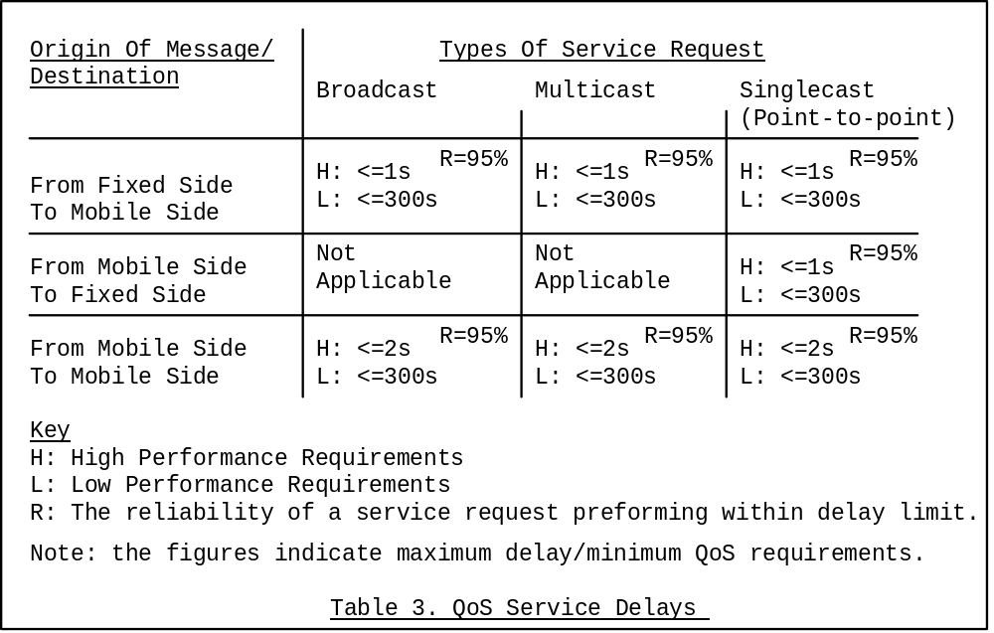

3.3.3 Protection (Security Management)
Security mechanisms are required by the PLMN operator in order to guard against fraud, and by the user in order to preserve privacy across the radio path. These mechanisms should provide a flexibility which reflects the variety of security profiles found in potential applications, some of which require low or no security, and some of which require very strict security.
For point-to-point packets, the security mechanisms available for existing tele-services and bearer services should be used if possible.
For point-to-multipoint packets, encryption is not required.

3.3.3.1 Requirement: Network Protection
Subscriber Validation to guard against unauthorised service usage.

3.3.3.2 Requirement: User Protection
Both user identity and user data shall be protected as follows:
Service | Protection
PTP | Yes
PTM-Multicast | No
PTM-Broadcast | No

3.3.4 Success Rate of Point-to-Multipoint Service
The success rate of point-to-multipoint services defines the probility of a message being received if the MS is within the geographical area and the radio coverage is adequate.

3.3.5 Residual Error Rates
The acceptable probability of a packet being lost, incorrectly delivered, or duplicated.
GPRS residual error rates must be comparable to those of existing dedicated packet networks, both proprietary and standardized.
The residual error rates are applicable to all types of service (i.e. point to point and point to multi-point including broadcast).
The required maximum residual error/minimum QoS figures below are those indicated by a preliminary study of potential applications.
High Performance Requirement: 1 Packet in 10,000
Low Performance Requirement: 1 Packet in 1000

3.3.6 Priority
Indicates how important a packet is in regard to (a) discarding the packet in the event of problems, and (b) degrading the quality of service, if necessary.
GPRS priority requirements must be comparable to those of existing dedicated packet networks, both proprietary and standardized.
The required levels of priority below are those indicated by a preliminary study of potential applications.
Number of Levels Required: 4 Levels

3.4 Phased Implementation
In order to satisfy the otherwise conflicting requirements of early service and high performance plus substantial capacity - e.g. up to one whole carrier dedicated to GPRS - the standard will be may be implemented in phases.
It is important that any phased implementation of GPRS shall consider the implications of forward and backward compatibility mechanisms.

4 GPRS Subscription and Charging Aspects

4.1 Charging aspects
The exact charging aspect are operator specific, however the following aspects may need to be considered:
There are two main methods of charging reflecting two broad types of application. Those applications that are offered to a set of subscribers independent of how many subscribers actually use the service at any point in time, and those applications whose subscribers are charged per service request.
- Subscription fees. Subscribers pay a regular fee for a fixed period in which no extra costs are accrued for service requests.
- Subscription and traffic fees. This is the traditional telephony pricing structure. In contrast to traditional telephony traffic fees, traffic fees in GPRS may include the volume1 of data, the type of service request (e.g. X.25 facilities) and the QoS etc. It should be possible to tariff GPRS use in the same manner as public packet switched data networks.
Reverse charging should be provided as an option.
1 Techniques to measure data volumes to be studied should include simple byte/packet counting and advanced statistical sampling of data traffic.

5 GPRS Security Aspects
The use of radio communications for transmission to/from subscribers in mobile networks makes them particulrly sensitive to:
1. Misuse of their resources by unauthorised persons using manipulated mobile stations.
2. Eavesdropping on the information being exchanged on the radio path.
Therefore, to protect the system in the two cases mentioned above, the following security features are provided for GPRS:
- MS authentication; i.e. the confirmation by the land-based part of the system that the subscriber identity, transferred by the MS within the identifcation procedure on the radio path, is the one claimed. The purpose of this authentication is to protect the network against unauthorised use. It also enables the protection of GPRS subscribers by denying intruders the ability to impersonate authorised users.
- Access Control; i.e. the network can support restrictions on access by or to different GPRS subscribers, such as restrictions by location, screening lists and so on.
- User Identity Confidentiality; i.e. the property that the user identity on the radio link is not made available or disclosed to unauthorised individuals, entities or processes. The purpose is to provide privacy of identities of the subscriber´s who are using GPRS radio resources. It allows for the improvement of other security features, e.g. User Information Confidentiality, and also provides for the protection against tracing the location of a mobile subscriber by listening to the signalling exchanges on the radio path.
- User Information Confidentiality; i.e. the property that the user information is not made available or disclosed to unauthorised individuals, entities or processes. The purpose is to provide for confidentiality of user data, i.e. protection of the message part pertaining to layers 3 and above, that passes over the radio path. This is FFS.

6 Interworking Requirements

6.1 Service Interworking
This is subject for further study which should include GPRS's interworking with "Supplementary Services (e.g. CUG)".

6.2 Network Interworking

6.2.1 Interworking with other data networks and other PLMN´s
Interworking between a PLMN and data networks is determined by the network operator. Interworking with the following types of data networks shall be defined:
- X.25 PSPDN
- Internet / OSInet
- Other GPRS PLMN´s, directly or via a transit network
- and other networks (eg Frame relay, ATM, etc) for which there are currently no clear requirements
GPRS shall support the features and facilities that are normally provided by each of the above fixed networks.
The MS is expected to interwork with the X.25 network using standardised X.3, X.28 and X.29 mechanisms for asynchronous access and X.25 mechanisms for synchronous access.
NOTE: Where X.75 is used for interworking between X.25 networks, it is not envisaged that there will be any additional implications for GPRS.

6.2.2 GPRS Numbering Plan
It is required that GPRS Terminating Equipment addresses conform to the numbering plan already defined for GSM, perhaps through the use of "Calling/Called Party Sub-addresses". This is already compatible with CCITT Recommendation X.121, suitable for Circuit Switched Packet Data Network / Packet Switched Packet Data Network interworking.

6.2.3 Addressing/Routing Requirements

6.2.3.1 Point to Point Network Layer Services
A GPRS subscriber shall have a network layer address (temporary and/or permanent association) that conforms to the standard addressing scheme of the respective network layer service used, e.g.:
- X.121 address (X.25)
- IP Version 4 address for Internet CLNS. This may include the "extended IP address" of the emerging IP Version 6.
- ISO CLNP NSAP (Network Service Access Point) for ISO CLNS.

6.2.3.2 Point to Multipoint Services
Routing Information for Multipoint services may be a combination of geographical and MS/DTE identifier.

6.3 Interworking for subscriber roaming
Interworking between different GPRS PLMNs is required in order to support subscriber roaming.

7 O & M Aspects
The ability to manage the GPRS system is required. Typically management of:
- Subscriptions
- Radio resources
- Multicast groups
- Broadcast groups
should be provided. Other aspects may also be required.

Annex A:
Change Record
ed = editorial change only, st = change to standard
NOTE: The referenced TDoc´s are the original source, but the resulting approved change does not always correspond to the original TDoc since any modifications agreed to during a meeting are not always documented other than in the requirements document itself.
Version | Issued  by | Description | Distributed  to
1.0 | SMG1/4 Joint Mtg Vienna | TDoc SMG4-299rev1 | SMG2/3
2.0 | SMG1 | - Changes as result of report from SMG2/3 joint mtg (TDoc SMG1-54/94).  - Success rate requirements added (§3.3.3) as a result of TDoc SMG1-60/94.
3.0 | TG-GPRS | - Changes as agreed at TG-GPRS-#1/94 to §2 (WD Definitions) and to §3.2.3, Ref. TDoc 21/94.
4.0 | TG-GPRS | - Changes as agreed at TG-GPRS-#2/94  - §3.2.5 and §3.2.6 Ref. TDoc 28r1/94.  - §3.1, §3.3, §3.4 Ref. TDoc 39/94  - §3.2.3.1 Ref TDoc 37r1/94
0.5.0 | TG-GPRS  -#3/94 | Changes as agreed at TG-GPRS-#3/94  e- §1 clarification of scope.  e- §3: Title = Service Req´s, Ref TDoc 50/95  e- §3.1: Text reworded, no change to meaning, Ref TDoc 71/94  r-§3.2.1: BS/TS support, OSI-model, Ref TDoc 71/94.  e-§3.2.2: First paragraph moved to 3.2.1 and modified, Ref TDoc 71/94  e-§3.2.3.1: slight rewording, no change to meaning, Ref TDoc 50/94.  r-§3.2.7: battery saving, Ref TDoc 54/94.  e-§3.2.8: clarification of resource allocation, Ref TDoc 54/94.  e-§3.2.10.1: slight improvement of text, Ref TDoc 50/94.  e-§3.2.10.2: text moved to 3.2.10.1, Ref TDoc 50/94.  e-§3.3: add bs capabilities table without values as guideline, Ref TDoc 66/94.  r-§3.3.1: table 3 may be extended, Ref TDoc 50/94.  e-§3.4: optional implementation phases, Ref TDoc 72/94.
1.0.0 | TG-GPRS  -#4/94 | Changes as agreed at TG-GPRS-#4/94:  s-§3.2.2, Ref TDoc 108/94  s-§3.3, Ref TDoc 91/94  e-§"Interworking Requirements", Ref TDoc 81/94.  e-§"Addressing Requirements" added, Ref TDoc 80/94. | SMG  SMG 1
1.1.0 | TG-GPRS  -#5/94  Helsinki  Nov.94 | TDocs discussed: 78, 121, 128, 131, 136, 144, 145, and 147  Changes as agreed at TG-GPRS-#5/94:  st-§"Multiple, parallel GPRS sessions", Ref TDoc 128/94  st-§3.1, Ref TDoc 131-k  st-§3.2.3.1, Ref TDoc 144/94  st-§3.2.3 - §3.2.3.5, Ref TDoc 147  st-§3.2.8, Ref TDoc 131-c  st-§3.2.9, Ref TDoc 131-d  ed-§3.2.9.3.1, Ref Tdoc 147  st-§3.2.9.3.2, §3.2.9.3.4, Ref Tdoc 147  st-§3.2.10.1, §3.2.10.2, Ref Tdoc 147  st-§3.3, §"QoS when Interworking", Ref TDoc 121  st-§3.3.1, §3.3.2, Ref Tdoc 147  ed-§3.3.2.2, Ref Tdoc 147  st-§3.4, Ref Tdoc 78  ed-§4, Ref Tdoc 147  st-§5, §"Subscriber Profiles", Ref TDoc 131-e  st-§6.6, Ref Tdoc 147  st-§7.2,§"Interworking Profiles", Ref TDoc 131-e  st-§7.2.4.1, Ref TDoc 131-e  st-§7.2.4.2, Ref Tdoc 147  st-§7.3, Ref Tdoc 145  st-§8, Ref Tdoc 147

History
Document history
V6.0.0 | April 1998 | Publication
ISBN 2-7437-2101-4
Dépôt légal : Avril 1998

