I made this token



Was showing info, but now empty. It comes and goes. Must be a bug or servers overloaded?

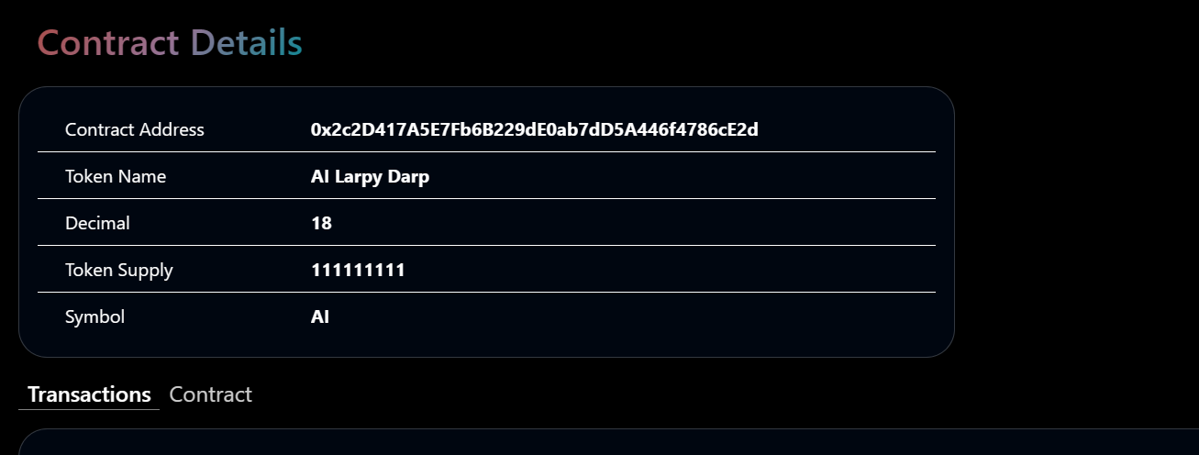

[Testnet Explorer (musascan.io)](https://testnet.musascan.io/token/0x2c2D417A5E7Fb6B229dE0ab7dD5A446f4786cE2d)

I sent 500 of AI to another wallet

Doesn’t show the amount I sent, what I sent etc. Should look like this

[Ethereum Transaction Hash (Txhash) Details | Etherscan](https://etherscan.io/tx/0xdb59e385f0dad1f498a89d4db6ffe084875d72c167e59503191007b619f7e62d)

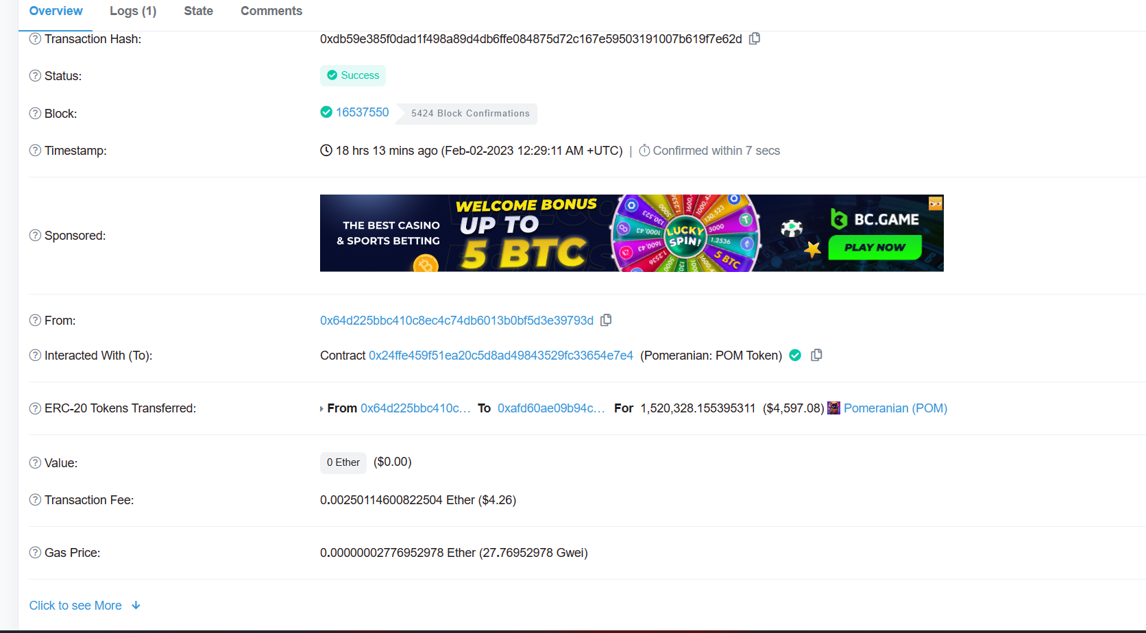

Additionally, no transactions show up under contract details.

