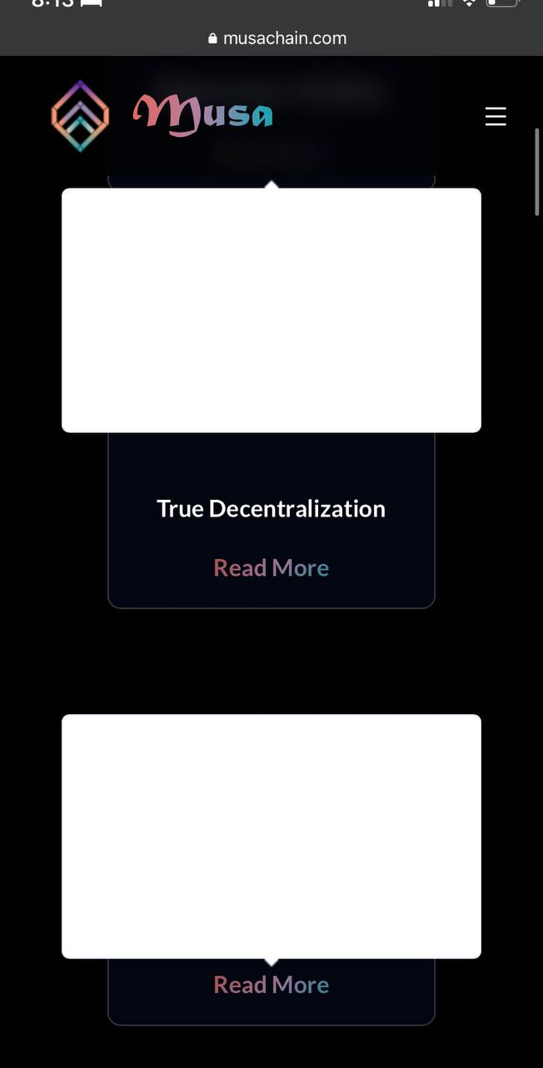

Problems showing this on any Apple product.



Please change to the following to fix my bad grammar.

As a relatively new technology, cryptocurrencies have been the target of fraud, hacking, and other illicit acts. Because of this, people have lost faith in the technology, which has prevented its wide adoption.

Please change to the following to fix my bad grammar.

For the average person, using and understanding cryptocurrency can be challenging. It can be hard for many people to comprehend the concepts of blockchain and recognize its potential benefits due to its technical nature and the absence of simple and accessible explanations.

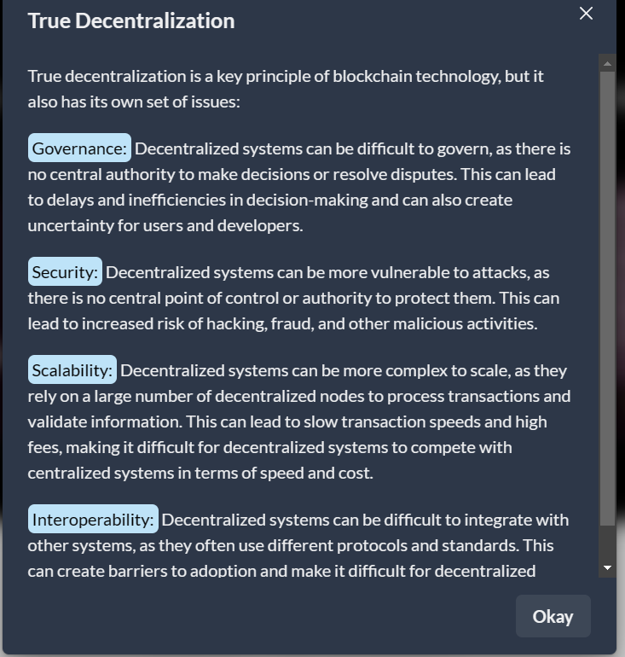

Please change to this:

**Use decentralized technology:** Decentralized systems are typically built on decentralized technology such as blockchain, peer-to-peer networks, and distributed ledger systems. These technologies allow for data distribution and decision-making power among all participants.

**Implement consensus mechanisms:** Decentralized systems require consensus mechanisms to ensure that all participants agree on the system's state and the transactions' validity.

**Encourage participation:** it is important to encourage as much participation as possible from all network members. Participation is done by providing incentives for participation, making it easy for new participants to join, and ensuring that the decision-making process is transparent and accessible.

**Security design:** Decentralized systems must be designed with security in mind to prevent malicious actors from compromising the system. Security includes:

* Implementing secure cryptographic algorithms.
* Using smart contracts to enforce rules.
* Implementing security measures to protect against attacks.

**Avoid centralization of power:** It is important to avoid the centralization of power in the hands of a few participants. We are designing the system to prevent the concentration of resources or decision-making power in the hands of a single entity or group.

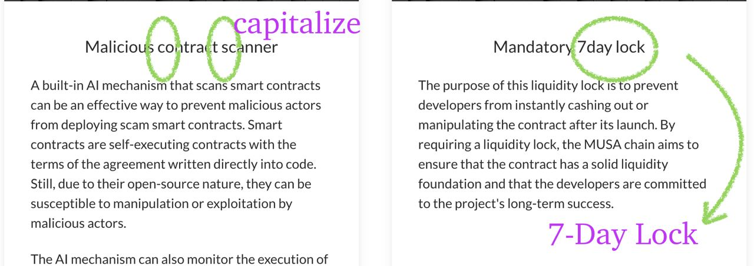

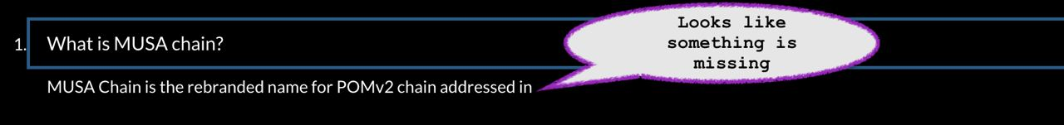

addressed in:

[Why MUSA chain will be better vs other Layer 1 chains | by Pomeranian | Dec, 2022 | Medium](https://pomeranianerc.medium.com/why-pomv2-chain-will-be-better-vs-other-layer-1-chains-68ea55c4fce9)

[POM 2.0 Proof of Concept (POC). POMv2 layer1 Blockchain | by Pomeranian | Medium](https://pomeranianerc.medium.com/pom-2-0-proof-of-concept-poc-9f1d565fdde4)