1. Determine the following:
Domain(inequality):_______________
Range (inequality): _______________
Max or Min: _______________
End Behavior: _______________
Parent Function: _______________
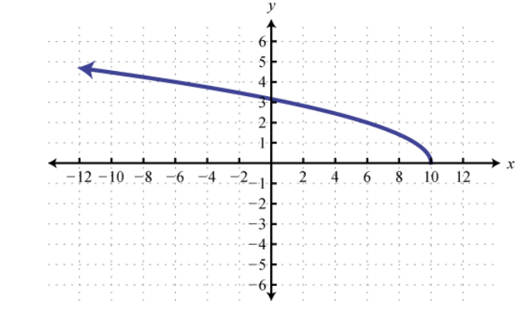

_____________________________________
2. Consider the set of points:
{(-3, 2), (0, 5), (2, 1), (5, 6),(-3,9)}
Domain:____________________
Range: ____________________
Max or Min: _________________
Is this a function?_____________
_________________________________________
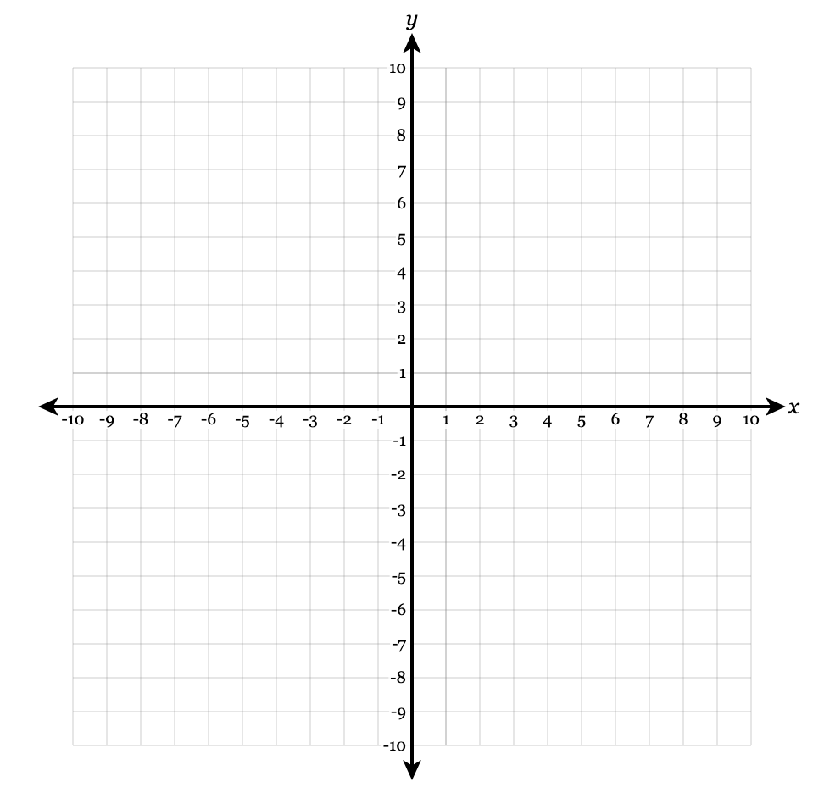
3. Sketch a function with domain (-4, 6] and range [-3, 2).

4. Determine the following:
Domain(interval):_______________
Range (interval): _______________
Max or Min: _______________
End Behavior: _______________
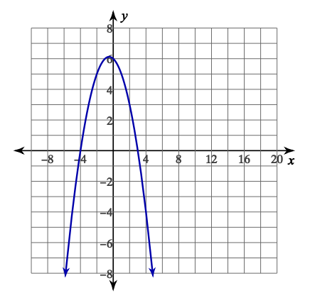
Parent Function: _______________

5. Determine the following:
Domain (set): _______________
Range (set): _______________
End Behavior: _______________
Max or Min: _______________
Parent Function: _______________

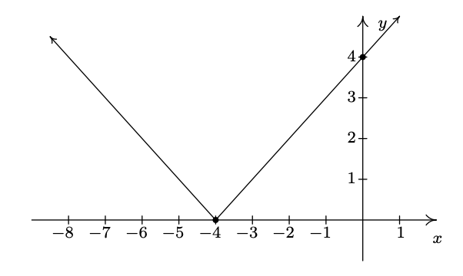

6. Which of the following represent a quadratic function? Circle all that apply:
a) $y=x^{2}-4$
b) $y=|x|$
c) $y=3x-7$
d) The area A of a square with side length s
is $A=s^{2}$
e) $y=\sqrt{x}$
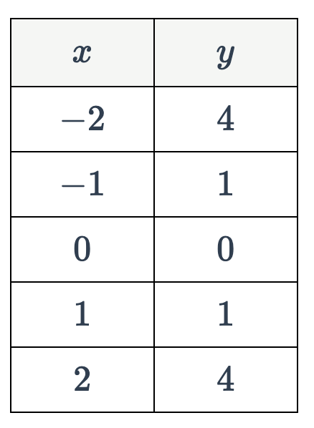
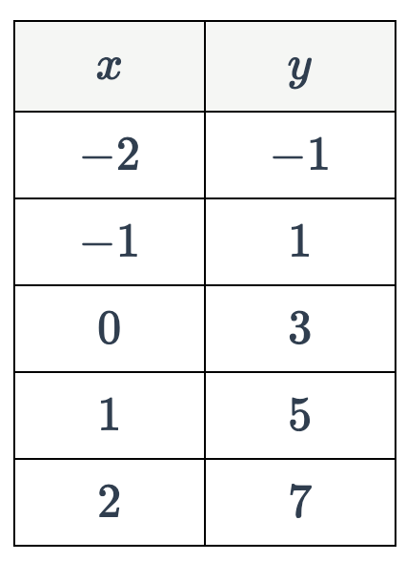
f) g)

________________________________________
7. The height h (in meters) of a ball thrown into the air is given by$h(t)=-5t^{2}+20t$ What is a reasonable domain for this situation?
a) All real numbers c) (0, 20]
b) [0, ∞) d) [0,20]

________________________________________
8. Consider the following graph:
Which value is in the domain of the function,
but is not in its range?
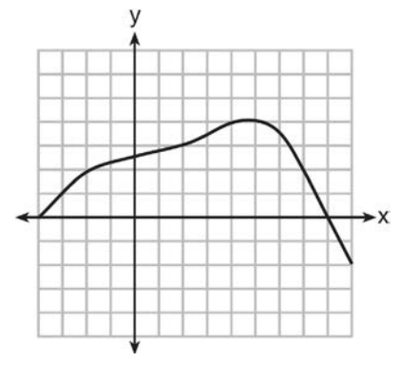

- 0
- 2
- 3
- 7

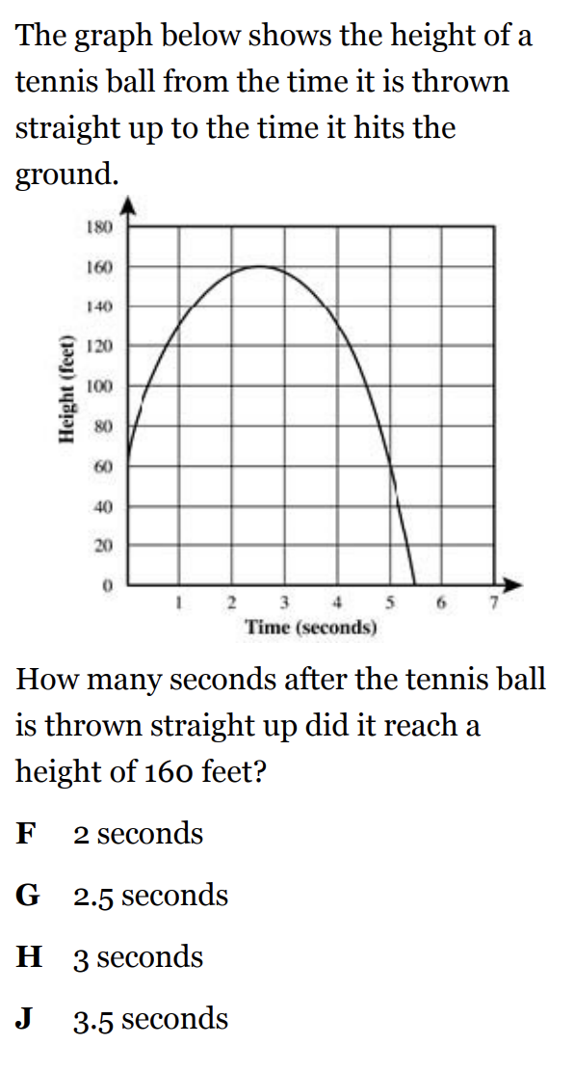
9.

Use Interval Notation:
State the Domain________________
State the Range_________________
What does the y-intercept represent?
_______________________________
What does the x-intercept represent?
_______________________________

10.
A construction company uses the function f(p), where p is the number of people working on a project, to model the amount of money it spends to complete a project. A reasonable domain for this function would be:
1) positive integers
2) positive real numbers
3) both positive and negative integers
4) both positive and negative real numbers

