How to Write Missile Command in Python
Missile command was a popular arcade game released by Atari in 1980; the goal was to defend your six cities from an infinite onslaught of missiles. For more instructions, see the Wikipedia entry here: http://en.wikipedia.org/wiki/Missile_Command. If you are unfamiliar with the gameplay, here is a brief demonstration video: http://www.youtube.com/watch?v=S34JIlI0bng. You’ll be making a stripped-down version of this game for homework; there will be no splitting missiles, smart bombs, or things that fly across the screen; the only threat to the cities will be traditional missiles. That being said, how can you approach something this large? Now would be a particularly good time to utilize top-down design: start with a very high-level version of the game, and work down from there. Break off testable chunks, and break those chunks down until each piece is solvable in a straightforward way. No part of this should be hard, so if you find yourself grinding away at a helper function and making little progress, take a short break and come back; hopefully you’ll feel refreshed and get some new insight. If that still doesn’t work, you can always ask a CA for help. Good luck!

Step 0: Setting the scene

A good way to start a game like this one is to get the background looking right. Luckily, the code for drawing the backgound has been provided already, as have the run and init functions in their entirety. Now would be an ideal time to familiarize yourself with the variables stored by init in canvas.data, as well as the list canvas.data[“missileTargets”], as it will be assumed throughout the project that you will be using this information. Also, for ease of calculations, you should be aware that that canvas.data[“size”] is already a floating point number.

Step 1: Getting started

It’s important to not feel bogged down in the details of specific functions, so you should think of this like any other animation-based program. What are the components of an animation-based program?
- User interaction: making the program responsive to mouse and button presses
- timerFired: repeatedly changing the canvas and calling redrawAll to make animation
- redrawAll: deleting everything on the canvas and redrawing what you want to keep
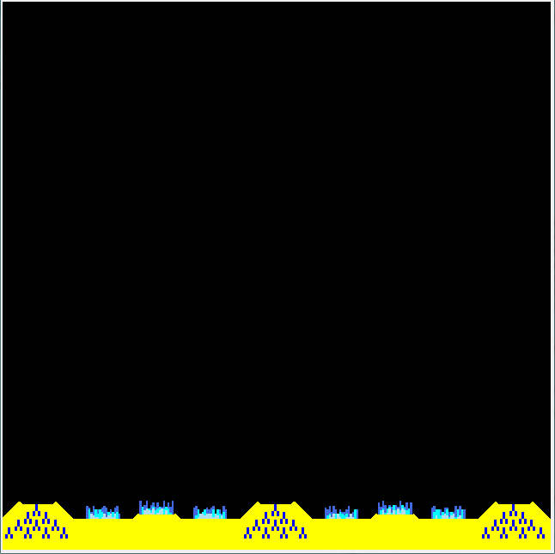
- init and run: initially setting up the canvas and canvas.data

We’ve already provided init, run, and part of redrawAll, so your work can be split into three main tasks: make the game’s timerFired, finishing redrawAll, and making it responsive to user input.

Let’s start with redrawAll. You’ve been given a function that draws the background, so use that, and your game should look like this:

When redrawAll is finished, it will draw everything on the screen, so now would be a good time to think about what it’s going to do. You’ll have to draw:
- The missiles (both yours and theirs)

- The explosions

- The various help messages that pop up throughout the game

- The crosshairs (the in-game mouse)

In order to remind yourself what this function will do later, define a helper function for each of these four subtasks and call them inside your redrawAll. Their names should be drawMissiles, drawExplosions, drawText, and drawCrosshairs. We’ll only be writing drawCrosshairs right now; when it makes sense to do so we’ll come back and write the other three helper functions.

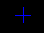
Writing drawCrosshairs(canvas): a crosshairs is a popular type of cursor for shooting games. They come in many styles but you’ll be making the simplest one here: just two intersecting blue lines. They should be ~16 pixels long*, and should look like this when you’re done:
Drawing them should be easy once you realize that the x and y coordinates of the mouse are already saved to canvas.data. (this is done in init)

Now that you have the crosshairs drawn, you need to make them follow the mouse as the mouse position changes. To do this, you’ll simply update the saved mouse position in canvas.data and call redrawAll, every time the mouse moves. You already have a function that’s called every time the mouse is moved (do you know which?), so this should be even easier than the last part.

*Now is a good time to talk about hardcoding: like many games, this game is based on the screen resolution (distance is pixels, speed is pixels per second, and so on). However, not all computers are created equal; if one person has to play with a canvas size of 320 instead of 640, the game should still work perfectly: the crosshairs shouldn’t be twice as large and the missiles shouldn’t move twice as fast. Periodically as you’re coding, run the game on a smaller canvas size (run takes canvas size as a parameter), and make sure that everything still works.

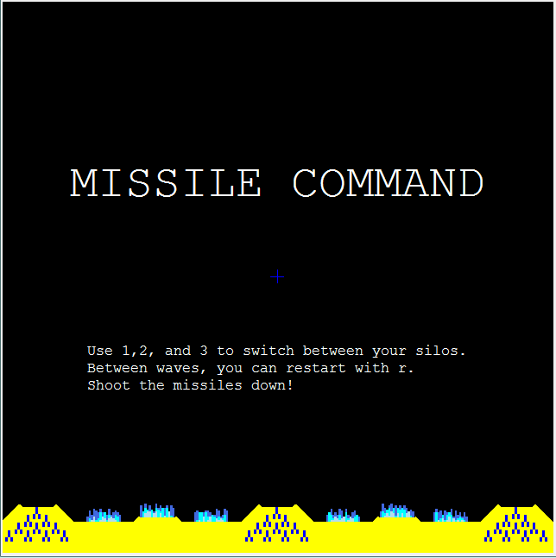
Finally, we’ll be making the game start screen. You may write any reasonable help text that you want here; we’ve provided a sample screen for reference:

You’ve already defined a helper function in redrawAll (called drawText) that will be responsible for drawing all of the game’s text, so just go into that function and make it display your message if the game hasn’t started yet.*

*If you consult init(), you’ll see that a variable is already defined which keeps track of whether the game has been started; use it!

Once you make the text, make it so that a mouse click starts the game (as of right now, all that should happen is that the title text should go away) For now, starting the game will only entail changing one stored variable, but we’ll expand on this in the next step. On to step 2!

Step 2: All about missiles

In this step you’ll be working mainly on timerFired, with the goal of making it possible to shoot missiles and watch them reach their targets correctly. This will be a lot more coding than step 1, so you’ll have to approach it piece by piece. First, timerFired. TimerFired handles all the animation in the game, so we want it to start running right when the game starts; go back to where you just were in your code (remember, a mouse click was supposed to start the game), and make it so starting the game calls timerFired as well. Just like when you started writing redrawAll, now would be a good time to figure out what timerFired should be doing. It will:
- launch enemy missiles to attack you
- move all the missiles on the screen once
- change the size of the explosions on the screen (remember from the video, explosions grow, then shrink until they disappear)
- check each missile to see if it should explode during this refresh
- check each city and silo to see if it was hit by a missile
- call redrawAll to put the changes it just made up on the canvas
- call itself again
It’s true that five of these tasks are unsolved right now, but don’t panic! Just define five helper functions for them named launchEnemyMissiles, moveMissiles, growExplosions, checkMissiles, and checkTargets, then call redrawAll, and call timerFired again using canvas.after and a delay of 20. You now have a running timerFired, and you’ll come back to flesh it out soon.
It’s time to dip into the user interface side of this game, but before you begin coding, you need to know how you’re representing missiles in the computer. Within this game, a missile is defined as a list of the following information:
startX,startY: the coordinates of the missile’s starting point
currentX,currentY: where the missile actually is at that point in time
targetX,targetY: where the missile is going towards (it will explode when it reaches there)
vx,vy: the missile’s x and y velocities in pixels per update
color: the color of the missile’s path
missile=[startX,startY,currentX,currentY,targetX,targetY,vx,vy,color]
All of the missiles on the screen will themselves be stored in another list called missiles.

Your first task will be to write a function, launchMissile, that takes in a canvas, starting point, ending point, speed, and path color, and adds that missile to the list of missiles. Here are two hints to help you:
- At the time that the missile is launched, the current location is the starting point
- The speed is a number, which you will need to split into x and y components. Using unit vectors is the easiest way to do this.

Now you need to use the function you just wrote to let the user shoot missiles at the cursor with the 1, 2 and 3 keys. Some more things to keep in mind:
- The locations of silos 0, 1, and 2 are the coordinates found at positions 0, 1, and 2 of missileTargets.
- The speed of the defense missiles is 30, but should be scalable if the user plays on a smaller or larger screen.
- The player’s missiles are blue

Next, you need to step into redrawAll and write the drawMissiles helper method that you left out. This should be easy though; a missile is just a line of the given color going from its starting point to its current location.

Once you’ve done that, you get to go back to timerFired! First you’ll write moveMissiles. All it does is look at every missile and increment their current x and y positions by their respective velocities. As an example: if a missile’s vx,vy is 5,7, then moveMissiles would add 5 to its currentX and 7 to its currentY. (This should be done destructively!)

Finally, finally, you can see something! Take this opportunity to player-test your other functions by firing missiles around the screen. In doing so, you will probably figure out what you need going to code next…

Next up: checkMissiles! You need to stop the missiles when they reach their targets, and not they just fly forward forever. Knowing that when a missile reaches its target, it explodes and the original missile vanishes, we have a pretty good idea of what should be going on in this function. It needs to look at every missile and check if it has reached its target (how you do so is up to you, but remember that because the missile is moving in steps of vx and vy, it may never reach its exact end coordinates!); if it has, you remove the missile from the list of missiles and create an explosion at that point. You don’t know how to represent an explosion yet so define a helper function called explode() which will do that for you, and finish writing the main function first. Once it’s all working, you should get missiles that fly towards their targets and vanish once they get there. Player-test this for a bit to make sure it works, then take a break; you’re done with step 2!

Step 3: Explosion time

The goal of step 3 is to make the explosions work, and to go back and tune up a few programs now that other things are working. First though: an explosion, much like a missile, is represented as a list of information. The exact syntax is as follows:
cx,cy : the coordinates of the center of the circle (explosions being perfectly circular here)
r : the current radius of the explosion
isGrowing : specifies whether the explosion is currently growing or shrinking
explosion=[cx, cy, r, isGrowing]
Again, all of the explosions are stored in a list called explosions, which is stored in canvas.data

Your first task is to write explode, which takes a cx and cy and makes a new explosion there. Remember: a new explosion has a radius of 0, and is growing.

Now you have to write growExplosions (we defined this back in step 2 in timerFired), which looks at every explosion in the list explosions, and either increases or decreases their r values based on whether or not their growing or shrinking. You also need to check their size, because if the explosion is too big it should start shrinking again. Remember that this should work equally well for any canvas size, so while the default max radius is 50 and the default growing and shrinking rate is +- 1.5, don’t hardcode those numbers into your program!

Now you have to write drawExplosions (we defined this back in step 1 in redrawAll), which draws every explosion in the list explosions. An explosion is a white circle of the given radius at the given point.

At this point you can easily player-test again! Take this opportunity to fire more missiles, and make sure that they’re growing and shrinking just as expected.

Next up, you have to revisit checkMissiles, because there was something we didn’t tell you about the first time. In addition to when they reach their target, missiles also explode if they’re in an explosion, so you should take this into account. It would definitely help you to write a helper function called inExplosion, which would take in a pair of coordinates that specify a point (and the canvas, as always), and determine whether or not that point was inside any of the explosions on the canvas. Hint: you’ll need the equation of a circle to do this!

Back to the user testing! Shoot a couple missiles, then try to shoot some more through them and see what happens. If everything’s working correctly, they should explode as soon as they reach the other explosions.

That’s it for the explosions (wasn’t that quick?), but there are a couple of related things that you might as well deal with right now; the missile silos should only have 20 ammo each, but right now you’re giving them infinite shots:
- Make shooting missiles subtract from missilesLeft, which is a list of the number of missiles remaining at each of the three silos.
- Make it so you can’t keep shooting if there are no missiles left at a silo.

And the second thing: did you notice how, once you started subtracting from missilesLeft, the number of missile symbols under each silo would decrease as you deplete the silo? That’s helpful, but not very obvious, so you should add text that appears under the silos when they are low (under 7 rockets left) or out of ammo (0 rockets left). Remember that the exact positions of the silos are stored in missileTargets. Here’s an example result:

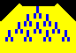
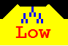
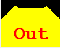

As always, do some play testing at this point. Make sure that the messages are drawn at the right times and in the right places. When you’re done with that you will be done with part 3!

Part 4: The enemy is above us
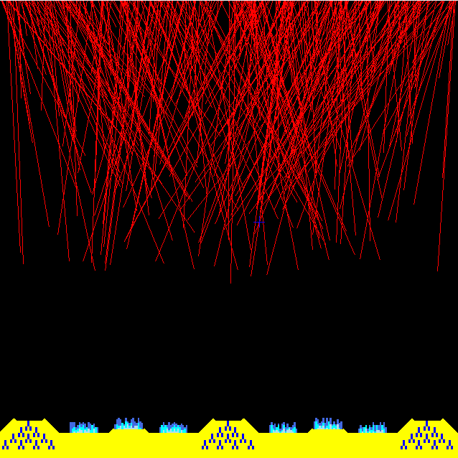
The next major step in this process is to make the enemy missiles. You’ve already defined a helper function, launchEnemyMissiles, which will do this for you. It’ll be refined later, but for now, say that it launches one missile (enemy missiles are red, remember) every time it’s called. Enemy missiles start at a random point at the top of the screen, have a speed of 1 (for now), and choose a random target from the 9 available targets (3 silos and 6 cities) at the bottom of the screen. Once you get all that working, give it a run and see what happens:

Clearly, launching a missile every time timerFired was called was too often! You only want to call launch missiles some of the time, and the best way to do this is to use a counter variable. The first time you call timerFired, you pass it a counter of zero, and every time it calls itself it adds one to the counter. For now you only want to spawn missiles every 50th time you call timerFired- that is, every time the counter is a multiple of 50. Once you’ve got that set up, feel free to play around with the numbers for testing purposes.
Now that you have some missiles falling, it would make sense to go back and write checkTargets (in timerFired, from step 2). CheckTargets should look at each of the 9 missile targets (your three silos and six cities) and, for each one, check if it’s in an explosion. If it is, you should destroy it. You destroy silos by setting their missile count to zero, and you destroy cities by setting their respective isStanding value in canvas.data[“standingCities”] to False. Three things to think about while you’re writing this:
- You already have a function called inExplosion, which you should use here.
- The location of a target, be it city or silo, is given in missileTargets.
- The list standingCities goes left to right, but the list missileTargets is organized slightly differently. Don’t forget!

Now that missiles can destroy your cities and silos, it’s time to impose a safety measure. Go back to mouseMoved and change the code there so that your crosshairs cannot be lower than four fifths of the way down the screen, with the result that you can no longer shoot missiles right at your own cities. Note: this should not use if statements!

Things should be safer now, so it’s time to make the enemy smarter; improve your launchEnemyMissiles code so that missiles are only launched at standing structures. At this point it might help you to write a function chooseTarget(), which keeps choosing a random target until it finds either a city that’s standing or a silo with missies in it, and returns that target for launchEnemyMissiles to use.

If you play-tested after that last function, you may have noticed a bug; when everything has been destroyed by missiles the game freezes. This is because the computer is trying to find a standing target when none exists, and so it won’t ever stop looking. The best way to fix this is to only call launchEnemyMissiles if something exists to aim the missiles at; write a helper function called aTargetExists to do this check for you, and player-test this carefully to make sure there are no bugs.

Congratulations: you’re now done with step 4, as well as most of the programming in this assignment! Keep pushing and you’ll be done soon!

Step 5: Levels 101

Now that the rest of the game is working, you need to implement levels. This is the longest step, but it’s also the last big step, so keep strong!
First, some theory: a level will be represented as a single instance of timerFired. Each level starts when timerFired is called for it, and ends when timerFired ends. With that idea in mind, rename the timerFired function to runLevel (be sure to rename it everywhere it’s called too!)

First step: runLevel needs to end. Write a function called levelHasEnded, which returns whether or not the level is over, and only have runLevel call itself if the level has not ended yet. For now, make it end after 1000 calls; you’ll improve this later on. Next, change when and how the enemy missiles are launched to meet these specifications: 5 missiles each at t==50, t==150, and t==250. Again, you’ll improve this later, but you need to build the rough structure of the level before you can refine it.
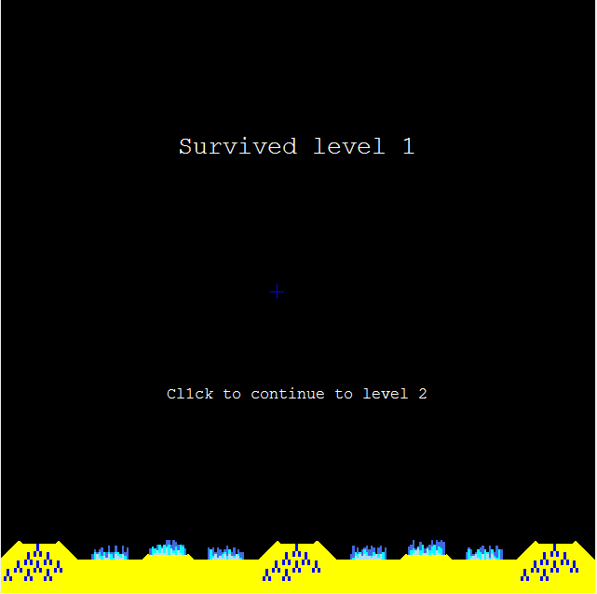
Next, so that it doesn’t look like the game’s crashed when a level ends, you’re going to go back to drawText in redrawAll, and make a helper function called drawBetweenLevelText, which draws something like this:

There are two things that need to be considered at this point:
- There is a variable in init that keeps track of the current level; use it where appropriate.
- This text should only draw if the game has started and you’re not in a level (both of those things are stored in canvas.data)

As long as you’re thinking about canvas.data[“inLevel”] and canvas.data[“level”], now would be the best time to go back and incorporate it into previous functions. In summary:
- clicking the mouse should make the player inLevel if the player is not inLevel, as well as calling runLevel to actually run the level.
- Pressing 1, 2, or 3 should only fire missiles during levels
- Within runLevel, ending the level should make inLevel false.
- Make pressing the mouse when not inLevel start a new level (every level is exactly the same right now; you’ll have to change that in a minute!)
- Make it so the game increments the level every time a new level starts

Now would also be a good time to make it so the player restart by pressing r. Restarting in-level would cause glitches because multiple runLevels would be running at once, so only let the player restart when they’re not inLevel. All you have to do to restart is call init; it will do the rest for you!

None of those should have been difficult changes to make: now it’s time to make the game recognize a game over! You only need to check to see if the player has lost the game after each level, not during the levels, so in your runLevel, when levelHasEnded returns true, have the program check if the game is over and save the information to canvas.data[“gameOver”]. You should check if the game is over by writing and using a helper function called gameLost (In missile command the player loses the game if all of their cities are destroyed, regardless of how many missiles they have left).
More revisions! Now that the computer understands the concept of a game over, go back and have it not listen to mouse clicks once the game is over. Also, have it not let the player launch missiles after all their cities are destroyed (as gameOver isn’t updated during levels, and this bug only happens during levels, you’ll have to call the function gameLost() to tell if they’ve lost instead)

Then, write yet another helper function for drawText, drawGameOverText, which in the event of a game over will produce the text shown here:

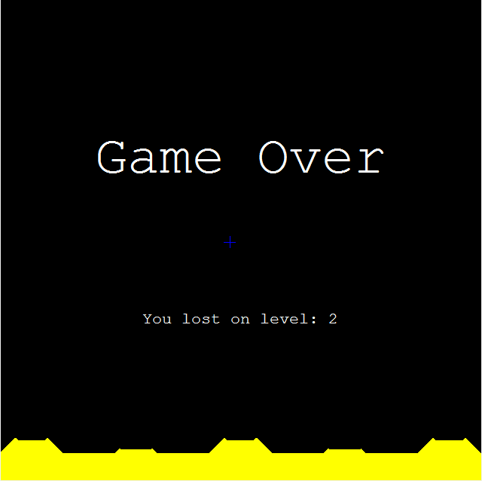
It’s good to keep in mind that the game can be both between levels and in a state of gameOver, and that the fact that the game is over should always have top priority.

Another small thing: every silo should be refilled to its original capacity of 20 missiles after every level. Do this by resetting your list of missilesLeft every time you start a new level.

Only two more things to do before you’re done with the levels! First, you originally wrote launchEnemyMissiles so that it always did the same thing. However, the number and speed of the enemy missiles should increase in difficulty as the player beats more levels. Modify launchEnemyMissiles so that the difficulty increases according to this pattern:
Current level | Missile speed | Missiles per “wave”
1 | 1 | 5
2 | 1 | 6
3 | 2 | 6
4 | 2 | 7
5 | 3 | 7
6 | 3 | 8

Finally: levelHasEnded should be improved. The new way you’ll tell if the level has ended is if:
- All three waves of enemy missiles have spawned.
- There are no missiles on the screen.
- There are no explosions on the screen.
Modify levelHasEnded so that it now operates according to these rules, (make sure to comment any hardcoded numbers that you use!) and do a little bit more play-testing to make sure it works. You’re now done with step 5, only one more to go!

Step 6: The finishing touches

Congratulations on making it to step 6; you’re so close now! There’s only one thing your game is missing: a way to keep score. The way you’ll be keeping score is as follows: at the end of every day the player receives points based on how well they did and how difficult the level was. Each intact city is worth 100 points (how does it feel to assign a point value to human life?), and each unused missile is worth 5 points. Add these two point values together and multiply by the level number to get the total number of points earned for that level, and add it to the total score, which is saved in canvas.data.

First you will write a helper function called updateScore, which will increase the player’s score according to the rules outlined above. The score only needs to be updated between levels, so a good place to call updateScore would be right when a level is ending. Remember, the level where a player loses should not count towards their overall score.

Once you’re updating the score correctly, go back and update your drawText function one last time so that it shows score-text like the pictures below:
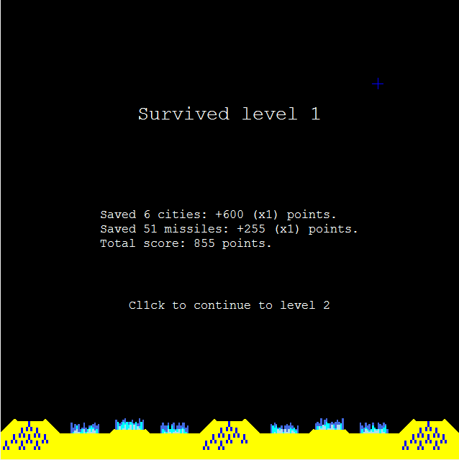

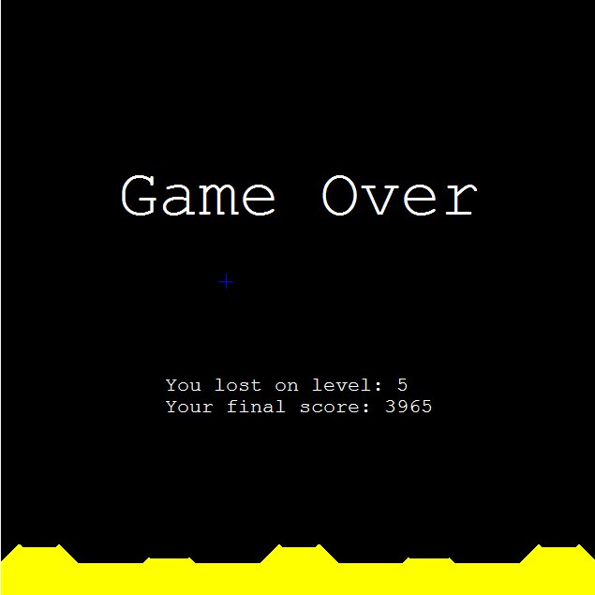

And with that, you’re done! It may have been bumpy at times, but you just wrote the main body of a video game, so pat yourself on the back!

