WIMP Operating System Installation Guide

These instructions are for people who would like to install the Operating System on their WIMP boards.

The first step is to install the particular OS for the board from the Light Tech website. Then you need the imager to write the OS on the SD card of the WIMP board. Open this [link](http://www.LightTechImager.com) and download the setup installer. You should get this: 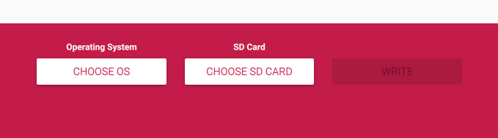

Select the OS from your PC, and then select your SD card, and then hit ‘write’. It should take 20 minutes to an hour to complete, but once done, plug in your board and follow the on screen guidance to finish setup of your WIMP board, peripherals, and localisation.