Game Design Document

By Smaran Vallabhaneni



1. Write the title of your project.

Run Platformer

1. What is the goal of the game?

To get from point A to point B while avoiding the spikes, exploding balls, and other things.

1. Write a brief story of your game

This game is inspired by Super Mario. But has some twists. Instead

of shooting the (Active)enemies, the player just needs to avoid the

passive(inactive) enemies.

1. Which are the playing characters of this game?

* Playing characters are the ones which respond to the user based on the input from the user
* Cars, monkeys, dinos, wizards etc, are the playing characters in the game.

|  |  |  |
| --- | --- | --- |
| Number | Character Name | What can this character do? |
| 1a | climber | This is controlled by the player. He/She can jump and go forward/backward. |
| 1b | runner | This is controlled by the player. He/She can jump and go forward/backward but can also go super fast. |
| 2 |  |  |
| 3 |  |  |
| 4 |  |  |
| 5 |  |  |
| 6 |  |  |
| 7 |  |  |

1. Which are the Non Playing Characters of this game?

* Non Playing characters are the ones which don't have an action or a behaviour when the user interacts with the game.
* Hurdles, stones, bananas, coins, etc are non playing characters in the game.

|  |  |  |
| --- | --- | --- |
| Number | Character Name | What can this character do? |
| 1 | Spikes | If the player falls towards this, he loses a life |
| 2 | Lazy explosive balls | This character can’t  Do anything on it’s own, but explodes when touched |
| 3 | Lava | Player melts in lava |
| 4 |  |  |
| 5 |  |  |
| 6 |  |  |
| 7 |  |  |
| 8 |  |  |

Draw your imagination of this game. What does this game look like?

* Draw the game either on your computer or on paper,
* Add images of scenes of the game to show each of the playing and non-playing characters at least once.

Images shown below (not to scale)

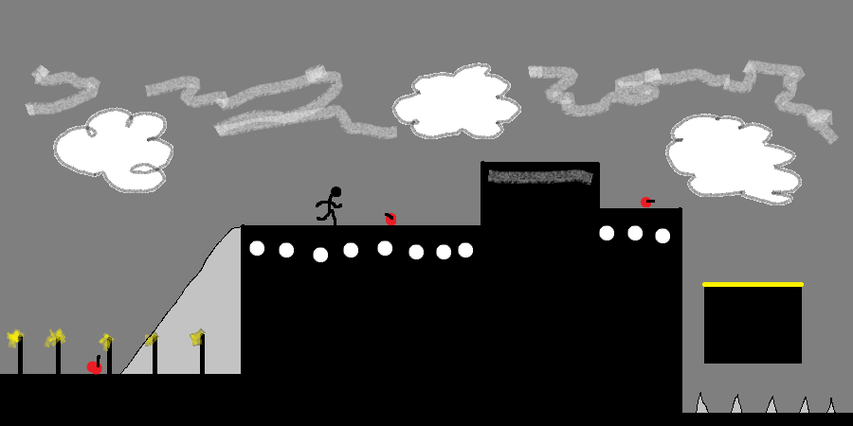

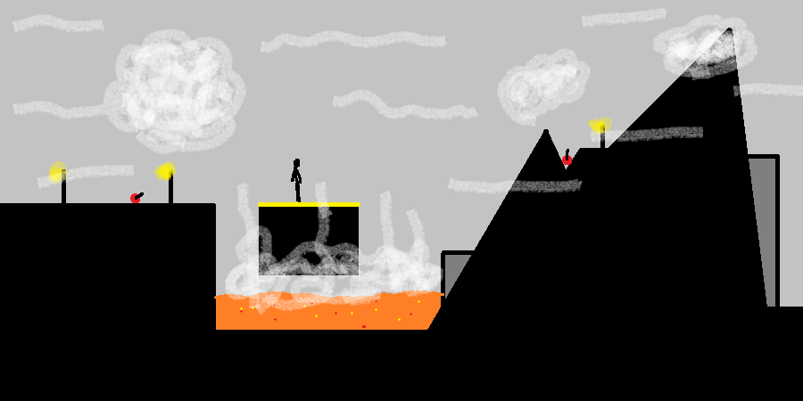

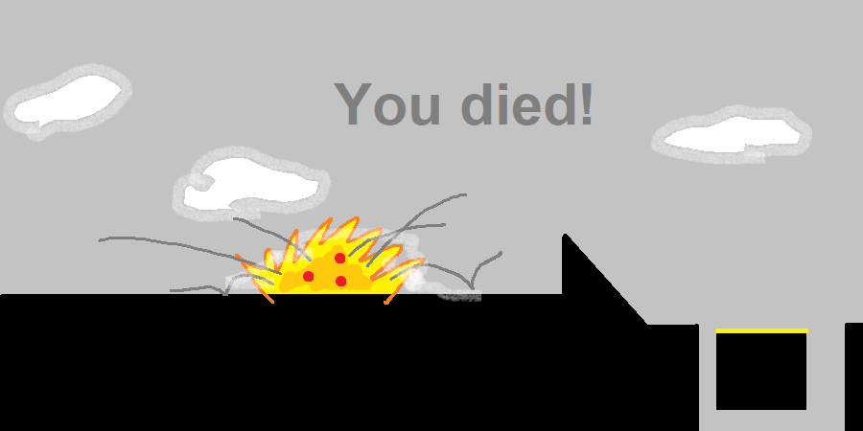

How do you plan to make your game engaging?

By adding lives to the player (5 lives) and by adding 2 characters to switch by pressing the ‘s’ key