**Capstone Project –**

**The Battle of Neighborhoods**

1. Introduction/Business Problem

In this project, I assume some friend asked me: is it fine to open a Chinese restaurant in Ford Bend, TX; and if it is, which region (zip code) for this restaurant. The selections of the business type (Chinese restaurant) and the county (Ford Bend, TX) for consideration are only due to my personal curiosity. Any other business types and locations can be studied (given the required data is available). To recommend the business locations, a classification model is developed based on the data from a nearby county Harris, TX, and many relevant factors, such as the neighborhood demographics, average house value, average income per household are included in the model development.

The location of a business unit, especially for a restaurant, often bears significant influence on the prosperity and profitability of that business. Therefore, I believe this topic is worth investigation and the developed workflow, maybe seem inmmature currently but upon continuous improvement, will have real business application in the future.

1. Data Sets

In order to train a model for restaurant location selection, the main factors influencing the profitability of a restaurant should be identified. There are many discussions on what factors should be considered, such as visibility, parking, space size, crime rates, surrounding businesses/competitor analysis, accessibility, affordability, safety[1]. Yet parameterizing these factors and finding the corresponding data sets are not easy. I spent a lot of time in selecting and appraising the appropriate data set. Finally, I concentrated my attention on the data contained in zip-codes.com. The specific webpage is <https://www.zip-codes.com/county/tx-harris.asp>. Fig.1 shows an excerption of the table contained in this webpage. The first column lists all the zip codes within Harris County, TX. By clicking each zip code, the browser is then directed to another webpage containing the detailed demographical data and other statistical data corresponding to the zip code, such as Fig.2 to Fig.4 show the Zip Code data, 2010 Census Demographics and other demographics for Zip Code 77002.

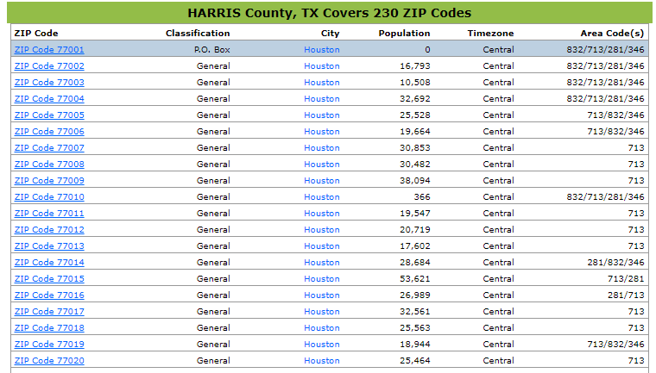

Fig.1 Excerption of Harris County Table

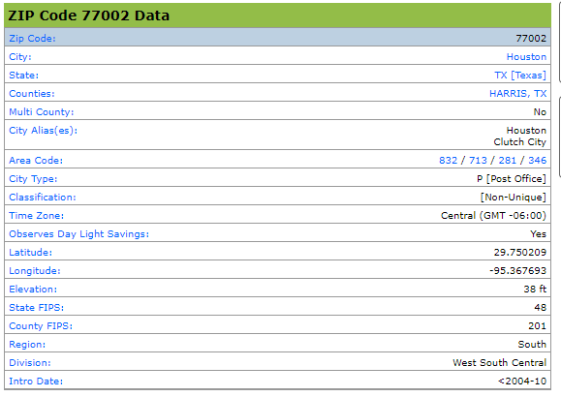

Fig.2 Zip Code 77002 Data

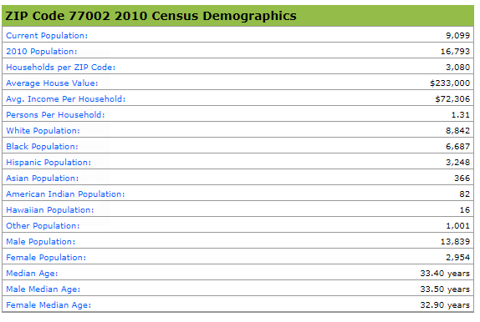

Fig.3 Zip Code 77002 Census Demographical Data

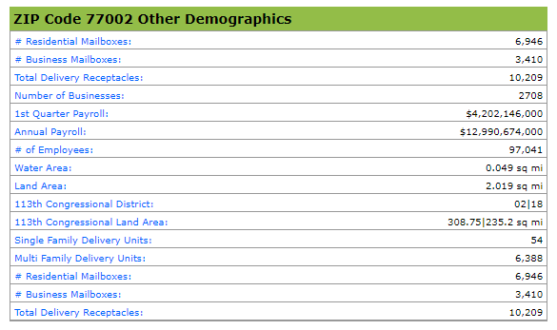

Fig.4 Zip Code 77002 Other Demographical Data

Since there is no ready-to-download file summarizing these data provided by website. A python code applying modules of BeautifulSoup and requests is developed to scrape the information from the specific webpage and all the pages linking the zip codes. The codes for scraping and processing the data are summarized in read_data.py and process_data.py. Process_data.py processes the data frame created by read_data.py, such as dropping the unnecessary columns, removing the “$” and “,” in currency columns, and others.

The final data set acquired is shown in Fig.5 as an example. There are 131 zip codes and 25 attributes, such as longitude, current population, average income per household, racial/age distribution, and others.

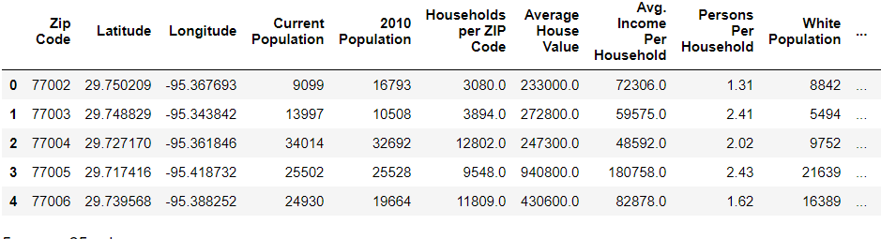

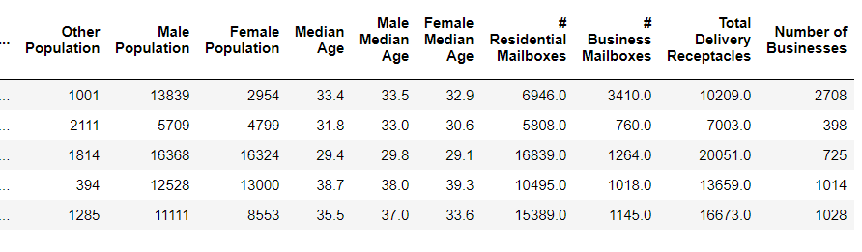

Fig.5 Example of data set acquired from zip-codes.com.

Since we have the latitudes and longitudes of zip codes in the data set, we can plot them on a map through the method we learned, which is shown in Fig.6.

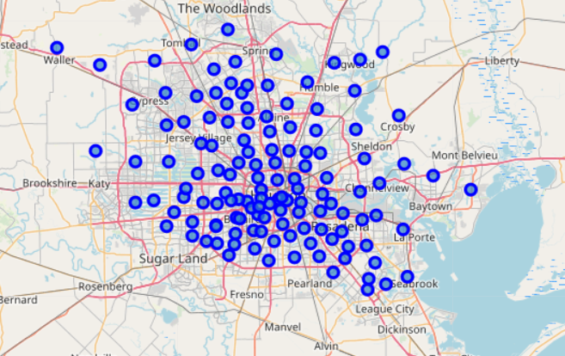

Fig.6 Regions (within Harris, TX) in data set acquired from zip-codes.com

We will develop our classification model to determine which location is good for a Chinese restaurant based on the data set shown in Fig.5, also the data set acquired through Foursquare for each zip code. Detailed discussions are covered in later parts of this report.

1. Methodology

Our approach is to explore the venues for each zip code in Harris, TX through Foursquare and classify the regions into two classes: having Chinese restaurant (Class 1) and no Chinese restaurant (Class 0). We add a new column labeling the classes to our data set in Fig.5. Then we can train a classification model using this augmented data set and predict where to set the restaurant location for the targeted county Ford Bend, TX. As it turned out that 10 out of 131 zip codes have Chinese restaurant. This indicates an imbalance classification problem (class 1: 10, class 0: 121). We tried different techniques to tackle the imbalance classification problem.

Through Foursquare, we can explore the avenues near every zip code in Harris, TX. And we can show the locations of class 1 (having Chinese restaurant), as shown in Fig.7. There are 10 different zip codes. (By the way, the area of having most Chinese restaurants is China Town of Houston.) I didn’t differentiate these 10 zip codes further by the number of the Chinese restaurants they have, see Table 1. We notice that Zip-77046 has 3 Chinese Restaurants, and the other 3 zip code regions have 2 Chinese Restaurants respectively. Since the numbers of zip codes having more than one restaurant are so small, I didn’t set them into separate classes. If more data sets are provided, we can set up multiclass classification models to consider those situations.

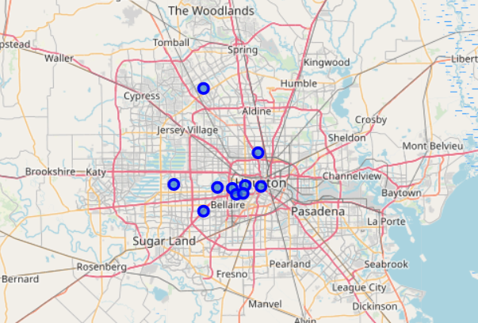

Fig.7 Regions (within Harris, TX) having Chinese restaurants

Table.1 Zip codes and Chinese restaurants number

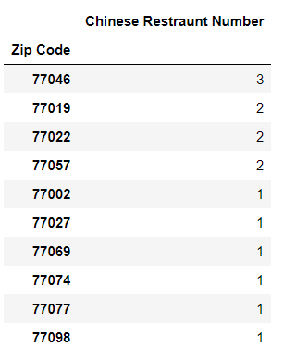

So we have the data set shown in as Fig.5 plus the additional column of “Chinese Restaurant Exist?” Since the ratio of Class 1 to Class 0 is 10:121. We are facing an imbalance classification problem. If without considering the characteristic of imbalance, false models would be developed [2]. For example, ignoring the class imbalance, when we derive a classification model using all the attributes from ['Current Population', '2010 Population', …, 'Total Delivery Receptacles', 'Number of Businesses'] (see the headers in Fig.5), the model prediction accuracy is 85.19%, while we use only one attribute ['Current Population'], the accuracy is not lower but higher as 92.59%, which are shown in Fig.8.

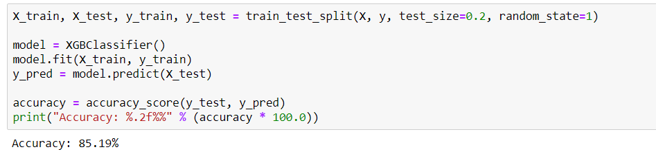

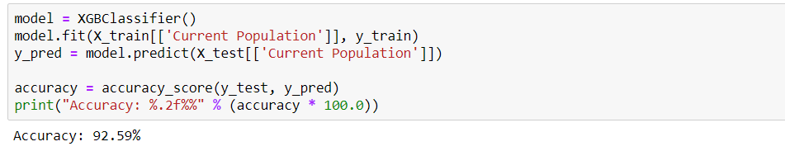

Fig.8 Model results using 22 attributes (up), and 1 attribute (down)

We can use resampling to deal with highly unbalanced datasets, such as undersampling and oversampling, as shown in Fig.9. The python imbalanced-learn module imblearn is adopted in our study. Specifically, three different methods, random under-sampling, random over-sampling and Tomek Links in imblean are used to resample the dataset and develop the models. The results are shown in the next part.

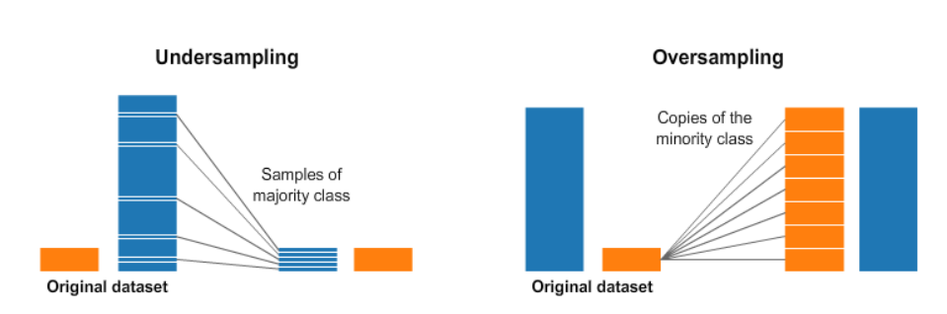

Fig.9 Resampling techniques for unbalanced datasets (from [2])

1. Results and Discussions

We use the module imblearn to treat the unbalanced classification. To be specific, the RandomUnderSampler and RandomOverSampler are used, which conduct undersampling and oversampling as depicted in Fig.9.

To inspect the treatments for undersampling and oversampling, we apply principal component analysis (PCA) to reduce the 25 attributes to 2 most significant ones. And the data set before applying resampling is shown in Fig.10.

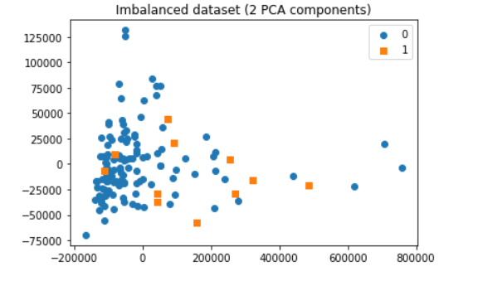

Fig.10 Class distribution on 2 principal plot

After resampling treatments, the plots become as shown in Fig.11 to Fig.13. There are 22 indexes removed in the undersampling process (Fig.11), and 109 random points added in the oversampling process (Fig.12). Notice that there are many points overlapping each other, thus Fig.12 and Fig.10 have small differences for eye inspection. Fig.13 shows the plot after Tomek links undersampling.

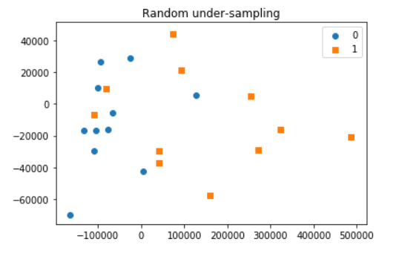

Fig.11 Class distribution after undersampling

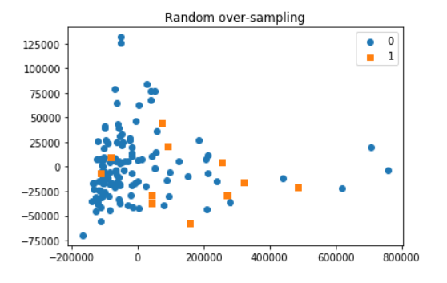

Fig.12 Class distribution after oversampling

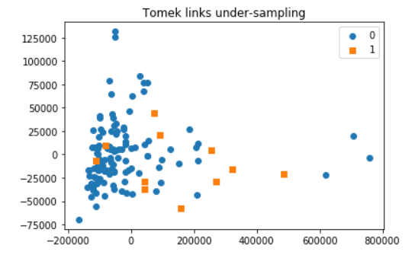

Fig.13 Class distribution after Tomek links undersampling

Next we would show the classification model training process and prediction results. Notice these studies are conducted using the whole 25 attributes instead of 2 as above. We use XGBClassifier in the classfiction. And Fig.14 shows an example for data set generated from random oversampling, where X_ros, y_ros are the data set after random oversampling. The test size is set as 0.2. The accuracy of the validation is 92.83%. Similarly, the accuracies using the methods of random undersampling and Tomek Links are 60.00% and 84.62%, respectively. Considering the low accuracy of undersampling approach, we don’t adopt this for prediction in Ford Bend, TX. And the reason of this lower accuracy needs future investigation.

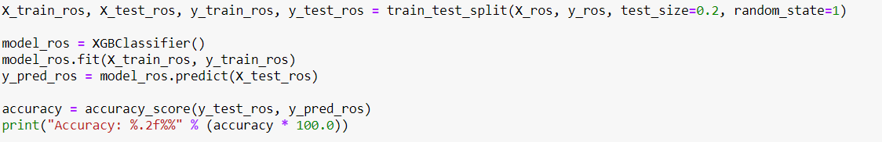

Fig.14 Code section for classification model training/verification

We use our trained models to predict the possible location of Chinese restaurant in Ford Bend, TX, which is shown in Fig.15. Zip code 77478 is predicted from the results. Both models predict this location, which gives me strong confidence on the prediction. Fig.16 shows the recommended location (red circle) to open a Chinese restaurant.

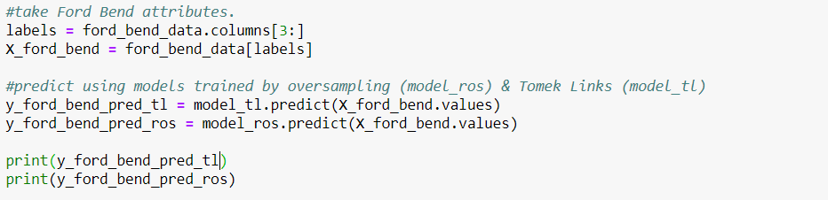

Fig.15 Code section for classification model training/verification

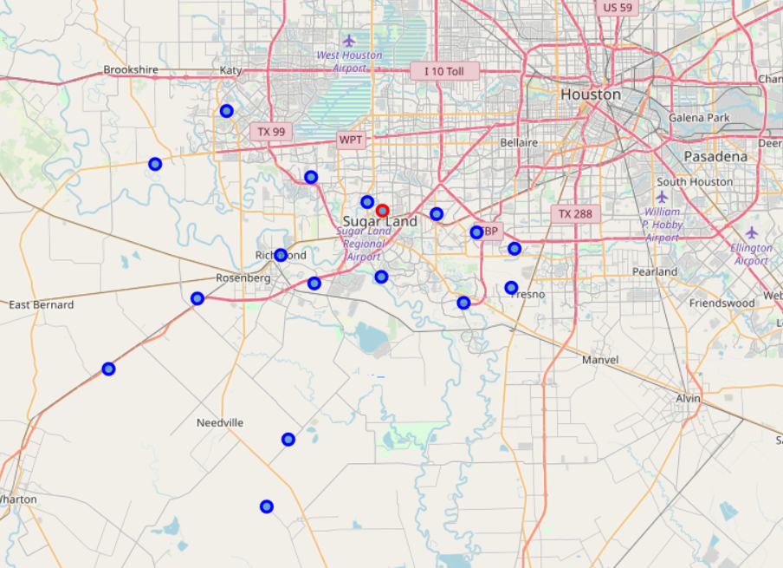

Fig.16 Recommended location (red circle) for opening Chinese restaurant

1. Conclusions and Recommendations

In this project, we developed a workflow to recommend locations for opening Chinese restaurant. Specifically, the achievements include developing specific codes to scrape and process data from online website, treatments of unbalanced classes using three resampling techniques (random undersampling, random oversampling, and Tomek links undersampling), training and testing XGBClassifiers, and predicting location to open the restaurant. Zip 77478, as in Fig.16, is shown to be a good place for such business. The workflow can be applied to other businesses given required data provided.

Finally, I want to mention a few points for future improvement. First, in our development of the classification model, we assume the merely existence of the Chinese restaurants in some region indicates that this is a good location for this business. We ignore the performance of the restaurants. (So maybe the restaurant is struggling, which should be excluded from our model development). So if we have more attributes reflecting the profitability of the restaurants, that would be very helpful to improve our model. Secondly, as we mentioned before, some regions may have more than one restaurant, a multi-classification model should be developed if we want to honor these situations.

1. References

[1] Tom Larkin (2017, September). 8 Factors for Choosing a New Restaurant Location. Retrieved from <https://www.foodnewsfeed.com/fsr/vendor-bylines/8-factors-choosing-new-restaurant-location>.

[2] Rafael Alencar (2017, November). Resampling strategies for imbalanced datasets. Retrieved from <https://www.kaggle.com/rafjaa/resampling-strategies-for-imbalanced-datasets>.