HTTP-Optimizing
2018-05-19 JK

Headers

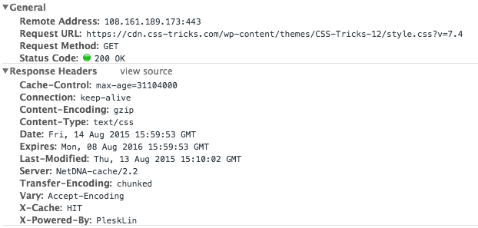
Links
https://css-tricks.com/strategies-for-cache-busting-css/
https://css-tricks.com/can-we-prevent-css-caching/
https://stackoverflow.com/questions/460389/browser-caching-of-css-files
http://www.radwin.org/michael/talks/http-caching.ppt
https://www.mnot.net/cache_docs/

