Begin

Input N,a1,a2,..,an

max=a1,i=2

While (i<N)

Do

If (max<ai) then max=ai

i=i+1

End Do

Display max

End

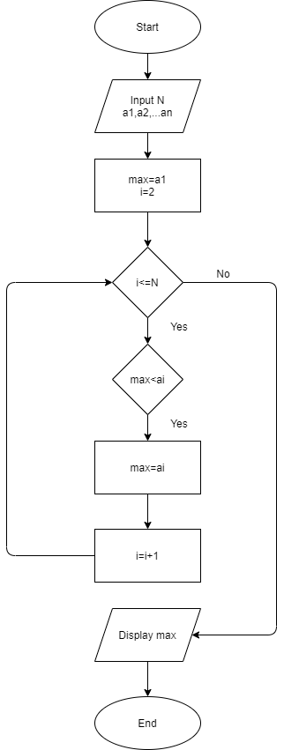

No