Chapter: Operators in Python

Chapter: Operators in Python (Mathematical, Comparison, Logical)

1. Mathematical Operators

1.1 Concept (What operators do)
In Python, an operator is a symbol (or special keyword) that performs an operation on values. In this section we focus on mathematical operators, which work with numbers such as:
- int (whole numbers): 5, 12, 250
- float (decimal numbers): 12.5, 99.99
Mathematical operators are used in everyday madrasa and Pakistani life calculations:
- total books in a Maktaba (addition)
- present students (subtraction)
- price × quantity (multiplication)
- sharing rupees equally (division)
- equal distribution with leftovers (floor division and remainder)

1.2 List of mathematical operators
- Addition (`+`): add values
- Subtraction (`-`): subtract values
- **Multiplication (*): multiply values
- Division (/): divide values (result is float)
- Floor Division (//): divide and keep only whole number part
- Modulus (%): remainder after division
- Exponent (**)**: power, e.g. \(2^3\)

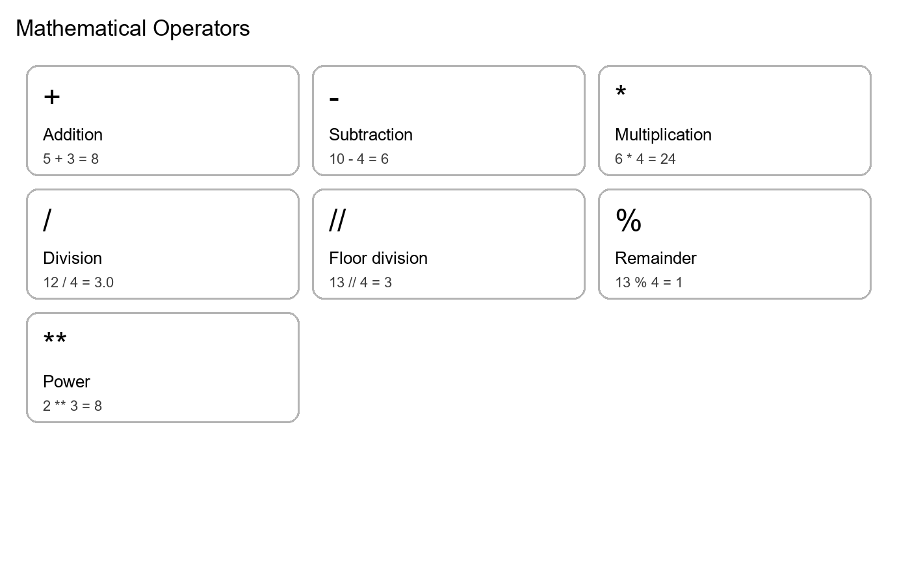

1.3 Very simple examples (start small)
print(5 + 3)
print(10 - 4)
print(6 * 4)
print(12 / 4)
- Line 1: 5 + 3 → 8
- Line 2: 10 - 4 → 6
- Line 3: 6 * 4 → 24
- Line 4: 12 / 4 → 3.0 (division returns float)

1.4 Floor division and remainder (distribution problems)
When we distribute items equally, we often need two different kinds of answers:
1. The equal share (whole number): “How many does each person/shelf/row get if we distribute equally?”
2. The leftover (remainder): “After giving equal shares, how many items are still left?”
Python gives us two operators for these two answers:
- Floor Division (`//`) gives the whole-number quotient (the equal share).
It throws away any decimal part.
- Modulus (`%`) gives the remainder (the leftover items).
This is extremely common in real life:
- Distributing Qurans on shelves in a Maktaba
- Distributing notebooks among students
- Sharing dates among friends after class
- Arranging chairs in equal rows
- / gives a float result (it keeps decimals). Example: 25 / 3 is 8.333...
- // gives a whole number result. Example: 25 // 3 is 8
So, if you are distributing physical items, you usually want // and %, not /.
If total = groups * share + leftover, then:
- share = total // groups
- leftover = total % groups
Both results come from the same division, but they answer two different questions.
1. How many each person gets (whole number) → use //
2. How many are left over → use %
Example: 25 Qurans distributed in 3 shelves.
qurans = 25
shelves = 3
per_shelf = qurans // shelves
leftover = qurans % shelves
print("Qurans per shelf:", per_shelf)
print("Leftover Qurans:", leftover)
- Line 1–2: We store total items and number of groups.
- Line 4: // gives the whole-number share.
- Line 5: % gives the remainder.
- Lines 7–8: We print results.

1.5 Exponent (power) with simple meaning
The operator Exponent (``) is used for powers**. It answers questions like:
- “What is \(2^3\) ?”
- “What is \(3^2\) (three squared)?”
In Python:
- a ** b means: “raise a to the power b.”
When b is a positive whole number:
- a ** 1 means a
- a ** 2 means a * a
- a ** 3 means a * a * a
So, we can say:
a ** b means multiply a by itself b times.
Exponent is used in many places:
- Square of a number (area-type calculations): n ** 2
- Cube of a number (volume-type calculations): n ** 3
- Fast growth examples in maths practice
At this level, the most important thing is to remember: ** is not multiplication.
For multiplication we use *. For power we use **.
print(2 ** 3)
print(3 ** 2)
- Line 1: \(2^3 = 2 \times 2 \times 2 = 8\)
- Line 2: \(3^2 = 3 \times 3 = 9\)

1.6 Program 1 (simple → practical): Madrasa shop bill
Concept: Total cost is always price × quantity.
item_price = 250
quantity = 4
total_cost = item_price * quantity
print("Total cost (rupees):", total_cost)
- Line 1: Price per item (rupees).
- Line 2: Quantity purchased.
- Line 4: Multiplication gives total cost.
- Line 5: Print the result.

1.7 Program 2 (slightly more complex): Total pages to revise
Scenario: A student revises 20 pages daily for 7 days. How many pages total?
pages_per_day = 20
days = 7
total_pages = pages_per_day * days
print("Total pages revised:", total_pages)
- Line 1–2: Store daily pages and days.
- Line 4: Multiply to get total pages.
- Line 5: Print.

1.8 Program 3 (mixing operators): Monthly budget leftover
Scenario: You have 5000 rupees. You buy 2 books at 850 each and also pay 600 rupees for stationery. How much is left?
budget = 5000
book_price = 850
books = 2
stationery = 600
spent = (book_price * books) + stationery
left = budget - spent
print("Total spent:", spent)
print("Money left:", left)
- Line 1–4: Store values.
- Line 6: Multiply for book cost, then add stationery (brackets make it clearer).
- Line 7: Subtract spent from budget.
- Lines 9–10: Print both.

2. Operator Precedence (BODMAS)

2.1 Concept (how Python decides the order)
When we write an expression like 10 + 5 * 3, Python must decide what to do first. Python follows operator precedence rules similar to BODMAS:
1. Brackets: ( )
2. Orders (powers): **
3. Multiply / Divide: *, /, //, % (left to right)
4. Add / Subtract: +, - (left to right)
This is why 10 + 5 * 3 becomes 25 (not 45): multiplication happens first.

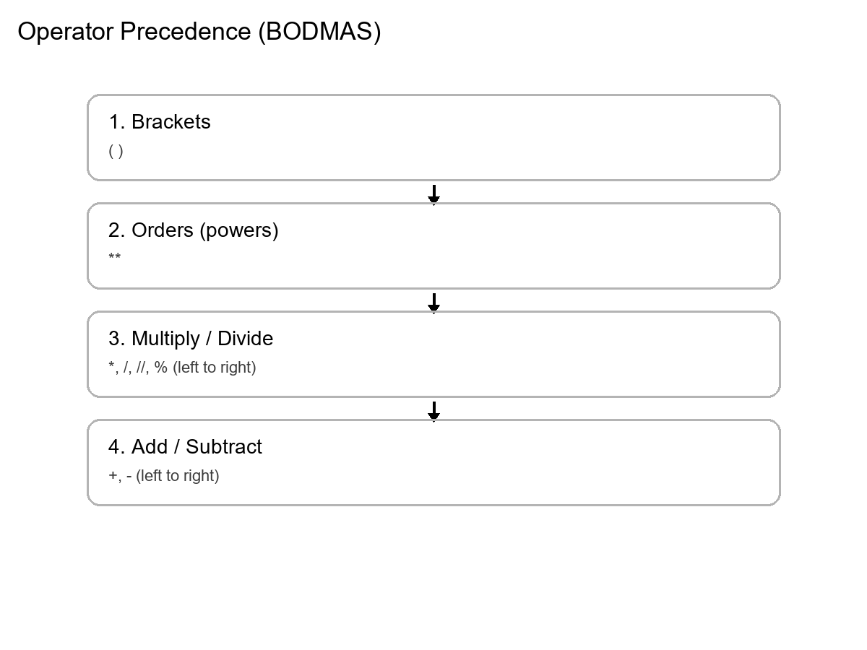

2.2 Simple to complex examples
print("10 + 5 * 3 =", 10 + 5 * 3)
print("(10 + 5) * 3 =", (10 + 5) * 3)
- Line 1: 5 * 3 happens first → 15, then 10 + 15 → 25.
- Line 2: Brackets first → 15, then 15 * 3 → 45.
print("2 * 3 ** 2 =", 2 * 3 ** 2)
print("(2 * 3) ** 2 =", (2 * 3) ** 2)
- Line 1: Power first: 3 ** 2 → 9, then 2 * 9 → 18.
- Line 2: Brackets first: (2*3) → 6, then 6 ** 2 → 36.

2.3 Program 4: Total tasbeeh in a week (clear brackets)
Scenario: After each prayer, a student reads 33 tasbeeh. There are 5 prayers per day. For 7 days, how many total?
tasbeeh_per_prayer = 33
prayers_per_day = 5
days = 7
total = tasbeeh_per_prayer * prayers_per_day * days
print("Total tasbeeh in a week:", total)
- Line 1–3: Store values.
- Line 5: Multiplication is left-to-right; we can multiply all three.
- Line 6: Print the result.

3. Comparison Operators

3.1 Concept (True/False comparisons)
Comparison operators compare two values and produce a boolean result: True or False.
- Equal to (`==`)
- Not equal to (`!=`)
- Greater than (`>`)
- Less than (`<`)
- Greater than or equal to (`>=`)
- Less than or equal to (`<=`)

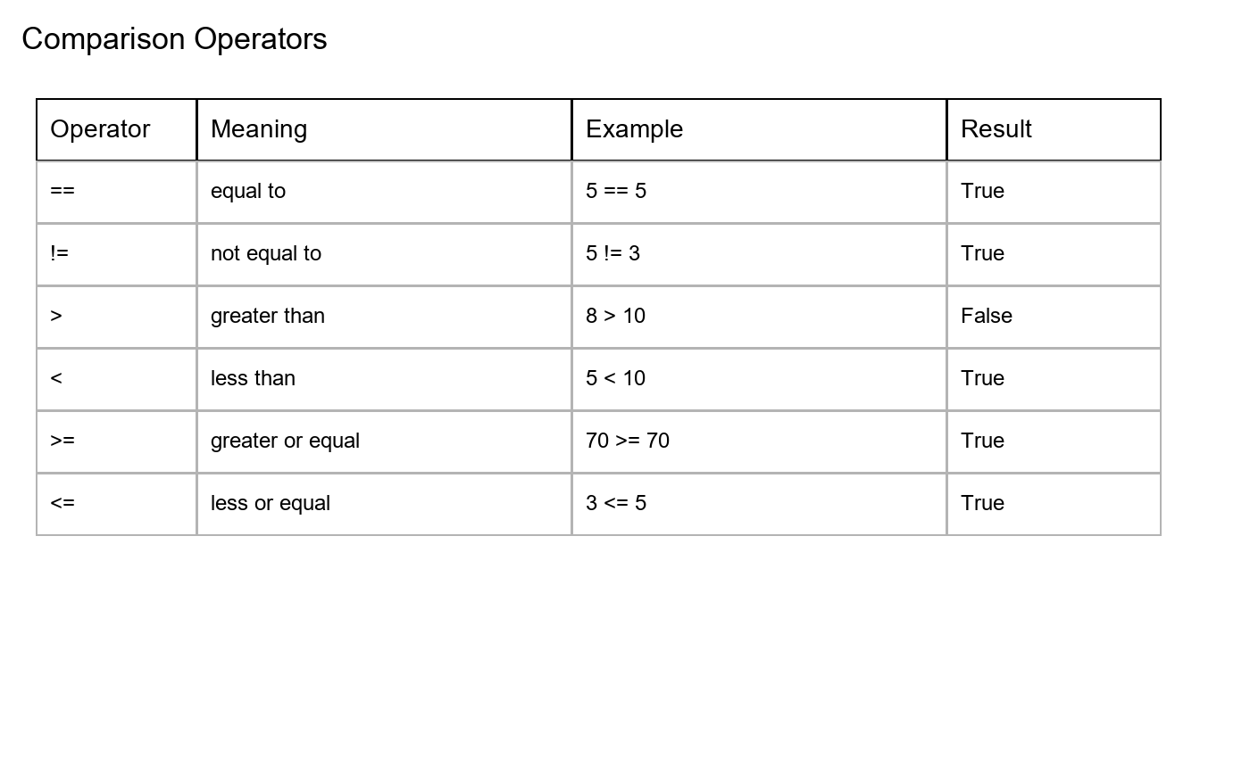

3.2 Simple comparisons (numbers and strings)
print(15 >= 10)
print(8 < 10)
print("Fajr" == "Fajr")
print("Maghrib" != "Isha")
- Line 1: True
- Line 2: True
- Line 3: True (same text)
- Line 4: True (different text)

3.3 Program 5: Pass/fail check using comparisons (no if yet)
Concept: A “pass” condition is a boolean expression like marks >= 70.
marks = 68
passed = marks >= 70
print("Passed:", passed)
- Line 1: Store marks.
- Line 2: Comparison returns True/False and is stored in passed.
- Line 3: Print the boolean result.

3.4 Program 6: Range check (between two values)
Scenario: Check if age is between 10 and 15 (inclusive). We use two comparisons and later we will join them using and (next section), but even now we can see each part.
age = 12
print(age >= 10)
print(age <= 15)
- Line 2: Is age at least 10?
- Line 3: Is age at most 15?

4. Boolean Values: True and False (Before and/or/not)

4.1 Concept (what True/False means in Python)
In Python, True and False are special values of the bool (boolean) type.
- True means a condition is correct / satisfied.
- False means a condition is not correct / not satisfied.
Logical operators and, or, and not do not work on “sentences” directly. They work on boolean values (True/False). So before we use and and or, we must know where True/False come from.
There are two common ways students will meet booleans at this level:
1. Direct booleans (we assign True/False ourselves)
Example: has_attended_class = True
2. Comparisons produce booleans
Example: marks >= 70 produces True or False automatically.
Important detail: In Python, the words are written with capital letters: True and False. Writing true or false is an error.

4.2 Code: Direct booleans (manual)
has_attended_class = True
has_done_homework = False
print("Attended:", has_attended_class)
print("Homework done:", has_done_homework)
- Line 1: A boolean variable set to True.
- Line 2: A boolean variable set to False.
- Lines 3–4: Printing shows the values as True/False.

4.3 Code: Comparisons create booleans automatically
marks = 68
passed = marks >= 70
print("Passed:", passed)
- Line 1: Store marks.
- Line 2: marks >= 70 is a comparison. It evaluates to True or False, and we store it in passed.
- Line 3: Print the boolean result.
prayer_time = "Maghrib"
is_isha = prayer_time == "Isha"
print("Is Isha time:", is_isha)
- Line 1: Store the text.
- Line 2: String comparison returns True only if the text matches exactly.
- Line 3: Print True/False.

4.4 Bridge to and/or/not
Once we have booleans like passed, has_attended_class, or is_isha, we can combine them:
- passed and has_attended_class
- passed or has_attended_class
- not passed
Now we are ready for logical operators.

5. Logical Operators (and, or, not)

5.1 Concept (combining True/False) — Quran-based understanding of AND / OR
Logical operators are used to combine boolean values:
- `and`: True only if both sides are True
- `or`: True if at least one side is True
- `not`: reverse True ↔ False

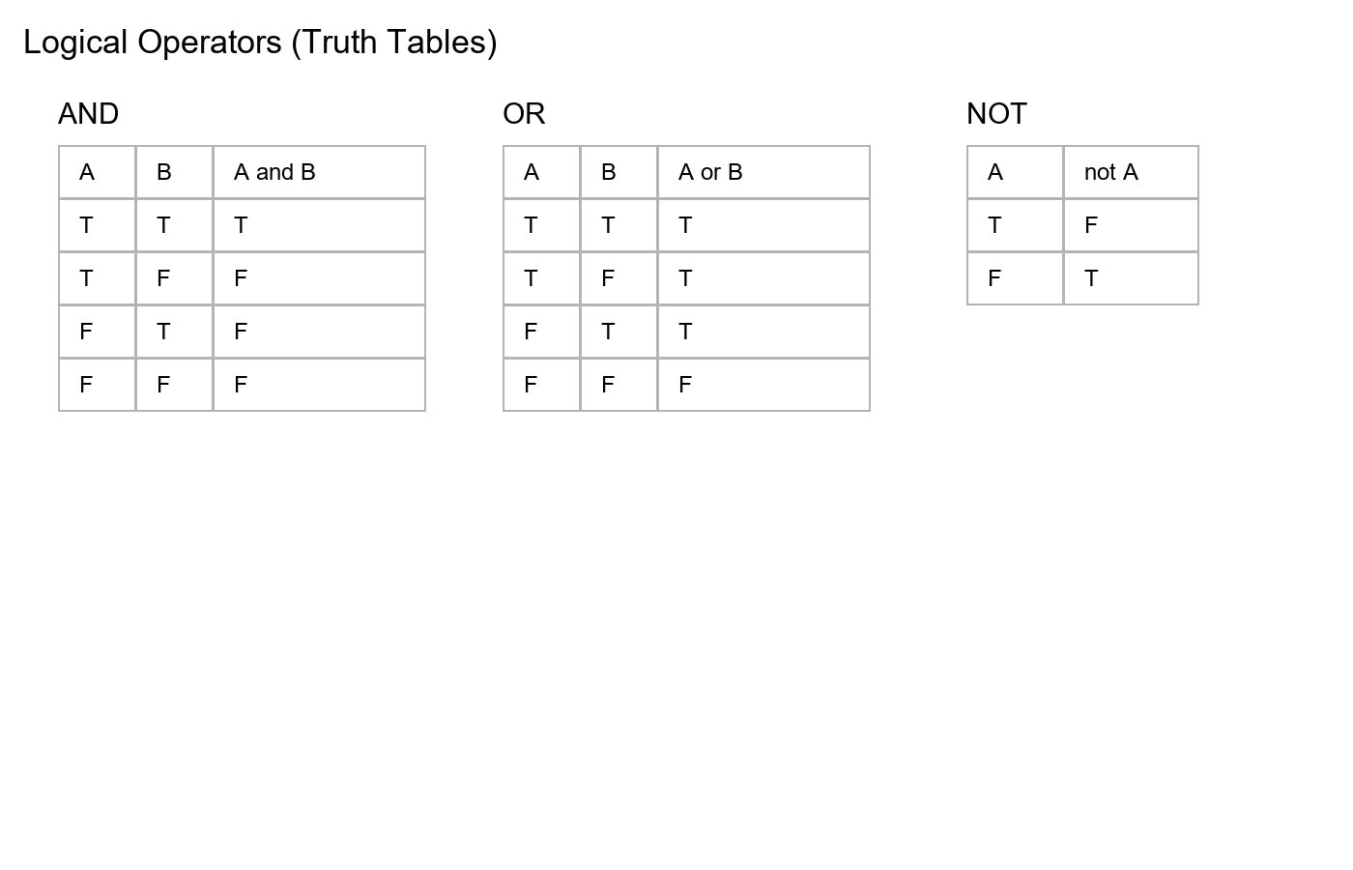

5.2 AND operator — Quran-based examples (pattern)
🧠 Programming concept (AND):
In programming, a chain like this:
Condition1 and Condition2 and Condition3 and Condition4
means:
- ALL must be True → only then the final result becomes True
- If any one is missing (False) → the final result becomes False
Arabic:
وَالۡعَصۡرِۙ‏ ١ اِنَّ الۡاِنۡسَانَ لَفِىۡ خُسۡرٍۙ‏ ٢ اِلَّا الَّذِيۡنَ اٰمَنُوۡا وَ عَمِلُوا الصّٰلِحٰتِ وَتَوَاصَوۡا بِالۡحَقِّ ۙ وَتَوَاصَوۡا بِالصَّبۡرِ‏ ٣
Translation (summary focus):
Except for those who:
- believed
- did righteous deeds
- advised each other to truth
- advised each other to patience
🧠 Step 1: Identify the AND operator
In the verse, multiple requirements are connected together (combined conditions). This is the natural form of AND logic.
🕌 Step 2: Mapping to the verse
| Condition | Meaning |
|----------|---------|
| Believe | ایمان |
| Do righteous deeds | عمل صالح |
| Advise truth | حق کی تلقین |
| Advise patience | صبر کی تلقین |
👉 All are required (AND).
👉 If any one is missing → the result changes (loss).
💻 Step 3: Basic programming mapping (boolean model)
believe = True
do_righteous_deeds = True
advise_truth = True
advise_patience = True
success = believe and do_righteous_deeds and advise_truth and advise_patience
print("Result (success):", success)
- Lines 1–4: Each condition is represented as a boolean (True/False).
- Line 6: and requires every part to be True.
- Line 7: We print the final boolean result.
💡 Teaching insight (very important):
This shows that success is not only one thing. It is belief AND action AND advising truth AND advising patience.
Arabic:
وَأَقِيمُوا الصَّلَاةَ وَآتُوا الزَّكَاةَ وَأَطِيعُوا الرَّسُولَ لَعَلَّكُمْ تُرْحَمُونَ
Translation:
Establish prayer AND give zakah AND obey the Messenger — so that you may receive mercy.
🧠 Step 1: Identify the AND operator
In the verse, the word وَ (wa) appears multiple times, joining actions together:
Action1 AND Action2 AND Action3
Conditions:
- Establish prayer
- Give zakah
- Obey the Messenger
👉 All are required → AND logic.
💻 Step 2: Basic programming mapping
salah = True
zakah = True
obey_messenger = True
if salah and zakah and obey_messenger:
print("Mercy from Allah")
- Lines 1–3: Three boolean conditions.
- Line 5: Mercy is printed only if all are True.
⚠️ Step 3: Important teaching insight
Zakah is conditional: it applies to people who are eligible (e.g., rich / above nisab). So in a realistic model, the “zakah condition” depends on whether zakah is required.
💻 Step 4: Realistic programming model
salah = True
obey_messenger = True
is_rich = False
zakah_paid = False
if salah and obey_messenger:
if is_rich:
zakah_condition = zakah_paid
else:
zakah_condition = True
if zakah_condition:
print("Mercy from Allah")
- Lines 1–2: Core conditions that are always required.
- Lines 4–5: Whether zakah is required depends on eligibility.
- Line 7: First check the always-required part.
- Lines 8–12: If zakah is required, it must be paid; otherwise it is treated as True (not required).
- Lines 14–15: Mercy message prints only when the final combined condition is satisfied.
🧠 Step 1: Identify the AND logic
In madrasa routine, joining a Tafseer class usually has multiple requirements. For example:
- the student is present
- wudu is done
- kitab/notebook is available
- class time has started
This is exactly the AND pattern: all requirements must be satisfied.
🕌 Step 2: Mapping to conditions
| Condition | Meaning |
|----------|---------|
| is_present | Student is present in Jamia |
| has_wudu | Wudu done |
| has_kitab | Tafseer kitab + notebook available |
| is_class_time | Class has started |
👉 If any one is missing → the student cannot properly join the class (result becomes False).
💻 Step 3: Programming mapping (using print)
is_present = True
has_wudu = True
has_kitab = False
is_class_time = True
can_join_tafseer = is_present and has_wudu and has_kitab and is_class_time
print("Can join Tafseer class:", can_join_tafseer)
- Lines 1–4: Each requirement is represented by a boolean value.
- Line 6: and makes the result True only when all are True.
- Line 7: We print the final decision as True/False.
✅ If you change has_kitab = True, the output becomes True (all conditions satisfied).
🧠 Step 1: Identify the AND logic
In a Maktaba, borrowing a book often requires all of the following:
- the student has a library card
- the book is available
- the student has returned the previous borrowed book
This is a clear AND rule:
has_card and book_available and returned_previous_book
🕌 Step 2: Mapping to conditions
| Condition | Meaning |
|----------|---------|
| has_card | Student has library card |
| book_available | Book is available in Maktaba |
| returned_previous_book | Previous borrowed book returned |
💻 Step 3: Programming mapping (using print)
has_card = True
book_available = True
returned_previous_book = False
can_borrow = has_card and book_available and returned_previous_book
print("Can borrow from Maktaba:", can_borrow)
- Lines 1–3: Store each requirement.
- Line 5: The result becomes True only if all three are True.
- Line 6: Print the final True/False decision.

5.3 OR operator — Quran-based examples (pattern)
🧠 Programming concept (OR):
In programming, a chain like this:
Condition1 or Condition2
means:
- If at least one condition is True → the final result becomes True
- If all conditions are False → the final result becomes False
Arabic:
اَيَّامًا مَّعۡدُوۡدٰتٍؕ فَمَنۡ كَانَ مِنۡكُمۡ مَّرِيۡضًا اَوۡ عَلٰى سَفَرٍ فَعِدَّةٌ مِّنۡ اَيَّامٍ اُخَرَؕ وَعَلَى الَّذِيۡنَ يُطِيۡقُوۡنَهٗ فِدۡيَةٌ طَعَامُ مِسۡكِيۡنٍؕ فَمَنۡ تَطَوَّعَ خَيۡرًا فَهُوَ خَيۡرٌ لَّهٗ ؕ وَاَنۡ تَصُوۡمُوۡا خَيۡرٌ لَّـکُمۡ اِنۡ كُنۡتُمۡ تَعۡلَمُوۡنَ‏
Translation (focus part):
Fasting is for a limited number of days. So whoever among you is ill OR on a journey, then an equal number of other days are to be made up.
🧠 Step 1: Identify the OR operator
The verse uses اَوۡ (aw) which gives the meaning of OR:
- ill OR traveling
This means: if any one of these situations is true, the ruling applies.
🕌 Step 2: Mapping to conditions
| Condition | Meaning |
|----------|---------|
| sick | بیمار |
| traveling | سفر میں |
👉 If sick OR traveling → make up the fast later.
💻 Step 3: Programming mapping (using print messages)
sick = True
traveling = False
cannot_fast = False
if sick or traveling:
print("Make up the fast later")
elif cannot_fast:
print("Feed a poor person")
- Lines 1–3: We represent the situation using boolean variables.
- Line 5: sick or traveling becomes True if at least one is True.
- Lines 6–8: We print the ruling message based on the condition.
🧠 Step 1: Identify the OR logic
In madrasa study life, “learning” can happen in more than one way. For example:
- reading Quran OR
- listening to a lesson/lecture
This is OR logic because any one path is enough to say the student is learning.
🕌 Step 2: Mapping to conditions
| Condition | Meaning |
|----------|---------|
| reading_quran | Student is reading Quran |
| listening_lecture | Student is listening to a lecture |
👉 If reading_quran is True OR listening_lecture is True → result becomes True.
💻 Step 3: Programming mapping (using print)
reading_quran = False
listening_lecture = True
learning = reading_quran or listening_lecture
print("Learning:", learning)
- Lines 1–2: Two possible ways of learning.
- Line 4: or becomes True if at least one is True.
- Line 5: Print the True/False result.
🧠 Step 1: Identify the OR logic
In routine planning, a student may be allowed to take a short rest if any one of these is true:
- the student is sick OR
- the student is very tired
Again, this is OR because one valid reason is enough.
🕌 Step 2: Mapping to conditions
| Condition | Meaning |
|----------|---------|
| is_sick | Student is sick |
| is_very_tired | Student is very tired |
💻 Step 3: Programming mapping (using print)
is_sick = False
is_very_tired = True
can_rest = is_sick or is_very_tired
print("Can take rest:", can_rest)
- Lines 1–2: Two possible reasons.
- Line 4: If either reason is True, the result is True.
- Line 5: Print the decision as True/False.

5.4 Very simple truth-table style examples
print(True and True)
print(True and False)
print(True or False)
print(False or False)
print(not True)
print(not False)

5.5 Simple → complex madrasa examples
Example A (and): A student is “fully ready” if attended class and did homework.
attended = True
homework = True
ready = attended and homework
print("Ready:", ready)
- Line 1–2: Two boolean variables.
- Line 3: and needs both True.
- Line 4: Print.
Example B (or): A student is “learning” if reading Quran or listening to a lecture.
reading_quran = False
listening_lecture = True
learning = reading_quran or listening_lecture
print("Learning:", learning)
Example C (not): If not fasting, then “can eat” becomes True.
is_fasting = False
can_eat = not is_fasting
print("Can eat:", can_eat)

5.6 Program 7 (combined logic): Eligibility rule
Scenario: A student is eligible for advanced class if:
- age is at least 12 and
- has_basic_knowledge is True and
- it is not weekend
age = 15
has_basic_knowledge = True
is_weekend = False
eligible = (age >= 12) and has_basic_knowledge and (not is_weekend)
print("Eligible:", eligible)
- Lines 1–3: Store values.
- Line 5: Combine comparisons and booleans. Brackets make each part clear.
- Line 6: Print result.

5. Mixed Practice Programs (Simple → Complex)

5.1 Program 8: Books per student with remainder
Scenario: 53 books must be distributed among 12 students. We need:
- books per student (whole number)
- leftover books
books = 53
students = 12
per_student = books // students
leftover = books % students
print("Books per student:", per_student)
print("Leftover books:", leftover)

5.2 Program 9: Monthly electricity bill check
Scenario: Compare two monthly bills and check if the second month is higher.
month1 = 1800
month2 = 2300
is_higher = month2 > month1
print("Second month bill higher:", is_higher)

5.3 Program 10: Study routine score (using operators only)
Scenario: A student has these booleans:
- attended class
- did homework
- read Quran
We want a single boolean message: “good day” if attended and (homework or Quran).
attended = True
homework = False
read_quran = True
good_day = attended and (homework or read_quran)
print("Good day:", good_day)
- Line 5: Brackets ensure homework or read_quran is decided before and.

6. Exercises (Practice) — Simple to Complex

Set A: Mathematical operators
1. Total books: 55 Tafsir books and 45 Hadith books. Print total.
2. Present students: 30 total, 4 absent. Print present.
3. Total cost: book price 250, quantity 6. Print total cost.
4. Share money: 9000 rupees among 6 people. Print share per person.
5. Distribution: 28 Qurans among 5 rows. Print:
- per row using //
- leftover using %

Set B: BODMAS
1. Print both results and explain:
- 10 + 5 * 3
- (10 + 5) * 3
2. Print both results and explain:
- 2 * 3 ** 2
- (2 * 3) ** 2

Set C: Comparison operators
1. Create age = 12 and print:
- age >= 10
- age <= 15
2. Create marks = 85 and print whether marks are at least 70.
3. Create prayer_time = "Maghrib" and print whether it is not "Isha".

Set D: Logical operators (simple → combined)
1. Create attended = True and homework = False. Print attended and homework.
2. Create reading_quran = False and listening_lecture = True. Print reading_quran or listening_lecture.
3. Create is_fasting = False. Print not is_fasting.
4. Combine:
- age = 14
- has_basic_knowledge = True
- is_weekend = True
Print eligibility using: (age >= 12) and has_basic_knowledge and (not is_weekend)

7. Summary and Key Terms
- Mathematical operators: + - * / // % **
- Comparison operators: == != > < >= <= → result is True or False
- Logical operators: and, or, not → combine or modify booleans
- Operator precedence (BODMAS): brackets → powers → multiply/divide → add/subtract
This chapter intentionally builds from very simple examples to more practical programs, with madrasa and local-life contexts.

