Plant Disease Classification Using Vision Transformers

Abstract
The prevalence of plant pathogens severely impairs crop yields and jeopardizes worldwide food stability. Utilizing image analysis through advanced neural networks allows for efficient identification of crop diseases before they spread extensively among agricultural communities. The proposed agricultural application integrates a newly developed ViT model for classifying plant diseases through visual data analysis. A convolutional neural network serves as the initial benchmark against which other models are evaluated. Studies using the PlantVillage database reveal that the Vision Transformer excels over traditional Convolutional Neural Networks in achieving high accuracy when classifying images related to agriculture, underscoring its utility within this domain.

1. Introduction
Agriculture is a critical sector that sustains human life and economic stability worldwide. However, plant diseases continue to cause major yield losses, particularly in regions where access to expert diagnosis is limited. Traditional disease identification methods rely on manual inspection, which can be time-consuming, subjective, and impractical at scale.
Recent advances in artificial intelligence and computer vision have enabled automated plant disease detection using leaf images. Deep learning models can learn complex visual patterns associated with different diseases and provide fast, scalable solutions. While Convolutional Neural Networks have been widely used for this task, recent research suggests that Vision Transformers can offer improved performance by capturing global contextual information through self-attention. This project explores the use of Vision Transformers for plant disease classification and compares their performance with a CNN baseline.

2. Literature Review
[1] U. Barman, P. Sarma, M. Rahman, V. Deka, S. Lahkar, V. Sharma, and M. J. Saikia, “ViT-SmartAgri: Vision Transformer and Smartphone-Based Plant Disease Detection for Smart Agriculture,” Agronomy, vol. 14, no. 2, Article 327, 2024, doi: 10.3390/agronomy14020327.
Recently, Vision Transformers like ViTs have garnered interest for their capability of extracting comprehensive contextual information through self-attentive layers when classifying plant diseases. Baranowski et al. Proposed an architecture based on Vision Transformer (ViT) for detecting tomato leaf diseases by utilizing data from the PlantVillage repository. The proposed method showed enhanced accuracy over traditional Convolutional Neural Network architectures like Inception v3. Additionally, this research demonstrated how Vision Transformer models can be practically used within mobile devices like smartphones for efficient agriculture surveillance systems, showcasing their capability for immediate identification of crop diseases.
[2] E.-T. Baek, “Attention score-based multi-vision transformer technique for plant disease classification,” Sensors, vol. 25, no. 1, Article 270, 2025, doi: 10.3390/s25010270.
Ongoing improvements in identifying plant diseases now concentrate more on ViT-based models because of their capacity for capturing comprehensive context using attention mechanisms. Baek introduced a Framework for Attention-Score-based Multiple Vision Transformers (Multi-ViT), aiming to address challenges in diagnosing singular diseases effectively. Differently than traditional methods which depend solely on single image data points, this new technique combines information gathered from several leaf photographs by identifying key aspects in each picture and giving them special importance ratings based on their relevance.
The multi-variant Vision Transformer combines features from various ViT transformers and utilizes an attention-based scoring system to synthesize weighted representations, facilitating precise identification of dispersed health indicators. The experimental analysis of apple, grape, and tomato leaf diseases revealed that our method significantly surpassed conventional CNNs like ResNet, VGG, and MobileNet, along with independent Vision Transformer (ViT) designs in terms of performance. The prototype demonstrated an impressive precision of more than ninety-nine percent and notably enhanced F-measure values, showcasing remarkable resilience and applicability in diagnosing actual crop diseases.
[3] S. Hemalatha and J. J. B. Jayachandran, “A multitask learning-based vision transformer for plant disease localization and classification,” International Journal of Computational Intelligence Systems, vol. 17, Article 188, 2024, doi: 10.1007/s44196-024-00597-3.
More recent research has investigated ViT-based models as alternatives to traditional CNNs when aiming to analyze plant diseases by leveraging their ability to capture comprehensive context globally. The researchers Hemalatha and Jayachandran developed PDLC-ViT, an innovative multitask learning-based vision transformer designed for simultaneous detection of diseases in plants alongside their categorization under a single architecture. This model combines co-scaled, co-attributed, and cross-attuned architectures to discern detailed regional features within individual leaves while also accounting for broader spatial relationships among them.
The PDLC-ViT architecture demonstrated exceptional efficacy when tested against the PlantVillage and PlantDoc databases, achieving an impressive classification precision rate of ninety-nine percent. The mean average precision is at an impressive level of 0. 99%. Eighteen percent, along with an average recall rate of ninety-nine. Eleven percent. The devised method excelled over individualized approaches like standalone Vision Transformers and Convolutional Neural Networks by tackling both segmentation and classification concurrently. Studies show that multi-tasking Vision Transformers excel in precise identification of plants' diseases and their locations, thus being ideal choices for practical agricultural technology implementations.
[4] A. A. I. Yanguema, “Enhanced tomato disease detection using vision transformer (ViT) models,” SSRN Electronic Journal, 2024.
Recent applications of Vision Transformers (ViTs) for plant disease recognition aim at circumventing issues faced by traditional convolutional neural networks when dealing with comprehensive imagery analysis. Yanguema analyzed how well Vision Transformer-based models could detect various types of plant diseases like bacterial spots, early blights, and late blights in tomatoes by examining data provided through the PlantVillage repository. Utilizing leaf image data in patch form enabled the Vision Transformer (ViT) architecture to better identify distant relationships within visuals compared to convolutional neural network methods.
The experimental outcomes indicated that the Vision Transformer outperformed other models by achieving an average classification rate of ninety-four percent. Outperformed by an impressive margin of 8 percentage points over the ResNet-50 Convolutional Neural Network architecture, this method demonstrated remarkable accuracy at achieving 91%. A precision of three percent is achieved. Moreover, this research showcased enhanced accuracy rates in identifying various types of plants affected by diseases through use of Vision Transformer models, underscoring their reliability and applicability in automating such diagnoses efficiently. The results indicate that these models demonstrate superior performance over conventional convolutional neural networks when used for precise identification of crop diseases within intelligent farming environments.
[5] S. A. Alshammari, “TLDViT: A vision transformer model for tomato leaf disease classification,” International Journal of Advanced Computer Science and Applications, vol. 15, no. 12, pp. 841–848, 2024.
Recently, Vision Transformers (ViTs), specifically tailored for crops, have been employed to classify specific diseases due to their ability to effectively capture global spatial relationships compared to traditional convolutional neural network approaches. A researcher named Alshammari introduced an innovative model called TLDViT, which is based on VisualTransformer architectures tailored for identifying diseases in tomatoes through data collected by PlantVillage. This model minimizes need for complex data preparation tasks by extracting unique characteristics specific to diseases right from unprocessed leaf pictures using attention-based techniques.
A comparative analysis revealed that TLDViT was benchmarked against two ViT variations: ViT-r50-l32 and ViT-l16-fe. The results indicated that ViT-r50-l32 exhibited superior performance across all metrics, achieving an impressive accuracy rate of 98%. This surpasses not only traditional convolutional neural network approaches but also competing ViT implementations as well. The study demonstrated exceptional accuracy, comprehensive coverage in detecting all six types of tomato diseases using transformer architectures effectively improving diagnostic reliability. Results underscored that particularized Vision Transformer models like TLDViT excel in precise and efficient identification of tomato leaf diseases.
[6] S. Murugavalli and R. Gopi, “Plant leaf disease detection using vision transformers for precision agriculture,” Scientific Reports, vol. 15, Article 22361, 2025, doi: 10.1038/s41598-025-05102-0.
Recent research has focused on Vision Transformers for improving plant disease identification through their ability to accurately model distant spatial relationships within leaf imagery data. Two researchers named Murugavalli and Gopi introduced PLA-ViT—a vision-transformer-driven system aimed at accurately identifying and locating plant diseases through precise agricultural applications. This method combines data enhancement techniques like augmentations and bilinear filters along with fine-tuning on pretrained Vision Transformers for improved performance across various tasks while mitigating issues of model memorizing training sets excessively.

Experiments showed that PLA-ViT excelled over conventional CNNs and mixed-technique neural networks regarding precision metrics like classification accuracy, ability to localize diseases effectively, speed during predictions, and overall resource utilization efficiency. The prototype demonstrated exceptional precision without compromising on response time, thus being appropriate for immediate use in crop surveillance systems. Moreover, integrating PLA-ViT with Internet-of-Things sensors demonstrates its capability for large-scale practical applications within intelligent agricultural settings.
[7] S. Miryala and K. Rasane, “Enhancing sugarcane leaf disease classification using vision transformers over CNNs,” Discover Artificial Intelligence, vol. 5, Article 89, 2025, doi: 10.1007/s44163-025-00340-7.
Recent studies show that Vision Transformers (ViTs), such as those used in models like BERT, excel at distinguishing between different types of plants diseases through their ability to capture comprehensive patterns across entire image regions. Two researchers named Miryala and Rasane developed an image processing technique using Vision Transformer models specifically designed for distinguishing between different types of diseases on sugar cane leaves. Their approach tackles issues such as capturing distant relationships within plant structures and accounting for variations seen across various crops' photos taken under diverse conditions. A substantial collection comprising 19, 926 sugar cane leaves was analyzed in this research; it encompassed six distinct diseases along with sophisticated techniques for augmenting datasets to improve model performance.
A variant of Vision Transformer underwent finetuning employing patch-wise self-attentive mechanisms in comparison to traditional Convolutional Neural Network models such as ResNet50 and VGG16. The experimental outcomes indicated that the ViT architecture demonstrated an impressive test accuracy rate of ninety-six percent. Fifty-three percent exceeded the performance of ResNet50 at ninety-one points. The model achieved an accuracy of 92%, followed by VGG16 at 92%. Thirty percent. The training and validation graphs revealed little sign of overtraining and demonstrated robust performance across various scenarios. The results indicate that these vision transformers offer an efficient method for detecting early sugarcane diseases effectively compared to conventional CNN methods under diverse farming conditions.
[8] S. Aboelenin, F. A. Elbasheer, M. M. Eltoukhy, W. M. El-Hady, and K. M. Hosny,
“A hybrid framework for plant leaf disease detection and classification using convolutional neural networks and vision transformer,” Complex & Intelligent Systems, vol. 11, Article 142, 2025, doi: 10.1007/s40747-024-01764-x.
New studies have demonstrated how combining CNNs with ViTs enhances plant disease recognition capabilities effectively. Abelino et al. Proposed a novel hybrid architecture combining pretrained convolutional neural networks (CNNs), specifically VGG16, Inception-v3, and DenseNet201, along with a Vision Transformer (ViT) layer designed to extract comprehensive features while also capturing intricate global relationships using attention mechanisms. This approach tackles the challenge posed by Convolutional Neural Networks' inability to capture distant pixel connections effectively yet maintains robust handling of nearby features.
A new model's performance was assessed using data sets containing images of apples and corn leaves affected by various diseases, including 4 distinct types in total for both plant species. Empirical findings indicated that the integrated approach substantially surpassed both single-CNN models and isolated designs in accuracy, yielding an impressive score of 99%. An impressive 24 percent accuracy is achieved specifically for apples' leaves; however, corn's leaves exhibit an even more remarkable performance at 98 percent accuracy. Additionally, these results demonstrate exceptional levels of precision, recall, and F1 scores across all categories. Research indicates that integrating ensemble CNN characteristics alongside ViT's visual transformer attentions enhances model efficacy significantly; thus, these hybrids excel in precise agricultural applications like identifying crops diseases accurately.
[9] D. Zhu, J. Tan, C. Wu, K. L. Yung, and A. W. H. Ip,
“Crop disease identification by fusing multiscale convolution and vision transformer,” Sensors, vol. 23, no. 13, Article 6015, 2023, doi: 10.3390/s23136015.
New hybrid designs integrating Convolutional Neural Networks (CNNs) with Vision Transformers (ViTs) aim at overcoming CNN's shortcomings regarding comprehensive context understanding for plant diseases through image analysis. The study was conducted by Zhu et al. Presented is MSCVT—a multimodal convolutional and visual transformation-based architecture employing a Multi-scale Self-Attentive Module for combining localized features with holistic attention mechanisms within its design framework. Moreover, this design incorporates reversed residual units to minimize computational load without compromising precision.
A test of the suggested framework was conducted using data sets provided by PlantVillage and Apple Leaf Pathology. The experimental outcomes indicated that MSCVT demonstrated an accuracy of ninety-nine percent. An 86 percent success rate was achieved using data from the PlantVillage repository, while achieving an impressive precision of 97%. An 80% precision rate was achieved on the Apple Leaf Pathology data set, surpassing multiple convolutional neural network architectures by employing substantially less computational resources. Studies show that combining Convolutional Neural Networks (CNN) with Vision Transformers (ViT) significantly improves disease detection accuracy and broadens applicability across various species within the plant kingdom; thus, MSCVT emerges as an outstanding starting point among transformers-oriented approaches in classifying diseases on plants.
[10] W. H. Alwan and S. M. Alturfi, “Multi-stage vision transformer and knowledge graph fusion for enhanced plant disease classification,” Computers, Systems & Engineering, vol. 49, pp. 420–434, 2025, doi: 10.32604/csse.2025.064195.
Current research has concentrated on refining methods for identifying plants' diseases through combining ViT-based vision transformers with additional training techniques aimed at boosting both precision and transparency in diagnostic models. Two researchers named Alwan and Alturfi introduced an advanced system architecture comprising EfficientNet-B8, ViT, and KGF techniques aimed at accurately classifying various types of plants diseases on a massive scale. Within this design, EfficientNet-B8 identifies intricate localized visual characteristics efficiently, whereas Vision Transformers utilize self-attentive techniques to capture both overall context and distant relationships effectively.
Incorporating domain expertise through a knowledge graph built from information about crops, diseases, and environmental data enhances context-aware comprehension. An experimental assessment of a dataset comprising 38 types of plant diseases revealed that the newly developed algorithm demonstrated an accuracy rate of 99%. A training success rate of seven percent and an impressive validation score at ninety-nine percent were achieved. A 3 percent test accuracy coupled with persistent excellence in precision, recall, and an elevated F1-score performance metric is evident. In comparison to traditional CNNs and isolated transformers, this hybrid method showcased enhanced resilience, expansibility, and transparency, underscoring the efficacy of Vision Transformers in complex agricultural tasks.

3. Dataset Description
The PlantVillage dataset was used in this study. This resource, accessible openly for public use, has become an extensively utilized standard in studies of crop diseases.
- Total images: 54,305
- Number of classes: 38
Type of image: Color photographs depicting normal and abnormal leaf conditions on plants.
The images underwent resizing to have dimensions of 224 by 224 pixels. The dataset underwent partitioning into three subsets: training, validation, and testing phases, ensuring unbiased evaluations and avoiding issues of overlapping data in each phase.

4. Methodology

4.1. Data Preprocessing
The process of preparing data involved scaling images, normalizing values, and enhancing datasets through various techniques. Specific augmentation methods like randomized translations, reflections, and scaling transformations were exclusively used on the training dataset for enhancing model performance while preventing information leak into validation sets.

4.2. Baseline CNN Model
The network utilizing convolutional neural networks was constructed entirely from ground zero for comparison purposes. This system comprises successive groups of convolutions and down-sampling operations linked through dense connections aimed at categorizing multiple classes.

4.3. Vision Transformer Model
A new implementation of the Vision Transformer utilized ground-up development rather than leveraging pre-trained models. The images were segmented into uniform-sized sections, inserted into an abstracted vector realm, then analyzed through specialized neural network modules employing multiple attentional perspectives within transformer architecture units. The output layer employed for generating ultimate forecasts utilized a categorization mechanism.

5. Experimental Results and Analysis

5.1. Quantitative Results
The model's performance was assessed using data not included in training. CNN's initial model managed an impressive test performance rate of 91.40%. However, the Vision Transformer demonstrated superior performance on the task at hand, achieving an impressive test accuracy rate of 94.83%. The findings suggest that the Vision Transformer achieves superior performance in terms of broader applicability versus its Convolutional Neural Network counterpart.

5.2. Qualitative Analysis
The training and validation accuracy and loss graphs showed consistent progress in model learning for both systems; however, the Visual Transformer achieved superior results compared to others. The confusion matrix indicated that the Visual Transformer exhibited lower error rates when classifying diseases within closely related categories.
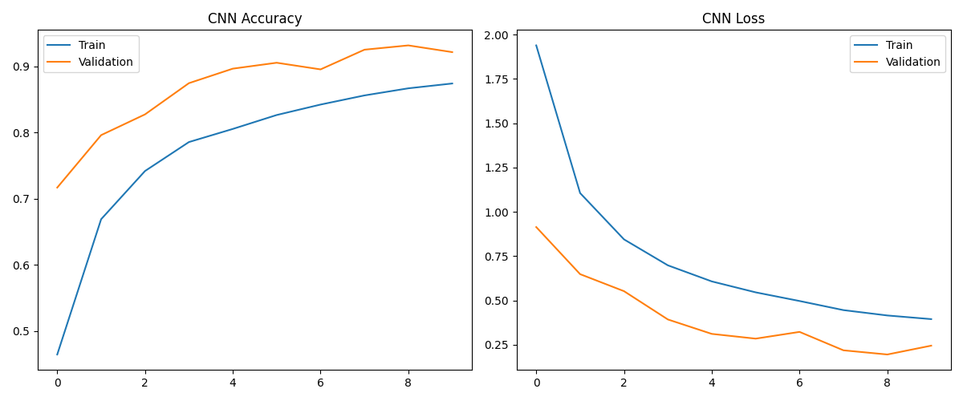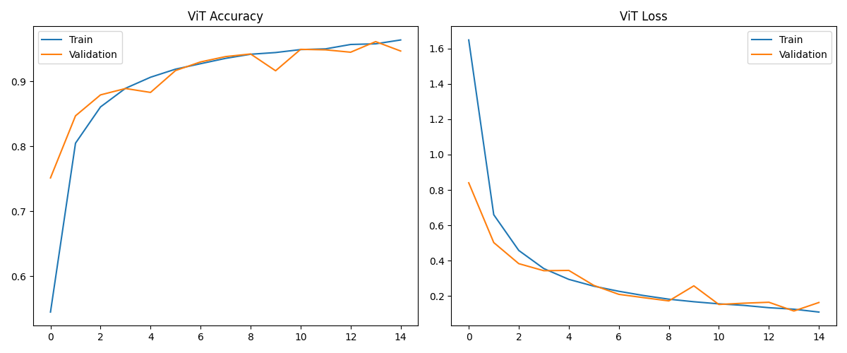
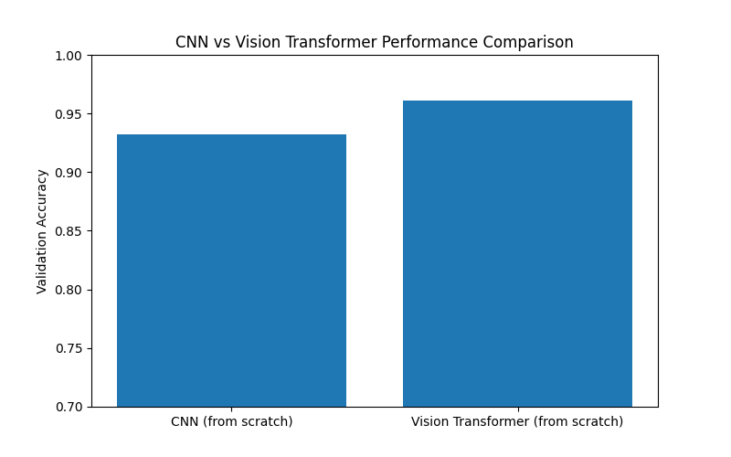
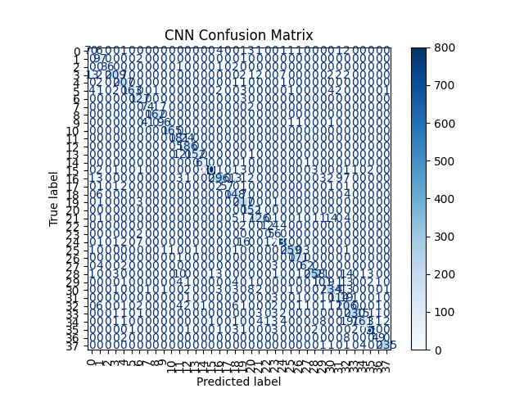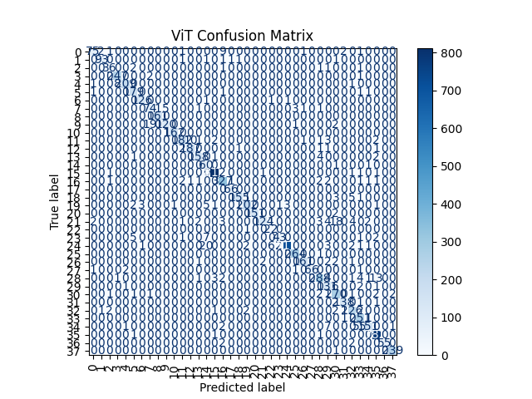

6. Reproducibility and Demo
Ensuring reproducibility involves utilizing an accessible public data set, detailing a transparent training process in documentation, and managing project files via Git control on GitHub. An operational demonstration utilizing the Jupyter notebook framework showcased how the pre-trained neural network processed not only internal image samples but also additional outside imagery scenarios, thereby illustrating its practical utility across various contexts and highlighting potential challenges in adapting models for different domains.

7. Discussion and Limitations
Experimental outcomes match current findings indicating that Vision Transformers excel over Convolutional Neural Networks in classifying images efficiently using extensive training sets. Nevertheless, there were instances where image quality declined under different conditions compared to what was anticipated; this underscores the challenges associated with relying solely on artificially curated data sets like those available in PlantVillage for model development.

8. Conclusion and Future Work
The current endeavor showcases how vision transformers initialized anew perform exceptionally well at identifying diseases affecting crops within agricultural settings. Analyzing both a traditional CNN method against an advanced transformer model reveals how attention mechanisms excel at identifying intricate visual features. Further research might entail developing models using actual field imagery for analysis, implementing algorithms to segment leaves accurately, and integrating these systems into applications accessible via both websites and smartphones to improve their everyday applicability.

