Prayaas (Hindi translation for "an attempt")

A six-axis robotic arm

## Objective

To fabricate an open-source six-axis robot arm that can be manufactured for under 1000$ using off-the-shelf, economical parts, motors, and electronics and using technologies like 3D printing and Arduino while minimizing compromise in performance.

## Motivation

The idea of making a robotic arm came to my mind after seeing the Universal Robot UR5 Co-bot in my college's Robotics Lab. Still, due to restrictions by the college, students were not allowed to use it, and there was an extensive procedure to get permission from the respected authorities to use it. That's when I considered designing my robotic arm and took it up as a challenge myself. It would also be a good learning experience as I could explore different engineering, electronics, mechanics, and programming domains. I first made a small 3 degrees of freedom robotics arm for my curriculum robotics project using stepper and servo motors and Arduino and integrated them with Robot Operating System (ROS). It helped me understand the real problems faced when executing a project on that scale and gave me a concept of what problems I might encounter while making a six-axis robotic arm.

## Introduction

Prayaas is a six-axis robotic arm that can almost entirely be 3D printed with any hobby 3D printer. I started the project in October 2021, and there have been three iterations of the design since then, v3.0 being the final one. I have improved the calculations in each iteration, changed the design to make manufacturing more manageable, and changed the power transmissions and gearboxes to simplify the assembly. The v1 consisted of self-designed, 3D printable cycloidal gearboxes and three planetary gearboxes, which made the design very difficult to assemble. The calculations for v1 were also done by assuming the weights of gearboxes, motors, and other components using software like Cura Ultimaker and in-built properties in Autodesk Fusion360. The following two iterations also focused on improving the same aspects of the arm. The below-given details are the description of the final iteration of the arm.

## Joint 1

In the v1, joint one consisted of a single NEMA 17 stepper motor with a 23:1 cycloidal gearbox connected to it, but the payload I was hoping to get at that time was around 200gm and a reach of 300mm. In v2, I changed the gearbox to a 52:1 with a different approach to the gearbox design. After 3D printing and assembling the gearbox, I realized that assembling the gearbox was very complex and needed many parts to be printed, hence defeating the purpose of keeping the design open. The final iteration, v3, consists of a simple timing belt reduction of 36:1 coupled with a bigger NEMA 23 stepper motor. This enabled me to achieve a good output torque, joint rpm, and simple construct.

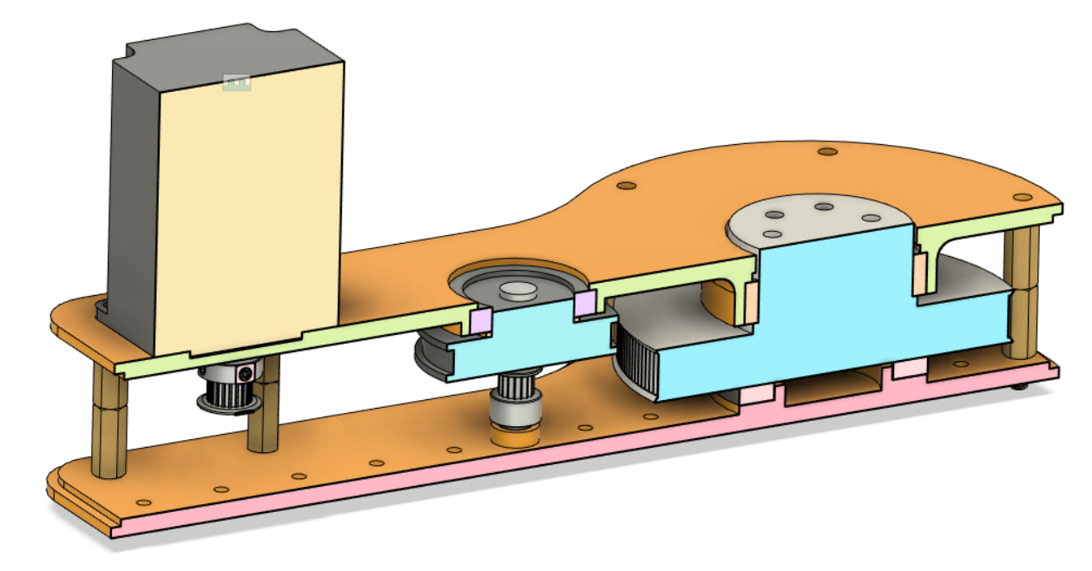

## Joint 2

The design of joint 2 in v1 used the same cycloidal gearbox that I used for joint one of v1, which I then changed to the gearbox used in joint one for v2. In the final design, due to the reasons mentioned in joint 1, I used timing pulleys and belts with a ratio of 96:1.

## Joint 3

Joint 3 in v1 consisted of a NEMA 17 coupled with a 3D printed planetary gearbox of ratio 5:1. The v2 has a 5:1 timing pulley which is input to a planetary gearbox of ratio 5:1. Which gives a final ratio of 25:1. Final version has a ratio of 48:1 using just timing belts and pulleys.

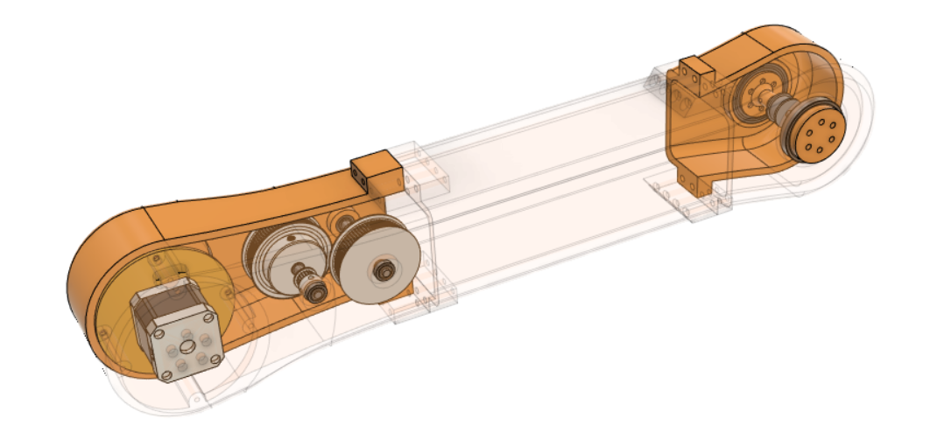

## Joint 4

Joint 4 consists of another NEMA 17 coupled with a planetary gearbox.

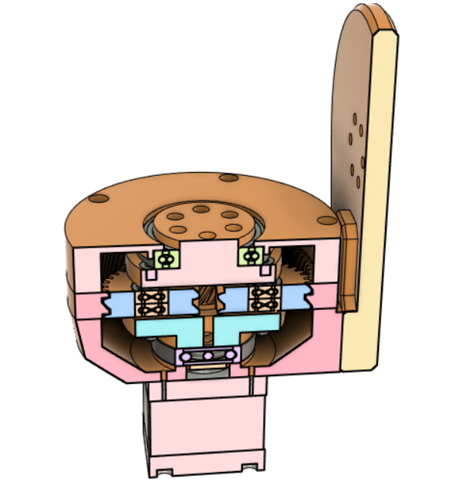

## Joints 5 and 6

Joints 5 and 6 rotation is achieved with a differential drive made by bevel gears. The bevel gears are connected to the motor using a timing belt. This arrangement helps me reduce the torque needed in the lower joints since the motors are closer to the lower joints. It also allows me to improve torque using the timing pulley, which enables me to use smaller, lighter, and more cost-effective motors.

## What's Next?

Currently, I am optimizing every joint and giving them a final touch. I will use the 3D printer available in the college innovation center and my personal 3D printer to manufacture the arm prototype. As of now, the final version of the arm looks like this:

