A Deep Learning Approach for Effective Intrusion Detection in Wireless Networks using CNN
In this paper author is using an addition algorithm called CRF-LCFS (Conditional Random Field and Linear Correlation Coefficient-based feature selection algorithm). CRF-LCFS algorithm will compute similarity distance between features and then select only those features which has high similarity between features. All existing algorithms were working on full features but their attack detection rate is not satisfactory so author extracted relevant features from dataset by applying CRF-LCFS algorithm and then extracted features will be trained with CNN algorithm.
CNN algorithm can be define with multiple layers and each layer will build a features map and then CNN will trained model by extracting important features. CNN trained model can be used to predict attack from network packets.
To experiment with this concept author has used KDD CUP dataset and I am also using same dataset and below screen shot showing implementation of CRF-LCFS with CNN algorithm.
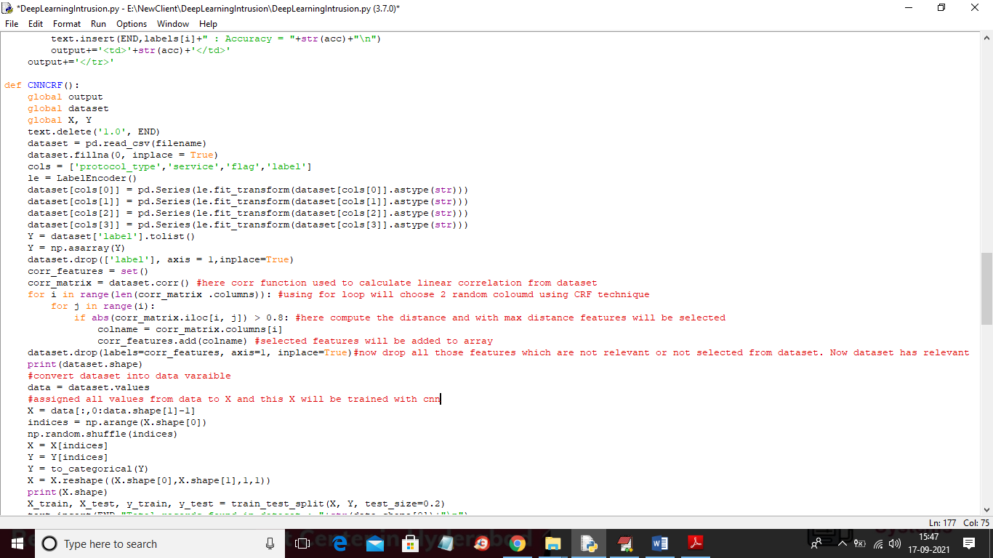
In above screen read red colour comments to know about CRF-LCFS implementation. In below screen you can see CNN implementation
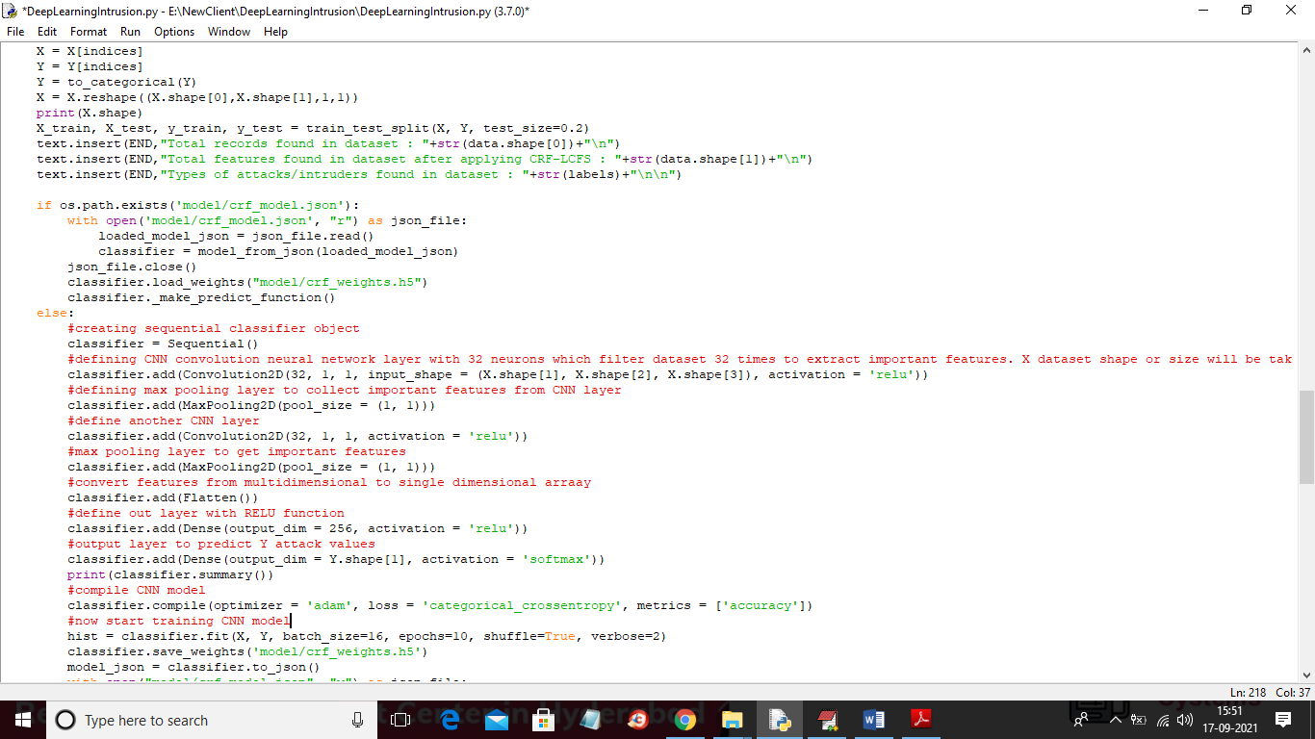
In above screen you can read red colour comments to know CNN implementation. To designed this project we have implemented following modules
- Upload KDD-CUP Dataset: using this module we will upload KDD dataset to application
- Preprocess Dataset: dataset contains some non-numeric data such as TCP, FTP and many more and CNN will not accept non-numeric data so we will process dataset to convert non-numeric data to numeric data. To each non-numeric values application will assigned unique numeric id.
- Train CNN on Full Features: using this module we will input processed full KDD dataset features to CNN to build a model and this model can be used to predict attack and then calculate accuracy.
- Train CNN with CRF-LCFS: using this module we will select relevant features from dataset and then input this features to CNN to build trained model and then calculate accuracy
- Accuracy Comparison Graph: using this module we will plot accuracy comparison between CNN with full features and CNN with CRF selected features.
- Comparison Table: using this module we will display predicted accuracy of each attack labels called DOS, PROBE, U2R and R2L.
SCREEN SHOTS
To run project double click on ‘run.bat’ file to get below screen
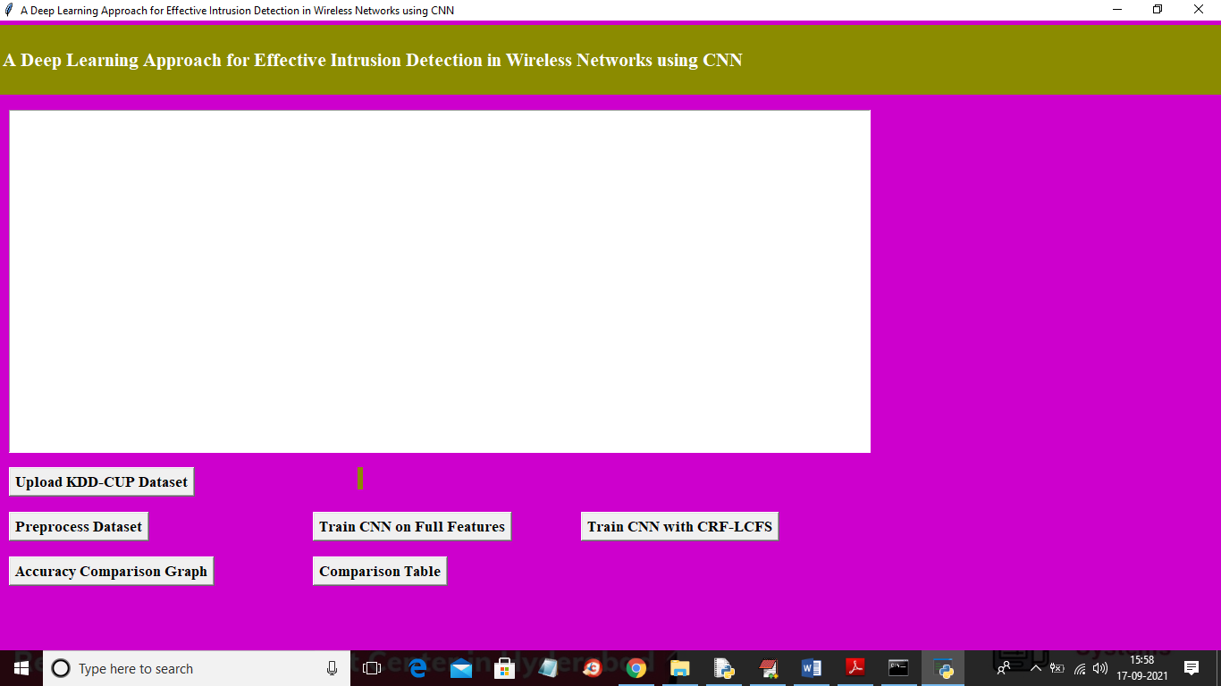
In above screen click on ‘Upload KDD-CUP dataset’ button to upload dataset and to get below screen
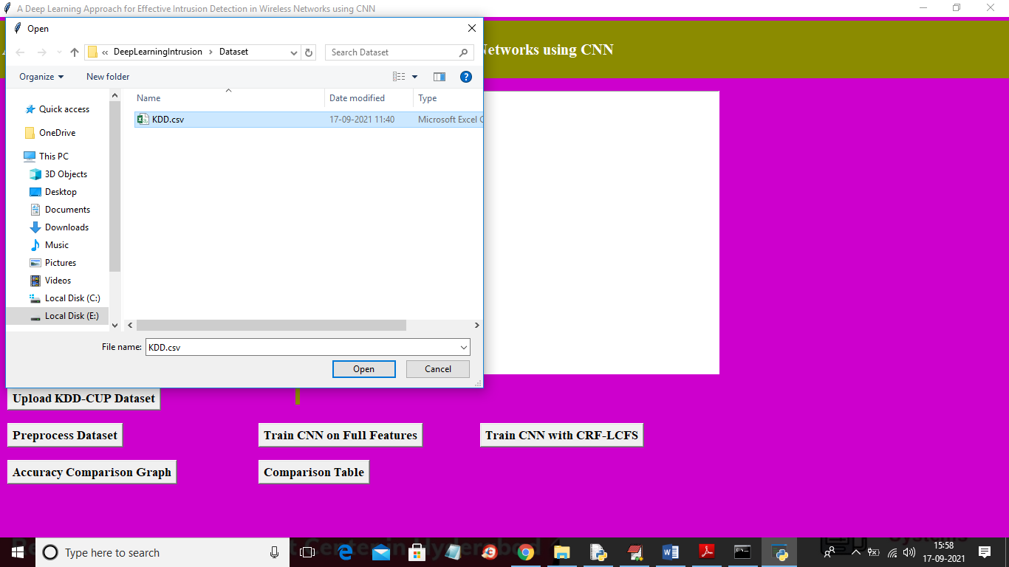
In above screen selecting and upload ‘KDD.csv’ dataset and then click on ‘Open’ button to get below output
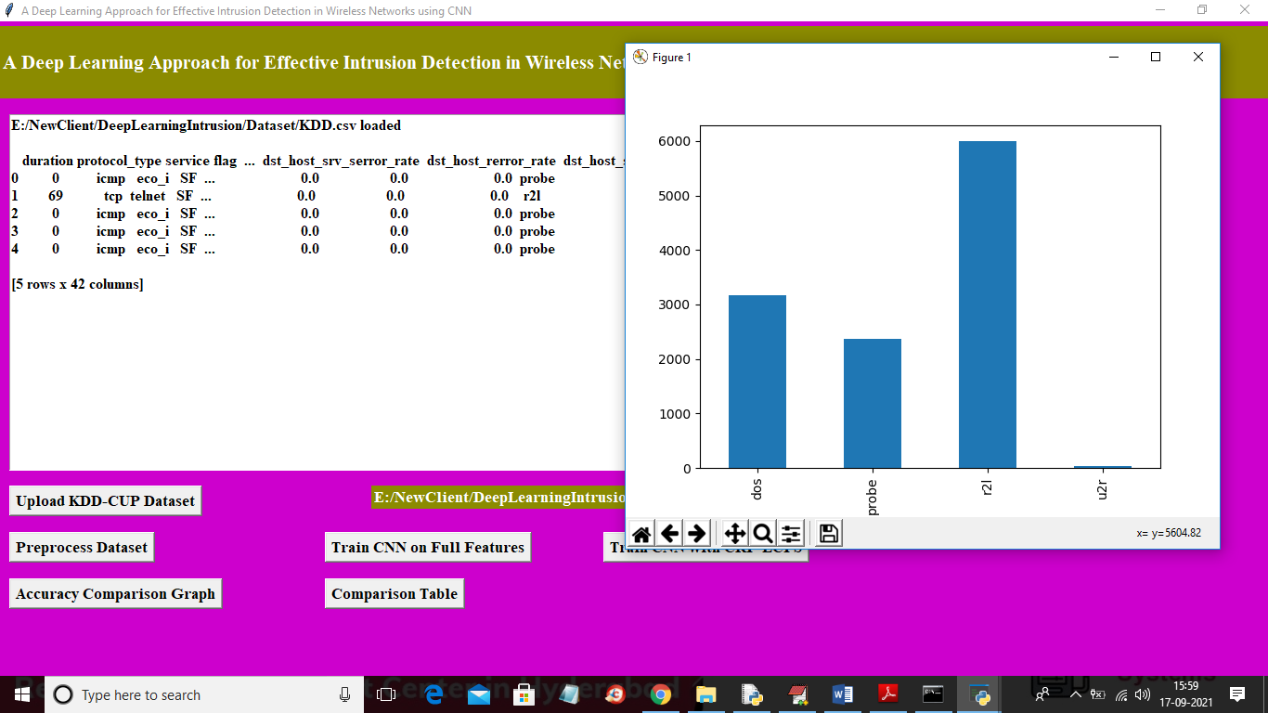
In above screen we can see dataset loaded and some values are non-numeric and CNN will accept such values so we need to process them to assign numeric id to each non-numeric values. In above graph x-axis represents attack name and y-axis represents total count of that attack. Now close above graph and then click on ‘Preprocess Dataset’ button to process dataset
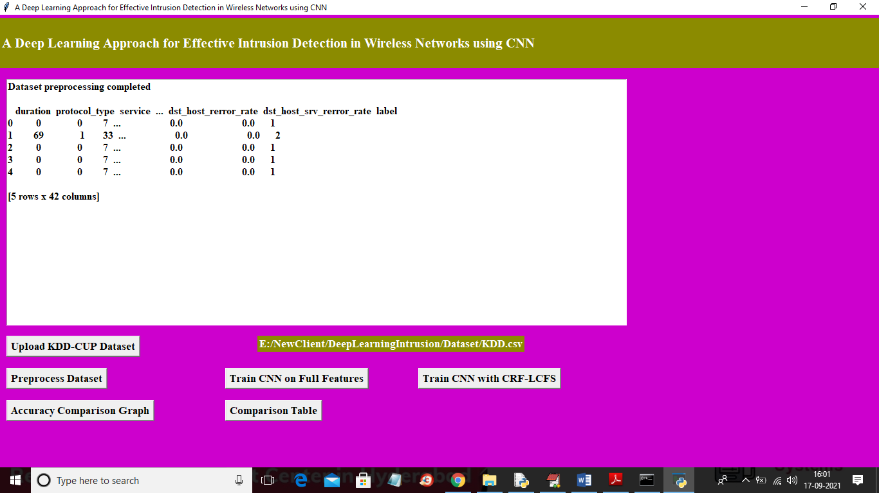
In above screen we can see all values are converted to numeric format and now click on ‘Train CNN on Full Features’ button to train CNN on all features and to get below screen
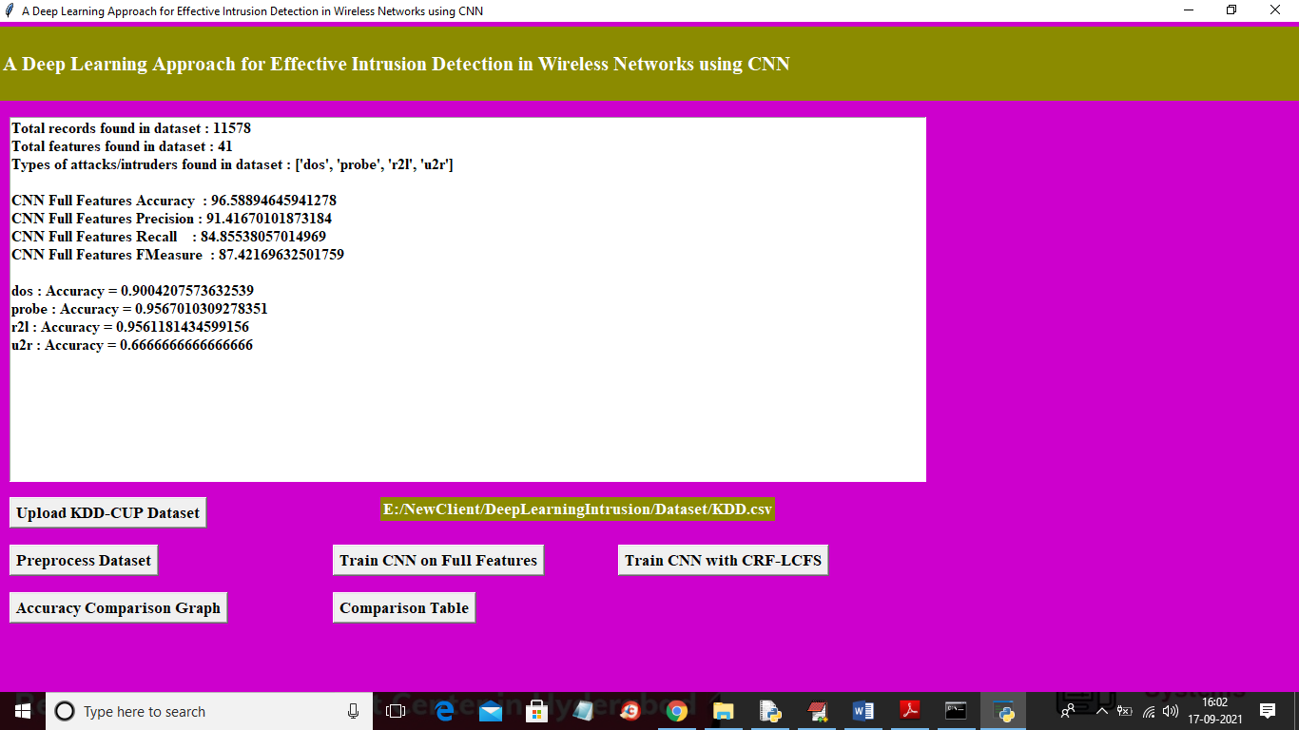
In above screen we can see CNN full features accuracy is 96% and then individually we calculate predicted accuracy of different attacks such as DOS, R2L, U2R and Probe. In above screen we calculate precision, recall and FSCORE also. In above screen we can see dataset contains total 41 features. Now click on ‘Train CNN with CRF-LCFS’ button to train CNN with CRF selected features and to get below output
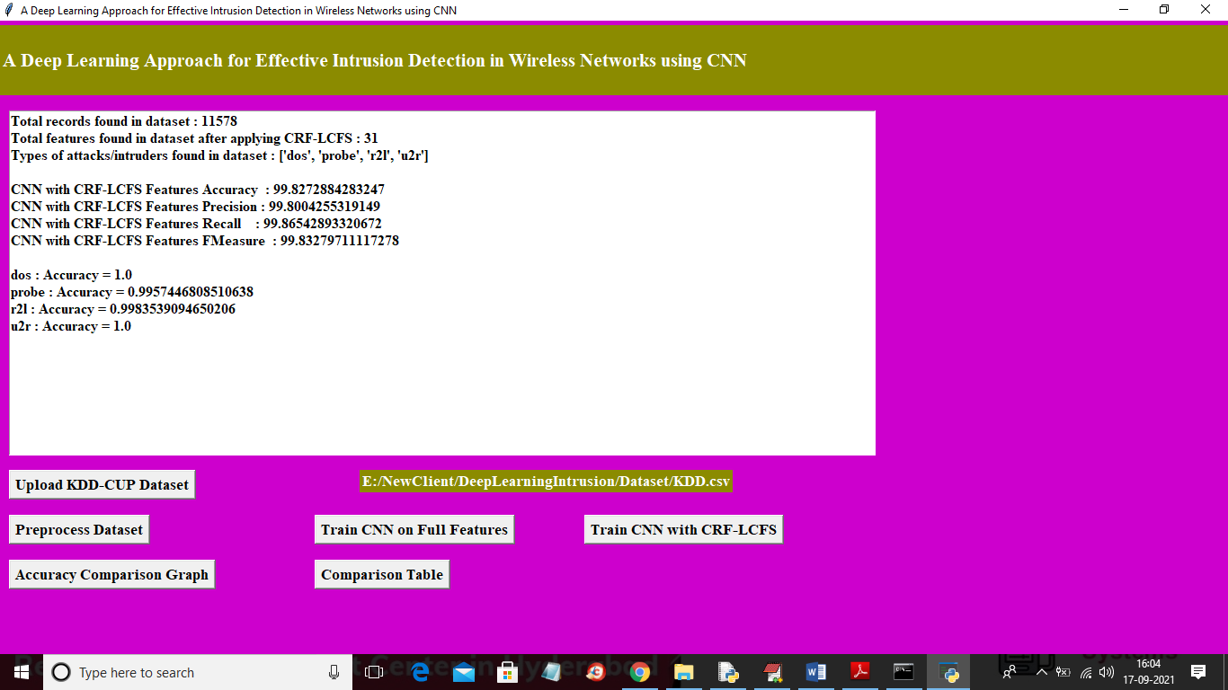
In above screen we can see selected features are 31 and we got CNN CRF accuracy as 99% which his higher than CNN with full features and now click on ‘Accuracy Comparison Graph’ button to get below graph
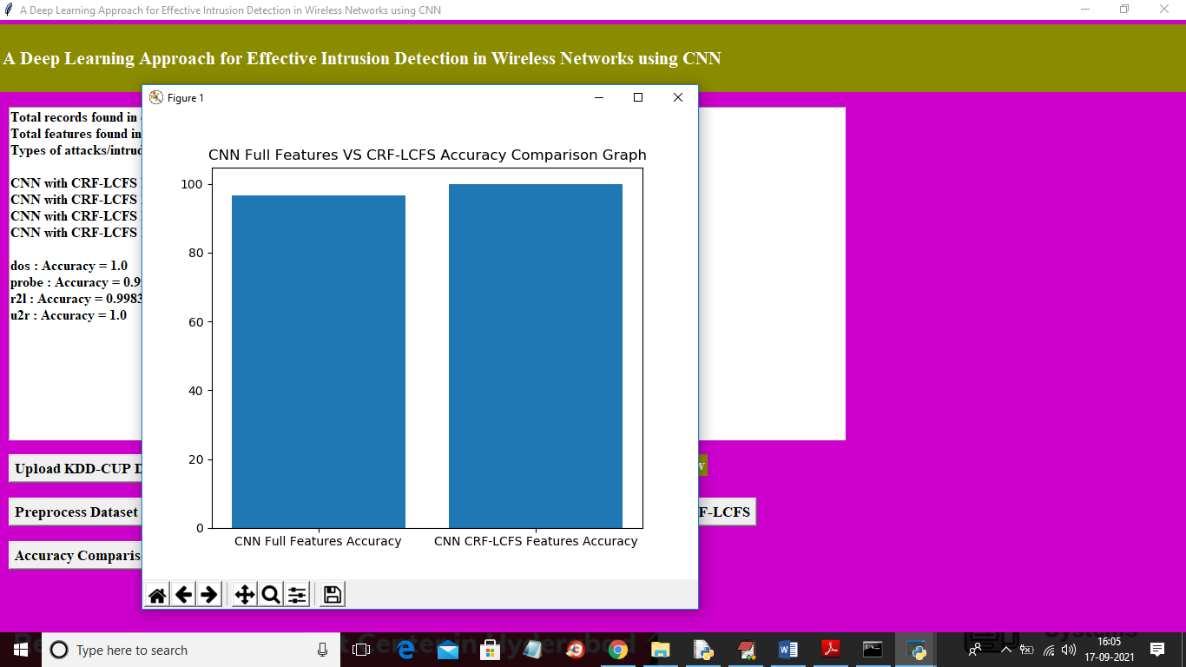
In above graph x-axis represents technique name and y-axis represents accuracy of that technique and in above graph we can see CNN with CRF has got high accuracy. Now close above graph and then click on ‘Comparison Table’ button to get below output
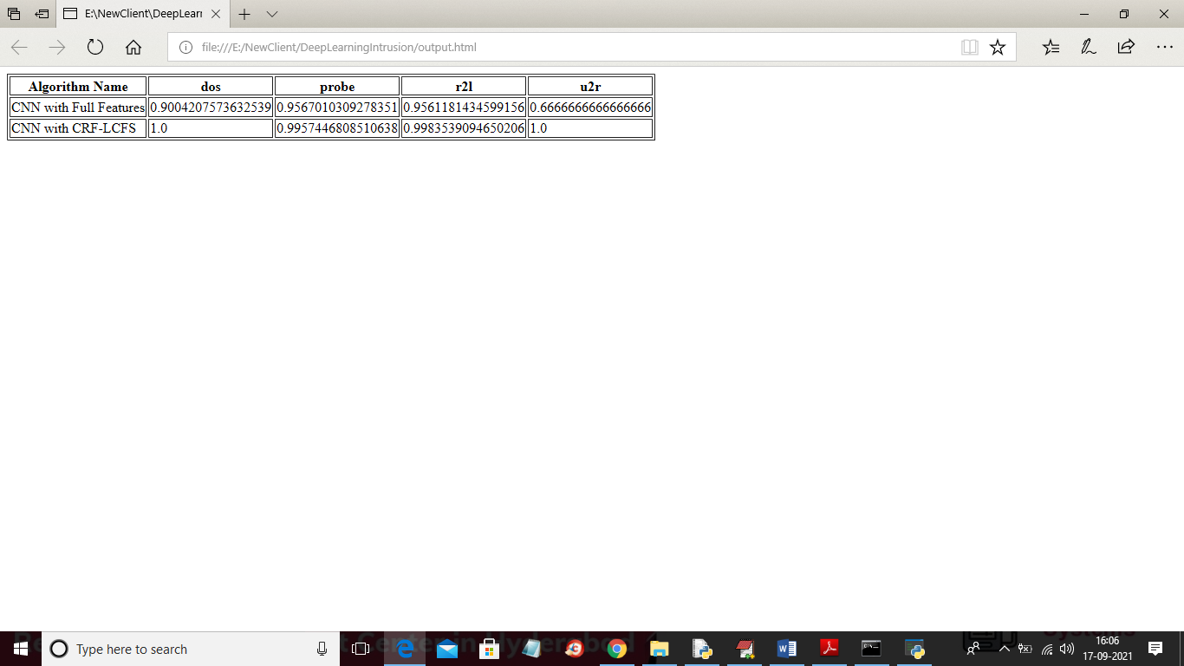
In above screen in tabular format we can see predicted accuracy of each attack using CNN with full features and CNN with CRF selected features and in both techniques CNN with CRF got better results.

