How to Run the KWIC Notebook in Google Colab (First-time users)
This guide explains how to set up and run the KWIC Search notebook in Google Colab.

A. Before you start: Open Colab from Google Drive
- Upload the project folder to Google Drive
- If you have received the project as zipped folder via email -> download the project folder (zip), then unzip it on your computer.
- Open Google Drive in your browser.
- Click New → Folder upload
- Upload the entire project folder to My Drive (recommended location).
- Do not rename or move files inside the project folder. The notebook expects a consistent structure.
- Open the notebook in Colab
- In Google Drive, open your project folder.
- Right-click the notebook KWIC-with-User-Interface.ipynb file → Open with → Google Colab.
Tip: Colab runs Python in the cloud, so you don’t install Python locally.

B. If you haven’t used Google Colab before: install/enable it
Sometimes “Google Colab” is not available under “Open with”.
Option 1 (recommended):
- Go to the Chrome Web Store
- Search for “Google Colaboratory”
- Click Add to Chrome
- Then return to Google Drive → right-click notebook → Open with → Google Colab
Option 2 (works without installing anything):
- Go to colab.research.google.com
- Click File → Open notebook
- Choose the Google Drive tab and select the notebook
(Which option is available can depend on your browser and organization settings.)

First-Time Setup: Google Drive Permissions
When you run the Colab notebook the first time, Google will ask you to confirm permissions. This is normal.

Step 1: Connect to Google Drive
- Look for the “Connect to Google Drive” button or link.
- Click it to start the authentication process.
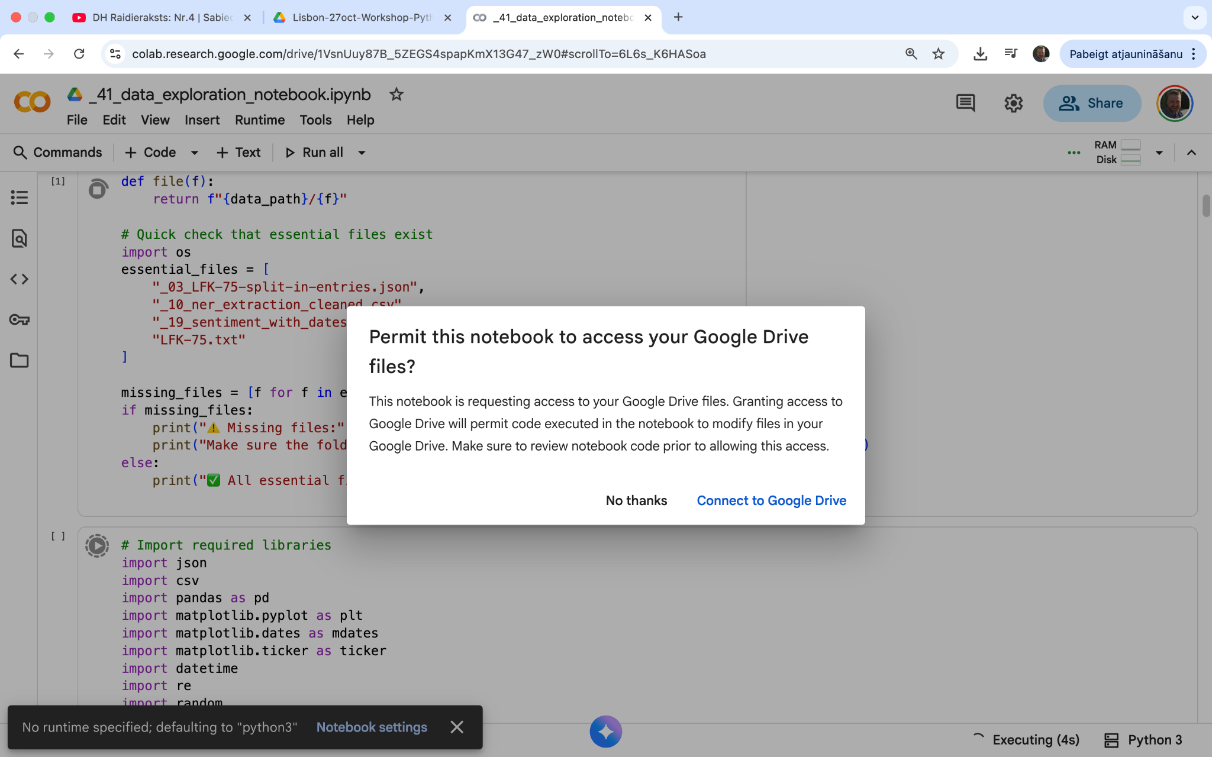

Step 2: Google Account Selection
- Choose your Google account from the list.
- If you don’t see your account, click “Use another account.”
- 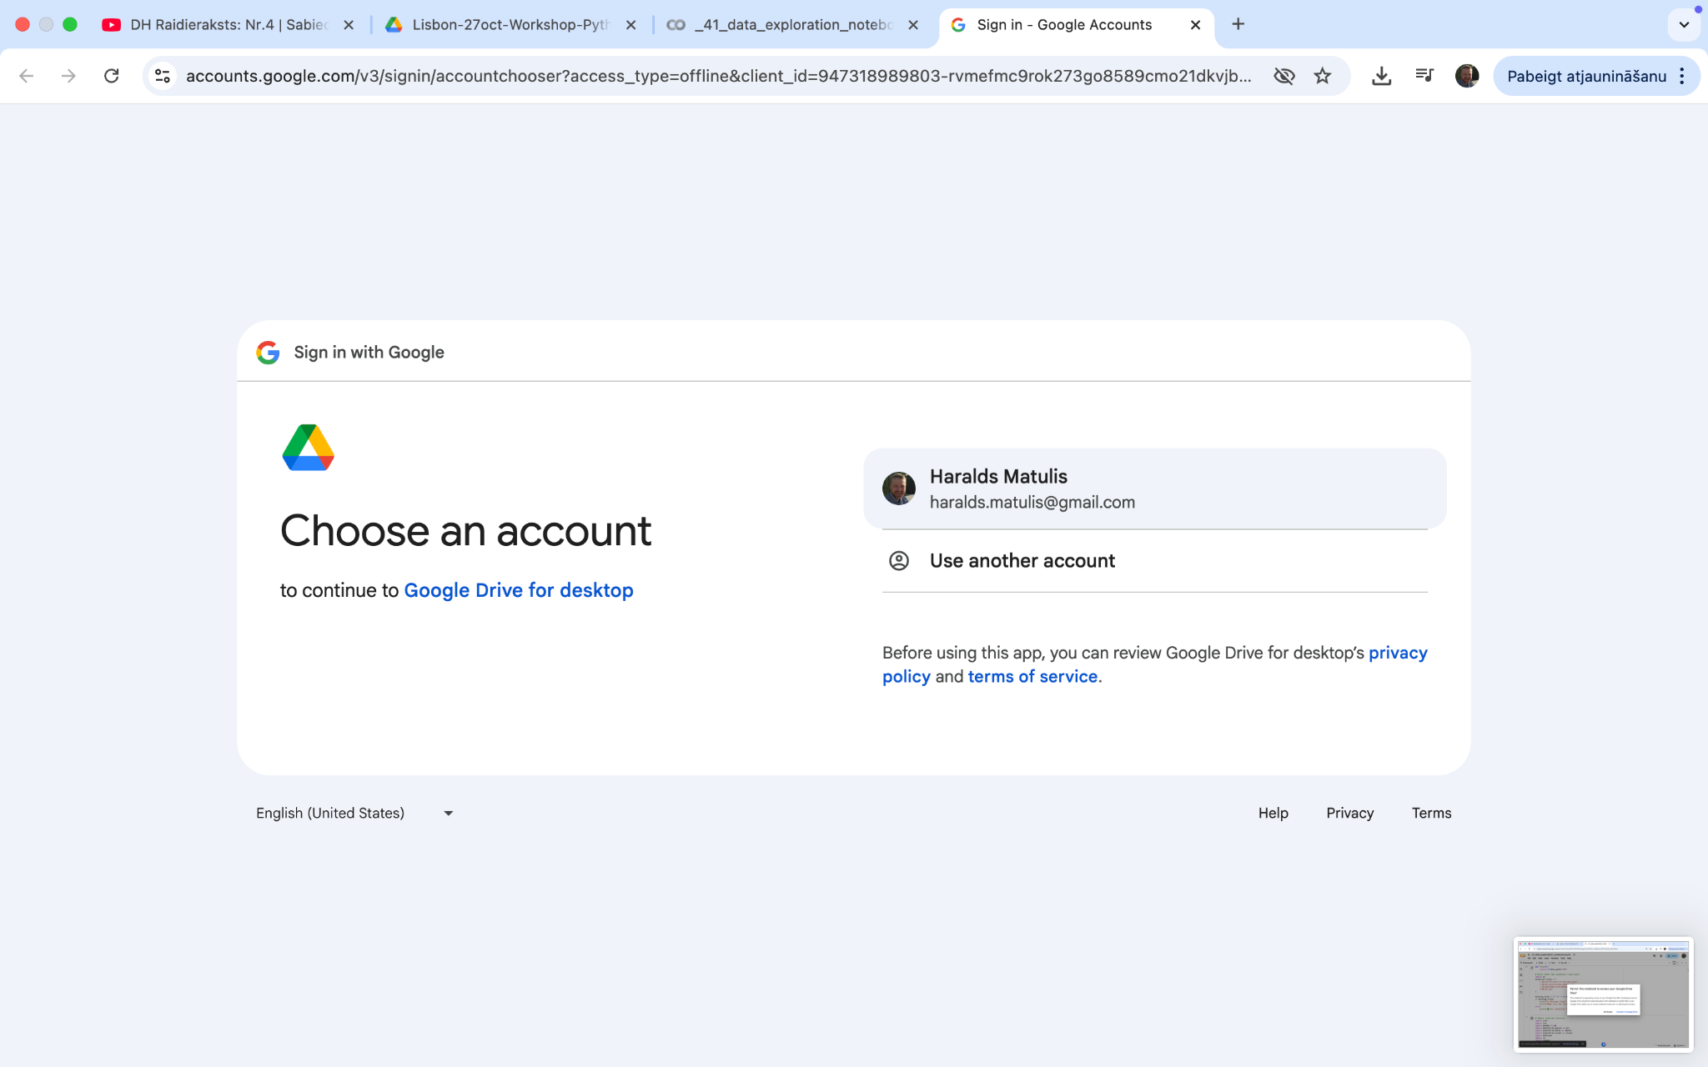

Step 3: Permission Requests
- Google will ask for several permissions.
- Click “Allow” for each permission request.
- These permissions are needed for:
  - Accessing your Google Drive files
  - Running Python code in the cloud
  - Installing packages automatically
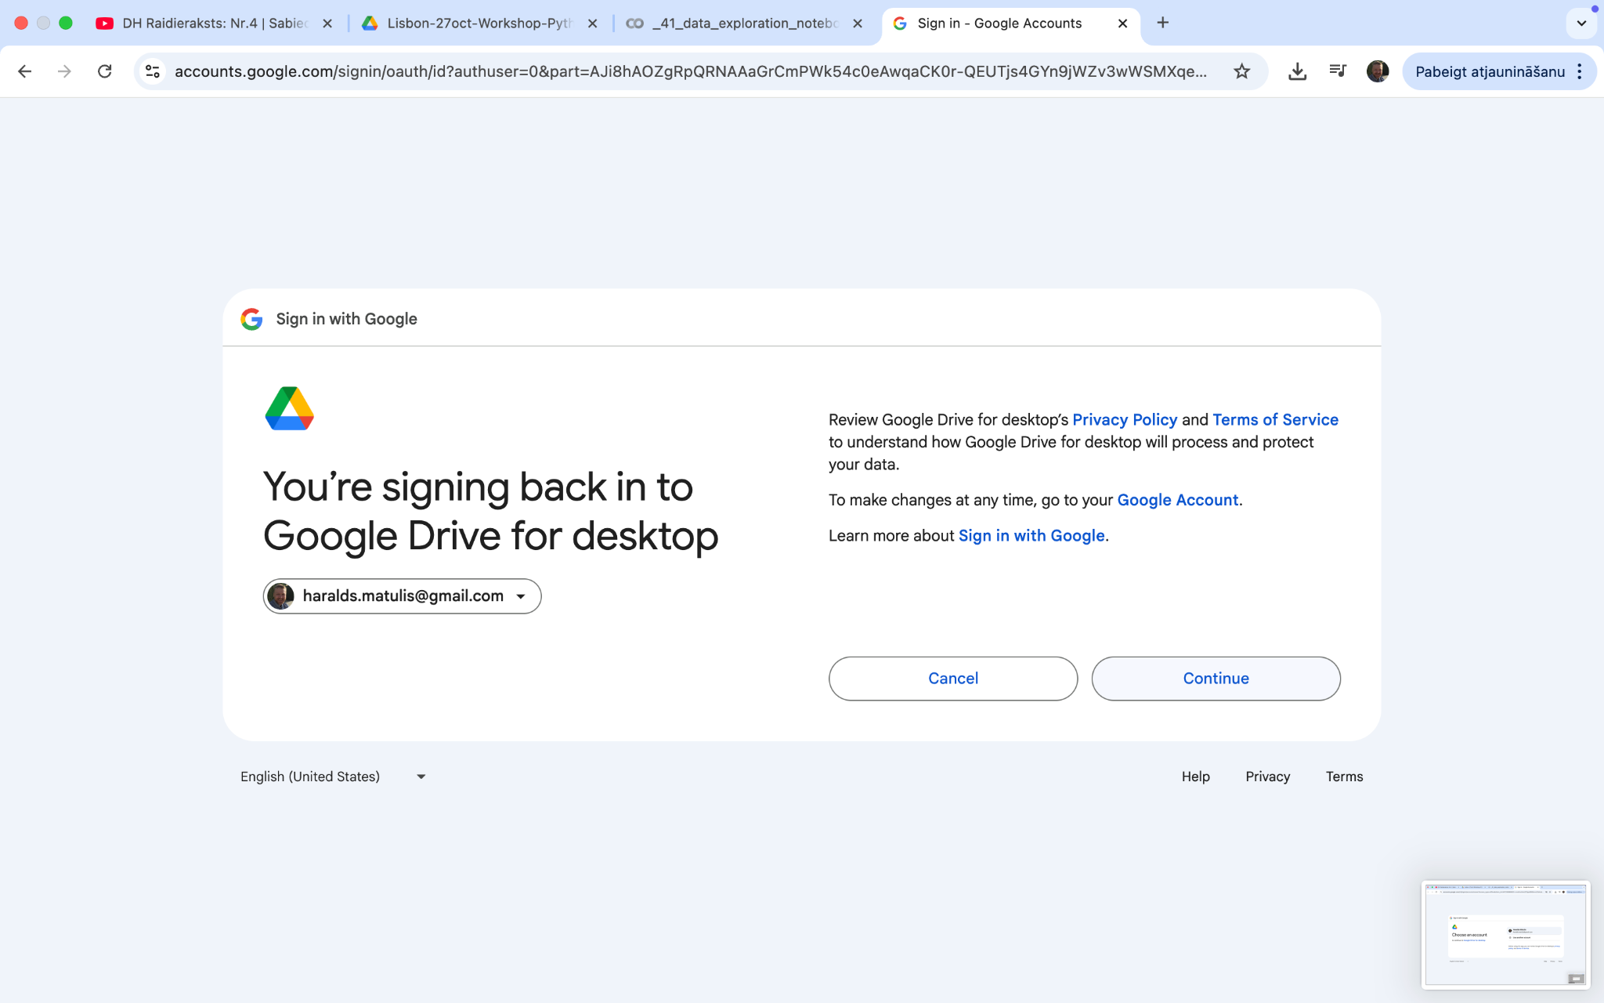
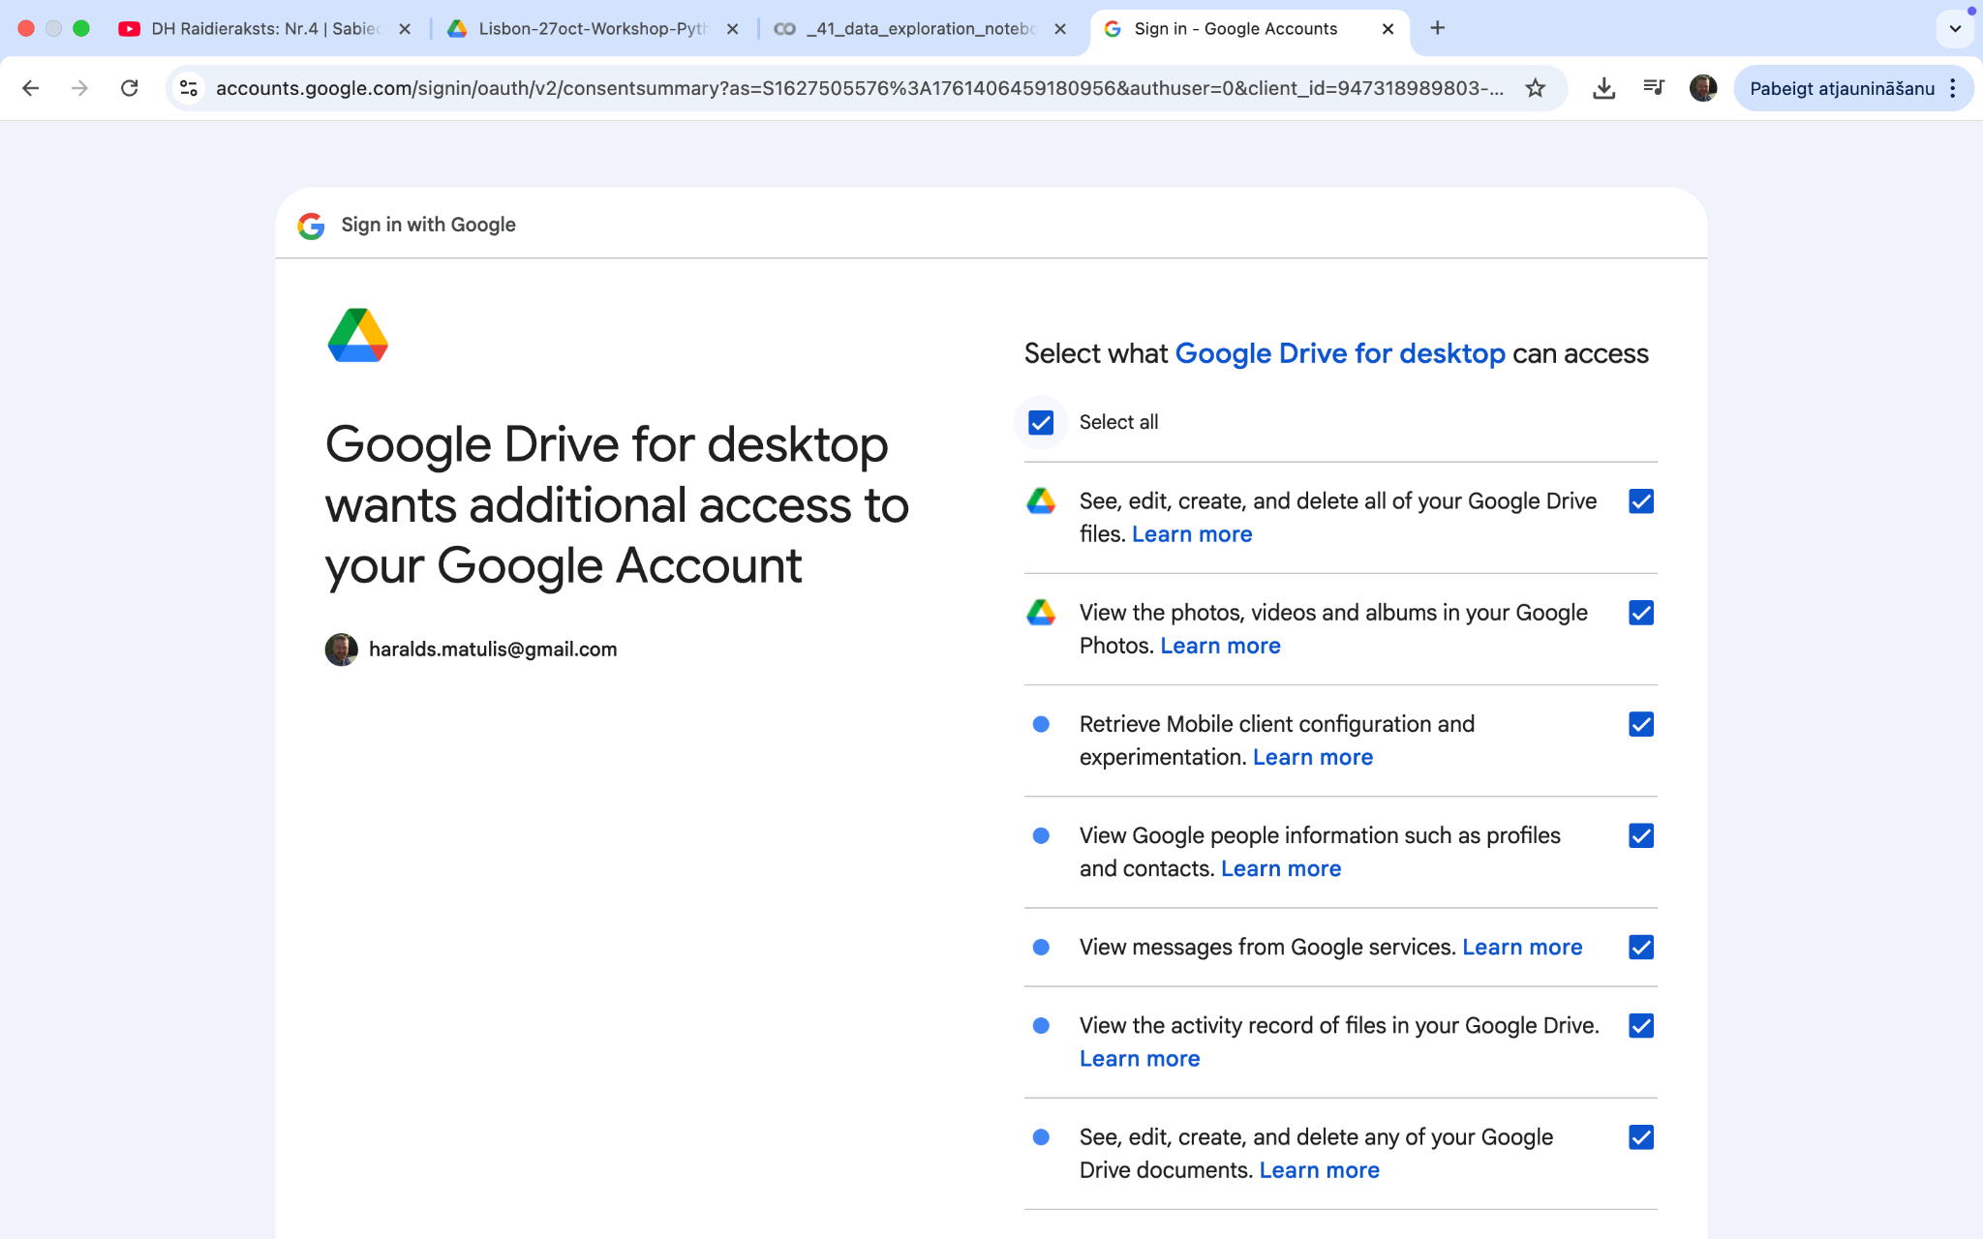
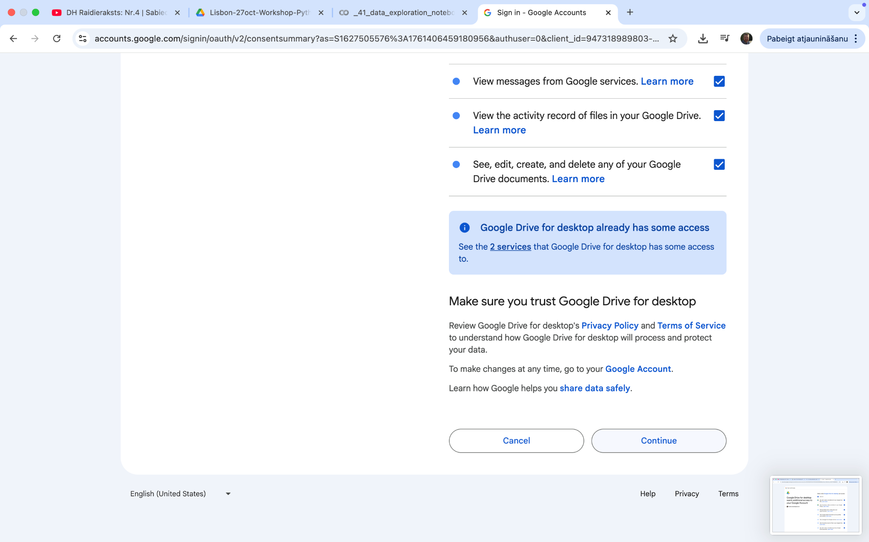

Step 4: Authorization Complete
- You’ll see a success message.
- The notebook will now have access to your Google Drive files.

D. Folder structure requirements (important)
To avoid “file not found” problems:
- Keep your input files in the project folder (or in the folder you set inside the notebook UI).
- Do not rename the project folder or move files around after uploading.
- The notebook will save outputs into:
  - results/ (inside the project folder / chosen Drive folder)

Troubleshooting
“File not found”
- Check the Drive folder path in the UI.
- Confirm your files are inside that folder.
- Confirm the notebook has Drive permissions.
Permission errors
- Rerun the code cell and reconnect Drive.
- Make sure you clicked Allow for all prompts.
Colab not available in “Open with”
- Use the colab.research.google.com method (Option 2 above), or install the Colab extension.

2) One sentence for the Intro cell (pointing to the permissions instructions file)
If you have problems with Google Drive permissions, open the “Permissions / First-time setup” instructions file in this project folder and follow the steps.
(If you tell me the exact filename you’ll store it under, I can make this sentence match it exactly.)

3) Keeping the “correct folder structure” message
Included above under D. Folder structure requirements (important) (and also referenced in Troubleshooting).

4) Colab extension steps
Added under B. If you haven’t used Google Colab before: install/enable it, with two clear options (extension vs opening from colab.research.google.com).

