**CS331 Project Phase 2 Report**

Team HaramBase

Shilei Lin, Joshua Folkerds, Matthew Kouniyom



*This project is dedicated to our hero, Harambe, the Gorilla that was.*

**Table of Contents**

PART I Conceptual Database Design – ER/EER Diagrams 3

PART II Logical Database Design – ER/EER to Relational Mappings 5

PART III Problems and Challenges 7

PART IV Task Decompositions 7

PART V Detailed Meeting Minutes 8

# PART I Conceptual Database Design – ER/EER Diagrams

* Entity with Attribute Lists:

1. **USER** is an entity with simple attributes *Email, Username, Password, FirstName, LastName, and UserID*.
   1. Primary key for **USER** is UserID.
2. **MEMBER** has a derived attribute of *Rating*.
   1. Primary key for **MEMBER** is UserID.
3. **ADMIN** has no extra attributes.
   1. Primary key for **ADMIN** is UserID.
4. **ITEM** is an entity with simple attributes *AuctionStartTime, AuctionEndTime, Descriptiuon, Category, ItemID, ItemName, and StartPrice*. But also has two derived attributes which are *CurrentBid, and Status.*
   1. Primary key for **ITEM** is ItemID.

* Relationship Descriptions:

1. **ADMIN** can create **USERs**.
2. **MEMBER** can have a list of 0 to many **ITEMs**.
3. **MEMBER** can leave *FEEDBACK* on 0 to many **ITEMs**.
   1. *FEEDBACK* has simple attributes of ItemQuality, Comments, OverallRating, and Delivery.
4. 0 to many **MEMBERs** can *BID* on 0 to many **ITEMs.** 
   1. *BID* has simple attributes of BiddingTime and MaxBidLimit, and has a derived attribute of winner.

* Constraints:

1. **ADMIN & MEMBER** are a disjoint specialization of the **USER** entity.

* Unobvious Choices and Assumptions:

We originally thought we needed to include an Auction relation in our model. However, after meeting with Prof. Rahal we realized this was not correct.

We assumed that all Users must be created by Admins.

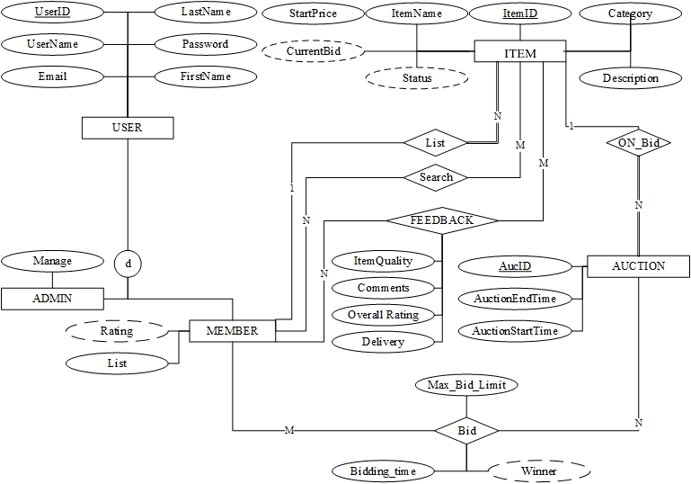

Figure 1 Original Design of ER Diagram

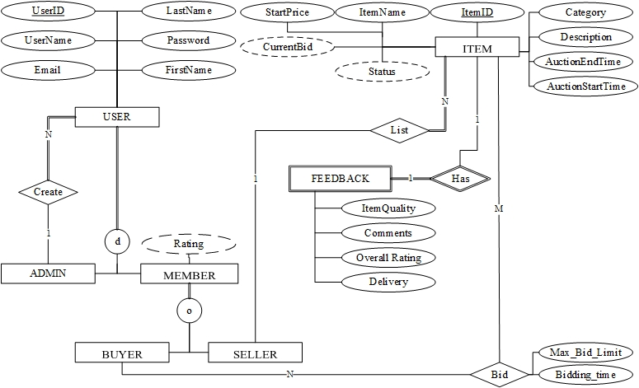

Figure 2 Final EER Diagram

# PART II Logical Database Design – ER/EER to Relational Mappings

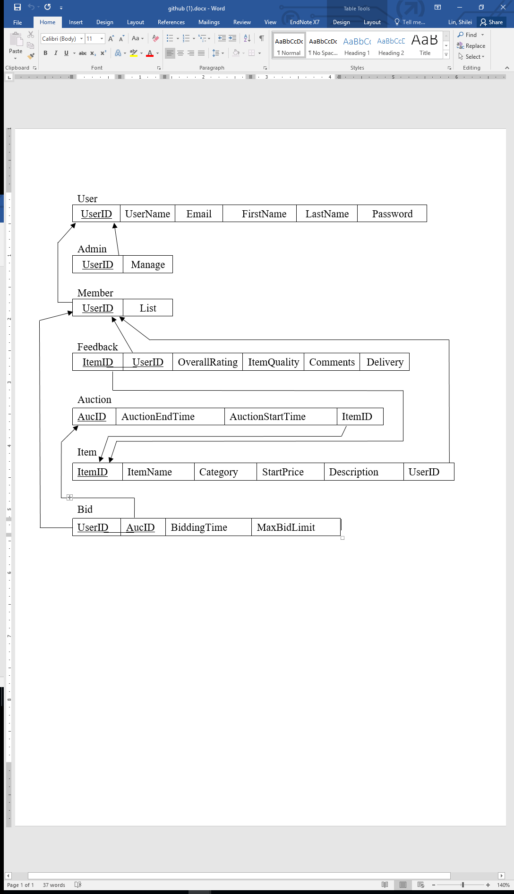

Figure 3 Original Mapping Diagram

|  |  |  |  |  |  |  |  |
| --- | --- | --- | --- | --- | --- | --- | --- |
| Admin |  |  |  |  |  |  |  |
| UserID | UserName | Email |  | FirstName | LastName | Password | CreatorID |

|  |  |  |  |  |  |  |  |  |  |  |  |  |  |  |  |
| --- | --- | --- | --- | --- | --- | --- | --- | --- | --- | --- | --- | --- | --- | --- | --- |
| Member |  |  |  |  |  | |  |  | | | |  |  |  |  |
| UserID | UserName | Email |  | FirstName | LastName | Password | CreatorID | | IsBuyer | IsSeller |

|  |  |  |  |  |  |  |  |  |  |
| --- | --- | --- | --- | --- | --- | --- | --- | --- | --- |
| Feedback |  |  | |  | |  | | |  |
| ItemID | OverallRating | | ItemQuality | | Comments | | Delivery |

|  |  |  |  |  |  |  |  |
| --- | --- | --- | --- | --- | --- | --- | --- |
| Item | | | | | |  |  |
| ItemID | ItemName | Category | StartPrice | Description | UserID | AuctionStartTime | AuctionEndTime |

|  |  |  |  |
| --- | --- | --- | --- |
| Bid | | | |
| UserID | ItemID | BiddingTime | MaxBidLimit |

Figure 4 Final Mapping Diagram

An alternative scenario would be to map the User specializations of Admin and User as their own relations. However, we feel that merging them into the User relation represented by a UserType is the ideal approach with less redundancy.

Alternative mapping of User:

|  |  |  |  |  |  |  |
| --- | --- | --- | --- | --- | --- | --- |
| User |  |  |  |  |  |  |
| UserID | UserName | Email |  | FirstName | LastName | Password |

|  |  |
| --- | --- |
| Member |  |
| UserID |

|  |  |
| --- | --- |
| Admin |  |
| UserID |

# PART III Problems and Challenges

* Some of our problems included having disagreements over how to model the database in ER/EER diagram. We overcame this issue by going to see Professor Rahal to clear up our questions and disagreements. This was the only major issue for this phase as the rest of it went very well.

# PART IV Task Decompositions

|  |  |
| --- | --- |
| **Name** | **Task Assigned and Completed** |
| Shilei Lin | I contributed in the brainstorming of our EER diagram and helped to sketch the diagram. I made some mistakes on the entities that we should have and made some unnecessary relations. I designed the bid and decided the specification on the two user types. Then I help with writing up the report in the part I, IV and V |
| Matthew Kouniyom | I helped to figure out how to model our database with the EER diagram. I contributed to help implement the EER diagram. I also helped implement the Mapping diagram by implementing the User and Feedback relations. I helped review the Mapping diagram to make needed changes as well. I helped complete the Meeting Minutes. |
| Joshua Folkerds | For this phase, I helped to brainstorm how to model the database with an EER diagram. I helped implement the EER diagram as well as making necessary changes along the way. As we were finishing the EER diagram, I worked on implementing the Mapping diagram. I specifically implemented the Item and Bid relations as well as making necessary changes during revision or our diagrams. I also helped complete the Meeting Minutes. |

# PART V Detailed Meeting Minutes

|  |  |
| --- | --- |
| Data | Details |
| 09/22 | We got together and fixed our issues from the previous phase. Then we started to brainstorm all the possible entities and relationships that can be including in the EER diagram. We worked through each entity and assigned perspective attributes to them. Lastly, we discussed what we would work on at the next meeting. |
| 09/25 | We embarked on our journey to create our EER Diagram. We discussed which attributes should or should not be included in the EER Diagram and then we talked about the relationships and their cardinality. We did not finalize the design and we agreed to review the design individually leading up to the next meeting. |
| 09/29 | We continued work on our EER Diagram. We conflicted on a few components of our EER Diagram and decided to seek help from Prof. Rahal to clear up the issues.  Next, we started our Relational Mapping Diagram. While working on the Mapping Diagram we realized other pieces of our EER Diagram needed review. Since we had some doubts on the EER diagram, we waited to speak with Prof. Rahal before continuing work on the diagrams. |
| 09/30 | Josh and Shilei had a brief Q&A session with Prof. Rahal, and solved the problems we were experiencing. |
| 10/06 | We reviewed and made necessary changes to our EER Diagram and Relational Mapping Table. Then we started our report and worked on finalizing our diagrams. The report was not yet finished. |
| 10/07 | We met one last time before the deadline to finalize our report and turn it in. |