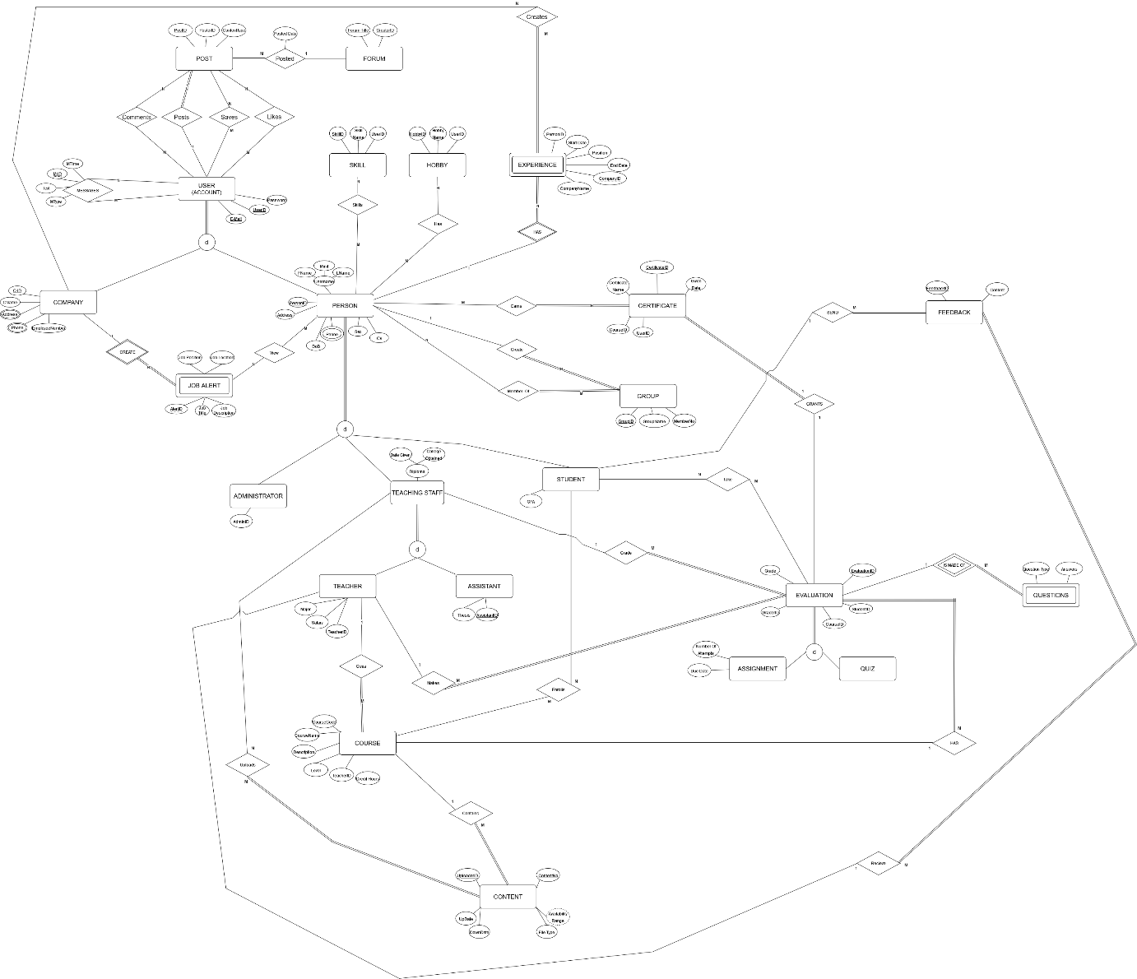

**1st Iteration**

**STEP 1 MAPPING OF REGULAR ENTITY TYPES:**

* **FORUM** (Forum Title, CreatorID) creator id taaa user Id’ye kadar uzanan bir fk
* **POST** (Post ID, Content Type)
* **SKILL** (Skill ID, Skill Name, Person ID) person ID, person’daki PersonID’ye uzanan bir fk
* **HOBBY** (Hobby ID, Hobby Name, Person ID) aynı mantık
* **CERTIFICATE** (Certificate ID, Certificate Name, Given Date, Course ID, Person ID) Course ID ve Person ID FK
* **GROUP**  (Group ID, Group Name, Member No)
* **COURSE** (Course Code, Course Name, Description, Level, CreditHours)
* **CONTENT** (Content No, File Type, Up Date, Down Date, Uploader ID) dervied attribute sor
* **FEEDBACK** (Feedback ID, Content)

**STEP 2 MAPPING OF WEAK ENTITY TYPES**

**-**

**STEP 3 MAPPING OF 1:1**

**-**

**STEP 4 MAPPING OF 1:N**

* Post M POSTED 1 Forum
  + **POST** (Post ID, Content Type, Forum Title, Posted Date) forum title, forum’dan gelen bir foreign key, post update edilmiştir.
* Course 1 Contains M Content
  + **CONTENT** (Content No, File Type, Up Date, Down Date, Uploader ID, Course Code), course code, course’dan gelen bir foreign key, content update edilmiştir.

**STEP 5 MAPPING OF M:N**

**-**

**STEP 6 MAPPING OF Multivalues Attributes**

**-**

**STEP 7 MAPPING OF Ternary**

**-**

**STEP 8 MAPPING OF Multiple Relations and stuff**

**-Mandatory, disjoint (USER)**

**8.A ile yapacak olursak:**

Superclass’ın PK’ini alıyorsun, Subclass’ın Attribute’u olarak yazıyorsun FK olacak şekilde. Subclass’ın Key attribute’u, kendisinin PK’I olacak

**USER:**

(User ID, Password, E-Mail, multival attr var unutma)

**COMPANY:**

(Company User ID, Company Name, EmployeeNumber)

**PERSON:**

(Person User ID, FName, Minit, LName, DoB, Sex, Cv, Person Type)

**8B**

**COMPANY**(User ID, Password, E-Mail, multival attr var unutma, CompanyName, EmployeeNumber)

**PERSON**(User ID, Password, E-Mail, multival attr var unutma, FName, Minit, LName, DoB, Sex, Cv, Person Type)

**STEP 9 MAPPING OF UNION TYPES**

-

**2nd Iteration**

**STEP 1 MAPPING OF REGULAR ENTITY TYPES:**

**-**

**STEP 2 MAPPING OF WEAK ENTITY TYPES**

* **JOB ALERT** (Alert ID, Company Alert User ID, Job Position, Job Location, Job Title, Job Description)
* **EXPERIENCE** (Company Name, Experience Person User ID, Position, Start Date, End Date)

**STEP 3 MAPPING OF 1:1**

**-**

**STEP 4 MAPPING OF 1:N**

* **POST** (Post ID, Content Type, Forum Title, User ID)
* **GROUP** (Group ID, Group Name, Member No, Person User ID)
* **CONTENT** (Content No, File Type, Up Date, Down Date, Uploader ID, CourseCode)

**STEP 5 MAPPING OF M:N**

* **Company M Creates N Experience**
  + **CREATES**(Company Name, PersonUserIDExperience, CompanyUserID)
* **User M Messages N User**
  + **MESSAGES**(SenderUserID, ReceiverUserID, MTime, Text, MType) //unary many to many
* **User M Follows N User**
  + **FOLLOWS(**FollowerUserID, FollowedUserID, FollowTime**)**
* metin içeren bir resim

  Açıklama otomatik olarak oluşturuldu**Post N Comments M User**
  + **COMMENTS**(UserID, PostID)
* **Post N Saves M User**
  + **SAVES**(UserID, PostID)
* **Post N Likes M User**
  + **LIKES**(UserID, PostID)
* **Person M Skills N Skill**
  + **SKILLS**(PersonID, SkillID)
* **Person M Has N Hobby**
  + **HAS**(PersonID, HobbyID)
* **Person M Earns N Certificate**
  + **EARNS**(PersonID, CertificateID)
* **Person M MemberOf N Group**
  + **MEMBER_OF**(PersonID, GroupID
* **Person M View N Job Alert**
  + **VIEW**(PersonID, AlertID)

**STEP 6 MAPPING OF Multivalues Attributes**

* **USER_PHONE**(UserID, UserPhone )
* **USER_ADDRESS**(UserID, UserAddress )

**STEP 7 MAPPING OF Ternary**

**-**

**STEP 8 MAPPING OF Multiple Relations and stuff**

**-Mandatory, disjoint (PERSON)**

**8A:**

**ADMINISTRATOR**(UserID)

**TEACHING_STAFF**(UserID, DateGiven, CollegeObtained)

**STUDENT**(UserID, GPA)

**STEP 9 MAPPING OF UNION TYPES**

-

**3rd Iteration**

**STEP 1 MAPPING OF REGULAR ENTITY TYPES:**

**-**

**STEP 2 MAPPING OF WEAK ENTITY TYPES**

**-**

**STEP 3 MAPPING OF 1:1**

**-**

**STEP 4 MAPPING OF 1:N**

* **FEEDBACK** (Feedback ID, Content, StudentUserID)

**STEP 5 MAPPING OF M:N**

* **Teaching Staff M Uploads N Content**
  + **Uploads**(TeachStaffID, ContentNo)

**STEP 6 MAPPING OF Multivalues Attributes**

**-**

**STEP 7 MAPPING OF Ternary**

**-**

**STEP 8 MAPPING OF Multiple Relations and stuff**

**8A:**

**TEACHING_STAFF**(UserID, DiplomaDateGiven, CollegeObtained, TeachStaffType)

**TEACHER**(UserID, Major, Salary)

**ASSISTANT**(UserID, Thesis)

**8A:**

**EVALUATION**(StudentUserID(studentID), EvaluationID, CourseID, GraderID, Grade, MakerID)

**ASSIGNMENT**(UserID,EvaluationID, DueDate, NumberofAttempts)

**QUIZ**(UserID, EvaluationID)

---- 8b version

8B

**TEACHER**(UserID, DateGiven, CollegeObtained,Major, Salary)

**ASSISTANT**(UserID, DateGiven, CollegeObtained,Thesis)

**8B**

**ASSIGNMENT**(UserID,EvaluationID, StudentID, CourseID, GraderID, Grade, DueDate, NumberofAttempts)

**QUIZ**(UserID, EvaluationID StudentID, CourseID, GraderID, Grade)

**STEP 9 MAPPING OF UNION TYPES**

-

**4th Iteration**

**STEP 1 MAPPING OF REGULAR ENTITY TYPES:**

**-**

**STEP 2 MAPPING OF WEAK ENTITY TYPES**

**QUESTIONS**(QuestionID, ExamEvaluationID, QuestionType, Answers)

**STEP 3 MAPPING OF 1:1**

* **Evaluation 1 Grants 1 Certificate**
  + **CERTIFICATE** (Certificate ID, Certificate Name, Given Date, Course ID, Person ID, StudentUserID(studentUserID), EvaluationID, MakerID(teachingStaffID), GraderID(teachingStaffID))

**STEP 4 MAPPING OF 1:N**

* **Teacher 1 Gives M Course**
  + COURSE (Course Code, Course Name, Description, Level, CreditHours, TeacherUserID)
  + **Diagram

    Description automatically generatedteacherID EER MODELDEN kaldırıldı, veri tekrarından dolayı ötürü.**
* **TeachingStaff 1 Makes N Evaluation**
  + **EVALUATION**(StudentUserID(studentUserID), EvaluationID, MakerID(teachingStaffID), CourseID, Grade)
* **TeachingStaff 1 Grade M Evaluation**
  + **EVALUATION**(StudentUserID(studentUserID), EvaluationID, MakerID(teachingStaffID), CourseID, GraderID(teachingStaffID), Grade)

**Course 1 Has M Evaluation**

* + **EVALUATION**(StudentUserID(studentUserID), EvaluationID, MakerID(teachingStaffID), CourseID(courseCode), GraderID(teachingStaffID), Grade)
* **Teacher 1 Receive M FeedBack**
  + **FEEDBACK** (Feedback ID, Content, StudentUserID, TeacherUserID) //RECEIVE

**STEP 5 MAPPING OF M:N**

* **Course M Enrolls N Student**
  + **Enrolls**(CourseCode, StudenUsertID)
* **Student M Take N Evaluation**
  + **Take**(StudentUserID, StudentUserID(studentUserID), EvaluationID, MakerID(teachingStaffID), CourseID(courseCode), GraderID(teachingStaffID))

**STEP 6 MAPPING OF Multivalues Attributes**

**-**

**STEP 7 MAPPING OF Ternary**

**-**

**STEP 8 MAPPING OF Multiple Relations and stuff**

**-**

**STEP 9 MAPPING OF UNION TYPES**

**-**