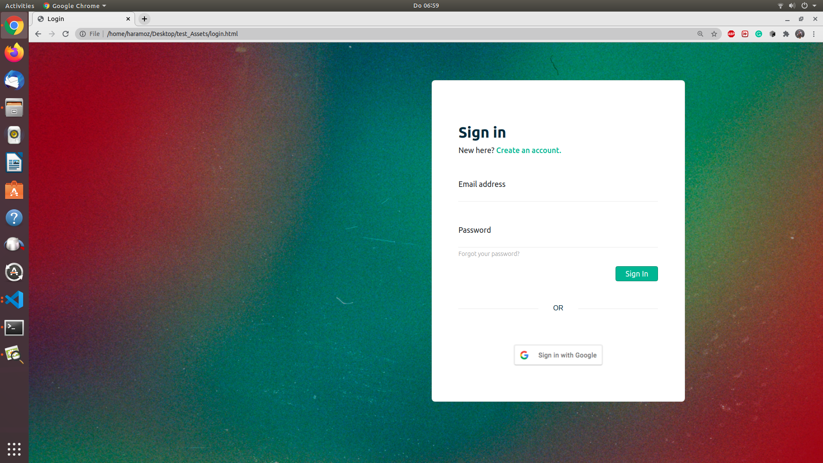
Test Job Report
Arka Mallick

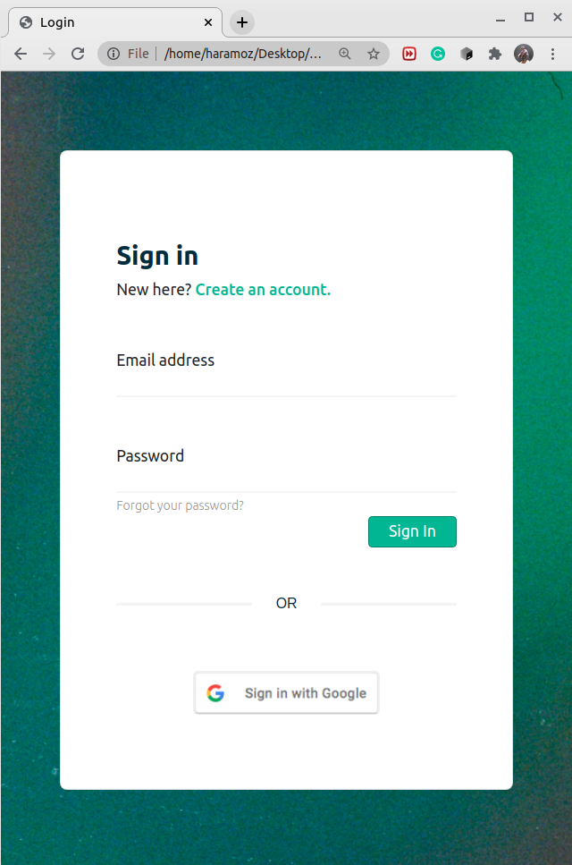
14 Jan 2020
Following is a progress report on the task.

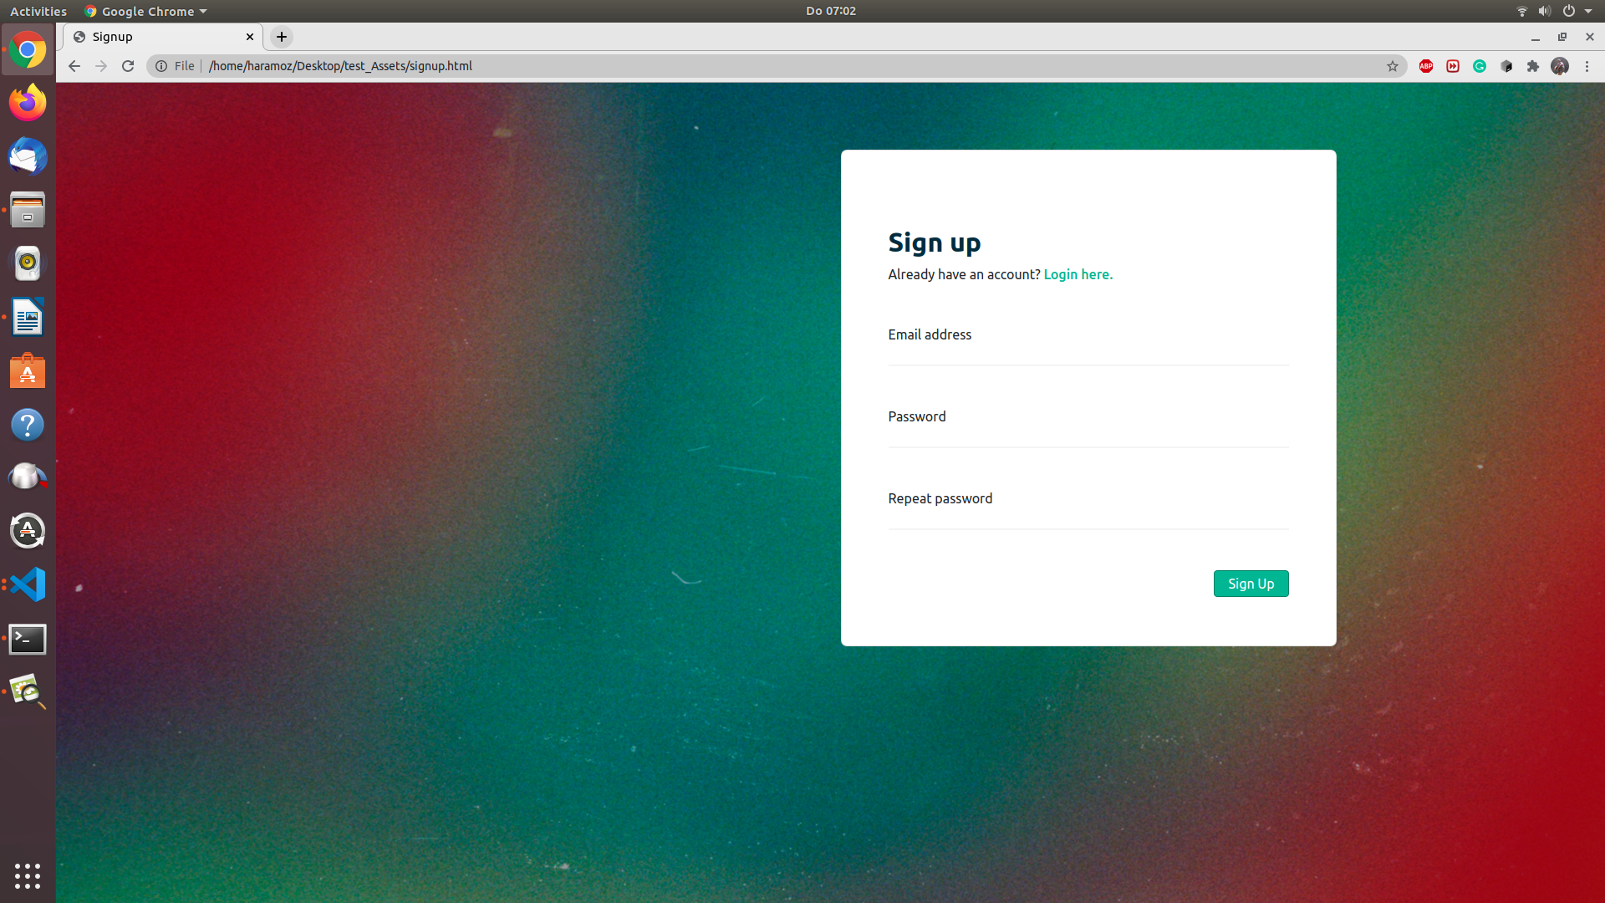
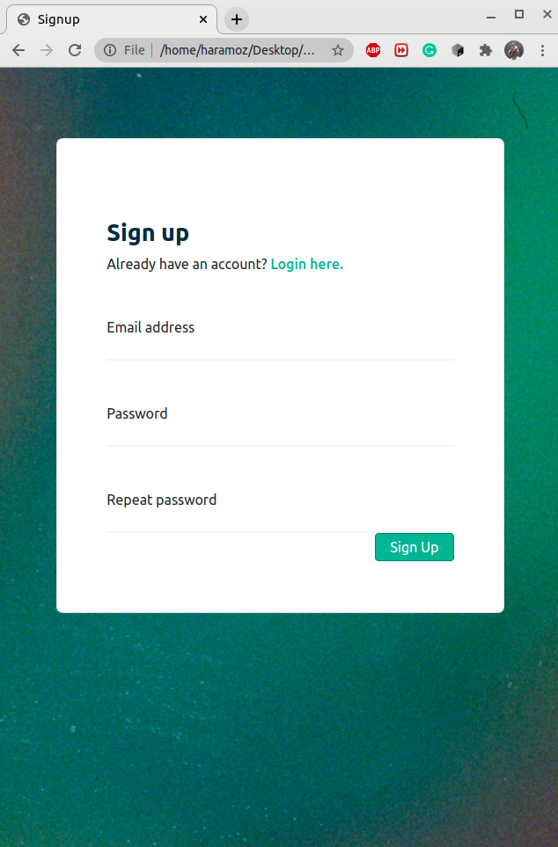

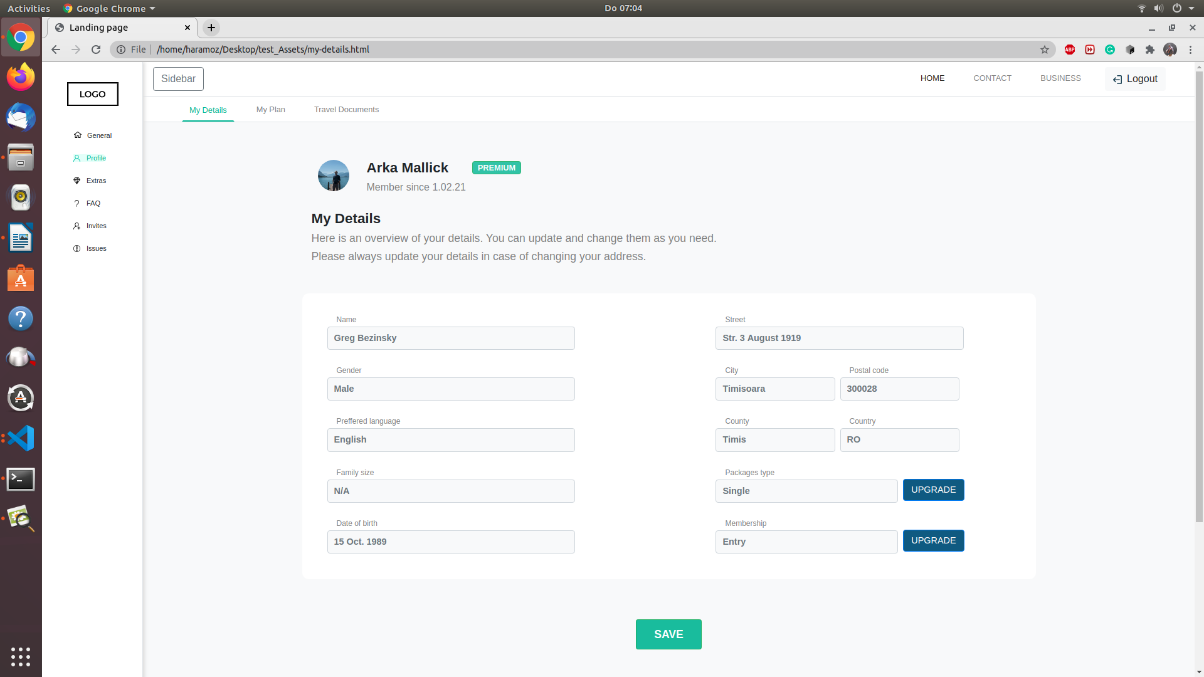


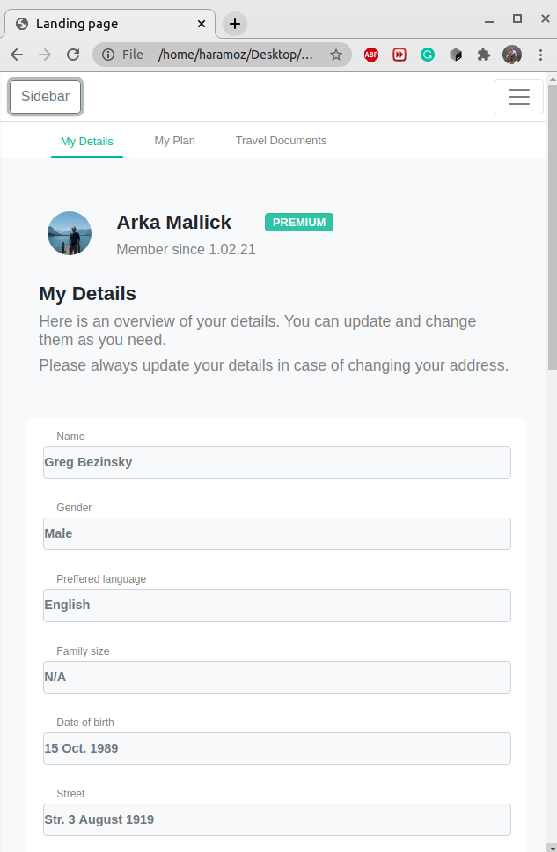
Landing page + footer in fullscreen mode

My details page in small screen view.

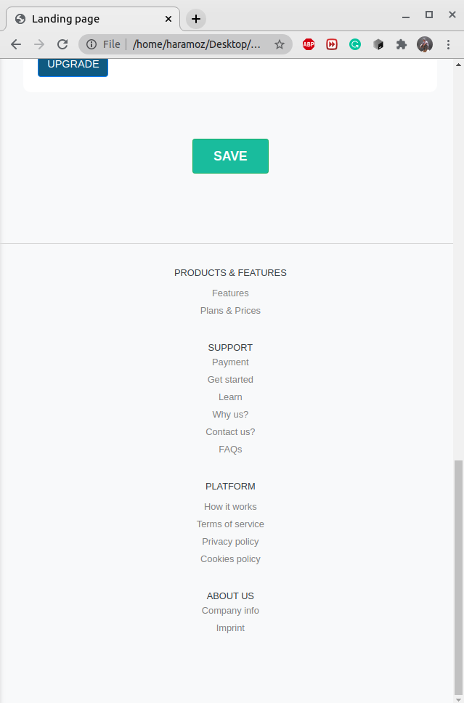

Footer in responsive view.
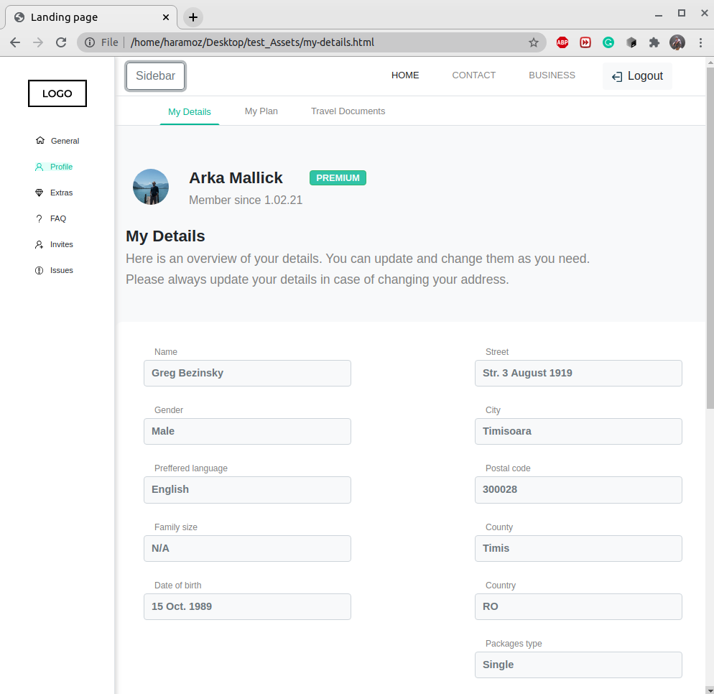

Sidebar: The left top corner button has been introduced to enable toggling of the otherwise fixed left sidebar menu which contains navigation buttons. In mobile or small screen view we can not show the fixed side bar. So hiding is a good option or we can make it a slick icon only or we can put it at top navigation bar.

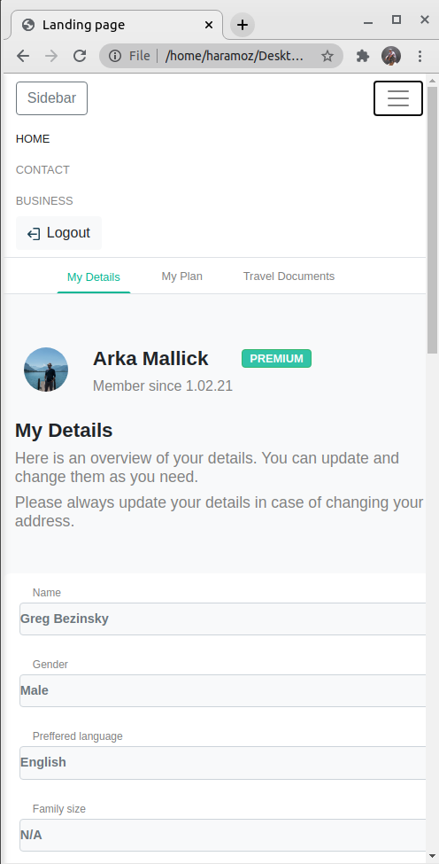

In small screen size the right corner menu icon can be used to slide up and down the navigation menu on demand, enabling responsive look and fill.

Time Log

Total time: 30hours
React functionality POC: 4hrs
Firebase: 2hrs
Responsive design: 18hours
Testing and bug fixing: 4hours
Integration + documentation: 2hours

Static HTML pages

1. login.html
2. signup.html
3. my-details.html
4. travel-documents.html(not implemented)
5. login-old.html (manual handling of the responsive behavior using jQuery. Was later replaced with normal bootstrap handling)

Comments:
There was lot of time spent in improving the design, creating the template etc from scratch, learning new features of bootstrap, even looking for the right font needed lot of time. All this are going to help next time saving time.

Continuous testing and bug fixing was needed to ensure the responsive design.

For making the responsive design the other screen views are missing, only the fullscreen views are available, so had to design that by myself, also suggested a design feature like navigation bar collapse and introducing the left sidebar toggle.

It was all together a great fun experience. :)

