**APPENDICES**

**I. WORK CONTRIBUTION**

**MEMBER 1: HARI HARAN D – Full Stack Developer**

* Developed Flask backend with multilingual support (Tamil & English)
* Integrated MongoDB for FAQ storage and chatbot query lookup
* Implemented weather and market price APIs for real-time data display
* Designed API endpoints for /chat, /tts, /weather, and /market
* Handled Tamil-to-English question translation using Deep Translator for improved query matching
* Enabled dynamic Text-to-Speech functionality with gTTS for both languages
* Built logic for language-based input normalization and response delivery
* Added logic to predict market prices for key vegetables (e.g., tomato, onion, carrot)
* Implemented CORS support for seamless frontend-backend communication
* Debugged and optimized API response performance for smooth user interaction.

**MEMBER 2: ABIRAMI D R – NLP & Translation Specialist**

* Handled query translation using Deep Translator API to support multilingual input
* Worked on Tamil-to-English normalization to enable accurate intent matching in the backend
* Ensured language accuracy and seamless answer mapping by translating responses back to Tamil when required
* Fine-tuned translation flow for both directions to preserve context and meaning clarity
* Implemented checks for non-empty, valid text before translation to avoid runtime errors
* Enhanced chatbot accessibility for Tamil-speaking users through local language adaptability
* Improved robustness in handling regional expressions, spelling variations, and mixed-language inputs.

**MEMBER 3: ARUNA A – Frontend Engineer**

* Designed clean and responsive React frontend UI tailored for farming chatbot users
* Connected frontend to Flask backend APIs (chat, weather, market price, and TTS) for seamless communication
* Implemented voice interaction using gTTS and audio playback, allowing users to hear responses in English and Tamil
* Developed language toggle feature to switch dynamically between English and Tamil modes
* Handled asynchronous API calls for real-time response rendering and smooth user experience
* Integrated default display of weather and market price dashboard on homepage load
* Managed state for chatbot question, answer, language, and dynamic info using React useState and useEffect hooks
* Ensured consistent styling and layout using flexbox and inline CSS for readability and accessibility.

**MEMBER 4: DEVADHARSHINI K – Data Analyst & Integration Lead**

* Collected, structured, and formatted FAQ data suitable for efficient querying in MongoDB
* Curated and added hardcoded market price predictions based on seasonal trends and regional demand
* Integrated OpenWeatherMap API to fetch and bind real-time weather data for the user’s location
* Ensured accurate data formatting and validation before rendering on the frontend dashboard
* Created mock data fallback for market prices in case of real-time API failure, ensuring system reliability
* Assisted in defining the data schema for MongoDB collections and ensuring consistent data entries
* Collaborated with the backend team to structure API responses in a frontend-friendly format.

**II. PUBLICATION CERTIFICATE**

HARI HARAN D

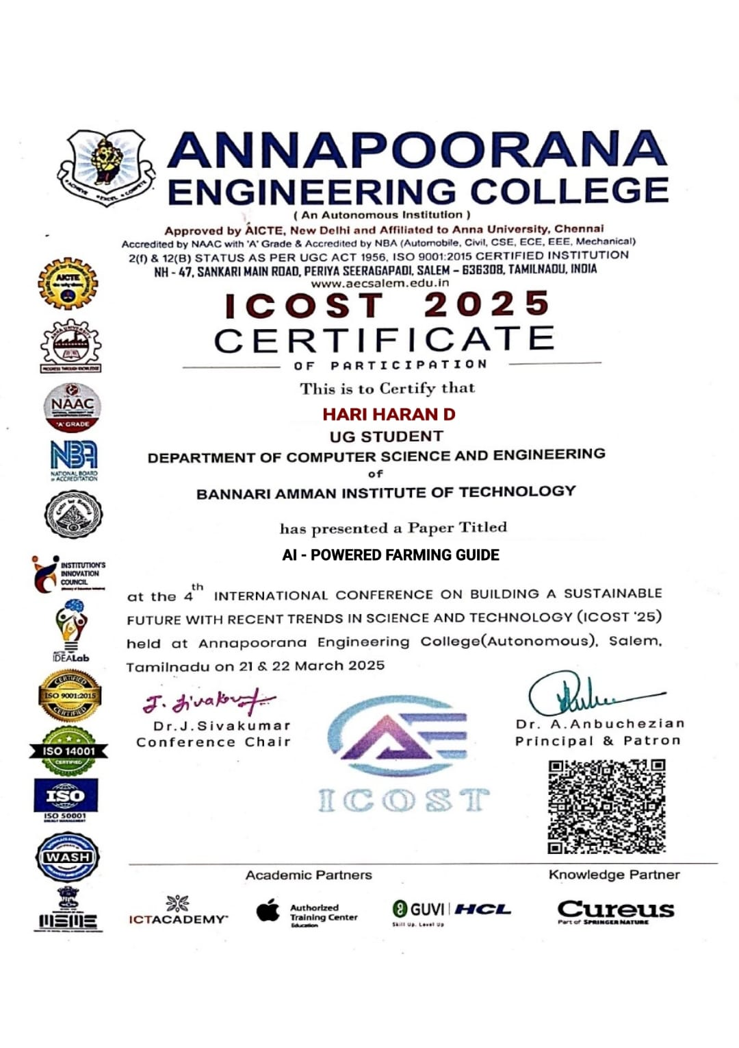

ABIRAMI D R

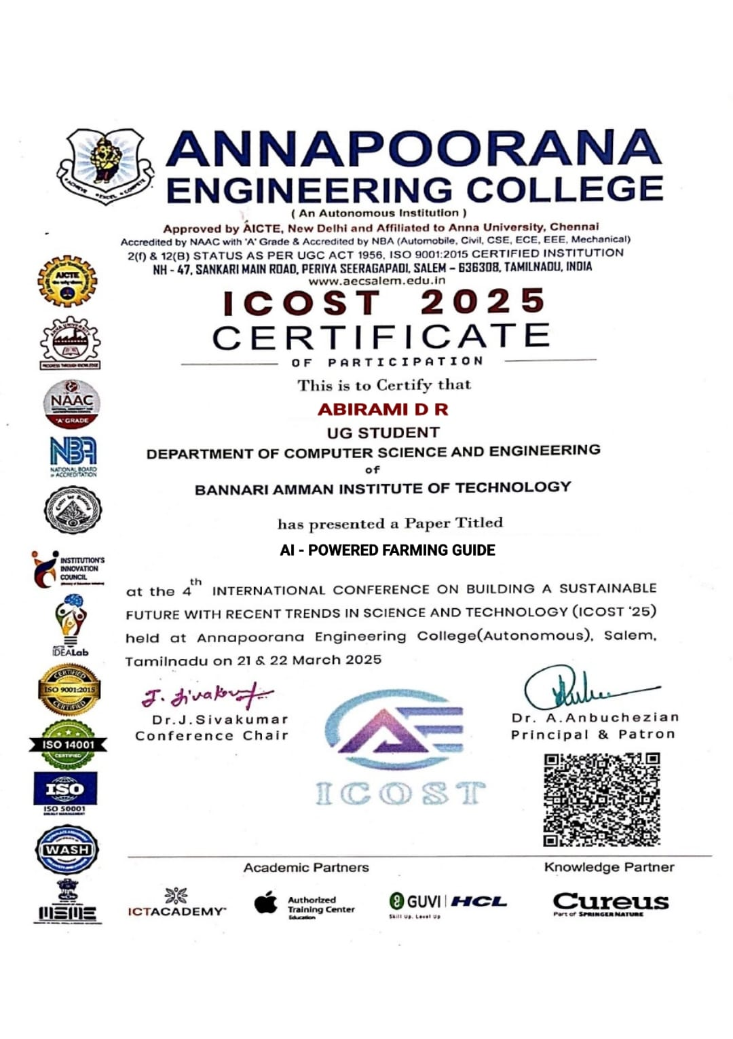

ARUNA A

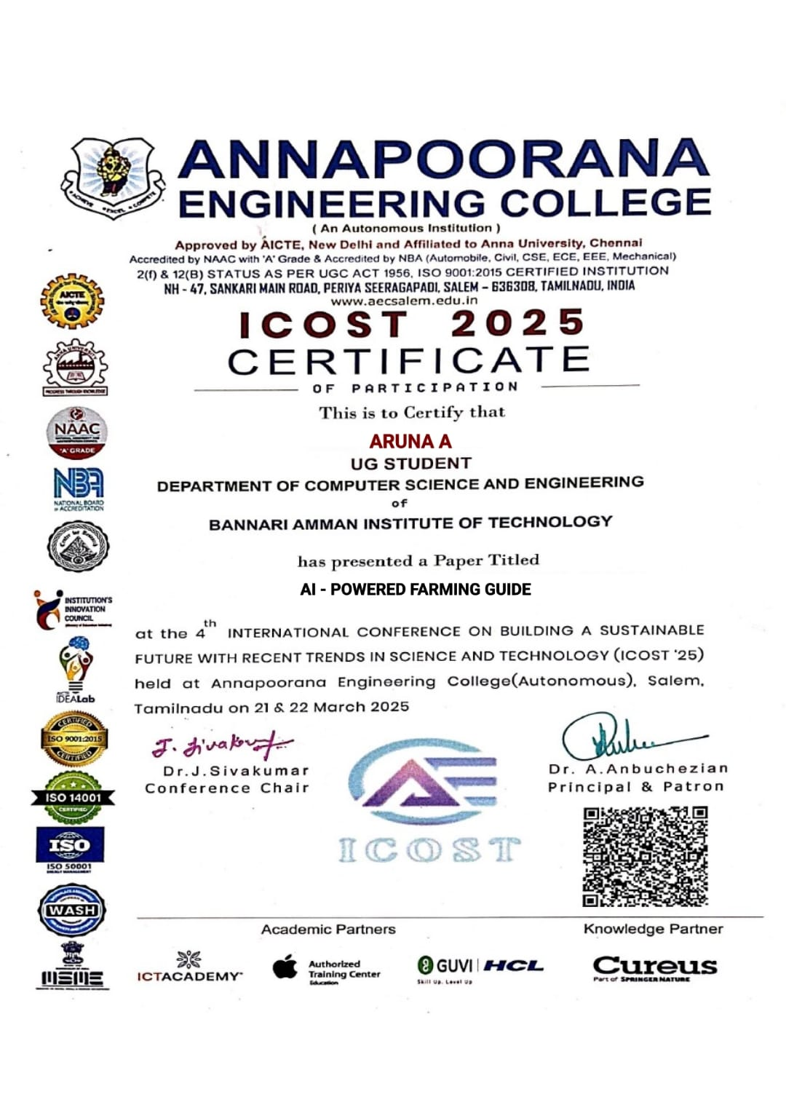

DEVADHARSHINI K

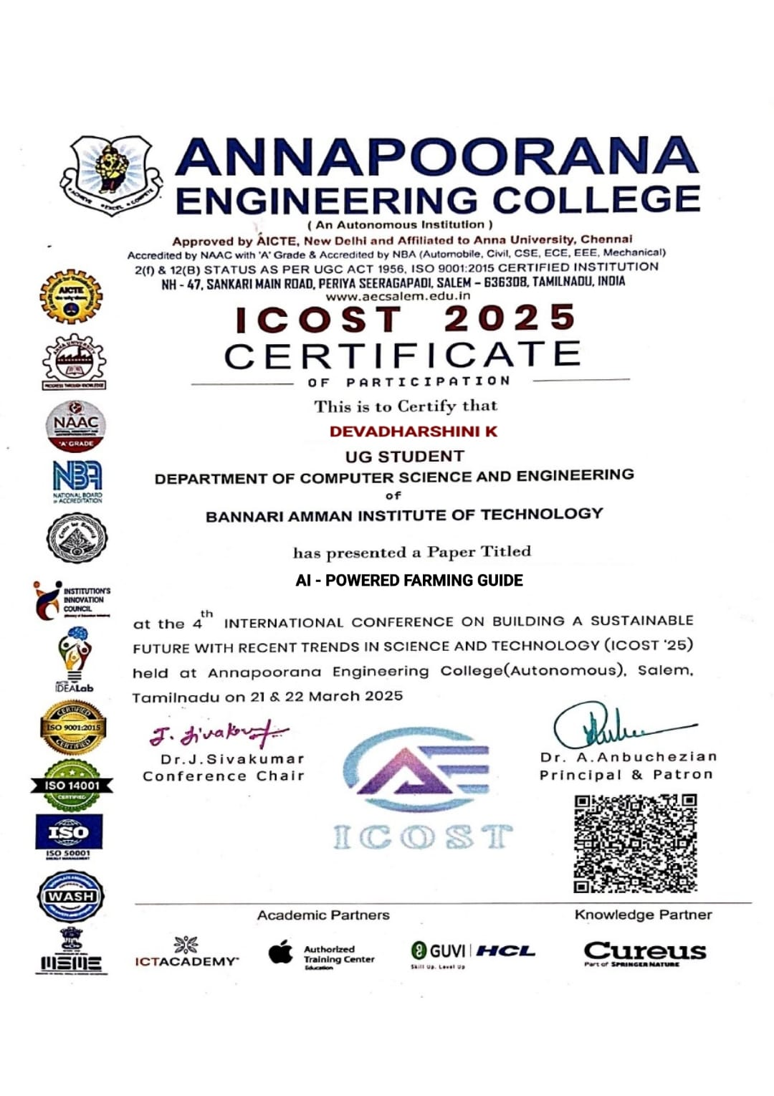

**III.BILL OF MARERIALS**

Due to the fact that only coding is used, there is no expense. Only the service cost, which would be the absolute least, is taken into account because my project doesn't include any components. Because of this, I declare it to be free.

**IV.PLAGIARISM REPORT**

